Musical Senses: Report 2026
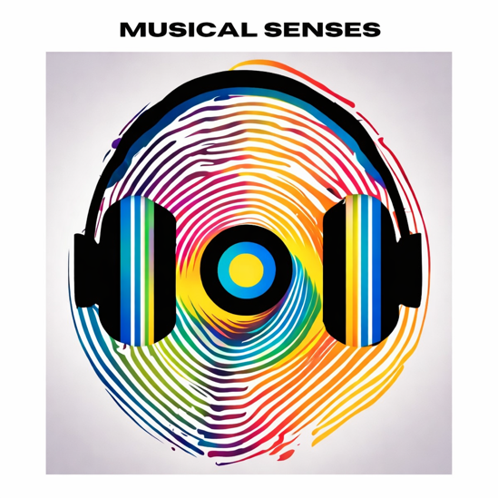
The Tri-borough Music Hub (TBMH) continued to create opportunities for children and young people to come together through music, learn from each other, and take part in high quality shared experiences.

Working in partnership with organisations including the Royal College of Music, ABRSM, Audiovisability, and this year The Amber Trust, the Musical Senses programme focused on supporting young people who are Blind/Visually Impaired (VI) and Deaf/Hard of Hearing (HoH).

This work was made possible thanks to funding from the Musical Boroughs Trust (registered charity no. 1183585, working name Tri-borough Music Trust - TBMT), John Lyon’s Charity, ABRSM, and other generous donors.

Programme Overview
Over the past five years, Musical Senses has developed around three main strands:
- Training and development for educators
- Working with role models who reflect the experiences of participants
- Creating high-quality musical opportunities for Blind/VI and Deaf/HoH young people

In 2025–26, the programme:
- Provided bursaries for 6 pupils across the year
- Delivered a two-day workshop and performance weekend on 11–12 April 2026 at the Royal College of Music (Jay Mews)
- Included online training for staff ahead of the weekend. This year, Ruth Montgomery (Deaf/HoH) and James Risdon (Blind/VI) led online training sessions for all staff involved, sharing practical strategies to support young people who are Blind/VI and Deaf/HoH.

Musical Senses Weekend Workshop Summary
This year’s weekend brought together 30 young people for two days of music-making, collaboration and performance.

Workshops were led by a team of musicians and practitioners. Returning leaders included Ruth Montgomery and Siobhan Clough (Deaf/HoH), and James Risdon and Bobby Goulder (Blind/VI). We were also pleased to welcome Fabiana and Paula Chavez, TBMH Blind piano tutors, who led a piano session as part of the weekend.
Bentley the buddy dog also joined us, helping to create a calm and welcoming atmosphere throughout.
A new addition this year was a Parents Q&A session with workshop leads, giving families a chance to connect, ask questions, and hear more about the work taking place.

Across the two days:
- The Blind/VI group worked on “You’ve Got a Friend in Me”, while also exploring harmony and developing keyboard skills
- The Deaf/HoH group learnt “Say a Little Prayer” and explored open score
- All participants also:
  - Created and performed their own group compositions
  - Prepared and shared solo performances
  - Took part in a final sharing for family and friends
- Young people were supported throughout by musicians and staff from the Royal College of Music, The Amber Trust, TBMH, and TBMH Alumni.

Young Musicians Represented
Participants came from a wide range of boroughs and local authorities:

Borough / Local Authority | Number of Participants
Wandsworth | 4
Westminster | 4
Hammersmith & Fulham | 3
Camden | 3
Bexley | 2
Essex | 2
Hampshire | 2
Oxford | 2
Southwark | 2
Hillingdon | 2
Kensington and Chelsea | 2
Lambeth | 1
Lewisham | 1
Richmond | 1
Hertfordshire | 1
Colchester City Council | 1

Impacts and Outcomes
Musical Senses 2026 supported 30 young people to take part in a shared musical experience.

- Through the weekend, participants:
  - Built confidence in their music-making
  - Developed new skills and ideas
  - Made connections with other young musicians
  - Had the chance to perform both individually and as part of a group

- The programme also:
  - Supported ongoing development for staff and workshop leaders
  - Created opportunities for musicians to lead and share their practice
  - Strengthened partnerships, including with The Amber Trust
  - Opened up more opportunities for families to engage

Legacy and Next Steps
We aim to continue our commitment by:
- Continue bursary support for students
- Deliver the next Musical Senses weekend in 2027
- Continue developing training and resources for teachers and music leaders
- Build on opportunities for parent and family engagement

Ongoing Challenges
- Reaching more young people in our local boroughs
- Ensuring strong participation from Deaf/HoH young people, although there was an increase in participants from this group compared to last year
- Meeting a wide range of learning needs across the groups
- Securing funding to sustain and grow the programme

Link to Musical Senses Resources
https://www.triboroughmusichub.org/school-services/musical-senses/

Conclusion
Musical Senses 2026 was a positive and energetic weekend, bringing together young people, families and musicians in a shared creative space. Participants developed their skills, performed with confidence, and contributed to a supportive and collaborative environment.

The programme continues to build strong partnerships, expand opportunities for young people, and strengthen its community of participants, staff and alumni.

Links to 2026 Media: films and photos
- Musical Senses Evolution video
This 11 min film captures the perspective of the Young People's experience of Musical Senses. It highlights the growth over the last 5 years as we follow the students' journey with music and the relationships they've built. The Young People interview each other and adults to answer questions around the need for this programme and how it’s supported their musical development and confidence.
- Deaf/HoH Concert
This 27 mins film presents the end of course sharing from the young musicians in the deaf/hard of hearing group.
- Blind/VI Concert
This 50 mins film presents the end of course sharing from the young musicians in the blind/vision impaired group.
- A selection of informal behind the scenes can be found HERE.

Testimonials/quotes from participants, parents/carers, and workshop leaders

It's been really fun. I've had I've learnt some things about chords and how I can.
play scales differently to do little piano exercises. It's been super duper inclusive for visually impaired people, thanks to all the adults help. Just making new friends, doing the thing I love. It's been absolutely wonderful. I'm actually a bit sad that it's over. Blind/VI participant

I've been with musical senses for as long as I can remember. I enjoy it a lot, yeah. I find it really fun and interesting because you get to learn new skills, and get to work with other people because... It's kind of like an orchestra. Deaf/HoH participant

The final concert gave me goosebumps. I have cried throughout the first performance. It made me realize how much joy the possibility of being noticed, appreciated and encouraged give to those young people. Parent Blind/VI Group

The entire event is incredibly inspiring for young people with disabilities. The entire weekend is well organised with wonderful and dedicated teaching staff who give up their time freely. I cannot thank you enough for the joy, happiness and confidence you have my daughter. Parent Deaf/HoH Group

A really great weekend of musical activity and a wonderful social opportunity for these young people to come together through music. Matthew Dear The Amber Trust Tutor

APPENDIX

MUSICAL SENSES PROJECT SPEND 2025-26

EXPENDITURE
Training and development, strategic development | £1,400
Employing specialist musicians to deliver programmes
- Workshop leads/Tutors/RCM mentors 11th and 12th April | £7882
Supporting pupils/families to engage in activity and resources
- bursary support for 2 pupils came from this budget  (NB: another 4 students are funded from a different TBMH route) | £1,900
Other Costs
- First Aid cover | £390
TOTAL COSTS / EXPENDITURE | £11,572
Income
Tri-borough Music Hub | £1,572
Musical Boroughs Trust | £5000
ABRSM | £5000
TOTAL COSTS / INCOME
IN-KIND SUPPORT
Tri-borough Music Hub (staff time) | £6485
ABRSM (filming) | £570
Royal College of Music (room hire, student support, staff time) | £8094
TOTAL IN-KIND SUPPORT | £15,149

Thank you to all the funders for their generous support –
our programme would not have been possible without your help!
If you would like to support us in the future, please contact
Stuart Whatmore, Head TBMH, stuart.whatmore@rbkc.gov.uk.

