JOB DESCRIPTION

Job Title | Vocal Music Leader (maternity cover, 9 months, Sept 2026 to July 2027)
Department | Children’s Services
Section or Service | Tri-borough Music Hub (TBMH)
Grade | G (£53,076 - £60,003)

DESIGNATION:
Responsible to: | TBMH Deputy Head / Senior Service Lead
- Employees directly supervised | - Peripatetic Vocal / Instrumental Tutors
Family Tree
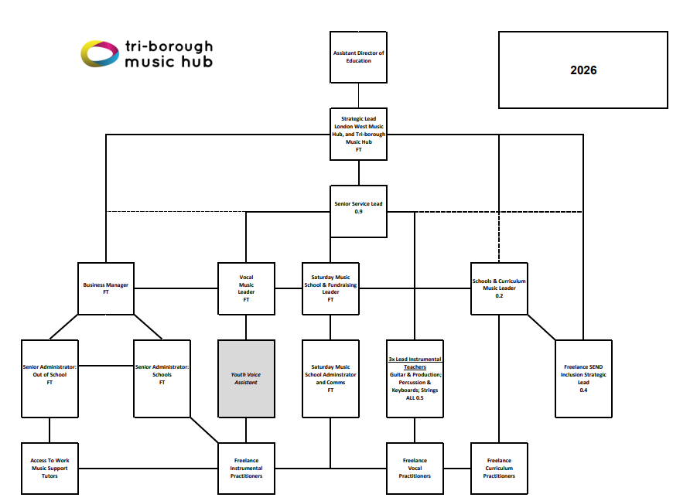
- JOB PURPOSE:

To act as the Vocal Music Lead of the Tri-borough Music Hub and to develop the standards of children and young people’s vocal music-making across Hammersmith & Fulham; Kensington & Chelsea; and Westminster by supporting the key strategic goals of the Tri-borough Music Hub. The post-holder will:
- Manage and lead a team of Tutors in the delivery of high-quality vocal music provision across in-school and out of school learning.
- Act as the Vocal Lead for high-profile performance events (Christmas Festivals and A Musical Rebellion)
- Lead the TBMH Youth Voice Council and support the growing presence of youth voice in the work of the TBMH.

- DESCRIPTION OF DUTIES:

List key personal duties in order of importance.

Main Duties and Responsibilities
- Manage and lead a team of Tutors in the delivery of high-quality vocal music provision across in-school and out of school learning:
  - to oversee the successful planning, delivery and quality assurance, and student recruitment, of the out of school vocal activity that includes:
    - First Voices choir, Yrs 1-2, Tuesdays after school
    - Junior Voices choir, Yr 3-6, Tuesdays after school
    - Next Level Voices choir, Yr 7-13, Tuesdays after school
    - Junior Choir, at Saturday Music School
    - Senior Choir, at Saturday Music School
  - to support the successful planning, delivery and quality assurance of the in school traded service (SLA) vocal teaching that includes:
    - 1:1 and small group vocal learning
    - singing and vocal work within whole class instrumental learning programmes
    - singing assemblies and choirs
  - to provide specialist leadership in regard to strategic vocal development
- to contribute and deliver (as appropriate) INSET to TBMH Tutors, school-based teachers, partner organisations and other LA teams as directed

- Act as the Vocal Lead for high-profile performance events:
  - Leading the co-ordination and delivery of the 3-day Christmas Festival series, including preparing resource packs, delivering CPD, running support visits, and ensuring successful event outcomes.
  - With a specific focus on the TBMH’s next major music education and performance programme, A Musical Rebellion, leading to a performance in the Royal Albert Hall in June 2027. This will include preparing all learning resource packs, leading CPD, and TBC acting as one of the satellite conductors in the performance event.

- Lead the TBMH Youth Voice Council and support the growing presence of youth voice in the work of the TBMH.
  - ensuring Youth Voice is present in TBMH activity, generating a broader range of pupils engaging in our work by connecting with non-formal sector (e.g. Youth clubs); and
  - developing equity and participation in music; ensuring that quality education is accessible to all.
General
- Provide support to the Head and Deputy Head of the Tri-borough Music Hub in the development of all musical learning opportunities and in writing evaluative reports on activity
- Contribute to the income generation of the Tri-borough Music Hub through school-based or other activities (e.g. teaching / ensemble leading)
- Ensure that an inclusive approach runs through all vocal activity in relation to Special Education Needs and Disabilities (e.g. using Makaton and / or British Sign Language) and across all protected characteristics
- Contribute to building / sustaining relationships with vocal partnerships

Other Duties
- To oversee data collection and reporting systems as necessary.
- To undertake other duties consistent with the scope of the post and within the competence of the post holder as required.
- To participate in Performance Evaluations, both for their own professional development but also for the direct reports to this post.
Equal Opportunities
- To carry out these duties with due regard to the Council’s Equal Opportunities Policy and priorities

- DIMENSIONS:

(WHERE APPROPRIATE)
Quote figures which give a picture of your job as follows:
(a) Annual budgetary amounts with which your job is either directly or indirectly concerned
(b) Any other statistics relating to your work

- The Tri-borough Music Hub has an annual turnover of approximately £1.5million. This is comprised of core funding from DfE via the Arts Council; and from delivering a traded service for schools and parents / carers.

- The TBMH works with all 150 schools across the Tri-borough, has an enormous reach and delivers a huge amount in relation to the core team it works with. The team is compact but highly effective.

In addition, you will be required to undertake other reasonable duties as directed by your line manager.

All staff are expected to carry out their job in compliance with the Council’s Constitution. This means being familiar with the policies and procedures relevant to the job and asking for information and advice if you are unsure of the correct course of action. The Council’s Constitution is published on the Internet.

In accordance with Bi-borough working arrangements, your employment will be with the Royal Borough of Kensington and Chelsea. Under the S113 of the Local Government Act 1972 you may also be required to act on behalf of Westminster City Council. This may mean that the location of your employment will vary.

The duties and responsibilities outlined in this job profile are indicative of the role, however they are not exhaustive and may be subject to change.

I agree to the above job description

Post Holder……………………………………………………………… Date…………………...

Head of Service………………………………………………………… Date…………………...

SELECTION CRITERIA / PERSON SPECIFICATION

Job Title: | Vocal Music Leader

Conditions to Note:

Candidates:
When completing your application form, please address your answers directly to each of the selection criteria below. This enables the panel to assess your ability to meet each criterion. It is essential that you give at least one example of your ability to meet each of the four Values and Behaviours: Putting Communities First, Respect, Integrity and Working Together.

Recruiting Managers:
The following values and behaviours are essential criteria in each post and must be addressed directly by candidates. The Guidance Notes on values and behaviours for managers give example questions to probe candidates in the interview and application stages of the recruitment process.

Values & Behaviours
The Royal Borough of Kensington and Chelsea has identified four key behaviours and values that should be demonstrated by all council employees. Successful candidates will show the ability to meet these behaviours.

A | Equal Opportunities  Demonstrate an understanding of and commitment to Council policies in relation to Equal Opportunity, Customer Care and service delivery, and the ability to implement these policies in the workplace.
B | Qualifications  Essential:  - Degree or equivalent similar experience  - Qualified Teachers' Status or equivalent similar experience
C | Skills, Experience and Attitude  Evidence of successful experience of:  - High standard of music delivery / teaching  - Effective project, staff and pupil management  - Highest level of playing or singing  - High quality music partnership engagement  - Quality assurance of instrumental / vocal / classroom provision to effect best practice  - Effective use of data and reporting systems to inform planning  - Effective leading / conducting of ensembles  - Successful event planning  - Planning and leading training  Essential Experience and Knowledge  - Specific experience of having led large-scale music education projects, demonstrating a clear understanding of how Music Education Hubs can contribute to whole school improvement and raising attainment and motivation of young people  - Up-to-date knowledge of current developments in music education (music hubs and schools)  - A good understanding of how schools operate and how music education can contribute to improving pupil learning and motivation  - A thorough knowledge of a range of teaching methods in music teaching in general and in specific with vocal / instrumental learning and development  - An understanding of what constitutes good or better teaching and how teaching and learning can be improved  - An understanding of working in partnership and how projects are effectively managed  Personal Qualities & Characteristics  - Able to demonstrate leadership skills  - Able to manage own workload, delegate, motivate and inspire others  - Able to work calmly, to cope well under pressure and meet deadlines  - Able to apply time management, planning and delegation tools effectively  - Approachable, flexible and able to prioritise for self and others  - Commitment to continuing professional development of yourself and others  - A demonstrable commitment to the safeguarding of students and child protection  - A demonstrable commitment to equal opportunities  - Acts with integrity, honesty and fairness  - Ability to always maintain confidentiality and discretion  - Able to access, analyse and interpret information  - Demonstrates a problem-solving approach to all areas of work  - Able to demonstrate creative thinking  - Ability to work successfully under pressure and prioritise effectively  - Ability to be flexible and able to revisit priorities as required for service delivery  - Ability to work collaboratively with colleagues as a member of the team  - Ability to communicate effectively with colleagues, parents, children, senior local authority figures and other stakeholders  - An understanding of partnership working and how to promote relationships in the wider community  - Ability to remain professional at all times and be consistent in giving a polite and expert approach to all duties

 | Our Values & Behaviours
D | PUTTING COMMUNITIES FIRST  - We put local people at the heart of decision making in everything we do.  - We seek to include and involve: all voices matter.  - We provide quality services that are responsive, effective, and efficient.  The following examples are indicators of effective behaviour:  - I actively involve and include the communities that I serve in my work.  - I shall reflect the views of the communities in my daily work.  - I shall improve the service I provide through seeking feedback from others.  Our residents will feel that:  - I have been included.  - I can see how my views have been taken into account.  - I can see improvements and developments based on my input.
E | RESPECT  - We listen to everyone and value the personal experiences of people in our communities and of each other.  - We adopt a fair, and involving approach regardless of any way in which an individual is different to us.  The following examples are indicators of effective behaviour:  - I adapt my approach to take account of all differences and cultures in the community and with colleagues.  - I ensure I am equitable and fair by including those who are quiet or may not be able to represent themselves.  - I communicate in a way that is respectful, encourages involvement and meets people’s needs.  Our residents will feel that:  - I feel my culture and background are respected.  - I have confidence that action is being taken.  - I feel I am being treated fairly.
F | INTEGRITY  - We act with openness, honesty, compassion, responsibility and humility.  - We let people know what we are doing and communicate why and how decisions have been made.  The following examples are indicators of effective behaviour:  - I demonstrate empathy in my interactions with others.  - I am honest and transparent about the decisions I take.  - I follow through on the actions I say I will take and take ownership for communicating the outcome.  Our residents will feel that:  - I am told when something is not possible, and the reasons why are explained to me.  - I feel my perspective is listened to and understood.  - I feel my views are valued.
G | WORKING TOGETHER  - We work together and in partnership with everyone that has an impact on the lives of our residents.  - We want to understand, learn from each other, and continually adapt.  The following example s are indicators of effective behaviour:  - I work with others to provide an effective service for residents, local communities and other departments within the Council.  - I seek ways to work with other departments to deliver a seamless service and find opportunities to improve.  - I seek out opportunities to learn from my colleagues and build on good practice.  Our residents will feel that:  - I can get my issue resolved without being passed around departments.  - I find it easy to access the services that I need.  - I feel the Council is open to new ideas.

