SpeedAdmin School Registration Guide

- If using SpeedAdmin for the first time, click ‘Forgotten Password’, enter your email address, and then create a new password. This will then give you access. If you have accessed SpeedAdmin before, please enter the same email and password that you used.

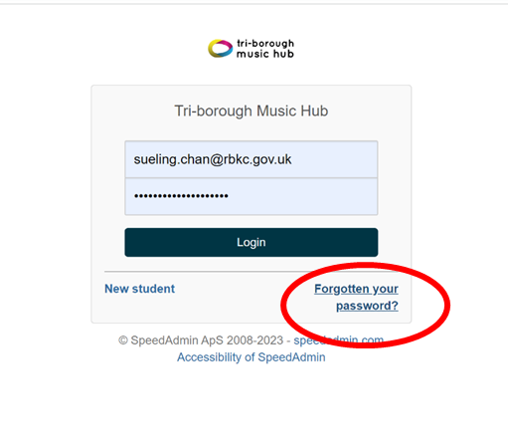

- When logged in, you will see your home page. Please click ‘School Year’ at the top to change it to ‘School year 26/27’:

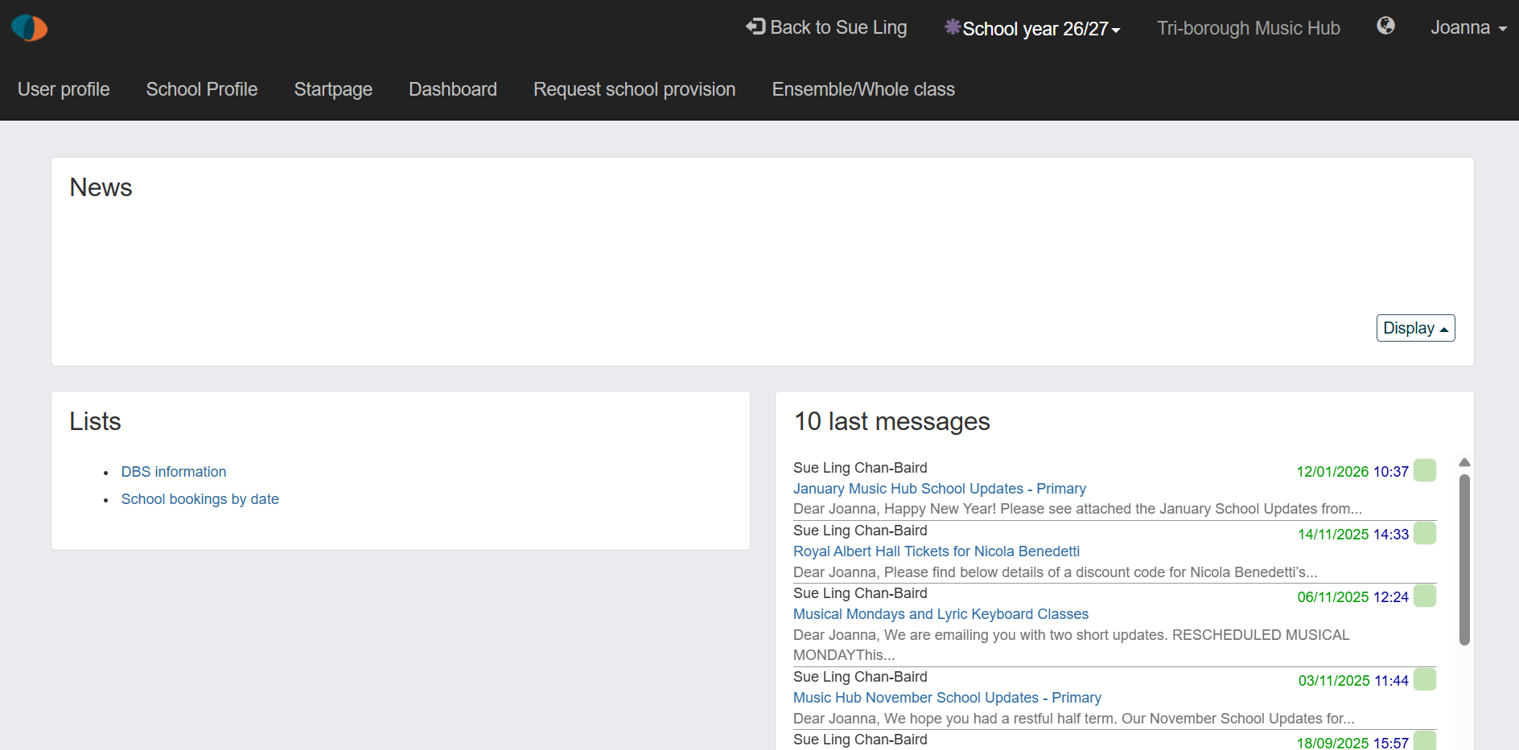

- Once ‘school year 26/27’ is selected, click on ‘Request school provision’ to book tuition:

- You will then see all the provision available to request ranging from Curriculum, Whole Class, and Ensembles/Choir, Small group/Individual Tuition. To read in more detail about the provision you are interested in, click ‘SHOW MORE’. Click ‘Subject Area’ to view certain provision:

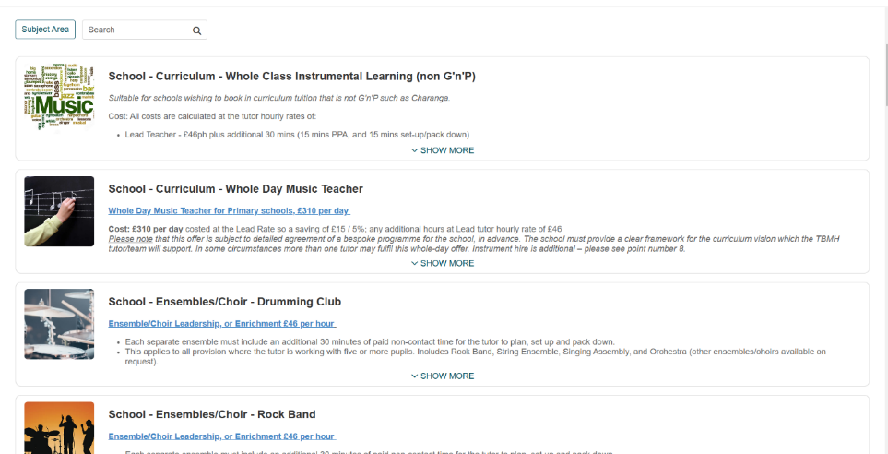

- Information on the clicked provision will appear. If interested in the provision, click ‘Request tuition’ and ensure it is for the 2026-27 academic year:

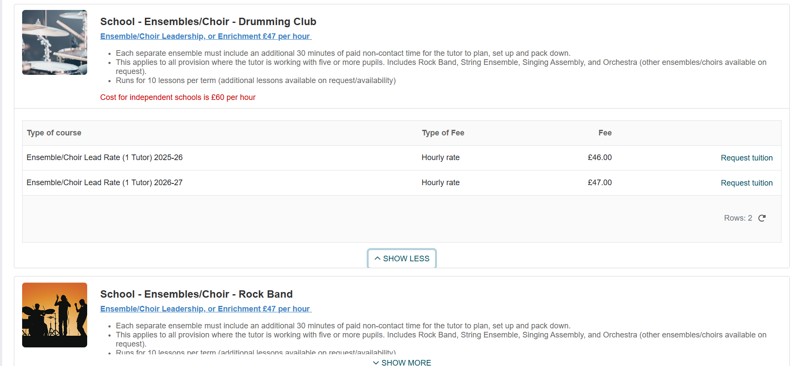

- This will then take you to the form as below. Ensure you fill in each field as accurately as possible and to summarise what you would like in the ‘Further Comment’ box at the bottom. Then click ‘Submit’ and your request will be sent to TBMH:

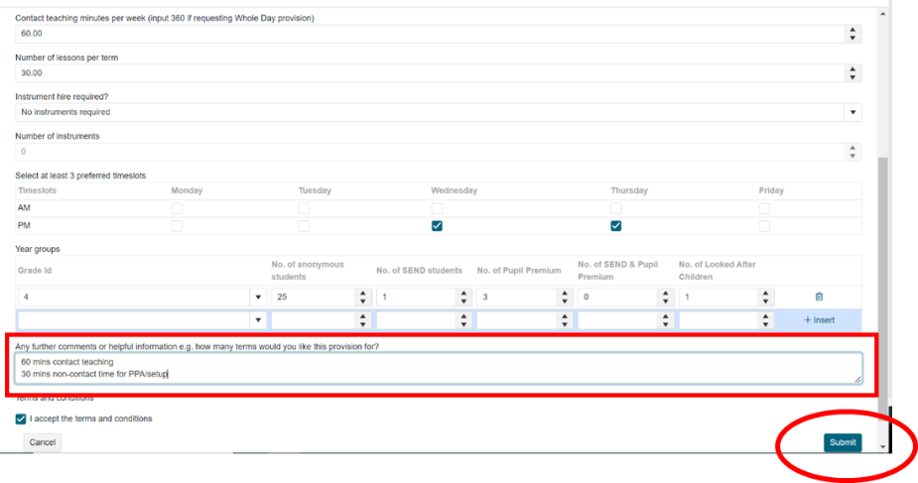

- TBMH will then receive your Request. If interested in booking another provision, follow from step 3 onwards again.

