**Musical Senses: Report 2025**

The Tri-borough Music Hub (TBMH) is committed to supporting children and young people from all backgrounds to access meaningful and inclusive musical opportunities. In partnership with organisations such as the Royal College of Music, ABRSM, and Audiovisability, we continue to develop and refine our focus on accessibility for young people who receive sensory support – specifically those who are Blind/Visually Impaired (VI) or Deaf/Hard of Hearing (HoH). This work is made possible through funding from Musical Boroughs Trust (registered charity no. 1183585, working name Tri-borough Music Trust - TBMT), John Lyon’s Charity, Ingles Trust, and other private donors.

**Programme Overview and Summary**

Building on our work over the past four years, the Musical Senses programme focuses on three key areas:

* Training and professional development for educators across the sector.
* Engaging positive role models as music leaders who reflect the lived experience of the participants.
* Providing high-quality, accessible musical experiences for children and young people with sensory needs.

In 2024–25, the programme:

* Provided bursaries for 6 pupils throughout the academic year.
* Delivered a weekend creative music workshop and concert series for 26 young people on 31st May and 1st June 2025 at the Royal College of Music, Jay Mews, London.
* Supported workforce development with training materials created by specialist practitioners.
* Led the first Roundtable event on 19th May for 40 delegates from across the country at the Elgar Room in the Royal Albert Hall.

**Musical Senses Weekend Workshop Summary**

Held across two days, the Musical Senses 2025 weekend brought together 26 young people who are either Blind/VI or Deaf/HoH. The aim was to give these young musicians a collaborative, joyful and high-quality musical experience through tailored composition workshops and performance opportunities.

Workshops were led by professional musicians who themselves are Blind/VI or Deaf/HoH, offering inspiring and relatable mentorship. The Blind/VI group also included 2 TBMH Piano Tutors Paula and Fabina, who are also blind musicians. The weekend culminated in two bespoke sharing concerts for families and friends, designed to reflect the unique journeys of each group.

* The **Blind/VI group** focused on learning, performing and arranging the song *"Pure Imagination"*. Their approach was largely aural, with strong emphasis on memory-based learning, supported by Braille and large print materials where appropriate—creating multiple access points to the music.
* The **Deaf/HoH group** worked on *"What a Wonderful World"*, using graphic scores and sheet music, supported by BSL interpreters to aid musical interpretation and expression.

Participants also composed and performed their own original group pieces, created collaboratively during the workshops, as well as worked on their own solo pieces. These were performed at the final concerts, which provided a platform for their voices, creativity, and achievements. All students were supported throughout the weekend by trained staff from TBMH and student mentors from the RCM.

**Young Musicians Represented**

This year’s programme included children and young people from a wide range of locations:

* London boroughs: Hammersmith & Fulham, Kensington & Chelsea, Westminster, Wandsworth, Camden, Lambeth, Lewisham, Barnet, Brent, Bexley
* Counties: Essex, Surrey, Hampshire, Worcestershire, Three Rivers (Hertfordshire)

|  |  |
| --- | --- |
| **Borough / Local Authority** | **Number of Participants** |
| Essex | 4 |
| **Hammersmith & Fulham** | **1** |
| **Royal Borough of Kensington & Chelsea** | **2** |
| **Westminster** | **4** |
| Wandsworth | 1 |
| Three Rivers (Hertfordshire) | 1 |
| Hampshire / Hampshire County Council | 3 |
| London (Unspecified Borough) | 1 |
| Worcestershire (resident in Bexley) | 1 |
| Camden | 2 |
| Surrey | 2 |
| Lambeth | 1 |
| Lewisham | 1 |
| Barnet | 1 |
| Brent | 1 |

**Impacts and Outcomes**

Musical Senses 2025 achieved the following outcomes:

* Delivered inclusive, high-quality music-making experiences to 26 Deaf/HoH and Blind/VI participants.
* Enabled young people to build confidence, skills, and lasting friendships.
* Created safe and accessible spaces for expression and peer connection.
* Continued professional learning and training for educators and music leaders.
* Supported employment opportunities for workshop leaders with lived experience of sensory difference.
* Strengthened cross-organisational partnerships.
* Expanded our understanding of how to support sensory access and musical participation.
* Supported families through bursaries and resource access.

**Round Table Event**

In addition to the workshops, we hosted a **Musical Senses Round Table event** on 19th May 2025, bringing together professionals, parents, and partners to discuss the future of music education for Deaf/HoH and Blind/VI learners. The event explored challenges and opportunities, with insights shared on inclusive teaching practices, curriculum design, and workforce development. The learnings from this event will directly inform the evolution of the Musical Senses programme. See Appendix B for the Roundtable Report.

**5 Key Takeaways from Musical Senses Round Table:**

1. Start Early with accessible learning
2. Embrace tech & aural skills
3. Train educators with lived-experience CPD
4. Build community through inclusive music
5. Plan long-term with sustained, connected provision

Photos from the event can be found [HERE](https://flic.kr/s/aHBqjCeGZ2). To keep the conversation going, the TBMH have created two LinkedIn groups that people are warmly invited to join, and the report from the Roundtable event can be found in those groups:

* Musical Senses Blind/VI Network: [**https://lnkd.in/eM58RV26**](https://lnkd.in/eM58RV26)
* Musical Senses Deaf/Hoh Network: [**https://lnkd.in/ejYMRRY6**](https://lnkd.in/ejYMRRY6)

**Legacy and Next Steps**

We aim to continue our commitment by:

* Providing 8 bursaries for the 2025–26 academic year.
* Planning for the next *Musical Senses* weekend in 2026 – dates to be confirmed soon.
* Further developing professional development resources created by this year’s workshop leaders.
* Exploring the possibility of continuing the Musical Senses Roundtable for year 2

**Ongoing Challenges**

* Recruitment: continued efforts are needed to reach young people in our **local boroughs**.
* Recruitment for Deaf/HoH young people: ensuring we have equal representation in both groups and that Deaf/HoH young people have access to the programme.
* Access: accommodating diverse needs and learning styles, particularly where access strategies differ (e.g. large-print vs. audio-based vs. tactile formats).
* Balancing experiences: ensuring activities are enriching for both Deaf/HoH and Blind/VI participants, while recognising their distinct access needs.
* Funding: additional support is needed to expand bursary provision, enhance workforce CPD, and invest in new resources and technologies.

**Musical Senses Resources**

#### Our specialist workshop leads and tutors have created bespoke resources to be used in the continuation of professional development and learning for our staff, tutors, and partners. These are available here, click on the links:

* [**Advice for working with HoH Musicians**](https://www.triboroughmusichub.org/media/6397/advice-for-working-with-hoh-musicians.docx)
* [**Deaf Awareness sheet**](https://www.triboroughmusichub.org/media/6398/deaf-awareness-sheet.pdf)
* [**Support Workers Guide Assisting Visually Impaired Educators at TBMH**](https://www.triboroughmusichub.org/media/6399/support-workers-guide-assisting-visually-impaired-educators-at-tbmh.pdf)

#### **Challenges Faced By Visually Impaired Musicians in Orchestras**

#### As part of our commitment to growing representation we have been fortunate to work with Paula Chavez (and her sister, Fabiana) for the past three years, both of whom are blind musicians and music educators. They teach curriculum music in schools, piano lessons at our Saturday Music School, and support our out of school ensembles. Paula has written a really candid and insightful piece of work which we feel is important for us to share more widely in order to raise awareness and build inclusivity in the work of music education. You can read Paula’s article by clicking on the links here: [**Word Version**](https://www.triboroughmusichub.org/media/6088/challenges-faced-by-visually-impaired-musicians-in-orchestras.docx) / [**PDF Version**](https://www.triboroughmusichub.org/media/6089/challenges-faced-by-visually-impaired-musicians-in-orchestras.pdf).

**Conclusion**

Musical Senses 2025 was a celebration of inclusion, creativity, and community. Through bespoke support, inclusive teaching, and youth-led music-making, the programme continues to offer transformative experiences for young people with sensory differences. We look forward to building on this work in the years ahead.

**Links to films and audio**

|  |  |
| --- | --- |
| **Young People’s Course (30th May/1st June)** | **Roundtable (19th May)** |
| Films (by Zac Emerson):   * Blind/VI Sharing Celebration: [HERE](https://vimeo.com/1105753653?share=copy) * Deaf/HoH Shared Celebration: [HERE](https://vimeo.com/1106129789) * Talking Heads: [HERE](https://vimeo.com/1105156169?share=copy)   Photos:   * Photos [HERE](https://flic.kr/s/aHBqjCnjBA) | Photos:   * Deaf Rave [Photos](https://flic.kr/s/aHBqjCj3Qv) * Tea Films [Photos](https://flic.kr/s/aHBqjCeGZ2) |

**Testimonials/quotes from participants, parents/carers, and workshop leaders**

*It was so fun because I got to perform with people in my situation. The staff helped me become a better musician even though I am visually impaired. We got to do everything by ear and I was not excluded because I cannot see sheet music. Sometimes people leave me out because I cannot read sheet music, but at musical senses I get to do things the easy way for a visually impaired person which gave me the chance to join in, have fun and learn.*

***Participant (Blind/VI group)***

*I think it really helped when Siobhan and I shared our experiences of hearing loss and how we’ve found our way through the music world. At first, some of the group were a bit reluctant to perform solos, but once Siobhan and I said we’d play too, it seemed to shift things. We’ve always wanted to give performance opportunities to young people, but this reminded us how powerful it is for them to actually see us performing too — whether it’s a solo or a duet. It definitely helped create a more open and supportive atmosphere.***Ruth Montgomery (Deaf/HoH Workshop Lead)**

*These workshops are so inspiring, a wonderful opportunity for these young musicians and a reminder to them (and to all of us) that they belong in spaces like the RCM. Our son Pablo has permanent hearing loss. He has taken part in the past two editions. His flute skills have been enhanced by the amazing teaching. Most importantly, he has learnt to work with other musicians with hearing impairment, to follow their cues, to adapt to their particular styles and to encourage them to keep trying when things are hard. In return he has become a better musician and a more caring and supportive young person. There was a real sense of joy, friendship and support in the room when we attended the final concert. It was really moving. Thank you so much for this opportunity.*

**Parent (HoH group)**

*Talented musicians with VI can easily end up getting excluded by systems and lack of accessibility - this shouldn't need to happen. Musical Senses is inspirational for the participants - to meet up with like minded youngsters who are facing the same hurdles but still passionate about music and finding ways into it is an absolute highlight. Moreover, to work with visually impaired adults who have managed to make music their job in life, despite all the barriers, shows the youngsters that there is hope and there are ways to continue music as they grow and develop. Many thanks to all the staff involved who always make sure that the visually impaired children can access absolutely everything over the course and that during the course, vision will not be a barrier to both brilliant music making and sheer joy.*

**Parent (Blind/VI Group)**

*As a professional musician who has been severely sight-impaired since age 10, I know that I would have really loved the opportunity to mix with, learn from, and make music with other talented peers with low vision in a safe and accessible music-making space. And to meet and work with professionals with sight loss would also have been so valuable, so it's really important to keep projects like this going.***Bobby Goulder (Blind/VI workshop lead)**

*As well as the music-making, the Musical Senses programme allows a rare opportunity for the young people to meet, share experiences and develop friendships with others who are also visually impaired. Musical Senses has developed a model which deserves to be repeated, expanded and shared more widely to give more blind and partially sighted young musicians the chance to develop their skills and share their love for making music.*

**James Risdon (Blind/VI workshop lead)**

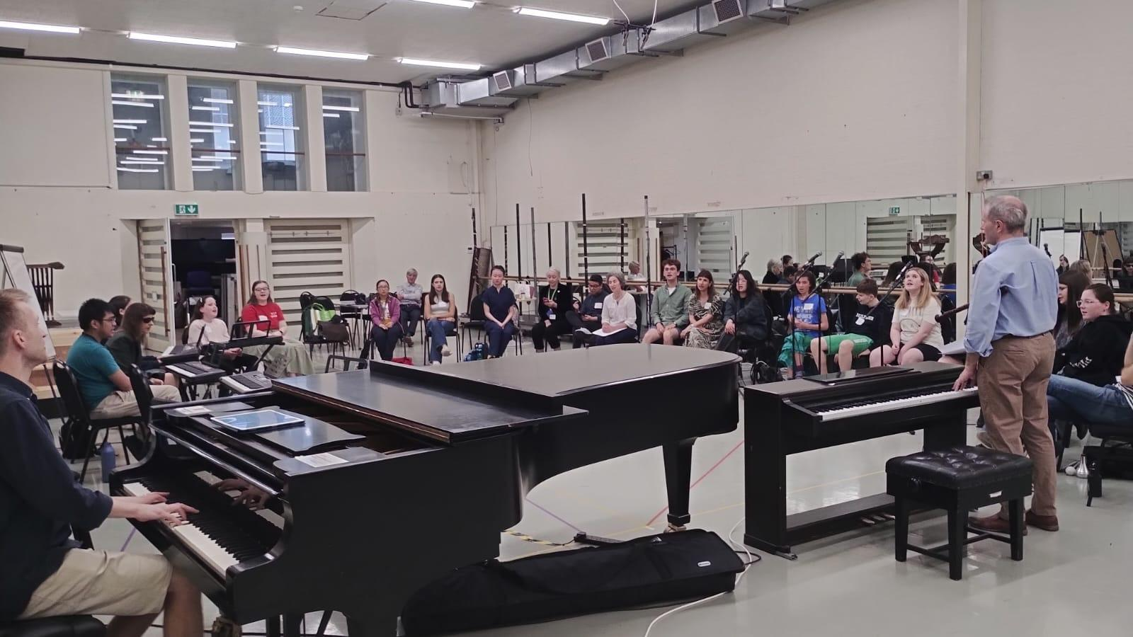 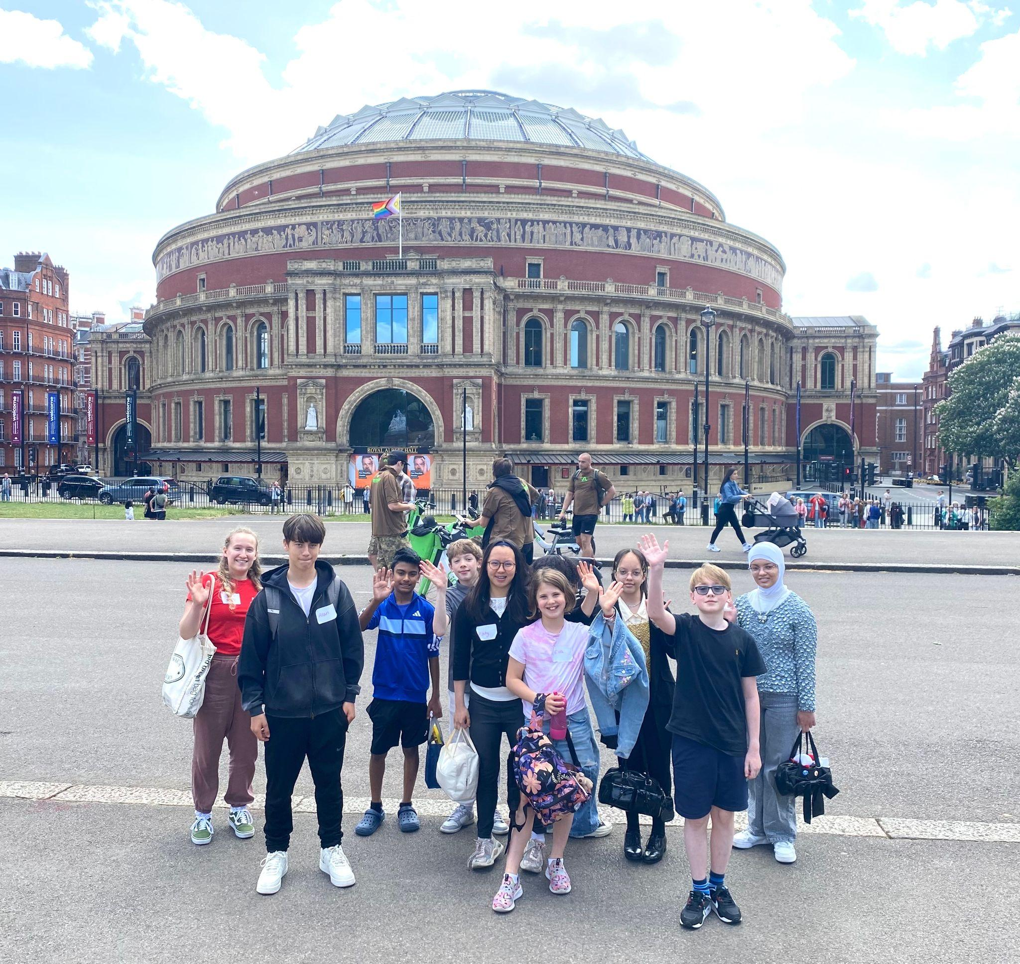

**APPENDIX**

**MUSICAL SENSES CYP PROGRAMME FINANCIALS 2024-25**

|  |  |
| --- | --- |
| **EXPENDITURE** | |
| **Training and development, strategic development** | £1,400 |
| **Staffing / Employing specialist musicians to deliver programmes** | |
| * Workshop leads/Tutors/RCM mentors 31st May, 1st June | £7,917 |
| **Supporting pupils/families to engage in activity and resources** | |
| * bursary support for 2 pupils came from this budget (NB: another 4 students are funded from a different TBMH route) | £1,900 |
| **Other costs** | |
| * supporting access (e.g. Audio recording, subtitles) | £1000 |
| **TOTAL COSTS / EXPENDITURE** | **£12,217** |
|  | |
| **INCOME** | |
| **Tri-borough Music Hub** | £2,217 |
| **Tri-borough Music Trust (Musical Boroughs Trust)** | £5,000 |
| **ABRSM** | £5,000 |
| **TOTAL RESOURCES SECURED / INCOME** | **£12,217** |
|  |  |
| **IN-KIND** | |
| **Tri-borough Music Hub (staff time)** | £5,823.00 |
| **Royal College of Music (room hire, student support, staff time)** | £11,019 |
| IN-KIND SUPPORT | **£16,842** |

**Thank you to all the funders for their generous support –**

**our programme would not have been possible without your help!**

**If you would like to support us in the future, please contact**

**Stuart Whatmore, Head TBMH,** [**stuart.whatmore@rbkc.gov.uk**](mailto:stuart.whatmore@rbkc.gov.uk)**.**

**APPENDIX B: Musical Senses Round Table Report**

**Date: 19th May 2025 | Compiled by: TBMH, ABRSM, RCM**

# **I. Blind and Visually Impaired (VI) Students**

## **Key Questions Raised**

• Where can educators access expertise in teaching Braille and music to VI students?  
 • How can we map and clarify roles in VI music education?  
 • How do we ensure meaningful access to group music-making (choirs, bands, etc.)?  
 • How do we prepare young VI people for music qualifications and employment?  
 • How do we promote both music literacy and aural skills?

**Learning Pathways and Perspectives**

• Bobby – Progressed from reading notation to learning by ear due to efficiency. Found greater musical depth in aural learning but faced barriers in professional settings due to lack of sight-reading.  
 • Daisy – No specialist support through early music education. Adapted with large print and ear training. Favors improvisation and teaching by ear.  
 • Kate – Strong advocate for Braille music. Learned entirely by ear initially but later used Braille for higher-level study and teaching. **Systemic Challenges**

• Expectation that students adapt to mainstream systems, rather than systems adapting to them.  
 • Delayed introduction to appropriate music resources (Braille, large print, adaptive tech).  
 • Inadequate early music literacy exposure hinders access to formal qualifications later. **Practical Tools and Resources**

• Software & Tools: Musescore (Braille output), Sibelius (accessibility options), Lime Aloud, Duxbury, Sao Mai Braille.  
 • Support Organisations: The Amber Trust, Gardner’s Trust, VICTA, Sound Without Sight.  
 • Recommendations:  
 o Begin Braille music literacy early.  
 o Share adapted resources centrally.  
 o Invest in both aural and music literacy skills.  
 o Provide flexible exam access arrangements.  
 o Develop peer and professional shadowing opportunities.

## **Advice to Educators and Music Hubs**

• Research technology before procurement.  
 • Refer to the Curriculum Framework for VI Learners.  
 • Prioritise early preparation of materials.  
 • Foster incidental exposure to musical elements.  
 • Ensure long-term project involvement, not just short-term interventions.  
 • Encourage cross-sector collaboration, including with QTVIs and music teachers.

**Future Actions**

• Create a national directory of VI-specialist music educators.  
 • Establish national music/Braille boot camps and holiday schemes.  
 • Promote social inclusion through accessible ensemble and community group participation.  
 • Encourage greater investment in training and paid shadowing opportunities.

**II. Deaf and Hard of Hearing (HoH) Students**

## **Key Discussion Themes**

• Awareness & Training: Widespread lack of training for mainstream educators about deafness and related complex needs.  
 • Access: EHCPs do not always include music; need stronger inclusion of 1-2-1 provision and music therapy.  
 • Communication: Importance of involving Teachers of the Deaf and ensuring teachers know how to reach them.  
 • Representation: Role models (Deaf musicians) are critical for student motivation and identity development. **Classroom & Pedagogical Considerations**

• Need for visual support and rhythm/pulse-based activities.  
 • Use of multiple signing systems, tailored to the child’s preferences.  
 • Inclusive shows must balance broad accessibility with deep inclusivity.  
 • Importance of consistent, long-term musical engagement (not one-off sessions). **Technology and Creativity**

• Greater use of technology (e.g. vibrations, visualizers, software) can support access.  
 • Need to better integrate creativity and student expression in pedagogy.  
 • Diverse qualification routes (e.g. RSL Awards) provide inclusive alternatives to traditional notation-heavy pathways. **Challenges in Early Years and Beyond**

• Poor EYFS music access for Deaf/HoH children due to lack of specialist knowledge.  
 • Limited pathways to progressive musicianship without formal notation.  
 • Underrepresentation in the professional music world due to access and cost barriers (e.g. BSL training).  
 **Key Quotes & Reflections**

• “Once you have rhythm and pulse, you can do anything.”  
 • “Without 1-2-1 tuition, it makes musical learning very challenging.”  
 • “Knowing the student well is everything.” **III. Cross-Cutting Themes**

## **Equity vs. Equality**

• Environments must adapt to meet each student’s specific needs rather than assuming a one-size-fits-all model.

## 

## **Mental Health and Social Inclusion**

• Both VI and Deaf/HoH students face increased mental health risks due to exclusion and invisibility.  
 • Music serves as a powerful tool for community integration and emotional expression. **Professional Development**

• Shadowing and lived experience are more impactful than generic training.  
 • Barriers to upskilling (e.g., BSL training costs) hinder workforce diversity and inclusivity.

**Systemic Recommendations**

• Invest in structured, funded pathways for teacher training and CPD.  
 • Establish formal access arrangements for music across the curriculum.  
 • Encourage ensemble inclusivity through minor adaptations (e.g. conductor visibility, tactile cues). **Additional Insights and Recommendations**

• Braille music is one way to access and process knowledge to produce music. But aural music skills are also hugely important to learning, particularly within folk traditions.  
 • Written notation remains important for Deaf/HoH musicians. The concept of ‘sound before symbol’ needs rethinking for these learners.  
 • Music tech and production tools provide valuable creative outlets for HoH and VI learners, enabling independent music creation.  
 • Provision must be locally responsive yet connected to a national network. A major barrier is lack of awareness and communication pathways among parents, educators, and specialists.  
 • Sustained funding is essential; reliance on short-term projects limits long-term development.  
 • Capturing young people’s perspectives helps ensure provision is relevant and meaningful.  
 • Intersectionality in learners with complex or multi-sensory needs must be further explored.  
 • Support staff (interpreters, access workers) are critical, and career pathways into these roles must be strengthened.  
 • Clarification needed between Makaton and BSL usage, and increased workforce training on this distinction.  
 • Define what makes a truly ‘inclusive’ event and work toward implementing those standards.  
 • Music supports social cohesion—ideas like summer camps, accessible ensembles, and residentials are powerful for youth expression and connection. **Conclusion**

Inclusive music education for Blind/VI and Deaf/HoH students requires early, flexible, and person-centred approaches. Collaboration between educators, specialists, and families is vital. Investing in tools, training, and long-term access can unlock not only musical potential but also emotional, cognitive, and social development.

**Music is not just education—it is empowerment.**