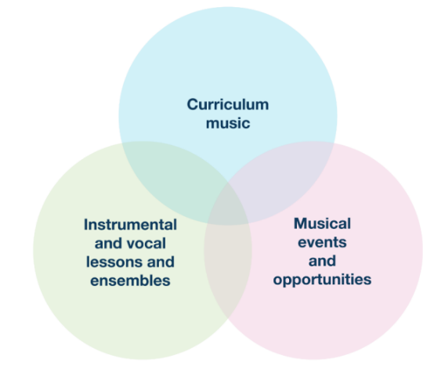
Summer Term Updates for PRIMARY PHASE Schools
The regular Music Hub Updates for schools will reflect the three inter-linked areas of provision as outlined on p.18 of the National Plan for Music Education (see graphic); and will be separated into bespoke updates for PRIMARY Phase; and SECONDARY Phase. This is the Primary Phase Update.

Primary Phase Music Headline Summary of Opportunities

Curriculum Music Support for School Staff
Date / Time | Event | Details | Booking Info
January – May 25 | NEW Absolute Music Essentials Online CPD Programme | See 3. below for details | Expression of Interest here
24.04.25, daytime | Championing Inclusive Musical Pathways CPD | In-person, Lyric Hammersmith | Sign up here
03.06.25 | Reception & KS1 In-person Music Essentials | Gateway Academy | Sign up here
04.06.25 | KS2 In-person Music Essentials | Gateway Academy | Sign up here

Instrumental/vocal lessons and ensembles/choirs
Date / Time | Event | Details | Booking Info
10 weeks per term | TBMH Out of School Learning  (variety of learning opportunities, please share with families) | Choirs, Ensembles, Music Production, Saturday Music School | Sign up now
16.06.25, daytime | TBMH Scholars Playing Day | Sinfonia Smith Square | By invitation

Musical events and opportunities
Date / Time | Event | Details | Booking Info
09.07.25, 11.15-12 | Musical Mondays 5: Beat Technique | Online performance | Sign up now
30.06.25, daytime | Infant Voices Festival: Day 1 | Kensington Town Hall
01.07.25, daytime | Infant Voices Festival: Day 2 | Kensington Town Hall
07.07.25, 11.15-12 | Musical Mondays 6: Alex and Archie | Online performance | Sign up now

More events and opportunities will be added over the course of the year, and we will update all schools when more information is available. Please do share all opportunities with any colleagues as appropriate.

More detailed information can be found in the next section covering:
- Working with schools 2025-26 academic year
- Nominating pupils for scholarships/bursaries
- Absolute Music Essentials CPD/Phase Specific CPD for school staff
- Musical Mondays
- Musical Senses 2025 – Register now
- Makaton Choir
- New ISM Frameworks for Curriculum, Pedagogy, and Assessment
- ABRSM Exam Discount Scheme
- Reminder: TBMH after school classes at the Lyric Theatre
- Virtual Music School
- WhatsApp Groups
- FREE Curriculum and Resources for every school/setting (birth - 25)
- Save the Date: 2nd October 2025: LWMH Secondary Phase Music Leaders CPD

- Key Message: Working with schools 2025-26 academic year
The Music Hub exists to work with every single state-maintained school in the three boroughs. We do this in many ways – every school can access a raft of free resources/support and some schools also buy-in traded service to enhance their in-school music delivery. The key message is that we want to hear from every music lead in every school/setting – Primary, Secondary, Alternative Provision, SEND, 16+, and EYFS. Together, the Music Hub and schools can amplify music education outcomes for all children and young people. All details can be found HERE, and this headline summary explains how it works (Word version HERE; PDF version HERE).

To keep things straightforward for schools, we split our work with schools into two categories:
- Free services for every school. The free services are open to any state-maintained school and range from performance events, whole-class teaching resources, access to the Virtual Music School, curriculum guidance documents, network meetings, and wider partnership opportunities
- Charged-for traded services. These include instrumental / vocal teaching in small groups and whole classes, ensembles, some CPD and performance events and consultancy work
- Standard Rate £44 per hour: for individual, paired, small group teaching, or whole-class support teacher work.
- Lead Rate £46 per hour: for leading whole class instrumental teaching and / or ensemble leadership.
Making a Booking for Traded Services for Sep 2025 to July 2026:
- Music Hub Schools Terms & Conditions 2025-26 (Word version HERE; PDF version HERE)

- Nominating pupils for scholarships/bursaries
London Music Fund (Autumn 2025-Summer 2029):
- 19th May - Applications are due to TBMH via email: katie.stuffelbeam@rbkc.gov.uk
- 3-4 nominations per borough, not guaranteed award (only 2 per borough awarded for 2024-28 cohort)
- 4-year bursary to attend the Saturday Music School for instrumental lessons (Not Piano or Voice), ensembles and musicianship held at Latymer Upper (W6 9LR)
- Possibility to also join weekday choir or ensemble held at Lyric Theatre Hammersmith
- Must be currently in year 4 or 5 (year 5 or 6 in September 2025)
- Need based bursary, must be able to show financial need (FSM/PP/Universal Credit/JSA)
- Please send an expression of interest to request the application form or to ask Katie of any questions or concerns: Katie.Stuffelbeam@rbkc.gov.uk

John Lyons Bursary (Autumn 2025-Summer 2029):
- 19th May - Applications are due to TBMH via email: katie.stuffelbeam@rbkc.gov.uk
- 2 bursaries will be awarded per borough (6 total awarded for 2025-2029)
- Need based bursary, must be able to show financial need (FSM/PP/Universal Credit/JSA)
- 4-year bursary to attend the TBMH Saturday Music School for instrumental lessons, ensembles and musicianship held at Latymer Upper (W6 9LR)
- Possibility to also join weekday choir or ensemble held at Lyric Theatre Hammersmith
- Must be currently in year 4, 5 or 6 (years 5, 6 or 7 in September 2025)
- Need based bursary, must be able to show financial need (FSM/PP/Universal Credit/JSA)
- Please send an expression of interest to request an application form or to ask Katie of any questions or concerns: Katie.Stuffelbeam@rbkc.gov.uk.

- One Off CPD Sessions for school staff – FREE
Phase specific Music Essentials - for school staff with prior music teaching experience:
We are offering some phase specific, free in-person sessions will be held at Gateway Academy as follows:

16:15 – 17:45 Tuesday 3 June – Reception & KS1 Music Essentials – BOOK HERE
16:15 – 17:45 Wednesday 4 June – KS2 Music Essentials – BOOK HERE

Sessions will clarify how the teaching of the Elements of Music (or the inter-related dimensions of music) can be taught in the context of infant and junior classroom practice.
Places for each of the sessions are limited and early booking is recommended.

Absolute Music essentials - for School staff without prior music teaching experience:
Basic training and development for TAs and Class Teachers who wish to teach curriculum music but require some training to feel more confident about delivering musical activities. Please forward the link below to school staff who would like to take part in a new series of online professional development sessions to support them in delivering music. The training is in the form of afternoon INSET sessions between 15:00 and 17:00 in summer 2025. This pilot is FREE to schools apart from needing to cover staff release to attend. Register here: Absolute Music Essentials Online CPD Request Form

- Reminder: Musical Mondays: Primary and SEND
Working in partnership with Live Music Now, we were thrilled to offer all the Primary and SEND schools across the London West Music Hub, the chance to engage with the series of online concerts happening across the academic year. This is all FREE. Joined by Music Hubs from Essex and Nottinghamshire the concert on 14th Oct reached 4664 pupils watching the performance live, and the concert on 9th Dec reached 2065 pupils. They are getting rave reviews from schools (See Instagram post here from one of our schools).

The next concert is on 9 June with BeatTechnique, 11:15am-12pm.
Link for schools to sign up: https://zoom.us/webinar/register/WN_qq1ZUN9wT324U1PdWgLMjA
Dean Yhnell (aka BeatTechnique) will show you that anyone can be a beatboxer as well as discussing his routine into Beatboxing and how it helps him manage his Tourettes Syndrome.
After the concert has taken place, LMN will contact all schools that were registered with a link to the concert recording, which will be available for 28 days.

Remaining concert dates:
- 14.10.24, 11.15-12.00, Musical Mondays 1: Blank Face (FINISHED)
- 09.12.24, 11.15-12.00, Musical Mondays 2: Edward & Rachel (FINISHED)
- 03.02.25, 11.15-12.00, Musical Mondays 3: Borges Machado (FINISHED)
- 03.03.25. 11.15-12.00, Musical Mondays 4: Alis Huws (FINISHED)
- 09.07.25, 11.15-12.00, Musical Mondays 5: Beat Technique
- 07.07.25, 11.15-12.00, Musical Mondays 6: Alex and Archie
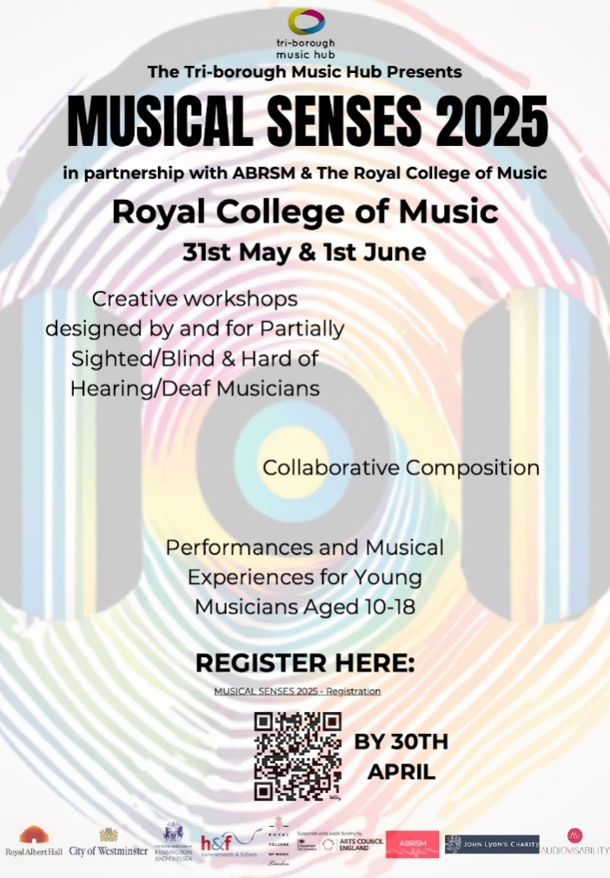
- Musical Senses 2025
We are hoping to reach the right people so we can maximise the two upcoming opportunities to highlight the focused work on Blind/Vision Impairment and Deaf/Head of Hearing music education.

Musical Senses: Background and Context
Now in its 5th year, the Tri-borough Music Hub’s (TBMH) Musical Senses programme, is an opportunity targeted at young musicians, who are blind/have a vision impairment (VI), or who are deaf/hard of hearing (HoH). Working in partnership with other organisations we have developed this specific focus on making what we do accessible to young people who receive sensory support. More details about the wider programme can be found HERE and the 2024 report HERE.

Opportunity 1: FOR ADULTS:
Musical Senses Roundtable: 19th May 2025 – REGISTRATIONS will close on 2nd May 2025:
The TBMH will be hosting the first ever Musical Senses Round Table Event on the 19th May 2025 sponsored by ABRSM. This is an opportunity for adults and organisations involved with the musical education of Young People who are Deaf/HoH and Blind/VI to come together to discuss, learn, and exchange knowledge and experience. There will be speakers and forum discussions to explore the burning issues specific/relevant to Blind/VI and Deaf/HoH learners.
- DATE: Monday 19 May 2025 9:15 AM - 2:30 PM
- VENUE: Royal Albert Hall, Elgar Room
NB: Refreshments and lunch will be provided.

Opportunity 2: FOR CHILDREN & YOUNG PEOPLE:
Musical Senses Weekend – REGISTER BY Wednesday 30th April
Our 2025 programme for young musicians is happening on Sat 31st May and Sun 1st June. We are running 2 consecutive days of musical activity at the Royal College of Music to give young musicians an inspiring, engaging, and high-quality musical experience which includes creative collaboration, performance, and musical experiences. We are aiming for all participants to come to work collaboratively and creatively in interactive music sessions where all young people and workshop leads – are either vision impaired or hard of hearing.
- We are focusing on working with Secondary aged/phase students, aged 10-18, who play, sing, or compose music.
- We are hoping to work with 20 x VI pupils and 20 x HoH pupils.
- Pupils will be expected to attend both days.

For any questions about any aspect of either of the Musical Senses opportunities please contact emily.stratford@triboroughmusichub.org, TBMH SEND Strategic Lead.

- Makaton Choir
We are continuing the TBMH Makaton Choir in 2025 by providing resources for ALL of our TBMH schools to access. You are welcome to incorporate the songs into your lessons and send us a celebration video at the end of the year that we can share with everyone. Please use this link to access the resources on the Virtual Music School: https://www.triboroughmusichub.org/tbmh-virtual-music-school/virtual-music-school/choirs/makaton-choir/
Login details:
- Username: info@tbmh.vms
- Password: tbmhvms

Please contact: emily.stratford@triboroughmusichub.org if you are interested in joining the TBMH Makaton Choir Community.

- New ISM Frameworks for Curriculum, Pedagogy, and Assessment
Designed to support the delivery of music education in primary and secondary schools, these frameworks will help you plan and assess musical learning in your classroom. They can be used in a number of ways: for individual lessons, for medium-term planning, for long-term planning and supporting and evidencing children’s musical learning and development over time. They are constructed upon sound research-based principles and evidence into effective teaching, learning and assessment in music.
- Primary curriculum booklet
- Primary curriculum wallchart

- ABRSM Exam Discount Scheme
ABRSM’s exam discount scheme is designed to alleviate some of the financial barriers that families may face when accessing exams, offering up to 95% discount off the exam fee. The scheme can only be used by music services and is not available to private tutors or individual entrants. Music hubs/services will identify students to whom they would like to offer a discount and determine the reason(s) and level of discount. The scheme runs from 1st February 2025 to 31st January 2026 and is valid for these exams:
- Prep Test
- Practical and Performance Grades (Initial to Grade 8)
- Practical Musicianship and Jazz Grades
- ARSM Music Performance diploma
- Performance Assessment
- Grades 1 to 5 (online) and Grades 6 to 8 (paper-based)

Basis for discounts:
- Service’s remissions scheme
- Other bursary e.g. AYM
- Qualifies for Free School Meals
- Pupil Premium
- Looked After Child
- Low exam uptake (targeted area or targeted school)
- Loss of work
- Bereavement
- Financial hardship (other)
- SEND with financial hardship
- Multiple reasons

The discount can either be used for eligible pupils who are nominated by a TBMH tutor who deliver lessons in schools via an SLA or for pupils who have lessons at a Tri-borough school with another provider. For more information, please email musichub@rbkc.gov.uk.

- Reminder: TBMH after school classes at the Lyric Theatre
There are many opportunities for students to access additional music learning opportunities outside of school. Please share this information with your families and students.

Applications are now open to join our ensembles, choirs and classes after school at the Lyric Theatre, Hammersmith for a Summer term start. Remissions and sibling discounts available for all classes, more information on this and what classes we offer are here: https://www.triboroughmusichub.org/out-of-school-music-tuition-24-25/

- TBMH Virtual Music School – click this link
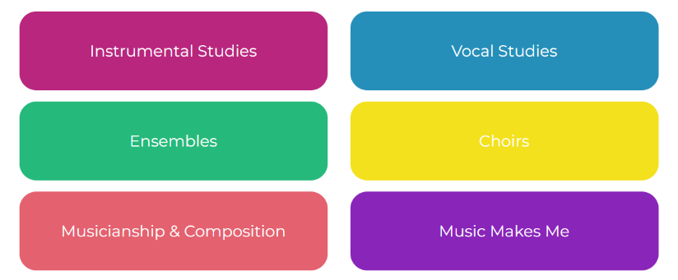
Originally set up for any child wanting access to free instrumental and vocal resources during lockdown, the Virtual Music School (VMS) is organised into 6 main areas. It has a wealth of free resources for students and facilitators. Whether you’re looking for ready-made worksheets for musicianship classes or a video with step-by-step instructions on how to put your instrument together – our VMS has it all. There are no schemes of work for curriculum or whole class learning, but the VMS does hold songs and music that could compliment your lesson plan.

- School WhatsApp groups
Here are the links to the WhatsApp groups for anyone teaching Music wanting to join.
- Primary: https://chat.whatsapp.com/FDVbTSl29Bl736p8bGpgQa
- SEND: https://chat.whatsapp.com/JKB9kQHA69mJDW6kyjNcpC

Please send any updated contact details for your music lead to musichub@rbkc.gov.uk

- FREE Curriculum and Resources for every school/setting (birth - 25)
To help all schools with curating a solid music curriculum, the Music Hub, provides the following FREE support documents and teaching resources for all schools. Click on the hyperlinks.
Free Curriculum Support Documents
- Music Curriculum Guidance for Schools, FULL Version: PDF / Word
This version contains all 3 separate component parts, or you can download each section separately:
  - Ofsted Inspection Framework and Handbook – PDF / Word
  - Creating your own School/Setting Music Policy – PDF / Word
    - Answer the prompt questions and you will be able to present a summarised description about how music is delivered in your school
  - Self-Evaluation Tool for Music – PDF / Word
    - Answer the prompt questions and you will be able to get a clearer picture of where your schools may sit within a framework of Silver/Gold/Platinum which tallies with the Artsmark framework.
- Writing your DfE School Music Development Plan – PDF / Word
- DfE Model Music Curriculum – Click HERE.
- Music Education Recovery Curriculum framework – Click HERE
- EYFS/Early Childhood:
  - Interactive EYFS self-assessment tool – Click HERE
  - Musical Development Matters – Click HERE

Free Resources and Teaching Documents/Materials
- TBMH Virtual Music School (1,500+ online resources)
- Singing Assembly Resource (HERE) for KS1, KS2, KS3
- KS3-5 Teaching and Learning Resources
  - Music Production – HERE
  - Song writing – HERE
  - Hip-Hop – HERE
  - Teaching young people with SEND additional resources HERE
- Singing With Meaning - SEND-friendly Vocal Resource (20 songs)

Music Makes Me: Teaching & Learning Song-writing Resource (Main page HERE)
- Click HERE to download PDF of the resource
The purpose of this resource is to look at how song writing can be brought into every classroom/school and can be accessed by teachers and students. By using this resource, schools will be able to co-create brand new song(s) that could represent a school anthem, class anthem, Year group anthem etc. This resource covers five song strands: Social Story Songs; Transition Songs; Emotional Regulation songs; Topic Songs; Celebration Songs.
- Whole Class Instrumental Learning – Groove’n’Play
- Every school can access a FREE whole class annual online licence for ONE Groove’n’Play programme – for school’s own delivery, plus free CPD for one teacher (worth £85). The licence gives access to GnP’s groove@school digital resources which includes animated delivery content, teachers’ e-book, session plans, and supporting documents (planning and progression, GnP in relation to National Curriculum for Music, and GnP in relation to New National Plan for Music).

- Save the Date: 2nd October 2025: LWMH Primary Phase Music Leaders CPD
9:30 – 12:30. This day will be focused on the London West Music Hub’s continuing work around supporting Primary Phase Music Subject Leaders. There are 337 primary schools across LWMH, so there is considerable strength and expertise to support those who are early career teachers or those new to leading music. This CPD is intended to provide ideas and inspiration for supporting evolving curriculums to engage our Primary aged students and for networking to happen across schools/LAs. The day is curated by the LWMH staff, the ENO Engage team, and Primary Lead Music School Teachers. Booking link coming soon.

Music Hub Contacts
- Sue Ling Chan, Schools’ Administrator, sueling.chan@rbkc.gov.uk
- Shannen Bassett, Senior Administrator, shannen.bassett@rbkc.gov.uk
- Rory Wilson, Saturday Music School Administrator Rory.Wilson@rbkc.gov.uk
- Hannah Keohane, Senior Service Lead, Instrumental Lead, hannah.keohane@rbkc.gov.uk
- Katie Stuffelbeam, SMS Manager & Fundraising Lead, katie.stuffelbeam@rbkc.gov.uk
- Evie Asio, Vocal Lead, evie.asio@rbkc.gov.uk
- Emily Stratford, SEND Strategic Lead Consultant, emily.stratford@triboroughmusichub.org
- Alex Wood, Business Manager, alex.wood@rbkc.gov.uk
- Louisa Roberts, Schools and Curriculum Leader louisa.roberts@rbkc.gov.uk
- Head, Stuart Whatmore stuart.whatmore@rbkc.gov.uk

Please contact the Music Hub with any questions or for more information; or to provide any feedback – good, bad, or otherwise – musichub@rbkc.gov.uk.

