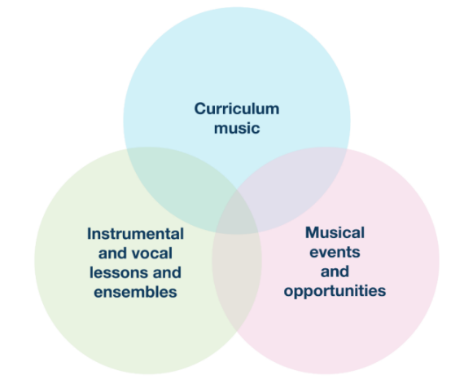
Spring Term Updates for PRIMARY PHASE Schools
The regular Music Hub Updates for schools will reflect the three inter-linked areas of provision as outlined on p.18 of the National Plan for Music Education (see graphic); and will be separated into bespoke updates for PRIMARY Phase; and SECONDARY Phase. This is the Primary Phase Update.

Primary Phase Music Headline Summary of Opportunities

Curriculum Music Support for School Staff
Date / Time | Event | Details | Booking Info
January – May 25 | NEW Absolute Music Essentials Online CPD Programme | See 3. below for details | Expression of Interest here
27.02.25, 4.30-5.30 | Online Network Meeting | Virtual | Sign up here
24.04.25, daytime | Championing Inclusive Musical Pathways | In-person, Lyric Hammersmith | Sign up here
03.06.25 | Reception & KS1 In-person Music Essentials | Gateway Academy | Sign up here
04.06.25 | KS2 In-person Music Essentials | Gateway Academy | Sign up here

Instrumental/vocal lessons and ensembles/choirs
Date / Time | Event | Details | Booking Info
10 weeks per term | TBMH Out of School Learning  (variety of learning opportunities, please share with families) | Choirs, Ensembles, Music Production, Saturday Music School | Sign up now
01.04.25, daytime | TBMH Strings Playing Day | Kensington Town Hall | Sign up now
02.04.25, daytime | TBMH Wind, Brass, Percussion Playing Day | Kensington Town Hall | Sign up now
03.04.25, daytime | TBMH Guitars Playing Day | Kensington Town Hall | Sign up now
16.06.25, daytime | TBMH Scholars Playing Day | Sinfonia Smith Square | By invitation

Musical events and opportunities
Date / Time | Event | Details | Booking Info
03.02.25, 11.15-12 | Musical Mondays 3: Borges Machado | Online performance | Sign up now
03.03.25. 11.15-12 | Musical Mondays 4: Mared Pugh-Evans | Online performance | Sign up now
19.03.25, 4,15-5.45 | Infant Voices Festival Inset | Lyric | Sign up now
09.07.25, 11.15-12 | Musical Mondays 5: Beat Technique | Online performance | Sign up now
30.06.25, daytime | Infant Voices Festival: Day 1 | Kensington Town Hall | Sign up now
01.07.25, daytime | Infant Voices Festival: Day 2 | Kensington Town Hall | Sign up now
07.07.25, 11.15-12 | Musical Mondays 6: Alex and Archie | Online performance | Sign up now

More events and opportunities will be added over the course of the year, and we will update all schools when more information is available. Please do share all opportunities with any colleagues as appropriate.

More detailed information can be found in the next section covering:
- Register for Playing Days in March
- Championing Inclusive Musical Pathways CPD 24th April
- Absolute Music Essentials Online CPD for ‘New to Music Teaching’ School Staff
- Phase Specific Music Essentials In-Person CPD – Summer Term
- Musical Senses 2025
- Musical Mondays
- Makaton Choir
- Infant Voices Festival 2025
- After School Classes at the Lyric
- Virtual Music School
- WhatsApp Groups
- FREE Curriculum and Resources for every school/setting (birth - 25)

- Register for Playing Days in March
Our Instrumental Playing Days (KS2-3) are massed playing for early-stage musicians. They are all happening at Kensington Town Hall and you can register now for the events HERE
- Tues 1st April 2025, Strings Playing Day, 10-3
- Weds 2nd April 2025, Wind, Brass, Percussion Playing Day, 10-3
NEW: With special guests, She’s Got Brass. 10-3
- Thurs 3rd April 2025, Guitars Playing Day, 10-3

- Championing Inclusive Musical Pathways CPD 24th April
We will be starting the summer term in 2025 with a focused of training for TBMH Tutors and our School Curriculum Leaders. The exact programme will be confirmed in the New Year but we encourage school curriculum leaders to register now and request release from their SLT.

- Absolute Music Essentials Online CPD Programme for New to Music Teaching Staff – FREE
We are responding to schools who are asking for basic training and development for school staff (TAs and Class Teachers) who wish to teach curriculum music but require some training to feel more confident about delivering musical activities. Please forward the link below to school staff who would like to take part in a new series of online professional development sessions to support them in delivering music. The training will be available from January 2025 and is in the form of afternoon INSET sessions between 15:00 and 17:00. This pilot is FREE to schools apart from needing to cover staff release to attend.
Register here: Absolute Music Essentials Online CPD Request Form

- Music Essentials In-Person CPD One Off Sessions for Music Teaching Staff – FREE
In addition to the progressive Music Absolute Essentials CPD Programme, we are offering some phase specific sessions in-person. These one-off 90 minute sessions are more suited to those practitioners who have some experience of facilitating classroom music and will be held in person at Gateway Academy as follows:

16:15 – 17:45 Tuesday 3 June – Reception & KS1 Music Essentials – BOOK HERE
16:15 – 17:45 Wednesday 4 June – KS2 Music Essentials – BOOK HERE

Sessions will clarify how the teaching of the Elements of Music (or the inter-related dimensions of music) can be taught in the context of infant and junior classroom practice.

Places for each of the sessions are limited and early booking is recommended.

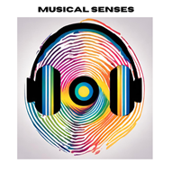
- Musical Senses 2025
Register for information about 2025
As a group of committed partner organisations, we will be continuing Musical Senses in 2025 and are currently in the planning stages. To help us ensure we are reaching the right young people and audiences, we are keen to develop a database of students/families who would like to be kept informed of future Musical Senses events and opportunities.

Therefore, if you would like to register for more information, we ask that this short form HERE is completed. We will then be in touch when we have new information to share about the 2025 programme.

The 4-page 2024 report summarises the context, impact, legacy, barriers, testimonial quotes, and budget – click HERE. All information about the programme can be found on our updated webpage HERE. These film links show the impact of the work:
- Main Performance Film 2024 HERE (70 mins)
- Short Film about Musical Senses 2024 HERE (6 mins)
- Musical Senses Summary Film from 2023: short version HERE (3 mins)
- Musical Senses Summary Film from 2023: Long version HERE (5 mins)

- Musical Mondays: Primary and SEND
Working in partnership with Live Music Now, we were thrilled to offer all the Primary and SEND schools across the London West Music Hub, the chance to engage with the series of online concerts happening across the academic year. This is all FREE. Joined by Music Hubs from Essex and Nottinghamshire the concert on 14th Oct reached 4664 pupils watching the performance live, and the concert on 9th Dec reached 2065.

Schools can register NOW for the upcoming February concert on 3rd February, 11.15-12.00: Borges Machado. Sign up here: https://zoom.us/webinar/register/WN_MovkYTS9SDilfomYvxIOdw

Remaining concert dates:
- 14.10.24, 11.15-12.00, Musical Mondays 1: Blank Face (FINISHED)
- 09.12.24, 11.15-12.00, Musical Mondays 2: Edward & Rachel (FINISHED)
- 03.02.25, 11.15-12.00, Musical Mondays 3: Borges Machado
- 03.03.25. 11.15-12.00, Musical Mondays 4: Mared Pugh-Evans
- 09.07.25, 11.15-12.00, Musical Mondays 5: Beat Technique
- 07.07.25, 11.15-12.00, Musical Mondays 6: Alex and Archie
After the concert has taken place, LMN will contact all schools that were registered with a link to the concert recording, which will be available for 28 days.

- Makaton Choir

We are continuing the TBMH Makaton Choir in 2024 by providing resources for ALL of our TBMH schools to access. You are welcome to incorporate the songs into your lessons and send us a celebration video at the end of the year that we can share with everyone. Please use this link to access the resources on the Virtual Music School: https://www.triboroughmusichub.org/tbmh-virtual-music-school/virtual-music-school/choirs/makaton-choir/
Login details:
- Username: info@tbmh.vms
- Password: tbmhvms

Please contact: emily.stratford@triboroughmusichub.org if you are interested in joining the TBMH Makaton Choir Community.

- Infant Voices Festival 2025

Applications are now open for our Infant Voices Festival, for Primary school groups from years 1-3, at Kensington Town Hall. This year we will be having two events, on Monday 30th June and Tuesday 1st July 2025, and schools can apply to take part on either event day.

If you would like to apply, please do so using the following Wufoo Form, or alternatively contact evie.asio@rbkc.gov.uk if you would like further information.

- TBMH after school classes at the Lyric Theatre
There are many opportunities for students to access additional music learning opportunities outside of school. Please share this information with your families and students.

Applications are now open to join our ensembles, choirs and classes after school at the Lyric Theatre, Hammersmith. Remissions and sibling discounts available for all classes, more information here: https://www.triboroughmusichub.org/out-of-school-music-tuition-24-25/

Ensembles:
Symphonic Band - is an advanced ensemble for all instrumentalists who are playing at a minimum of Grade 5 level up to Grade 8 and beyond. The aim of this ensemble is to challenge pupils to develop the most intricate skills of playing in an ensemble.

Breakout Band - explores different genres of fun repertoire for all instrumentalists working as a continuer (knows 5 notes on their instrument) to instrumentalists working towards their Grade 5 exam. Pupils will be encouraged to develop ensemble skills such as balance, tuning and style through fun and accessible repertoire.

Large Group Guitar Class – is a group class for beginner and continuer students learning acoustic guitar.

Beginners Keyboard Class – is for pupils who are complete beginners. Pupils can expect to learn how to play simple pieces in a fun and supportive environment with a focus on learning the basics of technique, rhythm, and musical notation.

Continuers Keyboard Class - is for pupils who have been learning for a year. Pupils can expect to learn how to play simple pieces in a fun and supportive environment with a focus on learning the basics of technique, rhythm, and musical notation.

Choirs:
Next Level Voices – This secondary aged choir will learn a range of repertoire from contemporary to classical in largely three-part harmony, with tuition on music reading and sight singing included in the sessions.

Junior Voices – This choirs for years 3-6 will learn to sing in unison and in harmony, having fun singing together while learning a wide range of songs from folk to musical theatre to pop.

First Voices - Together you’ll learn a wide range of fun songs, rounds and musical games, and by the end of the term you will have increased confidence when singing and have developed your musical skills.

Classes:
Music Production using GarageBand and Logic Pro – The main objective of this course is to learn how to confidently and efficiently use GarageBand/Logic Pro X to create beats and compositions, and how to mix and balance the different instrumental elements into a final product.

- TBMH Virtual Music School – click this link
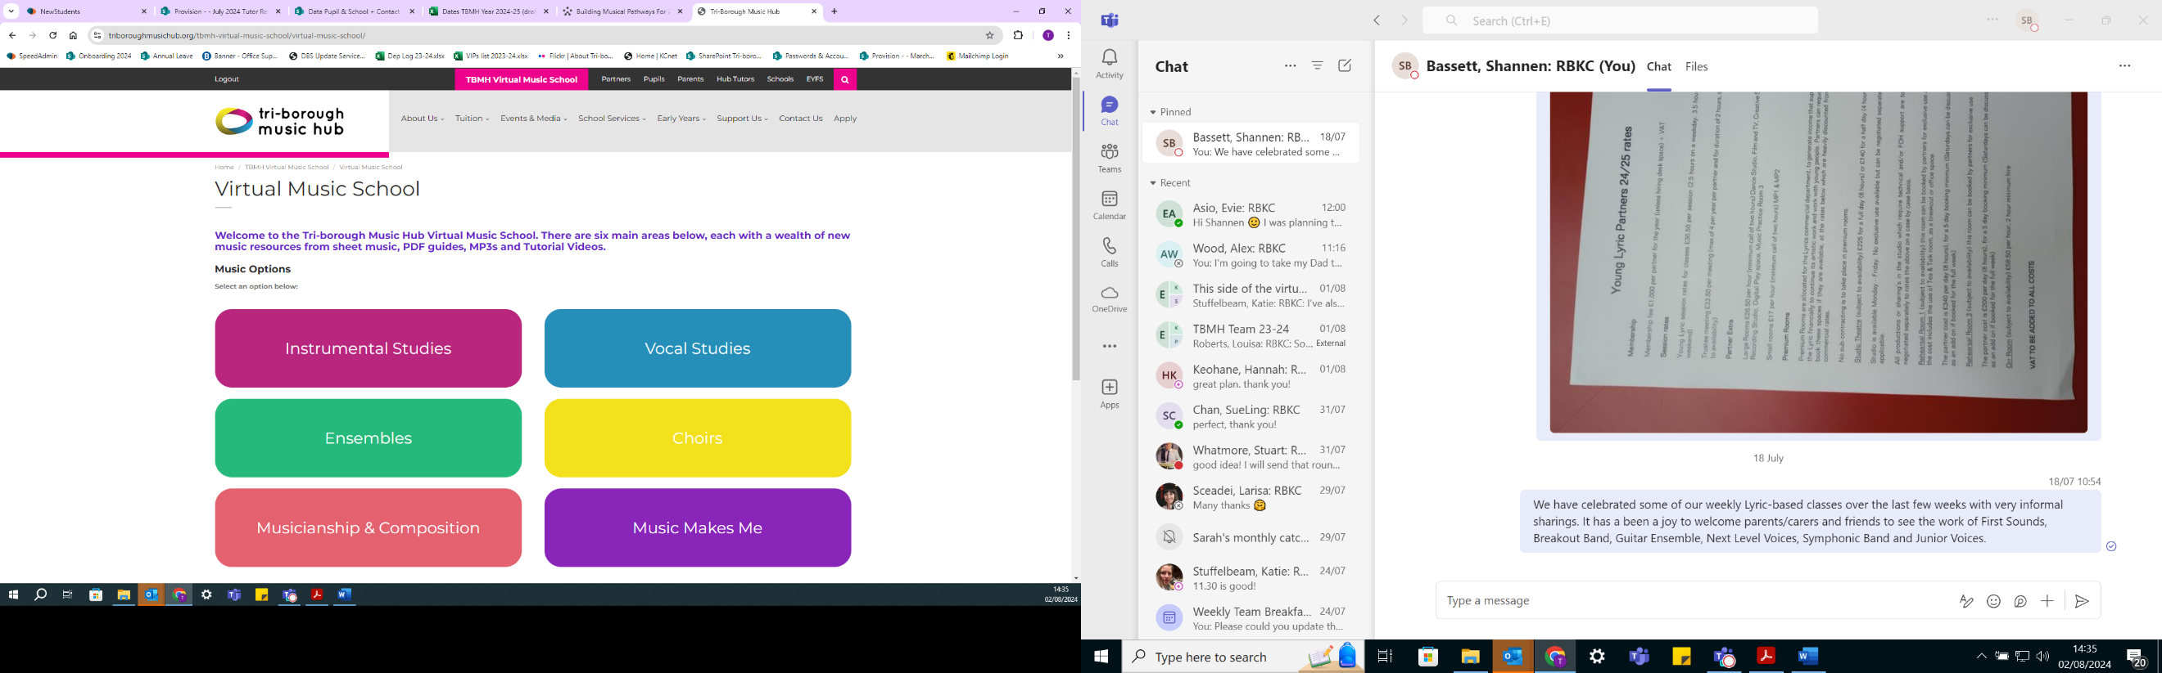
Originally set up for any child wanting access to free instrumental and vocal resources during lockdown, the Virtual Music School (VMS) is organised into 6 main areas. It has a wealth of free resources for students and facilitators. Whether you’re looking for ready-made worksheets for musicianship classes or a video with step-by-step instructions on how to put your instrument together – our VMS has it all. There are no schemes of work for curriculum or whole class learning, but the VMS does hold songs and music that could compliment your lesson plan.

- School WhatsApp groups
Here are the links to the WhatsApp groups for anyone teaching Music wanting to join.
- Primary: https://chat.whatsapp.com/FDVbTSl29Bl736p8bGpgQa
- SEND: https://chat.whatsapp.com/JKB9kQHA69mJDW6kyjNcpC

Please send any updated contact details for your music lead to musichub@rbkc.gov.uk

- FREE Curriculum and Resources for every school/setting (birth - 25)
To help all schools with curating a solid music curriculum, the Music Hub, provides the following FREE support documents and teaching resources for all schools. Click on the hyperlinks.
Free Curriculum Support Documents
- Music Curriculum Guidance for Schools, FULL Version: PDF / Word
This version contains all 3 separate component parts, or you can download each section separately:
  - Ofsted Inspection Framework and Handbook – PDF / Word
  - Creating your own School/Setting Music Policy – PDF / Word
    - Answer the prompt questions and you will be able to present a summarised description about how music is delivered in your school
  - Self-Evaluation Tool for Music – PDF / Word
    - Answer the prompt questions and you will be able to get a clearer picture of where your schools may sit within a framework of Silver/Gold/Platinum which tallies with the Artsmark framework.
- Writing your DfE School Music Development Plan – PDF / Word
- DfE Model Music Curriculum – Click HERE.
- Music Education Recovery Curriculum framework – Click HERE
- EYFS/Early Childhood:
  - Interactive EYFS self-assessment tool – Click HERE
  - Musical Development Matters – Click HERE

Free Resources and Teaching Documents/Materials
- TBMH Virtual Music School (1,500+ online resources)
- Singing Assembly Resource (HERE) for KS1, KS2, KS3
- KS3-5 Teaching and Learning Resources
  - Music Production – HERE
  - Song writing – HERE
  - Hip-Hop – HERE
  - Teaching young people with SEND additional resources HERE
- Singing With Meaning - SEND-friendly Vocal Resource (20 songs)

Music Makes Me: Teaching & Learning Song-writing Resource (Main page HERE)
- Click HERE to download PDF of the resource
The purpose of this resource is to look at how song writing can be brought into every classroom/school and can be accessed by teachers and students. By using this resource, schools will be able to co-create brand new song(s) that could represent a school anthem, class anthem, Year group anthem etc. This resource covers five song strands: Social Story Songs; Transition Songs; Emotional Regulation songs; Topic Songs; Celebration Songs.
- Whole Class Instrumental Learning – Groove’n’Play
- Every school can access a FREE whole class annual online licence for ONE Groove’n’Play programme – for school’s own delivery, plus free CPD for one teacher (worth £85). The licence gives access to GnP’s groove@school digital resources which includes animated delivery content, teachers’ e-book, session plans, and supporting documents (planning and progression, GnP in relation to National Curriculum for Music, and GnP in relation to New National Plan for Music).

Music Hub Contacts
- Sue Ling Chan, Schools’ Administrator, sueling.chan@rbkc.gov.uk
- Shannen Bassett, Senior Administrator, shannen.bassett@rbkc.gov.uk
- Rory Wilson, Saturday Music School Administrator Rory.Wilson@rbkc.gov.uk
- Hannah Keohane, Senior Service Lead, Instrumental Lead, hannah.keohane@rbkc.gov.uk
- Katie Stuffelbeam, SMS Manager & Fundraising Lead, katie.stuffelbeam@rbkc.gov.uk
- Evie Asio, Vocal Lead, evie.asio@rbkc.gov.uk
- Emily Stratford, SEND Strategic Lead Consultant, emily.stratford@triboroughmusichub.org
- Alex Wood, Business Manager, alex.wood@rbkc.gov.uk
- Louisa Roberts, Schools and Curriculum Leader louisa.roberts@rbkc.gov.uk
- Head, Stuart Whatmore stuart.whatmore@rbkc.gov.uk

Please contact the Music Hub with any questions or for more information; or to provide any feedback – good, bad, or otherwise – musichub@rbkc.gov.uk.

