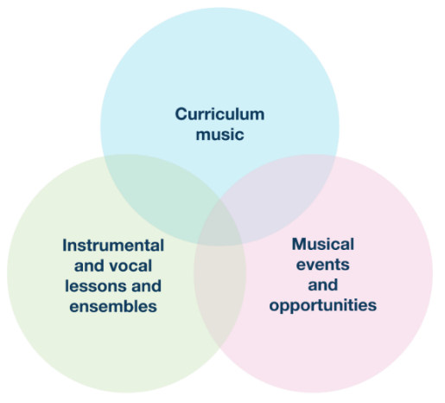
Mid-Autumn Term Updates for SECONDARY PHASE Schools

The regular Music Hub Updates for schools will reflect the three inter-linked areas of provision as outlined on p.18 of the National Plan for Music Education (see graphic); and will be separated into bespoke updates for PRIMARY Phase; and SECONDARY Phase. This is the SECONDARY Phase Update.

Secondary Phase Music Headline Summary of Opportunities

Curriculum Music Support for School Staff
Date / Time | Event | Details | Booking Info
13.02.25, 9.00-3.30 | Secondary Phase Music Curriculum Day | In-person (venue TBC) | Sign up HERE
27.02.25, 4.30-6.00 | Online Network Meeting | Virtual | Sign up here
24.04.25, daytime | Championing Inclusive Musical Pathways | In-person (venue TBC) | Sign up here

Instrumental/vocal lessons and ensembles/choirs
Date / Time | Event | Details | Booking Info
10 weeks per term | TBMH Out of School Learning  (variety of learning opportunities, please share with families) | Choirs, Ensembles, Music Production, Saturday Music School | Sign up now
01.04.25, daytime | TBMH Strings Playing Day | Kensington Town Hall | Sign up now
02.04.25, daytime | TBMH Wind, Brass, Percussion Playing Day | Kensington Town Hall | Sign up now
03.04.25, daytime | TBMH Guitars Playing Day | Kensington Town Hall | Sign up now
16.06.25, daytime | TBMH Scholars Playing Day | St. John’s Smith Square | To follow

Musical events and opportunities
Date / Time | Event | Details | Booking Info
27.11.24 & 28.11.24 | Music for Youth Creative Project | Royal Albert Hall | Sign up now
30.01.25, 4.00-6.30 | Prelim 1 for Future Sounds | Rhythm Studio | Sign up now
04.02.25, 4.00-6.30 | Prelim 1 for Future Sounds | Rhythm Studio | Sign up now
14.03.25 | Secondary Schools Choir Showcase | Details to follow | Sign up now
26.03.25, 7.00-9.30 | Future Sounds Performance  (10th anniversary) | Bush Hall | Tickets soon

More events and opportunities will be added over the course of the year, and we will update all schools when more information is available. Please do share all opportunities with any colleagues as appropriate.

More detailed information can be found in the next section covering:
- Rescheduled Secondary Curriculum Day
- Seeking 3 Secondary Lead Music Schools
- Secondary School’s Showcase
- Future Sounds
- Musical Senses 2025
- Performance Slot on Weds 11th Dec in Festival
- Register for Playing Days in March
- Musical Senses
- Youth Voice Council
- Virtual Music School
- WhatsApp Group

- Secondary Phase Curriculum Day – Rescheduled to Thursday 13 February 2025

Sign up HERE
Schedule to Include:
- Beatboxing with Shamime Ibrahim
- Setting the scene: Discussion on secondary music – reality and challenges
- Introduction to technology that supports Blind and Vision Impaired students in accessing music technology in the secondary classroom. Interactive workshop with Jay Dasent from Overdrive Recording.
- Vocal development in KS3/4 with Evie Asio (TBMH Vocal Lead)
- Plus, opportunities to share concerns, relevant topics and celebrations in the current arts education landscape.

DATE: 9:00 AM - 4:00 PM
LOCATION: TBC

- Recruiting Secondary Music Lead Schools
In accordance with the new DfE/ACE changes and the new National Plan for Music Education (NPME), we are looking for Secondary Lead Music Schools to take on a vital role in assisting the TBMH in supporting CPD, learning networks, collaborative projects and more.

More information HERE and application HERE

Does your school exemplify high quality music provision and teaching? Does it...
- champion best practice within your local authority
- show commitment to delivery with significant time-table allocation, co-curricular opportunities, inclusive provision and teacher development?
- contribute to a strategic approach to inclusion
- advocate for music education and the work of the Music Hub to colleagues in other schools?

Application submission deadline: 5pm Monday 13 January

- Secondary School’s Showcase
Applications are now open for the TBMH Secondary Choir Showcase, taking place on Friday 14th March 2025, at Kensington Aldridge Academy, from 9:15am-1pm. This is an opportunity for choirs to perform, to learn from and engage with singers from other schools, as well as take part in a vocal workshop lead by the Tri-borough.

Please use the following Wufoo form to register your school’s interest, by Friday 29th November.

- Register for Future Sounds 2025!
In partnership with The Rhythm Studio, Future Sounds 2025 is returning for its 10th year! This is a competition for 11-18 year old contemporary musicians who are either a solo act, in a duo, or a band. The event is for:
- Pupils of secondary school age, 11-18, that attend a state-maintained school (including Free schools and Academies) in one of the three Tri-borough Local Authorities (RBKC, WCC, LBHF).
- Pupils who have their own bands outside of school (e.g. groups that contain pupils from multiple schools) must contain 50% or more members that are Tri-borough area residents or attend a Tri-borough state-maintained school (including Free schools and Academies).

Acts must be available for prelims on either Thursday 30th Jan or Tuesday 4th Feb at The Rhythm Studio, W14 9BL, and anyone selected to the next stage must be available at the final on Wednesday 26th March at Bush Hall. Register HERE by Friday 24th Jan.

- Musical Senses 2025
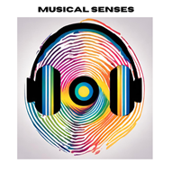
Following the conclusion of the 2023-24 Musical Senses programme, we are pleased to share the finalised 4-page report that summarises the context, impact, legacy, barriers, testimonial quotes, and budget – click HERE. All information about the programme can be found on our updated webpage HERE. These film links show the impact of the work:
- Main Performance Film 2024 HERE (70 mins)
- Short Film about Musical Senses 2024 HERE (6 mins)
- Musical Senses Summary Film from 2023: short version HERE (3 mins)
- Musical Senses Summary Film from 2023: Long version HERE (5 mins)

Register for information about 2025
As a group of committed partner organisations, we will be continuing Musical Senses in 2025 and are currently in the planning stages. To help us ensure we are reaching the right young people and audiences, we are keen to develop a database of students/families who would like to be kept informed of future Musical Senses events and opportunities. Therefore, if you would like to register for more information, we ask that this short form HERE is completed. We will then be in touch when we have new information to share about the 2025 programme.

- Performance Slot on Weds 11th Dec in Festival:
The annual three-day Primary Christmas Singing Festivals are back. On the Wednesday 11th December performance day, we are able to offer two five-minute performance slots for secondary-aged students, either as soloists or as a duo. For more information or to express interest in taking part, please email evie.asio@rbkc.gov.uk.

- Register for Playing Days in March
Our Instrumental Playing Days (KS2-3) are massed playing for early-stage musicians. They are all happening at Kensington Town Hall and you can register now for the events HERE
- Tues 1st April 2025, Strings Playing Day, 9.30-2.30
- Weds 2nd April 2025, Wind, Brass, Percussion Playing Day, 9.30-2.30
- Thurs 3rd April 2025, Guitars Playing Day, 9.30-2.30

- Youth Voice Council:
We are looking for more young people from our secondary schools to join our Youth Voice Council - a group of musicians representing the voices of students from Hammersmith & Fulham, Kensington & Chelsea, and Westminster:
- Network with other musicians in the Tri-borough and nationally.
- Organise and take part in special events.
- Meet and have discussions with music industry professionals.
- Have a say on how the Tri-borough can improve to help young people.
Most importantly, the work of the Youth Voice Council is steered by young people, so they get to have a say in how they want to use it.

The council meets on Fridays at 4:30pm online, approximately 4 times a term, and is free of charge. There will also be special online and in-person events organised throughout the year, that we will share information about closer to the time. To become a member, parents of interested students can contact musichub@rbkc.gov.uk.

- TBMH Virtual Music School – click this link
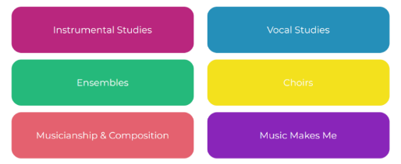
Originally set up for any child wanting access to free instrumental and vocal resources during lockdown, the Virtual Music School (VMS) is organised into 6 main areas. It has a wealth of free resources for students and facilitators. Whether you’re looking for ready-made worksheets for musicianship classes or a video with step-by-step instructions on how to put your instrument together – our VMS has it all. There are no schemes of work for curriculum or whole class learning, but the VMS does hold songs and music that could compliment your lesson plan.

- School WhatsApp group
Here is the link to the WhatsApp group for anyone teaching Music wanting to join.
- Secondary: https://chat.whatsapp.com/Fb5Mo4EWthd6ZTmYwuidhj

Please send any updated contact details for your music lead to musichub@rbkc.gov.uk.

Music Hub Contacts
- Sue Ling Chan, Schools’ Administrator, sueling.chan@rbkc.gov.uk
- Shannen Bassett, Ensemble’s Administrator, shannen.bassett@rbkc.gov.uk
- Rory Wilson, Saturday Music School Administrator Rory.Wilson@rbkc.gov.uk
- Hannah Keohane, Senior Service Lead, Instrumental Lead, hannah.keohane@rbkc.gov.uk
- Katie Stuffelbeam, SMS Manager & Fundraising Lead, katie.stuffelbeam@rbkc.gov.uk
- Evie Asio, Vocal Lead, evie.asio@rbkc.gov.uk
- Emily Stratford, SEND Strategic Lead Consultant, emily.stratford@triboroughmusichub.org
- Alex Wood, Business Manager, alex.wood@rbkc.gov.uk
- Louisa Roberts, Schools and Curriculum Leader louisa.roberts@rbkc.gov.uk
- Head, Stuart Whatmore stuart.whatmore@rbkc.gov.uk

Please contact the Music Hub with any questions or for more information; or to provide any feedback – good, bad, or otherwise – musichub@rbkc.gov.uk.

