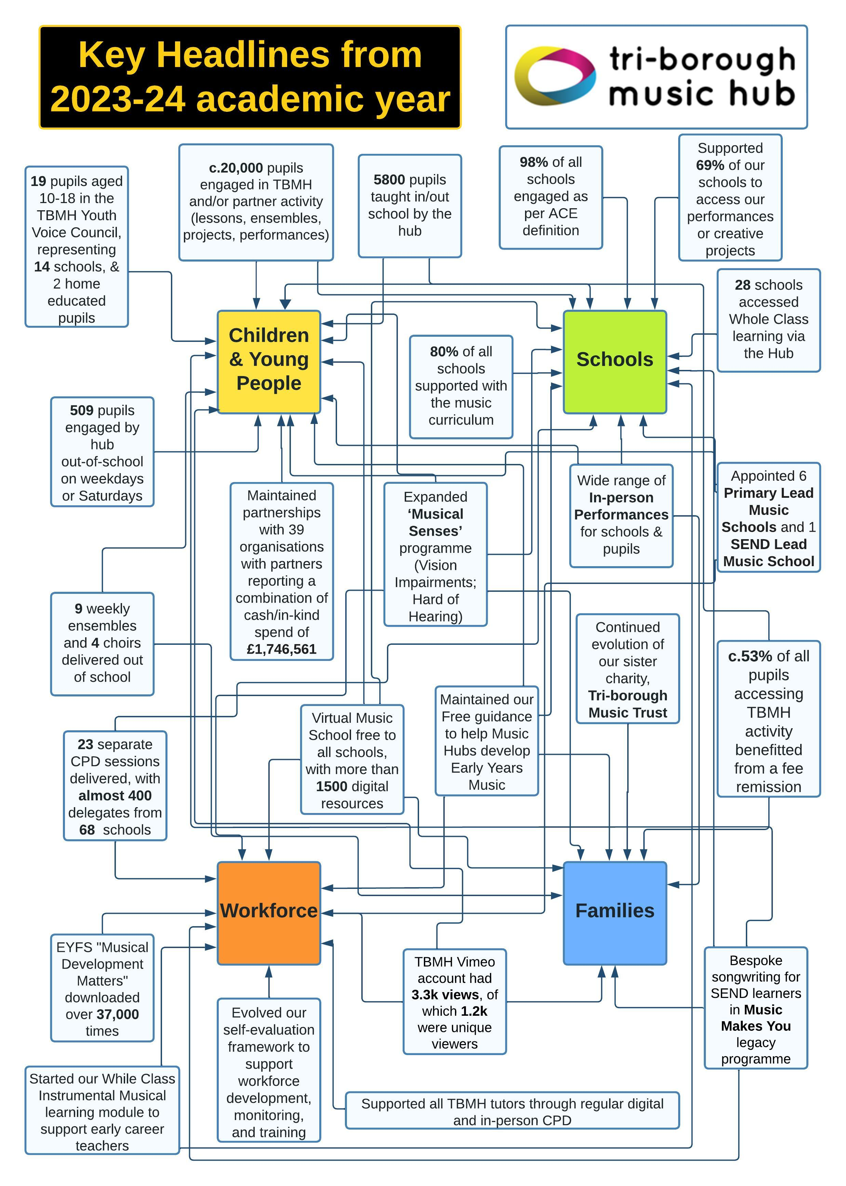

# Contents

Feedback from stakeholders 3

Montage of photos from the year 4

Executive Summary (in words and figures) 5

Executive Summary (in pictures and video) 6

About the Tri-borough Music Hub 7

Music Education for All 7

Key Themes in the evolution of the TBMH 8

TBMH focus priority areas and strategic vision 8

2023-24: The Year in Numbers 11

Our work with Schools and Pupils 11

Hub Workforce Diversity survey, comparison with national data 18

School Music Context 20

Hub Finances 22

Musical Boroughs Trust / Tri-borough Music Trust 23

Our Partner Organisations 25

The essence of the Tri-borough Music Hub: Working in Partnership 26

How well are our partners meeting our Strategic Aims? 26

Appendix: The work of our Partner Organisations 28

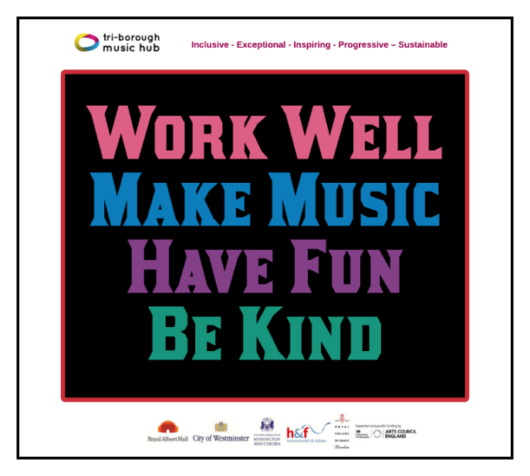

Tri-borough

Music Hub:

Annual Report for 2023-24

Academic Year

# Feedback from stakeholders

“It was so wonderful to be able to attend the TBMH Christmas Festival yesterday - it was an excellent event, I absolutely loved it. The children, musicians and readers were brilliant and oozed warmth and love for singing and music - which is a testament to all the amazing work you do. You should feel so very proud, it was wonderful.”

***Head of Learning and Participation, Royal College of Music***

We really would not be providing our kids with such an enriched and enriching curriculum and meaningful supporting experiences if it wasn’t for all your hard work and effort, and I appreciate it so much, thank you.”

***Primary School Music Teacher***

“Thank you again for your fabulous tuition and the support you have given us as a school to establish this strand of our instrumental provision. I know the children have loved their sessions with you and returned to their classes buzzing! Thank you too for helping to grow our numbers...a sure testament to your wonderful singing tuition.”

***Primary School Music Lead***

“In the hub, they don’t judge you based on your ability or skills, everyone is eligible to join and learn music together. TBMH offers so many contrasting classes which enabled me to observe different teaching and learning aspects in UK. I feel the workshops, classes and ensembles provided by TBMH were very useful for everyone and they also respect and help people who are disabled through music. The way that the hub promotes music to the society is very respectful and meaningful.”

**Feedback on observations during visit by guests from Nanyang Academy of Fine Arts, Singapore**

“Just a line to thank you so much for inviting me to the wonderful Senior Ensembles Showcase at the College on Thursday evening. I thoroughly enjoyed every minute of it and it is a joy to see such active and inspirational music making taking place in the TBMH! I was so impressed with the confidence of the young performers. It’s no mean feat to stand on any stage let alone that particular stage! The TBMH is a shining example of the successful provision of music education to young people when they are being so dismally failed in many other areas of the country.”

**Guest of Senior Ensemble Showcase**

# Montage of photos from the year

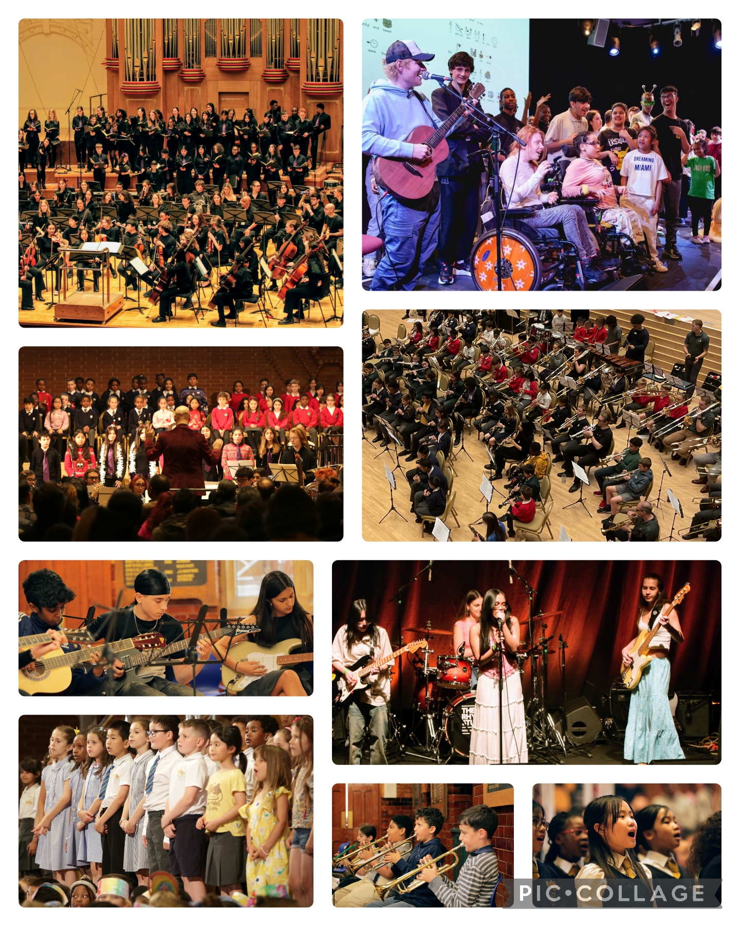

# Executive Summary

## In words and figures

The 2023-24 academic year was another successful one for the Tri-borough Music Hub, in which we:

* worked with over 20,000 children / young people (approx. 5.8k in schools, 700 out of school, 14k via partners)
* worked with 98% (previous year 93%) of all schools in some way across Hammersmith and Fulham, Kensington and Chelsea, and Westminster, including every single primary, secondary, and special school, and every Alternative Provision setting:
  + supported 119 schools (80%) with their curriculum
  + engaged with 98% (prev. 87%) of all schools (Primary 100%; Secondary 100%; 16 plus 40%; Special 100%, AP 100%).
  + provided lessons in or out of school for learners at 95 of our schools (64%)
  + provided ensemble opportunities in or out of school for learners at 87 of our schools (59%)
  + delivered Classroom Instrumental Learning |(CIL) at 28 (19%) of our schools.
  + supported 102 schools (69%) to access a performance opportunity or creative project
  + delivered high-quality CPD to teachers from 68 of our schools (46%)
  + supported 110 schools (74%) with their School Music Development Plan
  + supported 111 schools (75%) with developing a Model Music Curriculum or an equivalent
  + facilitated 88 schools (59%) to access instruments, equipment or venues
  + offered 100% of all schools free musical opportunities including making the Virtual Music School available to every school; and gave every school free membership to Music Mark
* continued our bespoke ‘Musical Senses’ programme of work focused on supporting young musicians who are either blind/visually impaired or deaf/hard of hearing with 15 bursary places and a performance celebration event in July 2024.
* delivered 23 separate CPD training events with 384 delegates, from 68 different schools (46%)
* presented more than 30 performance events, featuring c.5k performers and c.10k audience members
* worked with 5,800 pupils (previously 4,448) via direct engagement by the hub in schools, through whole-class teaching, individual and small group lessons, and hub-led ensembles and choirs
* delivered pilot workshops in Alternative Provision settings, SEND schools, and Secondary schools
* taught a total of 509 pupils out-of-school (including 81 vulnerable pupils), after school or on Saturday mornings, via:-
  + three choirs, three ensembles, and six classes running weekdays after-schools
  + Saturday Music School: a full range of instrumental and vocal lessons, a senior choir, a senior orchestra and six additional ensembles each Saturday.
* Supported 268 pupils through either a scholarship, bursary, or other fee remission.
* worked in partnership with 39 Delivery Partners and 5 Additional Providers, bringing high-quality opportunities to pupils, schools, teachers, and families. These partners reported that they spent **£1,535,726** hard cash on activity for Tri-borough schools, pupils, or teachers; and an in-kind spend of **£210,835**. This totals **£1,746,561** of additional funding spent by the TBMH partners for the benefit of schools, pupils and teachers in our area.
* continued our Youth Voice Council with events in conjunction with Barnet Music Hub at Cecil Sharp House, and a bespoke fundraiser event in July 2024 organised by the YVC.
* continued to develop our 3-year SEND Musical Access, Inclusion and Belonging Programme, funded by John Lyon’s Charity.
* expanded our varied and in-depth programme of work focused on leaners with Special Education Needs with a highlight of performing with Ed Sheeran at the West London Inclusive Arts Festival in May 2024.
* appointed 6 Primary Lead Music Schools and 1 SEND Lead Music School.

A huge thank you to everyone involved with the Tri-borough Music Hub this past year. Special thanks to the entire TBMH team, tutors, headteachers, teachers, schools, Local Authorities, partner organisations, the Arts Council, and Tri-borough Music Trust Trustees. Each person's tireless and collaborative efforts have made a significant positive impact on children's musical learning in our community. Without this dedicated group, our achievements would not have been possible.

**Stuart Whatmore, Head, Tri-borough Music Hub, November 2024**

## In pictures and video

|  |  |  |
| --- | --- | --- |
| **Event** | **Photos** | **Film(s) / Media** |
| **Music Makes Me, June 2023** | * All event info [HERE](https://www.triboroughmusichub.org/school-services/music-makes-me/) | * Documentary [HERE](https://vimeo.com/843187100?share=copy#t=0) * Performance [HERE](https://vimeo.com/843172310?share=copy#t=0) |
| **Windrush, 8th Oct 2023** Celebration of the legacy of Windrush through music, collaboration, and community, featuring, Etienne Charles, Carnival Village Trust, City of London Sinfonia, Revere Arts, Tri-borough Symphonic Band, Justin Fung, and the UK All Steel Pan Orchestra. | * [HERE](https://flic.kr/s/aHBqjAXUSB) |  |
| **Christmas Festivals December 2023**  The Tri-borough Music Hub, in partnership with the Royal College of Music, with music from composer Sally Greaves, showcasing the extraordinary talents of local primary school singers across three separate events. | * Photos Day 1: [HERE](https://flic.kr/s/aHBqjB7EGM) * Photos Day 2: [HERE](https://flic.kr/s/aHBqjB7KkW) * Photos Day 3: [HERE](https://flic.kr/s/aHBqjB7Gt1) | * Vox Pops: [HERE](https://vimeo.com/896566508) * Video Day 1: [HERE](https://vimeo.com/907032230) * Video Day 2: [HERE](https://vimeo.com/907033335) * Video Day 3: [HERE](https://vimeo.com/907033936) * Santa Shuffle (SEND): [HERE](https://vimeo.com/908181698) |
| **Playing Days 2024**  These are opportunity to bring together hundreds of pupils from multiple schools to play in a massed instrumental ensemble. | * Strings: [HERE](https://flic.kr/s/aHBqjBmSQ5) * Wind, Brass, Percussion: [HERE](https://flic.kr/s/aHBqjBmSXV) * Guitar: [HERE](https://flic.kr/s/aHBqjBmUP7) |  |
| **Future Sounds March 2024**  Each year we jointly present Future Sounds with The Rhythm Studio – a Battle of the Bands style competition – that celebrates the best local young contemporary music talent across our three boroughs (Hammersmith & Fulham; Kensington & Chelsea; Westminster). Industry judges give feedback and advice to the 7 finalists | * All Photos can be found [HERE](https://flic.kr/s/aHBqjBiNd7) | All films in this Showcase [HERE](https://vimeo.com/showcase/11066659) with some highlighted films below:   * This short video [HERE](https://vimeo.com/928362774?share=copy) provides Vox Pops (about Future Sounds). * Winners:   + Genesis Brown, [HERE](https://vimeo.com/927965098?share=copy), Star Performer   + Meg Banister, [HERE](https://vimeo.com/928340649?share=copy), Overall Winner   + Elena (from The Crosswalks), [HERE](https://vimeo.com/928341584?share=copy), Outstanding Vocalist |
| **Weekday Sharings Spring 2024** Every week we run 12 separate after-school classes at the Lyric. End of term sharings happen for the groups. | * Photos [HERE](https://flic.kr/s/aHBqjBiPNW) |  |
| **Senior Ensembles Showcase @RCM March 2024**  On Thursday 28th March, we celebrated our SMS Chamber Choir, Next Level Voices, SMS Orchestra, Symphonic Band, and piano student Laurence Mossner in an evening of performances at the RCM. This was a showcase supported by and in collaboration with the RCM, St Paul’s Girls’ School, Royal Albert Hall, ABRSM, TBMH tutors, James Brady Music. | * Photos [HERE](https://www.flickr.com/photos/triboroughmusichub/albums/72177720315924045/) | * Film [HERE](https://vimeo.com/932426172?share=copy) |
| **Building Musical Pathways CPD April 2024** The end of this inclusion focused CPD featured us signing ‘The Things We Do For Love’ with Graham Gouldman, 10CC |  | * Instagram film [HERE](https://www.instagram.com/p/C56YDpPoYtd/?utm_source=ig_web_copy_link) |
| **Ed Sheeran Visit to TBMH May 2024** On 15th May, students in West London were treated to a sensational once-in-a-lifetime experience with a visit from global superstar guest, Ed Sheeran. Co-ordinated by TBMH, Ed joined students to our sing & sign performance of his song, ‘Perfect’ at the West London Inclusive Arts Festival hosted in the Elgar Room of the Royal Albert Hall. We then made the short journey to The Rhythm Studio to learn about the work they do creating music opportunities for young people. |  | * Tri-borough Music hub Instagram item [HERE](https://www.instagram.com/p/C7CVH39tEg1/?utm_source=ig_web_copy_link&igsh=MzRlODBiNWFlZA==) * The Rhythm Studio Instagram item [HERE](https://www.instagram.com/p/C7KKunELIr8/?utm_source=ig_web_copy_link&igsh=MzRlODBiNWFlZA==) * Royal Albert Hall Press Release [HERE](https://eur02.safelinks.protection.outlook.com/?url=https%3A%2F%2Fwww.royalalberthall.com%2Fabout-the-hall%2Fnews%2F2024%2Fmay%2Fed-sheeran-makes-it-a-perfect-day-for-kids-in-west-london%2F&data=05%7C02%7Cstuart.whatmore%40rbkc.gov.uk%7Cc9cb11e91a044857059308dc7670bc4e%7C50d8c115b77f4395a3ba3b407caf0d88%7C0%7C0%7C638515473798079666%7CUnknown%7CTWFpbGZsb3d8eyJWIjoiMC4wLjAwMDAiLCJQIjoiV2luMzIiLCJBTiI6Ik1haWwiLCJXVCI6Mn0%3D%7C0%7C%7C%7C&sdata=rIyG1u2pGvhTxnRGZrceb2%2B1oR7%2FjzpdAvVCCXUaI58%3D&reserved=0) |
| **Infant Voices Festival June 2024** We celebrated talented singers from Yrs 1/2/3 from 16 schools and the TBMH’s First Voices Choir | * Photos [HERE](https://flic.kr/s/aHBqjBxdUx) | * Film [HERE](https://vimeo.com/986380278?share=copy) |
| **Saturday Music School Concert July 2024** Our end of year SMS concert showcased many of the ensembles and choirs. | * Photos [HERE](https://flic.kr/s/aHBqjByEHs) | * Film [HERE](https://vimeo.com/983022549?share=copy) |
| **Music Teacher Network & CPD July 2024**  The last School Music Subject Leader’s network meeting of the year featured Musicking with Ollie Tunmer from Beat Goes On; and Isabella Mayne (Music Teacher at Larmenier & SH school) |  | * Film [HERE](https://vimeo.com/985638184?share=copy) (beat Goes on) * Film [HERE (Isabella Mayne)](https://vimeo.com/986567684) |
| **Musical Senses July 2024**  The culmination of 3 weeks of work happened at the RCM on 14th July in our programme of work that supports young musicians are Blind/Vision Impaired or Deaf/Hard of Hearing. |  | * Main Performance Film [HERE](https://vimeo.com/1008201417) * Short Vox Pops [HERE](https://vimeo.com/1008353260) * Audio [HERE](https://soundcloud.com/music-makes-you-603542511/waking-up-carnage?in=music-makes-you-603542511/sets/musical-senses&utm_source=clipboard&utm_medium=text&utm_campaign=social_sharing) from VI group * Audio [HERE](https://soundcloud.com/music-makes-you-603542511/battle-of-the-elements?in=music-makes-you-603542511/sets/musical-senses&utm_source=clipboard&utm_medium=text&utm_campaign=social_sharing) from HoH group |
| **Makaton Choir**  Celebration of students performing together. |  | * Mountain [HERE](https://vimeo.com/1005777981) * It’s Alright [HERE](https://vimeo.com/1005778632) |

# About the Tri-borough Music Hub

## Who we are

The [Tri-borough Music Hub](http://www.triboroughmusichub.org/) (TBMH) is the award-winning lead organisation that oversees the delivery of music education in the three West London boroughs of Hammersmith and Fulham, Kensington and Chelsea, and the City of Westminster. We work with schools, pupils, music educators and the community. We are a centralised Local Authority service which receives core funding from the Department for Education via Arts Council England. We operate a shared-services model across three Local Authorities to deliver an expansive programme of musical learning, in and out of school.

Alongside the three Local Authorities, the TBMH Strategic Partners are the Royal Albert Hall and the Royal College of Music. In addition, a quality-assured group of delivery partner organisations work to meet the TBMH’s strategic aims and positively contribute to our stakeholders. The TBMH is a music-specific service focused on high quality outcomes inclusive of all learners. It recognises the numerous benefits that music can bring to everyone from all backgrounds and in all circumstances. For more information about the work of the TBMH see annual reports [HERE](https://www.triboroughmusichub.org/about-us/annual-reports/).

## Vision

For every child or young person – whatever their age, ability, or life circumstances – to have their voice heard, to feel included, and to be able to access enriching and relatable musical experiences.

## Mission Statement

Our mission is to provide a broad range of progressive and inclusive musical pathways and opportunities for all Children and Young People to develop a life-long love of music and realise their musical potential whilst developing their personal and social identity. We aim to expose Children and Young People to a range of music that broaden horizons and provide holistic musical learning by making connections that support a sense of cultural identity and belonging in our community. We will work closely in partnership with outstanding music and education organisations that are committed to our ethos. Together we will strive to embed best-practice, and implement visionary and effective models of partnership work to ensure comprehensive routes of engagement, opportunity, and progression for learners.

## Music Education for All

The TBMH works hard to provide a fully inclusive service to ensure that our outputs are embedded in representation, equity, diversity, and inclusion - we aspire to be REDI. We champion the importance of Youth Voice, respond to need, and support all our learners, including our most vulnerable SEND learners. We strive to ensure that Children and young people's music is **HEARD**:

* **Holistic** - emphasis on personal, social, and musical outcomes.
* **Equitable** - those facing the biggest barriers receive the most support.
* **Authentic** - developed with and informed by the people we do it for.
* **Representative** - participants and colleagues reflect our diverse society.
* **Diverse** - all musical genres, styles, practices are valued equally.

All TBMH activity will be equitable and inclusive across all [protected characteristics](https://www.equalityhumanrights.com/en/equality-act/protected-characteristics), to allow our participants (children, young people, workforce) to genuinely feel like they belong. We will create a space where everyone has equal access to opportunities and can be themselves without fear of discrimination, prejudice, harassment, or bullying. This will ensure that a fully rounded, progressive, and innovative music education will be representative of all children, young people, families, and communities who live or go to school within our three boroughs, regardless of their backgrounds or circumstances.

# Key Themes in the evolution of the TBMH

We continue to respond to the four common themes that emerged from our 2021 stakeholder ([HERE](https://www.triboroughmusichub.org/about-us/strategic-review-2021/)) consultation and research, which highlighted the challenges that need to be overcome in order to deliver the best possible service.

* **Access, diversity, inclusion:** Ensuring all children and young people who wish to access our services, can do so
* **Children’s enjoyment and wellbeing**: Providing enjoyable activities for children and young people and supporting their health and wellbeing as we emerge from the challenges of the pandemic
* **Youth voice:** Ensuring that young voices are at the heart of our offers and the decisions we make as a service
* **Relationships and communication:** The importance of listening to and communicating clearly with our audiences, partners, service users and workforce.

# TBMH focus priority areas and strategic vision

Like all Music Hubs (MHs), the TBMH is expected to deliver against the DfE/ACE’s one vision, three aims, and five strategic functions as laid out in the National Plan for Music Education (source [HERE](https://assets.publishing.service.gov.uk/government/uploads/system/uploads/attachment_data/file/1086619/The_Power_of_Music_to_Change_Lives.pdf)), all summarised in a Local Plan for Music Education (LPME).

## DfE/ACE Vision:

All children and young people should be able to learn to sing, play an instrument and create music together, and have the opportunity to progress their musical interests and talent, including into a professional creative career.

## DfE/ACE Three Aims (for Music Hubs):

1. To support schools and other education settings to deliver high quality music education.
2. To support young people to further develop their musical interests and talent, including into employment.
3. To support all children and young people to engage with a range of musical opportunities in and out of school.

## DfE/ACE Five Strategic Functions:

1. Partnerships
2. Schools
3. Progression and Musical Development
4. Inclusion
5. Sustainability

## TBMH Focus Priority Areas

The TBMH has its own locally agreed **focus priority areas**, which link to our overall music strategy ([click HERE](https://www.triboroughmusichub.org/media/3191/tri-borough-music-strategy-feb-2017-update.pdf)), based on need, as laid out in the table below. Listed within each of the priorities below are the areas in which the TBMH and its partners contribute to, and which also map to our LPME.

|  |  |
| --- | --- |
| **Musical development of children and young people**   1. To support musical progression through a broad range of outstanding and fully inclusive musical pathways for children and young people withYouth Voiceembedded in our work | **Enhancing music provision in schools and settings**   1. To engage with all schools to enhance the delivery of an effective music curriculum by supporting access to high-quality music education opportunities |
| 1. Access to learning instruments for all pupils 2. Whole Class Instrumental learning 3. Ensemble and Singing opportunities 4. Inclusive progression and pathway routes 5. Youth Voice is heard and embedded 6. Access to large-scale music experiences | 1. Support for School Music Development Plans with Support for curriculum delivery and CPD for school workforce 2. Identifying Lead School Partners 3. Ensemble and Singing opportunities 4. Whole Class Instrumental Learning 5. Diverse offer of activity 6. Access to large-scale music experiences |
| **Developing the music workforce**   1. To provide a broad range of effective continuing professional development opportunities for the wider workforce that enhances the quality of music education delivery for young people | **Family and community engagement / Events**   1. To support families in our community by ensuring that financial access is not a barrier to pupils’ engagement in music education opportunities led by ourselves and our diverse range of partner organisations |
| 1. CPD for wider workforce (tutors, Higher Education students) 2. Involvement in music education opportunities 3. Representation across all protected characteristics | 1. Affordable access to music education for children 2. Instrument loan service 3. Families feel welcome, valued, and included |
| Everything above is underpinned by innovative music education  which ensures all TBMH, and partner, activity follows our values of:  **Inclusive — Exceptional — Inspiring— Progressive — Sustainable**  with **representation**, **equity**, **diversity**, and **inclusion** at the core of our work | |

## **TBMH Music Strategy:**

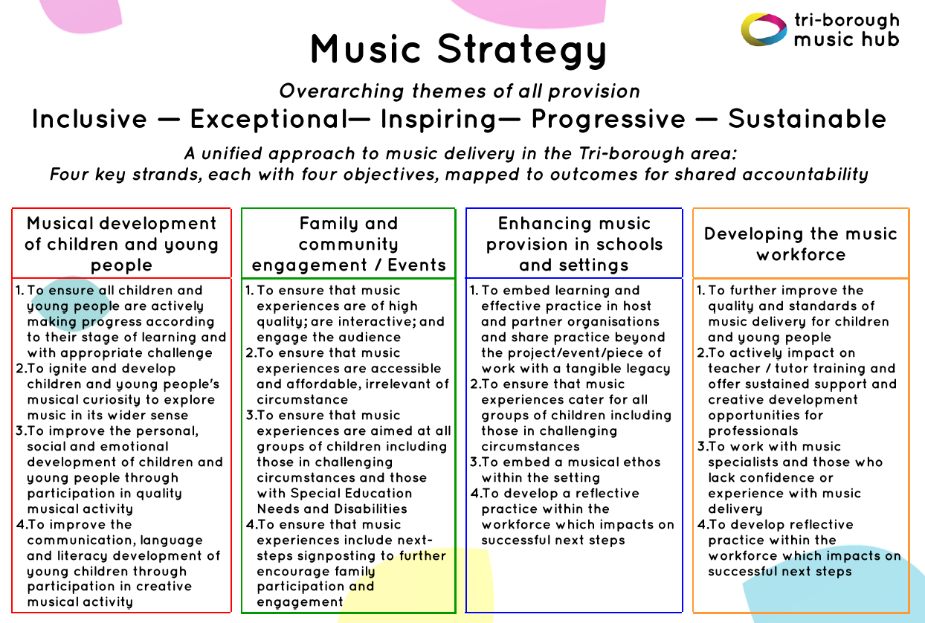

# 2023-24: The Year in Numbers

## Who we serve

Our main client group is children and young people attending state-funded schools or settings (Year Groups Nursery to Year 13) in the Tri-borough area comprising the Royal Borough of Kensington and Chelsea, the London Borough of Hammersmith and Fulham, and the City of Westminster.

Other children who benefit from hub provision include those who are resident in the Tri-borough area but attend school elsewhere and those that are elective home educated or schooled independently. We also have a large programme of Early Years work for birth to 5-year-olds. Approximately 56,000 five to 18-year olds attended state-maintained education settings in the Tri-borough area in 2023-24.

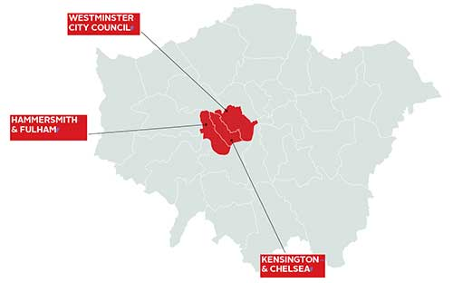

Image source: <http://www.kcwtoday.co.uk>

In 2023-24 there were:-

* 161 maintained schools and settings, including:-
  + 16 EYFS settings
  + 102 mainstream primary schools and 28 mainstream secondary schools
  + 2 all-through schools with primary and secondary provision
  + 2 Sixth Form colleges
  + 4 Alternative Provision settings
  + 11 special schools and settings including 1 Non-Maintained Special School (NMSS)
* Approximately 56,000 children and young people on roll (Yr R0 to 13) at maintained schools in the Tri-borough
* Approximately 111,000 children and young people aged 0-18 resident in the Tri-borough
* 49% female and 51% male
* Approximately 1% of pupils at maintained schools are Looked After Children

Census contextual data (Summer 2023)

|  |  |  |  |  |
| --- | --- | --- | --- | --- |
| **Borough** | **Pupil Premium\*** | **English as an Additional Language** | **Education Healthcare Plan** | **SEN Support** |
| Hammersmith and Fulham | 35% | 41% | 6% | 12% |
| Kensington and Chelsea | 41% | 46% | 6% | 13% |
| Westminster | 45% | 53% | 5% | 13% |

*NC Year R0 to 11

# Our work with Schools and Pupils

## Successes and challenges in delivering core and extension roles

The Arts Council sets out how it records the engagement of schools, and this changed for the 2023-24 year. The degree to which we engaged schools in each role is specified in the table below. Every single school and setting was offered free music support of some kind. The main headline is that we engaged 145 of our 148 ACE-remit hub schools (98%) in some way.

|  |  |  |  |  |  |  |  |  |  |  |
| --- | --- | --- | --- | --- | --- | --- | --- | --- | --- | --- |
|  | **ACE Core role** | **Curriculum Support** | **CPD** | **School Music development Plan support** | **Support with a Model Music Curriculum** | **Lessons** | **Ensembles** | **CIL** | **Performances and Projects** | **Access to Equipment or venues** |
| **Core schools supported** | **145** | **119** | **68** | **110** | **111** | **95** | **87** | **28** | **102** | **88** |
| **Core schools not supported** | **3** | **29** | **80** | **38** | **37** | **53** | **61** | **120** | **46** | **60** |
| **Core schools total** | **148** | **148** | **148** | **148** | **148** | **148** | **148** | **148** | **148** | **148** |
| **Other schools supported♪** | **48** | **6** | **2** | **6** | **6** | **31** | **23** | **0** | **6** | **0** |
| **Percentage of Core schools supported** | **98%** | **80%** | **46%** | **74%** | **75%** | **64%** | **59%** | **19%** | **69%** | **59%** |
| ***Breakdown of engagement by school type*** |  |  |  |  |  |  |  |  |  |  |
| **Mainstream Primary ♫ engagement** | **102/102 = 100%** | **85/102 = 83%** | **56/102 = 55%** | **77/102 = 75%** | **77/102 = 75%** | **73/102 = 72%** | **64/102 = 63%** | **27/102 = 26%** | **75/102 = 74%** | **73/102 = 72%** |
| **Mainstream Secondary ♫ engagement** | **28/28 = 100%** | **19/28 = 68%** | **8/28 = 29%** | **18/28 = 64%** | **19/28 = 68%** | **22/28 = 79%** | **19/28 = 68%** | **0/28 = 0%** | **19/28 = 68%** | **9/28 = 32%** |
| **Sixth Forms / colleges engagement** | **2/5 = 40%** | **1/5 = 20%** | **0/5 = 0%** | **1/5 = 20%** | **1/5 = 20%** | **0/5 = 0%** | **0/5 = 0%** | **0/5 = 0%** | **2/5 = 40%** | **0/5 = 0%** |
| **Special Schools engagement** | **11/11 = 100%** | **11/11 = 100%** | **0/11 = 0%** | **11/11 = 100%** | **11/11 = 100%** | **1/11 = 9%** | **5/11 = 45%** | **1/11 = 9%** | **7/11 = 64%** | **6/11 = 55%** |
| **Alternative Provision engagement** | **4/4 = 100%** | **4/4 = 100%** | **0/4 = 0%** | **4/4 = 100%** | **4/4 = 100%** | **0/4 = 0%** | **0/4 = 0%** | **0/4 = 0%** | **1/4 = 25%** | **1/4 = 25%** |

♪ Includes schools outside of the Tri-borough area and independent schools.

♫ There are two all-through schools, which are included in both the Mainstream Primary and Mainstream Secondary totals.

## Heat map of out of school pupil engagement against the indices of deprivation

**Kensington and Chelsea; and Westminster (Bi-Borough):**

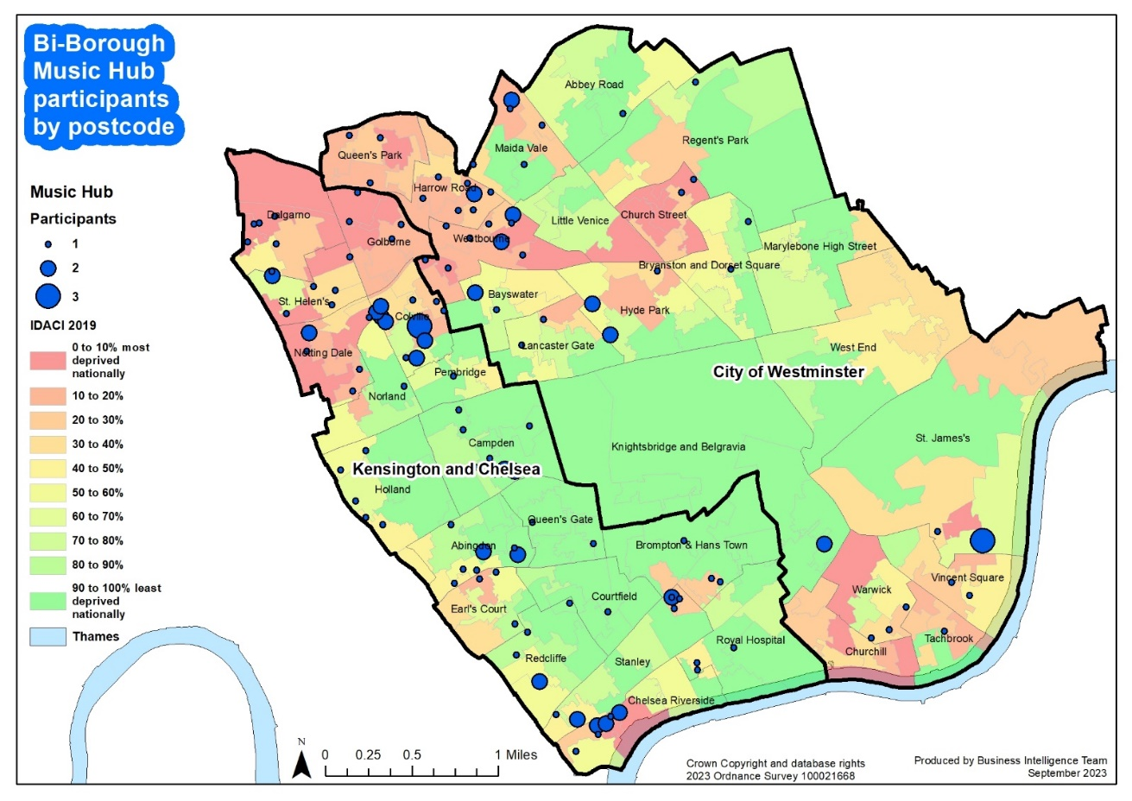

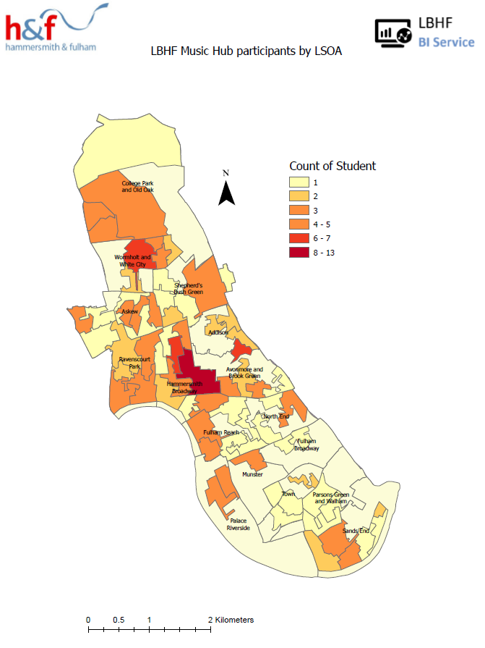**Hammersmith and Fulham:**

NB: Lower Layer Super Output Area (LSOA) boundaries

## Classroom Instrumental Learning (CIL) / Whole Class Ensemble Teaching (WCET)

CIL stats remain low at 19% of schools (previous year 21%). Many schools are still rebuilding their own music curriculums and are not ready to re-engage with this particular strand. Of the 28 schools (down from 32) who did run this, they accepted our ongoing FREE support for schools to access high-quality resources by receiving a free license of one of our Groove’n’Play programme ([HERE](https://www.groovenplay.com/)) to deliver themselves. An increased number of pupils (4,160) benefitted from our CIL programme this year, up from 3,727 in 2022-23.

In addition to the Rastamouse Rocksteady Reggae School, created by Sally Greaves, TBMH has also delivered our specially commissioned ‘groove ‘n’ play’ programmes, also devised by Sally Greaves. The 'groove 'n' play' series, available under license to other music hubs, includes:

* KS1: Rastamouse Rocksteady Reggae School
* KS1: groove ‘n’ play Ukuleles, Sticks, and Songs
* KS1: groove ‘n’ play Fiddle, Sticks, and Songs
* KS1: groove ‘n’ play Recorders, Sticks, and Songs
* KS2/3: groove ‘n’ play FIFTHS (multi-instrumental)
* KS2/3: groove ‘n’ play FIFTHS 2 (multi-instrumental)
* KS2/3: groove ‘n’ play Strings (violin, viola, cello, double bass)
* KS2/3: groove ‘n’ play Woodwind (flutes and clarinets in C)
* KS2/3: groove ‘n’ play Brass (trumpets and trombones)
* KS2/3: groove ‘n’ play Guitar and Mini Bass (guitars and mini-basses)

These programmes are designed to be varied and progressive across KS1-KS3 and can be delivered in three ways. Schools can choose to:

Have Lead & Support TBMH tutors deliver WCET in partnership with the class teacher

Have a Lead TBMH tutor deliver WCET in partnership with the class teacher

Use TBMH resources to deliver the programme themselves

Many schools continue to use our hub's historic resources to deliver their own programmes, though they have not all reported back to us.

## Core roles delivered via out of school activities

Outside of school the TBMH offered a wide range of musical opportunities, and these were taken up in increasing numbers this year.

The full programme involved 509 pupils (up significantly from 378) in after-school weekday activity and / or Saturday Music School; and covered ensembles, singing, and musical progression and pathways. The programme included:-

### Out-of-school Ensembles

* *First Sounds: Ensemble for instrumentalists up to Grade 1;*
* *Breakout Band: Ensemble for instrumentalists from Grade 2-4;*
* *Symphonic Band: Ensemble for instrumentalists from Grade 5-8+;*
* *Saturday Music School (SMS) Senior Orchestra and a wide range of other SMS ensembles (Training Ensemble, Guitar Ensemble, Junior Strings Ensemble, Percussion Ensemble, Wind and Brass Ensemble)*

### 

### Out-of-school Choirs

* *First Voices: Choir for Pupils in R, Yr 1, Yr 2*
* *Next Level Voices: Choir for Pupils in Yr7-Yr13*
* *Junior Voices: Choir for Pupils in Yr3-Yr6*
* *Saturday Music School (SMS) Junior Choir and Senior Choir*

### Out-of-school Lessons

* *A full range of instrumental and voice lessons at Saturday Music School (SMS)*
* *Musicianship classes at SMS*
* *Large Group Guitar Class*
* *Cello Maestros: 1:1/paired lessons*
* *Keyboard Beginner Classes: Open access keyboard for pupils in Yr4-Yr9*
* *Keyboard Lessons: continuers to intermediate*
* *BandLab Music Technology: For pupils in Yr4-Yr7*
* *Garage Band Music Technology: For pupils in Yr 5-Yr13*
* *Online digital lessons at all levels*

The number of different ensembles, bands and choirs available via our hub and those of our partners who submitted a data return increased to 297 (up from 289 in the previous year).

Progression, in all guises, remains integral to our approach and ethos. Our tutor workforce all engaged with our self-evaluation reflection tool with follow-up visits based on need.

## Music lessons (small group and individual) in and out of school

The percentage of hub schools with pupils taking hub-led individual or small group lessons was 64% (unchanged). The total number of pupils learning with TBMH tutors at school was 699, a slight decrease on the previous figure of 721. This figure excludes whole-class teaching (4,160 pupils, up from 3,727).

336 pupils learned an instrument out of school with the hub in an individual / small group cohort.

## Delivering on the Arts Council’s different elements of school engagement

Arts Council England consider a school to be engaged with its local music hub if the hub has supported it in one of a number of different ways. In summary:

* We supported 145 schools (98%) (previously 87%) in some way defined by ACE
* 80% of schools were supported by the hub or partners with the music curriculum
* 46% (previously 49%) of schools engaged in our CPD programme
* 74% of schools were supported with their School Music Development Plan
* 75% of schools were supported with a Model Music Curriculum or equivalent
* 90 (previously 119) pupils hired an instrument from the hub as part of their out of school activity
* 102 schools (69%) took part in a performance or project with the hub or its partners.

## One of our top priorities is engaging with schools, as this is where most children and young people participate in educational learning and have a statutory right to music education within the curriculum. We boast high levels of engagement with schools and maintain positive relationships with both music teachers and senior leaders. By working with schools, we can influence the music education pupils receive through the curriculum, marking the start of an equitable music education progression. Achieving a genuine, cohesive music education progression is a shared responsibility between schools and a Music Education Hub (MEH). This underscores the necessity of collaboration between schools and hubs.

## Continuing Professional Development (CPD)

Professional development (CPD) forms a significant part of our work—spanning schools, tutors, early years, partners, and higher education. We firmly believe in the importance of CPD as it supports individuals and opens up greater opportunities for children and young people. Our overall CPD programme was developed in response to emerging needs brought about by the pandemic and post-pandemic period, and has supported a wide range of stakeholders. For 2023-24, workforce training and CPD were structured under multiple strands:

* Safeguarding
* Phase-specific network meetings
* Curriculum training opportunities Inclusion
* SEND focus
* Specific CPD for schools participating in performance events
* Whole Hub staff meetings with an open discussion platform

Additionally, the Head and Lead Managers contributed to undergraduate and postgraduate courses for RCM students, strengthening the links between HR and the industry and helping shape the next generation of music teachers.

In 2023-2024, the TBMH hosted 23 different CPD training workshops and events online, with 384 attendees from our workforce, including tutors, core team members, partners, school teachers, and other music educators, including staff from 68 of our core schools.

## Large-scale, high-quality performance events

We were delighted to continue to stage in-person events, and this year these included:

* Three Christmas Festivals featuring 33 schools and 850 pupils (videos [here](https://vimeo.com/907032230), [here](https://vimeo.com/907033335) and [here](https://vimeo.com/907033936))
* The Infant Voices Singing Festival featuring 14 schools, our First Voices choir and a total of 379 pupils (video [here](https://vimeo.com/986380278)).
* Future Sounds final featuring seven contemporary artists aged 11-18 at Bush Hall (Vox Pops video [here](https://vimeo.com/928362774))
* End of term informal sharing sessions throughout the year for all of our Saturday / after school classes, ensembles and choirs
* The Wind, Brass, and Percussion Playing Day; Strings Playing Day; and Guitars Playing Day were chances for hub learners to play together with learners from other schools
* We staged a Senior Ensembles showcase at the RCM for Next Level Voices, Senior Orchestra and Symphonic Band (video [here](https://vimeo.com/932426172))
* Saturday Music School end of year concert (video [here](https://vimeo.com/983022549))
* Three Musical Senses events in June and July 2024 at the Royal College of Music for our cohort of young musicians who are blind/vision impaired, or who deaf/hard of hearing (video [here](https://vimeo.com/1008201417))

## Using technology to deliver for our stakeholders

### Supporting the music curriculum

Starting from the Autumn Term 2021, our [Virtual Music School](https://www.triboroughmusichub.org/tbmh-virtual-music-school/) has been freely accessible. This allows approximately 150 schools (around 56,000 pupils) to potentially benefit from it. The VMS offers more than 1,500 customized digital resources, including PDFs and videos, covering aural practice, instrumental tutorials, music technology, and composition courses, tailored for all age

groups.

The hub’s continued partnership with Charanga has led to increased engagement with its digital learning support for core and extension roles. Charanga is a multi-hub online learning platform that provides schools, instrumental teachers, and young people with access to a variety of musical digital technology support programs, training, and CPD.

In 2023-24:

* Our partnership with Charanga has supported schools and instrumental teachers with online digital resources and CPD for teaching the music curriculum and instrumental learning.
* 26 primary and special schools, along with 4 instrumental teachers, regularly accessed the Charanga platform, utilizing its musical digital technology for 4,615 hours of teaching.

### Music Technology learning

We continued to deliver weekly BandLab and Logic Audio classes as part of our out of school offer. This has been a really positive development for the TBMH and is now part of the regular offer of music production.

### Music Technology resources

* Music Production – T&L Resources ([HERE](https://cas5-0-urlprotect.trendmicro.com:443/wis/clicktime/v1/query?url=https%3a%2f%2fdrive.google.com%2ffile%2fd%2f1Bt9%2dDSeKK8istqA%2dcMUI1%2dFGYcie2xsx%2fview%3fusp%3dsharing&umid=add6256b-9de5-4993-98a9-2646a604d9f0&auth=f23bd3b3794c7a5914053bd0a99b1b4837b89b14-e4002997d030ee18f68510627c5d60618a2278c7))
* Song writing – T&L Resources ([HERE](https://cas5-0-urlprotect.trendmicro.com:443/wis/clicktime/v1/query?url=https%3a%2f%2fdrive.google.com%2ffile%2fd%2f13%2dNetyH7YM96jKD5t5fvuq%2dj485oOgrR%2fview%3fusp%3dsharing&umid=add6256b-9de5-4993-98a9-2646a604d9f0&auth=f23bd3b3794c7a5914053bd0a99b1b4837b89b14-8f523c8e3d0b0d0ecb42467cda65d40f692f9678))
* Hip-Hop – T&L Resources ([HERE](https://cas5-0-urlprotect.trendmicro.com:443/wis/clicktime/v1/query?url=https%3a%2f%2fdrive.google.com%2ffile%2fd%2f1Sqo9WcRZX9bfTRVazI18rqutTYKALe31%2fview%3fusp%3dsharing&umid=add6256b-9de5-4993-98a9-2646a604d9f0&auth=f23bd3b3794c7a5914053bd0a99b1b4837b89b14-d9151502489c17ae2b53adf729daf42908e529e2))
* Teaching young people with SEND additional resources ([HERE](https://cas5-0-urlprotect.trendmicro.com:443/wis/clicktime/v1/query?url=https%3a%2f%2fdrive.google.com%2ffile%2fd%2f1zqi3FwWpaPEGXKhvoLJnCSnpNe5h7be3%2fview%3fusp%3dsharing&umid=add6256b-9de5-4993-98a9-2646a604d9f0&auth=f23bd3b3794c7a5914053bd0a99b1b4837b89b14-d916d676326b0dd4778cfa57745802e4e9db6105))

### Extending reach and engagement

Our Music Hub has significantly expanded its reach and engagement through digital advancements and a forward-thinking approach. Social media, digital delivery, and a wealth of teaching and learning resources have been key in this endeavour.

Our TBMH Vimeo account logged 3,282 views and 839 watched hours, with 1,229 unique viewers, showcasing the wide audience we're engaging. Vimeo also hosts all teaching and learning resources for the Sounds Like Hammersmith & Fulham legacy programme, with 34 videos shared to date. The video resources for our Virtual Music School are hosted on YouTube.

We’ve also harnessed social media effectively, with Twitter and Instagram as our primary platforms, complemented by Facebook and our website. Additionally, we use MailChimp for e-newsletters to keep our audience informed and engaged.

This multi-faceted digital strategy has allowed us to enhance our outreach and engagement significantly.

## Supporting Access, Inclusion, Representation, Equity and Diversity

TBMH is dedicated to driving positive change and ensuring our services are accessible to as many young people, schools, teachers, and communities as possible. Over the past five years, we have invested significant time and resources into enhancing our efforts in Representation, Equity, Diversity, and Inclusion (EDI). Our core strategy revolves around the cycle of: Listen, Hear, Respond, which fosters continuous learning.

Our [Access, Inclusion, and Belonging Strategy](https://www.triboroughmusichub.org/support-us/news/send-musical-access-inclusion-and-belonging/) was designed to embed EDI across all areas of Hub delivery. We are committed to ensuring equity of opportunity for all pupils, regardless of race, gender, location, talent levels, parental income, special educational needs or disabilities, and whether they are looked after children or care experienced.

**Partnerships**

We have done a lot of this by working in partnership with other organisations who share our ambitions. Partnerships remain an absolutely core feature of our work and these have formed the backbone of three major music education programmes that we have been working on recently. One being the legacy from **Music Makes Me** which culminated in June 2023 but continues with bespoke songwriting in **Music Makes You**; one being **Musical Senses**, our ongoing programme of work that supports young musicians who are blind/have a vision impairment (VI), or who are deaf/hard of hearing (HoH); and the other being our Makaton choir.

**Approach**

At the core of these programmes and also how we approach most of our work in general, is a 3-pronged approach:

1. Training and professional development for teachers to upskill and equip them.
2. Working with and engaging positive role models into the roles of music leaders to promote representation.
3. Targeted Music activity for young people that helps support engagement with high-quality musical activity.

**Challenges Faced by Visually Impaired Musicians in Orchestras**

As part of our commitment to growing representation we have been fortunate to work with Paula Chavez (and her sister, Fabiana) for the past two years, both of whom are blind musicians and music educators. They teach curriculum music in schools, piano lessons at our Saturday Music School, and support our out of school ensembles. Paula has written a really candid and insightful piece of work which we feel is important for us to share more widely in order to raise awareness and build inclusivity in the work of music education. You can read Paula’s article by clinking on this link [**Word Version**](https://www.triboroughmusichub.org/media/6088/challenges-faced-by-visually-impaired-musicians-in-orchestras.docx).

**Youth Voice**

During the year, we continued to develop our Youth Voice Council which had 19 members (11 male, 8 female) from Year Groups 6 to 13, representing 14 schools and 2 home educated pupils, as well as TBMH Young Ensemble Leaders.

The focus of the Youth Voice council was building relationships amongst students, as well as promoting student-led ideas and events. This led to a spring term in-person meet up, alongside BEAT (Barnet Education Arts Trust) at Cecil Sharpe House, as well as a Summer Fundraising Event for Musical Boroughs Trust.

In addition to working with the Youth Voice Council, the TBMH Youth Voice strategy has included developing more ways to gain feedback from students in schools and out of school activity. TBMH met with Youth Voice Leads from other London Boroughs, to gain a wider perspective of the needs of young people across London. This conversation led to a youth voice consultation with approximately 80 students across 6 secondary schools in Kensington & Chelsea, Hammersmith & Fulham, and Westminster. The thoughts and feedback shared across these platforms will feed into the work that the TBMH Youth Voice Council carries out in the following year.

**Financial Access and Support**

The TBMH continues to successfully source scholarship funding and apply effective remissions for the families of our pupils. On top of our already heavily subsidised prices for out-of-school activity, in 2023-24 we applied a further £18,362 of concessions to parents/carers of pupils in receipt of free school meals, or with siblings attending the same activity. 93 individual pupils benefitted - 60 from the FSM concession (£13,714) plus 33 from the sibling discount concession (£4,648). These discounts benefitted 23% of all pupils. A further 131 pupils (33%) were supported by full scholarship fees, with a value of £61,082. Collectively over 56% of the 400 pupils engaging in TBMH out-of-school activity benefitted from partial or full financial support.

## Hub Workforce Diversity survey, comparison with national data, and trends over time

This year we again carried out a diversity survey of our core hub team, tutors and governance and oversight stakeholders. Not every member submitted a response to this anonymous survey, so this summary necessarily only compares respondents to the TBMH survey rather than the whole workforce. With four consecutive years of data, we are able to indicate whether the hub is becoming more or less representative of the broader population over time (by comparison to national averages garnered from a range of sources).

|  |  |
| --- | --- |
| Becoming more representative | Green means that, relative to the previous year’s figure, this year’s figure is **converging** with the national average used as a comparator. In these categories the survey indicates that the hub is becoming more representative. |
| Becoming less representative | Pink means that, relative to the previous year’s figure, this year’s figure is **diverging** from the national average used as a comparator. In these categories the survey indicates that the hub is becoming less representative. |
| Neither more nor less representative | Orange means that the figure for this year is neither moving towards nor away from being representative of the specified comparator cohort. |

Please note that **no value judgement is attached to these colours**, they simply indicate whether the difference between the hub workforce and the population in terms of representation has closed or widened statistically since the previous year.

Please also note that in both the TBMH and comparator sets of figures, we have excluded non-respondents, including “prefer not to say” respondents, to make a more valid comparison between the two sets of figures.

### Sex

ACE now requires us to ask people to report their sex (rather than gender identity as in previous years)

|  |  |  |
| --- | --- | --- |
|  | TBMH | England & Wales (2021 census) |
|  | **2023-24** | Comparator |
| Female | **61.2%** | 51.0% |
| Male | **38.8%** | 49.0% |

### Gender identity

|  |  |  |  |  |  |
| --- | --- | --- | --- | --- | --- |
|  | TBMH | | | | England & Wales ([2021 census](https://www.ons.gov.uk/peoplepopulationandcommunity/culturalidentity/genderidentity/bulletins/genderidentityenglandandwales/census2021)) |
|  | 2020-21 | 2021-22 | 2022-23 | **2023-24** | Comparator |
| Woman | 68.2% | 68.8% | 77.4% | **57.1%** | 50.7% |
| Man | 31.8% | 31.3% | 22.6% | **36.7%** | 48.7% |
| Non-binary |  |  |  | **6.1%** | 0.6% |

Men are under-represented, and women over-represented within the hub workforce, compared to the national picture in the 2021 census. “Prefer Not to Say” (PNTS) responses are excluded from these figures, as are non-respondents to the comparator census.

### Gender identity different to sex registered at birth

4 survey respondent identified as having a different gender to their sex registered at birth (7.7% of respondents), compared to a 0.53% figure from ONS ([Census 2021](https://www.ons.gov.uk/peoplepopulationandcommunity/culturalidentity/genderidentity/bulletins/genderidentityenglandandwales/census2021), England figure).

### Sexual Orientation

|  |  |  |  |  |  |
| --- | --- | --- | --- | --- | --- |
|  | TBMH | | | | ONS data ([UK 2022](https://www.ons.gov.uk/peoplepopulationandcommunity/culturalidentity/sexuality/bulletins/sexualidentityuk/2021and2022)) |
|  | 2020-21 | 2021-22 | 2022-23 | **2023-24** | Comparator |
| Heterosexual / Straight | 74.5% | 84.8% | 79.3% | **77.1%** | 93.4% |
| Lesbian or Gay | 10.6% | 4.4% | 6.9% | **7.9%** | 1.8% |
| Bisexual | 6.4% | 4.3% | 10.3% | **7.9%** | 1.5% |
| Queer / Other | 2.1% | 6.5% | 3.4% | **7.9%** | 0.6% |

Gay Men and Women, Bisexual and Queer people are over-represented in the hub compared to 2022 ONS data, whereas Heterosexual people are under-represented.

### Ethnicity

|  |  |  |  |  |  |
| --- | --- | --- | --- | --- | --- |
|  | TBMH (excluding PNTS) | | | | England and Wales working age population ([2021 Census](https://www.ethnicity-facts-figures.service.gov.uk/uk-population-by-ethnicity/demographics/working-age-population/latest)) |
|  | 2020-21 | 2021-22 | 2022-23 | **2023-24** | Comparator |
| White ethnic groups | 84.7% | 87% | 76.7% | **80.0%** | 80.7% |
| Asian ethnic groups | 6.5% | 6.5% | 6.7% | **4.0%** | 10.1% |
| Black ethnic groups | 2.1% | 2.2% | 3.3% | **2.0%** | 4.4% |
| Mixed ethnic groups | 2.1% | 4.3% | 13.3% | **10.0%** | 2.5% |
| Other ethnic groups | 4.3% | 0% | 0% | **4.0%** | 2.3% |

White, Asian, and Black ethnic groups are all under-represented, whereas Mixed and Other ethnic groups are over-represented in the hub.

### Disability

|  |  |  |  |  |  |
| --- | --- | --- | --- | --- | --- |
|  | TBMH (excluding PNTS) | | | | ONS Labour Force Survey ([Q1 2023](https://commonslibrary.parliament.uk/research-briefings/cbp-7540/#:~:text=How%20many%20people%20in%20the,of%20the%20working%2Dage%20population.)) |
|  | 2020-21 | 2021-22 | 2022-23 | **2023-24** | Comparator |
| D/deaf / Disabled | 7.1% | 8.5% | 29% | **14.6%** | 23% |

D/deaf and Disabled people are now under-represented in the hub compared to the working age population, and the percentage of D/deaf and Disabled people working for the hub is now further from being representative of the working-age population.

### Neurodivergence

This year, for the first time and in line with ACE reporting expectations, we asked our workforce the question “Do you consider yourself to be neurodivergent?

|  |  |  |
| --- | --- | --- |
|  | TBMH (excluding PNTS) |  |
|  | **2023-24** | Comparator* |
| Neurodivergent | **13.0%** | 15% |

*N.B. We are not aware of a reliable comparator yet available for the prevalence of neurodiversity in the UK working population. The figure of 15% is widely quoted by available publications (including government publications) but not accompanied by reliable citations.

## Supporting Grenfell

In the years following the Grenfell tower tragedy, the TBMH has supported the most affected schools and pupils in a number of ways – directing targeted work delivered by partners to North Kensington; providing additional support to schools; training and advice to TBMH tutors re: working with affected schools and pupils; linking with the Children’s Services support network to focus the most appropriate response. The 2023-24 academic year saw work between the Grenfell Team and the TBMH, and Strategic Partners but more work should happen here to support bereaved and survivors.

# School Music Context

## Performance in Public Exams data

We maintain our absolute commitment to engaging all secondary schools to support the teachers and their pupils through CPD, performance events, and partner opportunities to enrich the curriculum. The TBMH is committed to working with the secondary schools to ensure that KS4 and KS5 provision is maintained and developed.

## Partner Opportunities

Beyond our centrally organized provision, the children and young people in the Tri-borough area enjoyed a wide range of tuition, ensemble, and performance opportunities, thanks to our partner organizations. Detailed breakdowns of the benefits for both pupils and staff are available in the appendix of this document. We are very fortunate to have the support of so many world class partner organizations and professionals, enabling pupils and our local music workforce to develop their skills, expand their repertoire, and raise standards.

Hub Finances

Tri-borough Music Hub Turnover: Historic and Projected

|  |  |  |  |  |  |  |  |
| --- | --- | --- | --- | --- | --- | --- | --- |
| **Financial Year** | **DfE / ACE  Core Grant** | **Turnover History** | **Non-Core Grant Turnover** | **Income Generation percentage** | **Partners Reported Spend  (For information only)** | | |
| 2012-13 | £411,982 | £436,164 | £24,182 | 6% | In-kind Spend | Cash Spend | Total Spend |
| 2013-14 | £511,488 | £692,943 | £181,455 | 26% |  | £605,938 | £605,938 |
| 2014-15 | £419,967 | £824,644 | £404,677 | 49% | £250,539 | £764,295 | £1,014,834 |
| 2015-16 | £527,054 | £1,069,452 | £542,398 | 51% | £240,576 | £1,263,856 | £1,504,432 |
| 2016-17 | £527,761 | £1,165,755 | £637,994 | 55% | £369,191 | £1,200,555 | £1,569,746 |
| 2017-18 | £525,350 | £1,293,622 | £768,272 | 59% | £223,750 | £1,208,793 | £1,432,543 |
| 2018-19 | £519,212 | £1,278,848 | £759,636 | 59% | £173,920 | £969,658 | £1,143,578 |
| 2019-20 | £518,377 | £1,504,150 | £985,773 | 66% | £336,287 | £688,765 | £1,025,052 |
| 2020-21 | £511,450 | £1,258,333 | £746,883 | 59% | £174,771 | £875,356 | £1,050,127 |
| 2021-22 | £502,902 | £1,635,123 | £1,132,221 | 69% | £179,382 | £633,886 | £813,268 |
| 2022-23 | £493,973 | £1,582,229 | £1,088,256 | 69% | £196,831 | £1,364,625 | £1,561,456 |
| **2023-24** | **£489,847** | **£1,229130** | **£739,283** | **60%** | **£210,835** | **£1,535,726** | **£1,746,561** |

Turnover in the 2023/24 Financial Year was significantly down on the previous year. Income from parents, LAs, the Arts Council and other sources were all down, and income from schools, charitable foundations and other earned income were up. The largest single factor was the ending of the Sounds Like Hammersmith and Fulham project and the loss of the associated project income. However, reduced costs meant that we were able to come very close to balancing the books.

The partner-reported in-kind and cash spend by our partner organisations reached £1.7M, the highest figure since we started to record this in 2013.

The 2023-24 Financial Year brought challenges for fundraising activities but both Tri-borough Music Hub and its sister charity, Tri-borough Music Trust (registered name, ‘Musical Boroughs Trust’, established in May 2019) were able to make progress. Several grant applications were made to Trusts and Foundations, with existing relationships (e.g. John Lyon’s Charity and the Ingles Charitable Trust) further developed, and new ones established.

TBMT was successful with securing 3-years funding (£94k) from JLC towards TBMH’s SEND Access, Inclusion & Belonging programme. This allows to appoint a 2-dpw Strategic SEND Lead, targeted activity, and bursary support.

TBMT maintained public fundraising campaigns using the charity’s website, text donations, a tailored DonorBox platform on MBT and TBMH internet sites. TBMH continued to receive generous support from several student Scholars and Bursary schemes to help disadvantaged young musicians gain access to our music education programmes. The HMRC Gift Aid status on top of donations from individual donors has enhanced income received. Trustees continued networking with local high-net-worth-individuals as potential future donors and advocates.

In 2023-24 the TBMH received the following additional income:

* £42,000 towards building costs/room hire from the Tri-borough LAs
* £30,000 from RBKC (in lieu of use of historic Gifted & Talented fund)
* £30,000 from TBMT via John Lyon’s Charity towards our SEND Musical Access, Inclusion and Belonging project
* £26,368 from LMF for scholarships
* £14,275 from the Royal Albert Hall to fund the Maestros scheme
* £14,224 from Thomas’ Foundation for scholarships
* £5,987 from TBMT for Musical Senses project and (via Co-op Local Community Grant Scheme) Music Makes Me legacy work
* £5,400 from John Lyon’s Charity for scholarships
* £5,236 from Access to Work for Support Worker reimbursements
* £5,000 from ABRSM for general sponsorship
* £2,000 from Ingles & Hayday
* £1,770 from the Royal College of Music for the Get Set Play scheme
* £600 from ABRSM for Senior Ensembles Showcase sponsorship
* £330 from the Lyric Hammersmith for bursaries
* £200 from Camden Music Trust for CPD attendance
* £200 from Richmond Music Trust for CPD provision

### **Tri-borough Music Hub Income FY 2023-24**

|  |  |  |
| --- | --- | --- |
| **Source of Income** | 2022-23 | **2023-24** |
| DfE / ACE Core Grant | £493,973 | £489,847 |
| Local authority grants/contributions | £175,886 | £61,965 |
| Other Arts Council grants | £29,500 | £2,583 |
| School contribution: | £441,774 | £450,178 |
| Parental contribution (including via schools) | £102,316 | £90,882 |
| Charitable foundations/trusts | £88,056 | £98,498 |
| Other earned/generated income | £18,752 | £26,410 |
| Other income | £231,972 | £35,177 |
| **Total** | £1,582,229 | **£1,229,130** |

### **Tri-borough Music Hub Expenditure**

|  |  |  |
| --- | --- | --- |
| **Cost** | 2022-23 | **2023-24** |
| Delivery costs | £1,215,423 | £1,075,056 |
| Administrative and other costs | £314,070 | £208,857 |
| **Total** | £1,529,493 | **£1,283,913** |

# Musical Boroughs Trust / Tri-borough Music Trust

The Tri-Borough Music Hub (TBMH) established a sister charity in May 2019. The charity’s legal name is Musical Boroughs Trust, but it operates under the name, Tri-borough Music Trust (TBMT). The main purpose of the TBMT is to generate additional income strands for the work of the Tri-Borough Music Hub and to support the Hub by promoting the value, importance and impact of its work to individuals, corporations and trusts and foundations. https://www.triboroughmusichub.org/support-us/about-tri-borough-music-trust/

Together, TBMT and TBMH have taken on responsibilities in coordinating the ways in which we support local music education to avoid a duplication of effort. Supported by its Trustees, who have a wide range of professional expertise, TBMT has begun a new phase of its existence by raising funds for activities to provide high-quality music making opportunities for approximately 20,000 children and young people each year. The three local authorities have always generously supported the excellent work of the Tri-Borough Music Hub, but recent cuts to central Government grants has meant that we urgently need the help of parents, trusts, foundations, businesses and individual donors to sustain the hugely valued inclusive work which has been pioneered in our three boroughs by offering a wide range of musical opportunities to disadvantaged young people.

TBMT's target is to raise c.£50k per year to help fund music programmes across our boroughs.

We aim to achieve this through grant applications to charitable trusts and foundations, such as the John Lyon’s Charity, and through the generosity of our donor community and corporate supporters. However, more support is urgently needed. We are raising funds for:

* Bursaries and music scholarships to cover the costs of music lessons for highly talented children/young people living below the poverty line.
* Inclusive music programmes that fully reflect the diversity of our three boroughs.
* Musical instruments of all types to support young musicians.
* Running costs of TBMH’s Saturday music school, weekday youth ensembles and choirs (covering multiple genres), and holiday courses, which build confidence, develop skills and consolidate learning.
* Special projects for children with additional needs, such as Musical Senses, specifically created for young people who are blind, partially sighted, deaf or hard of hearing.
* Salaries of specialist music staff who work with disadvantaged children and enable them to access new opportunities and develop life chances they wouldn’t otherwise have.
* Performance events that inspire children and encourage them to aim really high, such as Convo and Music Makes Me at the Royal Albert Hall.

We want every child in our area to be able to access and enjoy music making - because we know it’s more than music. Music helps the educational development and wellbeing of children and young people. Through music, the foundations of learning are strengthened, helping to build confidence, teamwork and sociability as well as academic achievement and creativity. In this way, aspirations are raised, and children's life chances are opened up.

We believe that music is an essential part of the school curriculum and we strive to ensure it reaches and engages all children equally, regardless of challenging circumstances. In our area, where almost half of children live in poverty, we help enable access for all by funding a broad range of inclusive music programmes delivered by TBMH.

Our trustees are:

Susan Whiddington CBE, Chair

Milica Vukovic-Smart, Deputy Chair

Ian Adams

Chloe Armstrong

Jonathan Chambers

Tim Garrard

Caroline Hansen

Linlin Jin

Catherine Marris

Edward McGovern

Eva Morrison

Socorro Torres-Duarte

The Tri-borough Music Trust endeavours to open the doors to future collaborations and connections for extending the scope and impact of TBMH’s work. Additionally, a long-term goal for the TBMT is that by securing access to new sources of funding for TBMH, moving forward, the Hub can devote more of its income to partnership working.

# Our Partner Organisations in 2023-24

|  |  |  |
| --- | --- | --- |
| Organisation | Focus | Category |
| Royal Albert Hall | **Strategic Partner** and concert venue | Non-NPO Arts/Cultural Organisations |
| Royal College of Music | **Strategic Partner** and conservatoire | Higher Education Establishment |
| ABRSM | Music Education exam boards and supporter of Musical Senses | Non-NPO Not for Profit Music Organisation |
| Aurora Orchestra | Orchestra, in-person education and online learning platform | Other National Portfolio Organisation |
| Bi-Borough (RBKC/WCC) Local Authorities | **Strategic Partner**, links with local schools and Children's Services | Local Authorities |
| Charanga | Music learning platform | Digital Music Technology Provider |
| Creative Futures (UK) Limited | Works in third sector and health, with Early Years focus. | Non-NPO Arts/Cultural Organisation |
| English Folk Dance and Song Society | Folk music cultural organisation | Other National Portfolio Organisation |
| English National Ballet | Ballet company | Other National Portfolio Organisation |
| English National Opera | Opera company | Non-NPO Arts/Cultural Organisation |
| Fulham Symphony Orchestra | Community orchestra | Community/Youth Organisation |
| Go Live Theatre | Theatre company for young people | Non-NPO Not for Profit Music Organisation |
| Groove'n'Play | Music curriculum provider and composer. | Non-NPO Music Organisation, Commercial/Industry |
| HarrisonParrott Foundation | Links with music industry and artist agency | Non-NPO Not for Profit Music Organisation |
| Imperial School of Medicine Music Society | Music organisation | Non-NPO Not for Profit Music Organisation |
| In - Deep | Music therapy | Community/Youth Organisation |
| Inspire-Works | Global arts organisation | Non-NPO Arts/Cultural Organisation |
| Kensington and Chelsea Council Culture Service | LA Culture Service | Local Authority |
| Latymer Upper School | Venue partner | Independent Educational Establishment |
| London Borough of Hammersmith & Fulham | Strategic Partner, links with schools and Children's Services | Local Authority |
| Live Music Now | Performances and CPD | Non-NPO Not for Profit Music Organisation |
| Malombo Music Association | Fostering cultural diversity | Non-NPO Not for Profit Music Organisation |
| Music House for Children | Early years and SEND music education | Other Partner Organisation |
| Music Masters | Sharing expertise and training opportunities | Non-NPO Not for Profit Music Organisation |
| Tri-borough Music Trust | Sister charity of the TBMH | Non-NPO Not for Profit Music Organisation |
| Nucleo | Community youth orchestra | Non-NPO Not for Profit Music Organisation |
| Revere Arts | Industry links with music artists and artist agency | Non-NPO Music Organisation, Commercial/Industry |
| Royal Academy of Music | Conservatoire and education outreach | Higher Education Establishment |
| Royal Philharmonic Orchestra | Orchestra and education outreach | Other National Portfolio Organisation |
| Serious Events Ltd | Jazz events organiser | Other National Portfolio Organisation |
| Sound Connections | Support with Youth Voice and CPD | Other National Portfolio Organisation |
| Southbank Sinfonia at St John's Smith Square | Orchestra and education outreach | Non-NPO Not for Profit Music Organisation |
| TEA films Ltd | Videography and photography | Other Partner Organisation |
| The Bach Choir | Choir and choral workshops | Non-NPO Not for Profit Music Organisation |
| The Rhythm Studio | Contemporary music learning | Non-NPO Music Organisation, Commercial/Industry |
| Turtle Key Arts | Arts organisation and SEND specialists | Other Non-NPO Arts/Cultural Organisation |
| Voices Foundation | CPD in choral leadership. | Non-NPO Not for Profit Music Organisation |
| Westminster Council | **Strategic Partner**, links with schools and Children's Services | Local Authority |
| Wigmore Hall | Venue and school outreach | Other National Portfolio Organisation |

**In our wider network**

|  |  |  |
| --- | --- | --- |
| Carnival Village Trust | Inner Voices | LBHF Culture |
| LBHF Learning Partnership | Lyric Hammersmith | Opera Holland Park |
| The Bhavan Institute | The Classical Roadshow | Westminster City Lions |

# The essence of the Tri-borough Music Hub: Working in Partnership

Partnerships are a vital part of the TBMH's extensive programme of activities. In 2023-24, we collaborated with 39 named delivery partners, and we're grateful to the 28 partners (72%) who responded to our annual data survey, reporting their invaluable contributions. Beyond this, we worked with various organisations within the wider cultural partnership, holding termly partner meetings that each focused on specific topics to enhance our collaboration.

Of the partners that did respond to our detailed survey for the 2023-24 academic year, they spent **£1,535,726** hard cash on activity for Tri-borough schools, pupils, or teachers; and an in-kind spend of **£210,835**. This totals **£1,746,561** of additional funding spent by the TBMH partners for the benefit of schools, pupils and teachers in our area. These figures are accounted for through each partner’s own accounts.

We further developed our innovative ‘Musical Senses’ programme aimed at supporting students who receive sensory support because they have either a vision impairment, or who are deaf or hard of hearing. The programme for 2023-24(more information [HERE](https://www.triboroughmusichub.org/school-services/musical-senses/)):

* supported 6 students with bursaries throughout the academic year
* saw the delivery of a creative 3-day programme and concert at the Royal College of Music for 17 students and their families
* provided training materials for the workforce directly created by specialist workshop leads

We have continued our development partnership with Charanga supporting 26 Primary and Special Schools and 4 instrumental teachers with access to the Hub's custom Charanga platform. Charanga assists the hub in supporting schools and instrumental teachers with online digital resources and CPD for teaching the music curriculum and instrumental learning.

# How well are our partners meeting our Strategic Aims?

In 2023-24 we continued to measure our partners’ success against 16 strategic aims in four strands, namely:

1. **Musical development of children and young people**
2. **Family and community engagement / Events**
3. **Enhancing music provision in schools and settings**
4. **Developing the music workforce**.

By gathering provision data from our partners, demonstrating how the provision met each of the strategic aims, and combining this with the numbers of service users, it was possible to estimate the number of children and young people who had quality experiences aligned with our strategic aims. For details of this, please see the table on the next page.

Through analysis and reviewing the partner organisations’ reach in the Tri-borough, we can focus and target future partner work. Whilst the figures below are estimates (as they don’t consider, for example, overlapping service user groups) we are able to make year-on-year comparisons as we have maintained the same strategic aims for a number of consecutive years.

The work of each of our Partner Organisations is described in detail in the appendix to this document.

## Table showing how many service users benefit from our partners’ work under each of our Strategic Aims

|  |  |  |  |  |  |  |  |  |  |  |  |
| --- | --- | --- | --- | --- | --- | --- | --- | --- | --- | --- | --- |
| Number of service users benefitting, year  Strategic Aim | 2014-15 | 2015-16 | 2016-17 | 2017-18 | 2018-19 | 2019-20 | 2020-21 | 2021-22 | 2022-23 | 2023-24 | %age change  YoY |
| Strand 1: Musical development of children and young people | | | | | | | | | | | |
| To ensure all children and young people are actively making progress according to their stage of learning and with appropriate challenge | 20,571 | 17,439 | 21,539 | 28,191 | 29,325 | 20,276 | 13,052 | 12,866 | 19,046 | **24,463** | **+28.4%** |
| To ignite and develop children and young people's musical curiosity to explore music in its wider sense | 25,316 | 40,944 | 28,830 | 54,091 | 50,152 | 54,246 | 14,647 | 16,088 | 20,012 | **35,295** | **+76.4%** |
| To improve the personal, social and emotional development of children and young people through participation in quality musical activity | 22,283 | 22,570 | 23,388 | 51,072 | 35,118 | 37,778 | 13,908 | 16,058 | 20,062 | **35,295** | **+75.9%** |
| To improve the communication, language and literacy development of young children through participation in creative musical activity | 19,194 | 18,520 | 24,665 | 33,182 | 33,446 | 31,967 | 13,511 | 15,838 | 19,306 | **28,171** | **+45.9%** |
| Strand 2: Family and community engagement / Events | | | | | | | | | | | |
| To ensure that music experiences are of high quality; are interactive; and engage the audience | 31,983 | 36,748 | 25,435 | 53,629 | 43,038 | 48,978 | 13,772 | 15,968 | 19,550 | **35,295** | **+80.5%** |
| To ensure that music experiences are accessible and affordable, irrelevant of circumstance | 28,325 | 34,998 | 25,436 | 43,209 | 32,760 | 43,859 | 12,962 | 14,817 | 19,550 | **35,295** | **+80.5%** |
| To ensure that music experiences are aimed at all groups of children including those in challenging circumstances and those with Special Education Needs and Disabilities | 24,199 | 25,780 | 24,001 | 46,454 | 34,520 | 29,882 | 12,685 | 16,088 | 17,475 | **35,295** | **+102.0%** |
| To ensure that music experiences include next steps signposting to further encourage family participation and engagement | 17,353 | 20,544 | 23,439 | 46,358 | 40,270 | 25,990 | 11,354 | 12,106 | 15,459 | **31,039** | **+100.8%** |
| Strand 3: Enhancing music provision in schools and settings | | | | | | | | | | | |
| To embed learning and effective practice in host and partner organisations and share practice beyond the project/event/piece of work with a tangible legacy | 17,441 | 10,826 | 20,684 | 11,075 | 15,444 | 10,295 | 11,789 | 8,416 | 19,316 | **23,172** | **+20.0%** |
| To ensure that music experiences cater for all groups of children including those in challenging circumstances | 20,080 | 31,386 | 28,735 | 53,680 | 28,287 | 24,191 | 12,793 | 14,667 | 20,022 | **35,295** | **+76.3%** |
| To embed a musical ethos within the setting | 16,504 | 29,501 | 27,301 | 44,865 | 27,566 | 18,497 | 4,497 | 12,392 | 20,022 | **33,721** | **+68.4%** |
| To develop a reflective practice within the workforce which impacts on successful next steps | 13,883 | 16,167 | 21,010 | 48,084 | 23,315 | 15,241 | 10,664 | 14,327 | 18,357 | **31,086** | **+69.3%** |
| Strand 4: Developing the music workforce | | | | | | | | | | | |
| To further improve the quality and standards of music delivery for children and young people | 17,698 | 26,522 | 21,821 | 43,455 | 21,710 | 18,632 | 11,508 | 16,058 | 19,972 | **34715** | **73.8%** |
| To actively impact on teacher / tutor training and offer sustained support and creative development opportunities for professionals | 8,806 | 11,819 | 21,425 | 19,850 | 12,350 | 14,951 | 10,799 | 7,862 | 18,626 | **20614** | **10.7%** |
| To work with music specialists and those who lack confidence or experience with music delivery | 11,890 | 8,328 | 19,788 | 15,239 | 14,394 | 20,050 | 11,512 | 10,933 | 19,433 | **28463** | **46.5%** |
| To develop reflective practice within the workforce which impacts on successful next steps | 10,184 | 19,490 | 19,683 | 27,144 | 21,086 | 16,719 | 11,837 | 8,182 | 18,896 | **25495** | **34.9%** |

Appendix: The work of our partner organisations

The following pages detail the work carried out by our partner organisations in the Tri-borough area and how they benefitted our key client groups: children and young people and their families and the music workforce. Our key Strategic Partners are listed first, followed by our other partner organisations listed alphabetically.

# Royal Albert Hall

**Strategic and Delivery Partner**  
royalalberthall.com

## Working with the hub

The Royal Albert Hall continues to work in close partnership with the Tri-borough Music Hub in it's roles as strategic partner and delivery partner. We strive to improve our offer to TBMH schools and families each year and work with the Hub to ensure that our projects and events are as effective and impactful as possible.

## Projects

**Orchestral Encounters** Workshops in schools to introduce Year 3 classes to the Orchestra and it's repertoire before creating and performing their own piece

**Royal Albert Hall Maestro Award** Students selected from Orchestral Encounters workshops invited to a concert at the Hall with their parents and given the chance to sign up to TWO years of instrumental lessons delivered by the TBMH and paid for by RAH

**Storytelling & Music** Regular early years music sessions for local families with children under 4 years old

**Sensory Programme** A variety of different immersive sensory opportunities for young people with SEND (including West London Inclusive Arts Festival)

**Friendship Matinees** Relaxed and accessible concerts for charities and community groups

**Future Makers** Performance opportunity for talented young musicians aged 14-19 to perform to industry professionals and a schools audience

## Benefits of partnership work…

### …for Royal Albert Hall

The ability to work with the TBMH to shape our Engagement programme is invaluable and enables us to develop workshops and events based on the knowledge of the need within our locals schools and communities.

### …for the Tri-borough Music Hub

The Royal Albert Hall is able offers specialist advice, support and challenge to the TBMH and it's staff in it's role as a strategic partner.

### …for stakeholders

An estimated 5379 stakeholders in the Tri-borough area (children, family members, pupils, or members of the musical workforce) benefitted.

## Quotes from service users

"This workshop was AMAZING. We absolutely loved it. The children (and teachers) had such a wonderful time! And I am so pleased to have an avenue to offer instrumental lessons to some of the children who are from families who can't afford it." *Teacher from Orchestral Encounters workshop*

"It was a wonderful experience which we all enjoyed very much. Thank you!" *Teacher from Orchestral Encounters workshop*

"I think you already do an amazing job and we couldn’t think of anything that you could improve. It was all we could have hoped for and more and the students really enjoyed it." *Teacher from Sensory Programme*

# Royal College of Music

**Strategic and Delivery Partner**  
rcm.ac.uk

## Working with the hub

During the 2023-24 year Sparks has been pleased to work closely with the TBMH team to bring a varied and vibrant programme of work that benefits local children, young people and families alongside training the next generation of music leaders.

Highlights include the ever-popular Lunchtime Concert series reaching over 1300 children for live concert events plus in-school workshops to explore the repertoire creatively. Other highlights include Musical Senses programme, hosted at the RCM in Summer 2024. Building on the successes and areas of development from last year the three workshop sessions offered deaf/hard of hearing or blind/partially sighted children creative music session and performance opportunities with other young people. The increase in their confidence across the three sessions was tangible and there was an increased sense of community within the group.

The TBMH partnership also offers an essential training platform for RCM students – with mentors supporting the weekly TBMH ensembles, SMC sessions and the Youth Voice Council.

## Projects

**Lunchtime Concert for Schools** Live performance at the RCM and per-concert workshops in schools

**Community programme: Explorers** Holiday music courses for young people age 8-12

**Community programme: Mini Sparks** Weekly early years music sessions for families in local community centres.

**Community programme: Launchpad and Music Creators** Composition-based sessions for young people from TBMH in Year 9-11 (Music Creators) and Year 6-8 (Launchpad)

**Community programme: Get Set Play** 6-week family programme in partnership with Groove n Play hosted at local community centres to support a pathway to instrumental learning.

**Sparks in Schools programme** Workshops, performances and creative projects with TBMH primary and secondary schools

**Sparks Juniors** Weekly music programme as part of RCMJD for young people from underrepresented groups

**Connect** Holiday music course for Sparks Juniors and Get Set Play graduates

**RCM Gamelan** Workshop visits to the RCM for school groups

## Benefits of partnership work…

### …for Royal College of Music

The RCM Sparks link with TBMH importantly offers vibrant training and experience opportunities for RCM students - connecting the young people of the Tri-Borough with inspiring role models and allowing the RCM students to gain first-hand experience.

### …for the Tri-borough Music Hub

TBMH benefit from a responsive partnership - where Sparks can respond to direct need throughout the year as well as plan needs-based projects to support the excellent opportunities on offer as part of the in-school, after-school and Saturday-school TBMH programmes.

### …for stakeholders

An estimated 2343 stakeholders in the Tri-borough area (children, family members, pupils, or members of the musical workforce) benefitted.

## Quotes from service users

I accompanied my son on his school visit to the RCM yesterday (Tues 3 October) for the Sparks “History of the Jazz Band” concert at 11.30 am. The concert made a really big impact on him and he can’t stop talking about it: he keeps asking me to look up the songs that were performed so he can listen to them again. *Schools Concert, Audience member*

Just to say the RCM team were in this morning and it was absolutely fantastic, I spoke to the team about how amazing their workshop was but please let whoever runs the programme know that it was great! *Oxford Gardens, Schools Concert Workshop (Spring)*

We had such an amazing day - the concert was very well organised and giving the children stories and places to interact in the concert kept them engaged throughout. We were also lucky enough to have a tour of the museum on the day and the children really loved seeing and hearing the old instruments and being able to make lots of noise in the room upstairs!  
*St Mary’s RC Primary, Schools Concert (Spring)*

We just wanted to say thanks again for visiting the Year 3 class at Melcombe Primary School. The students found the workshop very engaging, and were particularly impressed by the singing! *Melcombe Primary, Schools Concert Workshop (Summer)*

# ABRSM

Delivery Partner  
abrsm.org

## Working with the hub

Following the success of the Musical Senses pilot project in July 2023, ABRSM has committed support and sponsorship to a three-year extension of the Musical Senses programme, including a three-date workshop series in July 2024 at the Royal College of Music for young musicians with visual- and/or hearing-impairments.

The work TBMH is doing continues to be sector-leading and we are delighted to play our part in opening up opportunities for young musicians from all backgrounds and experiences to engage in high-quality, inclusive and fun musical activities.

## Projects

**Musical Senses** Three workshop days at the Royal College of Music for young musicians with hearing- or visual-impairment, delivered by professional musicians with lived experience of hearing- or visual-impairment.

## Benefits of partnership work…

### …for ABRSM

TBMH works tirelessly to provide young people in its locality with opportunities to make and progress in music. TBMH is a very engaged partner, providing regular opportunities to meet as a hub network and reporting in detail on activities throughout the year. This contributes to ABRSM's broader partnership work, which has a significant impact on the organisation, both internally and externally.

### …for the Tri-borough Music Hub

Our partnership is multi-faceted, including financial sponsorship, staff time and commitment, and sharing of resources, ideas and best practice. As a global organisation, having ABRSM as a partner can give additional weight to projects.

### …for stakeholders

An estimated 50 stakeholders in the Tri-borough area (children, family members, pupils, or members of the musical workforce) benefitted.

# Aurora Orchestra

Delivery Partner  
auroraorchestra.com

## Projects

**Mozart in the Garden** One day delivering 5 interactive and sensory performances/workshops for PMLD students

**Beethoven and the Dinosaurs** One day delivering 6 interactive and sensory performances/workshops for learners with autism and complex learning difficulties

**Mendelssohn and the Moving Machines** Two days delivering interactive and sensory performances/workshops for learners with autism and complex learning difficulties, and children with PMLD

## Benefits of partnership work for stakeholders

An estimated 208 stakeholders in the Tri-borough area (children, family members, pupils, or members of the musical workforce) benefitted.

# Charanga

Delivery Partner  
charanga.com

## Working with the hub

We have supported 26 schools, 239 teachers and 7,265 students but providing access to our learning platform this year. The schools pay a small licence fee annually. We have provided access to over 25,000 interactive resources as well as accessible music technology including free access to our DAW, YuStudio. Teachers across the borough have unlimited access to CPD and support throughout the year and our team regularly support hub events.

## Projects

**Digital Resources and CPD for Schools** 26 Schools across the Tri-borough area use the Charanga platform to support music delivery across their school

We provide an ongoing service to schools across the borough and have helped to embed music into these schools over many years.

## Benefits of partnership work…

### …for Charanga

It is always good to be part of the hub and enjoy attending networking events. I would like to work more closely to provide CPD and other support for schools and teachers.

### …for the Tri-borough Music Hub

Charanga provides a clear service to support music in schools. We provide accessible resources and clear guidance for non-specialist musicians as we as a fully customisable platform for those with more experience. Our resources and music technology are available for every student to use anywhere that they are on just about any device at no cost to them. The impact across the schools that we work with and the number of students that we are able to engage is, I hope of benefit to the hub.

### …for stakeholders

An estimated 7507 stakeholders in the Tri-borough area (children, family members, pupils, or members of the musical workforce) benefitted.

# City of London Sinfonia

Delivery Partner  
cls.co.uk

## Projects

**The Rose/Windrush Project** Conceived with the trumpeter Etienne Charles, this was a multi-artist project bringing together players from the youth orchestra, steelpan and CLS to explore and play together important poeces of music from the history of windrush.

## Benefits of partnership work…

### …for City of London Sinfonia

Overall, being a professional orchestra partner to TBMH makes us a better organisation. Not only do we get the joy of sharing and making music with young people - the next generation who love music, and love making it - but CLS players learn new things too and are inspired by the young players they are sat besides. It's an honour to be part of the extended community in this way.

### …for stakeholders

An estimated 65 stakeholders in the Tri-borough area (children, family members, pupils, or members of the musical workforce) benefitted.

# Creative Futures (UK) Limited

Delivery Partner  
creativefuturesuk.com

## Working with the hub

Creative Futures continues to focus its Tri-borough work through delivering 'Community Families' in north Westminster. This long-running initiative reaches more than 500 families with pre-school aged children every year through 8 free music drop-in sessions delivered every week in community locations and Family Centres. In addition, our therapeutic singing 'Music at Heart' sessions with St Mary's Hospital serve mothers with severe postnatal depression and mental health conditions, and provide the first step in our Musical Care Pathway.

## Projects

**West London Zone - afterschool clubs** Providing a range of music/arts afterschool clubs to targeted KS2/3 pupils

**Community Families** 8 free music drop-in sessions per week for families with pre-school aged children in north Westminster

**Music at Heart** Therapeutic singing sessions for mothers (& babies) with severe mental health conditions.

## Benefits of partnership work…

### …for Creative Futures (UK) Limited

It's great to be associated with such a forward thinking and excellent Hub. Provides useful networking with other local organisations, and access to schools.

### …for the Tri-borough Music Hub

Creative Futures provides early years and strategic advice when requested.

### …for stakeholders

An estimated 1151 stakeholders in the Tri-borough area (children, family members, pupils, or members of the musical workforce) benefitted.

## Quotes from service users

“For a parent like me who suffered from postnatal depression and anxiety Julie's music groups on a Monday and Friday were a lifeline for me and gave some structure to my week. Monday was a calm and welcoming environment with the friendly faces of the maternity champions and Friday was spacious and welcoming.” *Parent, Community Families*

"My daughter LOVES the sessions - she’s entranced by Julie’s ukelele, calmed by the music, and particularly loves the Kenyan songs" *Parent, Community Families*

# English National Ballet

Delivery Partner  
ballet.org.uk

# HarrisonParrott Foundation

Delivery Partner  
harrisonparrott.com/foundation

# The Bhavan

Delivery Partner  
www.bhavan.net

# In-Deep Community Task Force

Delivery Partner  
in-deep.org.uk

## Working with the hub

In-Deep has been providing free music therapy for children and young people in the Tri-borough. We deliver both group and individual sessions in schools as well as offer community group sessions that run every second Saturday of the month in Pimlico with students from the Royal College of Music to enhance provision. All sessions are delivered by qualified, experienced therapists.

## Projects

**Regular music therapy in schools** Weekly group music therapy in schools for children with SEND by qualified music therapists

**Regular art therapy in schools** Weekly group art therapy in 2 schools for children with SEND delivered by qualified art therapists

**Community Music Therapy for children and young people with SEND** Free monthly group music therapy sessions for children and young people with SEND delivered by qualified professionals

**Disney Holiday Workshop** 3 day arts based holiday workshop for children and young people with SEND delivered by qualified experienced professionals

**Regular drama sessions** Bi monthly drama sessions for children and young people with SEND delivered by qualified experienced teachers

## Benefits of partnership work…

### …for In-Deep Community Task Force

It has helped us build connections with others and helped us build partnerships with others

### …for the Tri-borough Music Hub

The Tri-borough Music Hub has a charity that offers free high quality music therapy and arts based programs. It is difficult for schools and parents to access music therapy and high quality arts provision which we provide.

### …for stakeholders

An estimated 1413 stakeholders in the Tri-borough area (children, family members, pupils, or members of the musical workforce) benefitted.

## Quotes from service users

H has shown great interest and excitement when attending these sessions. He is very positive toward attending the session and shows great willingness to engage throughout the session.

We have been coming for nearly a year and seen great development in our son in that time

The sessions are fun

The tutors are excellent, very patient and engaging

N really enjoys the music therapy and looks forward to it

# Inner Voices

Delivery Partner  
innervoices.co.uk

# Kensington and Chelsea Council Arts Service

Delivery Partner  
rbkc.gov.uk/parks-leisure-and-culture/arts-and-culture/arts-services

## Working with the hub

From July 2023 to July 2024 the Kensington and Chelsea Art Service has worked with internal and external partners and stakeholders to deliver a programme of creative and cultural activities within the borough both directly and via annual small grant schemes. These have included creative workshops, creative professional development opportunities and cultural institution visits all aimed at supporting the local creative economy, increasing community cohesion, reducing loneliness and removing societal barriers to support access, inclusion and equity for residents of all ages. Highlights include Royal College of Music (RCM) Sparks Programme Get, Set, Play. A free family programme, targeted to families in socio-economically disadvantaged areas in the Royal Borough of Kensington and Chelsea. It took place at the Rugby Portobello Trust and was delivered in partnership with the Tri-borough Music Hub, with whom RCM Sparks has a long-standing relationship.

## Projects

**Arts Grants Scheme** Annual scheme. Non-repayable funding support for a selection of eligible community projects across RBKC

**Black History Month small grant scheme** Annual scheme. Non-repayable funding support for a selection of eligible community projects across RBKC

**Creative workshops in community spaces** A series of creative workshops in community spaces for adults and children to increase access to arts and culture

**Come and Discover Days** A series of visits to creative and cultural local institutions for residents living in social housing.

## Benefits of partnership work…

### …for Kensington and Chelsea Council Arts Service

Being and partner with Tri-Borough Music Hub is an extremely valuable relationship for Kensington and Chelsea Council Arts Service. It is important for young people to have exposure and access to opportunities to learn, and explore music throughout early years, academic life and beyond.

### …for the Tri-borough Music Hub

The partnership between the Tri-Borough Music Hub and the Kensington and Chelsea Council Art Service enhances music education and access to the arts for students in the area. The collaboration allows for shared resources, including facilities, instruments, and expertise, which enriches the educational experience for students. The partnership fosters community involvement in music education, encouraging local participation in cultural activities and promoting a sense of belonging among residents. Students and residents gain access to a wider range of musical programs and events, including workshops, performances, and masterclasses that may not be available through individual organisations. Collaborative efforts can attract more funding and grants aimed at supporting arts education, allowing for sustained program growth and innovation. Overall, this partnership strengthens the music education landscape in Kensington and Chelsea by providing comprehensive support to students, educators and residents.

### …for stakeholders

An estimated 423 stakeholders in the Tri-borough area (children, family members, pupils, or members of the musical workforce) benefitted.

## Quote from service user

"Learning instruments and making friends was our highlight!" *Get, Set, Play participant*

# Latymer Upper School

Delivery Partner  
latymerfoundation.org/

# Live Music Now

Delivery Partner  
livemusicnow.org.uk

## Projects

**Inspire - a programme of creative music projects and performances in special schools** A range of interactive live performances, creative music projects and residencies in special schools ranging from a year-long Musician in Residence to 3-day and 8-week creative projects.

**Tresham Centre creative residency** A series of interactive performances followed by a 10-week creative project involving families at the Tresham Centre Tresham Centre for disabled children and young people which offers after-school, weekend and school holiday provision..

## Benefits of partnership work for stakeholders

An estimated 639 stakeholders in the Tri-borough area (children, family members, pupils, or members of the musical workforce) benefitted.

# Music Masters

Delivery Partner  
musicmasters.org.uk

## Working with the hub

Music Masters offers fortnightly Musicianship lessons to students in Reception at St Barnabas, as well as support with class teacher delivery of activities on the off week. This sets students up for small group and paired/trio instrumental lessons on violin for KS1 students. In Year 3 to 6, a number of students continue with their instrumental learning with weekly group lessons and individual lessons. As well as this students and families have access to termly whole-school concerts, regular events and creative music-making projects visiting artists and musicians and more. Teachers receive termly teacher training and access to a range of workforce development projects, including our Emerging Educator programmes which offers musicians with limited experience in school or group music teaching with the opportunity to learn under our support and experience.

## Projects

**Schools Programme - St Barnabas' CE Primary School** Weekly instrumental and musicianship tuition and regular music events and projects for whole school.

## Benefits of partnership work…

### …for Music Masters

Networking, highlights for training and workforce development opportunities, interactive sessions with experienced professionals at meetings, as well as the ability to share workforce or participant opportunities through newsletters.

### …for the Tri-borough Music Hub

Participating in meetings and bringing perspective, access to workforce development opportunities that we may share throughout the year.

### …for stakeholders

An estimated 87 stakeholders in the Tri-borough area (children, family members, pupils, or members of the musical workforce) benefitted.

# Nucleo

Delivery Partner  
thenucleoproject.org

## Working with the hub

75% of our 465 students come from the Tri-Borough area, as school students, residents, or both. This year has been another busy one: we provided music education for six days a week in the form of orchestral rehearsals and musicianship classes, culminating in almost 300 students on stage at Opera Holland Park at our 11th anniversary concert! We are very proud of the achievements of all our students, and the support of their families, many of whom show high commitment by attending three or four times a week.

## Projects

**Community programme** Immersive, free orchestral education for children and young people aged 0 to 18

**Young Leaders** 4-day residential music and leadership camp for students aged 10-18 from across the UK

## Benefits of partnership work…

### …for Nucleo

It's always beneficial to be part of a greater whole, and our strength together will surely increase with the introduction of the London West Music Hub next year. We are very grateful of the hub's support, whether it's through providing recommendations, connections or references. It's also great to be able to attend network meetings and meet other music educators!

### …for the Tri-borough Music Hub

We are a strong delivery partner reaching a very diverse spread of students in the TBMH catchment area. We have a reputation for high quality music making (as does the Hub as a whole!) and we are proud to contribute to that.

### …for stakeholders

An estimated 367 stakeholders in the Tri-borough area (children, family members, pupils, or members of the musical workforce) benefitted.

## Quotes from service users

'I am grateful that all the teachers and advanced students help me to be one step closer to becoming a better musician.' *Violin student on community programme, aged 11*

‘Through my children’s involvement with Nucleo, it has exposed me to going to places that I might otherwise not [have] visited, and also possible school places within the private sector. My own friendships circle has also grown.’ *Parent of child in community programme*

'It is a great program. Very generous charity to try to introduce music to kids especially kids such as mine who has some mental health difficulties. The dedication of the staff is very impressive.' *Parent of student in community programme*

‘First of all [Nucleo] teaches you how to play an instrument. And it's fun…it makes lifelong best friends.’ *French Horn Community Programme student, aged 12*

‘I have loved Young Leaders. The past four days have been incredibly important in my journey as an independent and emotionally secure musician who is looking to start a career in the music industry. Thank you.’ *17-year-old participant in Young Leaders*

# Open Academy, Royal Academy of Music

Delivery Partner  
ram.ac.uk/study/departments/open-academy

## Working with the hub

## Similarly to previous years, all our projects in the Tri-Borough area were run with partner organisations.

## We have worked on two concert series in the Tri-Borough area: For Crying Out Loud! for babies and their families, and Music for the Moment for adults living with dementia and their friends, families and carers. We also organised an ensemble performance at a regular Age UK Westminster coffee morning at Regent Hall.

## Open Academy elective students and Fellows regularly took part in a range of projects this year across the tri-borough. They supported projects with people living with dementia and their friends, family and carers through Wigmore Hall’s Music for Life programme and with Julian West at 60 Penfold Street. They have also taken part in projects with young people in hospital and adults with experience of homelessness.

## Our projects provide a range of free provision for a variety of different communities in the Tri-Borough area. Through our projects, we provide access to a high-quality music offer, as well as access to research-based programmes and projects benefiting from reflective practice.

## Projects

**60 Penfold Street** Weekly sessions led by Julian West and a team of musicians and dancers at 60 Penfold Street, a care home close to Edgware Road. Sessions investigating improvisation and play as a way for people living with dementia to connect and communicate, thereby supp

**All Sing! Harrow Road Community Choir** Harrow Road Community Choir has been running for 13 years, led by Issy Adams and Joe Cummings. There are around 20 members aged between 40 – 80, who meet during term-time. to sing a range of repertoire including folk songs, jazz and English choral arrange

**Awards for Young Musicians** Award for Young Musicians (AYM) support talented young musicians from low-income families to overcome barriers in their musical journeys. In the Autumn term, AYM ran a series of Sunday sessions for a small group of young musicians at the Academy, led by

**Camden Learning Centre - Recorder project** On this project, 3 Academy recorder students visited with four classes of Camden primary school children, all of whom have started learning to play recorder this year as part of Camden Music Service's First Access programme. They demonstrated their instru

**Music for the Moment** Music for the Moment is a free monthly concert series for people living with dementia and their friends, family and carers, held at St Marylebone Parish Church and the Wigmore Hall. The concerts feature performances from Academy musicians, as well as refr

**The Choir with No Name** The Choir with No Name runs choirs and building joyful singing communities with homeless and marginalised people around the UK. Their London choir, led by Sam Chaplain, invited Academy students to participate in five rehearsals with them this year.

**City of London Sinfonia - Sound Young Minds** Sound Young Minds is a bespoke programme run in partnership with City of London Sinfonia, Bethlem and Maudsley Hospital School and Chelsea and Westminster Hospital.The sessions aim to build confidence and self-esteem in young people living with severe mental health and psychiatric conditions through music-making and sharing.

**For Crying Out Loud**  For Crying Out Loud' is an informal concert series for parents and carers, and their babies under 1 at the Wigmore Hall, organised by the Learning team.

**Wigmore Hall's Music for Life programme** We work with Music the Life on three projects for people living with dementia and their friends, families and carers; Singing with Friends (weekly choir), Music for Thought (weekly improvsatory project) and Out of the Ordinary (online project for people living with rare forms of dementia).

**The Connection with ASMF** Weekly music workshops with people experiencing homelessness led by Jackie Walduck, emphasising creativity, building interpersonal connections and using improvisation to work as a "creative ensemble" to devise its own work.

**Academy concert as part of Students Create festival** We arranged for Year 5 and Year 6 classes from St Mary & St Pancras Primary School to visit the 'Young Persons Guide to Brass' concert as part of the Students Create festival at the Academy.

## Benefits of partnership work…

### …for Open Academy, Royal Academy of Music

Being able to attend the termly meetings throughout the year has had a positive impact on our team. It’s been great to stay up to date with what the Hub and other partners were up to, as well as having the opportunity to share best practice between us.

### …for the Tri-borough Music Hub

Our projects provide a range of free provision for a variety of different communities in the Tri-Borough area. Through our projects, we provide access to a high-quality music offer, as well as access to research-based programmes and projects benefiting from reflective practice.

### …for stakeholders

An estimated 7124 stakeholders in the Tri-borough area (children, family members, pupils, or members of the musical workforce) benefitted.

## Quotes from service users

"This project has really encouraged me to step outside of my comfort zone." *Academy student on Choir with No Name*

"Everyone took part in the singing / physical movements and it was lovely seeing them emotionally connect." *Academy student on Singing with Friends*

"As always - great feedback from the schools saying how much they enjoyed it." *Camden Learning Centre staff member on performance at the Academy*

"I enjoy so much playing music with you and laughing together." *Participant on Music for Thought*

# Opera Holland Park

Delivery Partner  
operahollandpark.com

## Working with the hub

Opera Holland Park has delivered a number of initiatives for schools and communities within the tri-borough. Our annual schools matinee performance un June 2024, exclusively for schools, will allow over 800 students and teachers to experience an opera, often for the first time, for very low cost. Alongside this, we are visiting 20 schools to deliver in-school workshops to enhance pupils learning, as well as creating a series of educational videos. Teachers have been invited to our theatre to watch a dress rehearsal furthering their own CPD training and allowing us to connect with teachers in our local area.

We are currently piloting a shadowing scheme, which allows 15 local students to experience a day in the life of various professions within our industry to showcase the various careers available. Our Peter & the Wolf workshops, which are free of charge, offer young children and families a way to engage with live music, as does our annual Open Day where 1,000 members of the public will get to see behind the scenes of OHP and take part in various activities. Alongside this, we offer heavily discounted tickets including free tickets for under 18s, and INSPIRE tickets, as well as 3 relaxed performances perfect for families.

## Projects

**Schools Matinee Performance** Special schools performance for schools and colleges in RBKC & across London, with around 830 students and teachers attending (to be held on 19th June). Tickets heavily subsidised or complimentary.

**Schools attending dress rehearsal** 2 schools/colleges attending a dress rehearsal of one of our productions for no charge.

**Schools workshops** Series of in-school workshops for schools around The Barber of Seville delivered by OHP musicians and facilitators

**Schools activity videos** OHP activity videos designed for schools to use to introduce opera to their students through a series of interactive videos

**Teachers attendance at OHP dress rehearsal** Complimentary tickets for teachers to attend a dress rehearsal performance of The Barber of Seville

**Opera Holland Park Open Day** Open Day for families to see behind the scenes at Opera Holland Park full of activities including children's workshops.

**Peter & the Wolf Musical Workshops** Free workshops held at libraries in RBKC for children aged 2-7 to engage with live music

**Morley College Shadowing** Shadowing days for students at Morley College to experience inner workings of an opera company and various career routes in the industry

## Benefits of partnership work…

### …for Opera Holland Park

Allowed us to connect with our partners to seek opportunities for collaboration. The tri-borough team has been supportive of our work and helped us to reach schools and young people in the area.

### …for the Tri-borough Music Hub

I hope we have made a positive impact offering many opportunities for schools, colleges and young people to engage with our work.

### …for stakeholders

An estimated 3503 stakeholders in the Tri-borough area (children, family members, pupils, or members of the musical workforce) benefitted.

## Quotes from service users

Such an enjoyable experience. It brought the orchestra together as a team and really excited them about the opera – for one child, it was the first trip he’d been on without his parents after a trauma suffered – he was so determined to go on the trip after enjoying the workshop so much ! Thank you. *Teacher from 2023 school matinee*

# Royal Philharmonic Orchestra

Delivery Partner  
rpo.co.uk/

# Serious Events Ltd

Delivery Partner  
www.serious.org.uk

# Sinfonia Smith Square

Delivery Partner  
www.sinfoniasmithsq.org.uk

## Working with the hub

This academic year we have worked closely with the primary school St Mary's Bryanston Square, providing the children with composition workshops. We have also produced a number of family concerts and workshops, including relaxed performances, which have been signposted to the TBMH community. The relaxed concerts have also included BSL interpretation. Finally, we have also provided rehearsal and performance space for a strings playing day.

## Projects

**Workshops at St Mary's Bryanston Square Primary School** Three musical composition workshops for children in year 5 including a performance by Southbank Sinfonia musicians to the whole of the upper school.

**TBMH Strings Playing Day** String players from the TBMH attended St John's Smith Square where they took part in a strings playing day. A quintet of Southbank Sinfonia members sat side-by-side with the students.

**Musical Zoe/ Musical Carousel** 6 workshops introducing children to the instruments of the orchestra. Held at St John's Smith Square.

**Southbank Sinfonia Family Concerts** Family Concerts - each with a different theme, held across the academic year. Four during the autumn term, one in the spring term and two in the summer term. These have also included BSL interpretation.

**Relaxed performances** Two relaxed performances of our family concerts aimed at very young children and children with SEN needs.

## Benefits of partnership work…

### …for Sinfonia Smith Square

We are thrilled to be strengthening our links with the Tri-borough Music Hub, and working more closely with young people in our local area. We are keen to provide a positive environment for children and young people to learn about and experience music, and working with the TBMH has allowed us to expand our reach. We look forward to continuing and developing this relationship next academic year.

### …for the Tri-borough Music Hub

We have provided the TBMH with rehearsal space and players in order to help the strings playing day run smoothly. We have also worked closely with Sr Mary's Bryanston Square, a TBMH primary school, and signposted a number of family concerts and workshops to the TBMH community.

### …for stakeholders

An estimated 1805 stakeholders in the Tri-borough area (children, family members, pupils, or members of the musical workforce) benefitted.

# Sound Connections

Delivery Partner  
sound-connections.org.uk

## Working with the hub

Sound Connections delivered professional development programmes for early career professionals, and the wider music education workforce. We provided a mix of practical training; mentoring and support; sharing and networking opportunities; and safe and inclusive spaces to reflect, discuss and be challenged. Online and in person training events explored youth voice and participation; equality, diversity and inclusion; music and social justice; and music in the early years.

## Projects

**Training and Professional Development Programme** A series of training opportunities and networks, both in person and online, to support music leaders working with young people.

## Benefits of partnership work…

### …for Sound Connections

Working with Tri-borough Music Hub continues to have a hugely positive impact on our work and wider partnerships.

### …for the Tri-borough Music Hub

We hope that teachers across the Music Hub have benefitted from our subsidised training and support and the networks and communities of practice that we host.

### …for stakeholders

An estimated 50 stakeholders in the Tri-borough area (children, family members, pupils, or members of the musical workforce) benefitted.

# The Bach Choir

Delivery Partner  
thebachchoir.org.uk

## Working with the hub

This year, The Bach Choir has worked with Ark Brunel, Wilberforce and Winton Primary Schools in a collaborative project leading to a public performance of Captain Noah and His Floating Zoo by Flanders and Horovitz, alongside other choral works on the theme of Every Living Creature, with David Hill MBE conducting, professional instrumentalists, and The Bach Choir. The project involved professional vocalists and pianists delivering choral workshops in each school over the course of the academic year, which were attended by volunteers from The Bach Choir, thus exposing the children in those schools to high calibre SATB singing, and creating an immersive learning experience. Throughout the programme, classroom teachers were offered free CPD to develop a singing classroom, and to incorporate the programme of music into the curriculum overview of Music at their key stage. This was offered as a twilight training, and all teachers were given resources and plans throughout the academic year detailing how they could further the learning from the workshops in their own classrooms. In addition, the children were able to attend a Winter Singalong with The Bach Choir and David Hill MBE, at Westminster Hall in December. This was attended by all schools, and watched by parents. Our final summer performance was held at The Grand Junction on 13th June, and was a great success. Audience feedback was excellent and schools commented on the superb opportunity the children had experienced together. This was a free event for parents, and was advertised regularly with schools via our Marketing Manager who also engaged with social media platforms to further promote the event.

## Projects

**Vocalise! Schools Project** Whole year programme of choral workshops for 3 primary schools, delivering CPD to teachers, and 10 choral workshops to designated year groups in each school, leading to a combined performance with The Bach Choir in June 2024.

**Vocalise! Silk Court Project for people living with Dementia** A summer term project delivering singing workshops in a dementia care home for residents and family members

## Benefits of partnership work…

### …for The Bach Choir

Being a partner with Tri-borough gives us more legitimacy with schools - they are far more likely to engage with us, rather than seeing emails from us as spam. This helps even getting the project started! In addition, it is great to be able to cooridnate with Tri-borough to gain information of schools we can work effectively with to further enhance the Music Hub's work. I'm thankful for the contacts we gain, and the access to a wide variety of professional musicians who we can work with.

### …for the Tri-borough Music Hub

Monetarily, we are bringing over £24,000 of quality music making to primary schools in the Tri-borough area. This enhances music provision, choral provision, and exposes children to a rich cultural experience, outside of their normal daily lives and lived experience. The Bach Choir is a pedigree ensemble, and has an outstanding reputation nationally and internationally. I believe that Tri-Borough benefits from being affiliated with us.

### …for stakeholders

An estimated 200 stakeholders in the Tri-borough area (children, family members, pupils, or members of the musical workforce) benefitted.

## Quotes from service users

“I just wanted to say a big thank you for all the organisation for the Vocalise performance last week. It was a real pleasure to see the children singing together with the choir, so a really big thank you from all of us.” *Kim Cooper, Head of School, Wilberforce*

“It was amazing and very exciting and that sometimes it was tense because I didn’t always know if I would start correctly.” *Year 4 pupil, Ark Brunel*

“I enjoyed that I got to perform for an audience and I had to show what I knew and I knew the reason I was singing.” *Year 5 pupil, Wilberforce*

"That was absolutely stunning. I'm so proud of all of the children." *Year 6 teacher, Winton Primary School*

# The Classical Roadshow

Delivery Partner  
www.classicalroadshow.co.uk

## Working with the hub

In the 2023-24 academic year we ran two concerts in Cadogan Hall with the Royal Philharmonic Orchestra. Children and teachers from 11 schools in the Tri-borough area joined children and schools from other London Boroughs for performances of Battle of Britain – A Turning Point. The topic linked to the KS2 music and history curricula. More than 1500 children took part in these exciting concerts. Newly updated Classical Roadshow learning materials were used by teachers in their classrooms to teach the audience songs ahead of the concerts. Marlborough Primary School (K&C) provided the stage choir of almost 40 children and we were able to offer seats for parents and governors from their school to join the audience, extending the concerts into their wider school community. The concerts continue to provide a unique opportunity for primary school children to perform alongside professional musicians in a shared concert experience.

## Projects

**Battle of Britain Concert in Cadogan Hall with Royal Philharmonic Orchestra March 2024** 2 participatory concerts with the Royal Philharmonic Orchestra. Children (aged 7-11 years) learn the audience songs in their schools using teaching materials provided by Classical Roadshow.

## Benefits of partnership work…

### …for The Classical Roadshow

Through the regular Music Hub newsletter we have been able to promote our concerts. (We are an additional provider rather than full partner)

### …for the Tri-borough Music Hub

Classical Road Show concerts offer a unique participatory concert experience for children in primary schools in particular providing a large scale concerts with professional orchestras such as Royal Philharmonic Orchestra. The opportunity to take part is available to all the Tri-borough area primary schools and concerts complement other activities run by the Music Hub providing a focus for in school music activities such as group singing. Some of the schools attending the concerts may not have other contacts with the Music Hub.

### …for stakeholders

An estimated 630 stakeholders in the Tri-borough area (children, family members, pupils, or members of the musical workforce) benefitted.

## Quotes from service users

Singing on stage was a magical opportunity:it brought the whole choir together *Y6 pupil in stage choir*

Outstanding value, high quality, enhanced the cultural capital of our children in both music and history *KS2 teacher*

Great to have a project to inspire singing - *KS2 teacher*

We learnt how to sing with expression and - my favourite part - sing alongside the RPO *Y6 pupil*

It was terrific, it was something new and exciting, which made our curriculum memorable - *KS2 teacher*

# The Rhythm Studio

Delivery Partner  
therhythmstudio.co.uk/

## Working with the hub

During the year The Rhythm Studio has provided instrumental and vocal lessons, band and music production classes, holiday camps and a full-time sixth form programme for young people in the Tri-Borough area. Meanwhile, The Rhythm Studio Foundation’s workshops have been a valuable resource to children at local primary schools and for those in care at St Mary’s and Chelsea & Westminster hospitals. Our young musicians have taken part in a great many live performance events throughout the year, including Future Sounds at Bush Hall, The Great Exhibition Road Festival and Future Makers at the Royal Albert Hall.

## Projects

**Full Time Sixth Form Course** 2 year full time sixth form course - Level 3 Extended Diploma

**After School & Weekend Lessons** Weekly one to one lessons, band sessions and music production sessions.

**Scholarship Places** Weekly one to one lessons, band sessions and music production sessions.

**Primary School Workshops** 10 week rock & pop band sessions and music production workshops

**Young Patients Programme** One to one online lessons for vulnerable young people, referred by one of our hospital partners.

**Hospital Visits** Weekly visits to Chelsea & Westminster Hospital and St Mary's Hospital - Music making on the children's wards.

**Fulham Good Neighbours Gigs** Termly lunchtime performances at their day centre from our sixth form students

**Burlington House Sessions** Weekly band sessions (working towards a final performance) and music production sessions (Level 2 Diploma).

**CPD - Paddington Academy** One-off sessions working our music production skills

**Rock & Roll Boot Camp** 5 day holiday course - band sessions and music production sessions with a gig at the end of the week

**Chelsea & Westminster Hospital Gigs** Termly lunchtime performances in the atrium of the hospital from our sixth form students

**RS Tutor CPD Sessions** New term CPD session for current tutors

## Benefits of partnership work…

### …for The Rhythm Studio

As a result of our partnership with TBMH, The Rhythm Studio has benefitted being a part of a network of music education organisations, allowing us to share best practice and improve our services. We are grateful to the introductions that have helped grow the breadth of our provision, amongst new schools and community groups, as well as events and performance opportunities. The TBMH also continues to develop its connections with the music industry, which feeds through to improve the offer to its young people.

### …for the Tri-borough Music Hub

The Rhythm Studio has continued to support TBMH during 2023-24 with specialised contemporary music teaching, CPD for teachers in the area, a shared music industry network and the organisation and delivery of live events.

### …for stakeholders

An estimated 1616 stakeholders in the Tri-borough area (children, family members, pupils, or members of the musical workforce) benefitted.

## Quotes from service users

"We have been so fortunate to work with The Rhythm Studio Foundation , who support the children and have the highest expectations for what they can achieve." *Claire Fletcher, Head, St Pauls CE Primary School*

“The young children learnt new skills, which brings a sense of achievement and pride; which is not easily achieved when access to group activities or hobbies is limited due to chronic health conditions.” *Dr Becky Armstrong, Imperial College Healthcare*

“Our child is extremely happy, making good progress and has great relationships with his tutors. He works with driven and like-minded students and this year has undoubtedly cemented to us and him that he can make a career in music. He has increased independence and has grown in so many ways that we were not expecting. The experiences at college mean he has become resilient, tenacious and very focused. He has learned a lot about himself and is having fun while learning - which is how it should be. Thank you to all the staff for making this year such a positive one.” *Sixth Form parent*

“The Rhythm Studio has helped me to improve my confidence when singing in front of others, being able to let go and knowing that it’s okay to make mistakes. It has also made me a more friendly and outgoing person when meeting new people.” *Scholarship Student*

“I enjoyed learning and understanding new songs, singing them with my friends and also learning how to be in tempo and to adapt certain techniques while singing with the band. It was a great experience and I would love to have a chance to do it again!”

# Westminster School

Delivery Partner  
westminster.org.uk

# Wigmore Hall

Delivery Partner  
wigmore-hall.org.uk/

## Working with the hub

We worked with 2 schools in the borough, providing high quality music-making experiences for all and trying to embed music into the school's culture.

## Projects

**The Nutcracker** Introduction and songwriting related to the Nutcracker

**Asaka Quartet** Interactive performance by a stringed quartet

**SEN Focus Project** A music-making session with children with SEN

**Celebration Day Project** Songwriting project with the aim of performing at the Wigmore Hall Sharing

**Picture Our Planet** Based on the school's theme, we explored music from different cultures.

## Benefits of partnership work…

### …for Wigmore Hall

The hub has played an important role in helping us respond to the needs of the local area. For instance, we are starting a pilot project in an Alternative Provision setting in 2024-25.

### …for the Tri-borough Music Hub

We have provided high quality musical experiences to the pupils, teachers and families of the borough.

### …for stakeholders

An estimated 850 stakeholders in the Tri-borough area (children, family members, pupils, or members of the musical workforce) benefitted.

## Quotes from service users

I just wanted to say an absolutely MASSIVE THANK YOU for the SEND Workshop that was run at Gateway. The children had a wonderful day and thoroughly enjoyed themselves. It was lovely to pop in and see them being so creative and enjoying music in a new way. I know the children were really engaged in the session and it was accessible for them all. They loved playing the instruments and drawing how the music made them feel. The staff that attended commented on how well the session was run and how the children's interests and ideas were encouraged. I really hope we are able to arrange another workshop like this in the future. Hopefully, another school will also be able to join us. *SENCO*

Work Well
Make Music
Have Fun
Be Kind