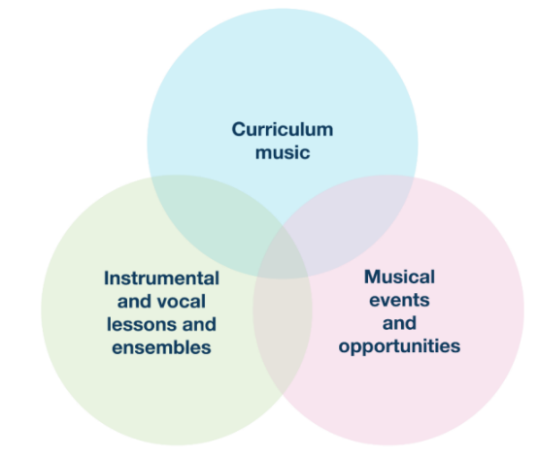
Mid-Autumn Term Updates for PRIMARY PHASE Schools
The regular Music Hub Updates for schools will reflect the three inter-linked areas of provision as outlined on p.18 of the National Plan for Music Education (see graphic); and will be separated into bespoke updates for PRIMARY Phase; and SECONDARY Phase. This is the Primary Phase Update.

Primary Phase Music Headline Summary of Opportunities

Curriculum Music Support for School Staff
Date / Time | Event | Details | Booking Info
January – May 25 | NEW Music Essentials CPD Programme | See 3. below for details | Expression of Interest here
27.02.25, 4.30-5.30 | Online Network Meeting | Virtual | Sign up here
24.04.25, daytime | Championing Inclusive Musical Pathways | In-person (venue TBC) | Sign up here

Instrumental/vocal lessons and ensembles/choirs
Date / Time | Event | Details | Booking Info
10 weeks per term | TBMH Out of School Learning  (variety of learning opportunities, please share with families) | Choirs, Ensembles, Music Production, Saturday Music School | Sign up now
01.04.25, daytime | TBMH Strings Playing Day | Kensington Town Hall | Sign up now
02.04.25, daytime | TBMH Wind, Brass, Percussion Playing Day | Kensington Town Hall | Sign up now
03.04.25, daytime | TBMH Guitars Playing Day | Kensington Town Hall | Sign up now
16.06.25, daytime | TBMH Scholars Playing Day | St. John’s Smith Square | To follow

Musical events and opportunities
Date / Time | Event | Details | Booking Info
27.11.24 / 28.11.24 | Music for Youth Creative Project | Royal Albert Hall | Sign up now
09.12.24, 11.15-12 | Musical Mondays 2: Edward & Rachel | Online performance | Sign up now
10.12.24, daytime | Christmas Singing Festival: Day 1 | Kensington Town Hall | n/a
11.12.24, daytime | Christmas Singing Festival: Day 2 | Kensington Town Hall | n/a
12.12.24, daytime | Christmas Singing Festival: Day 3 | Kensington Town Hall | n/a
03.02.25, 11.15-12 | Musical Mondays 3: Borges Machado | Online performance | Sign up now
03.03.25. 11.15-12 | Musical Mondays 4: Mared Pugh-Evans | Online performance | Sign up now
19.03.25, 4,15-5.45 | Infant Voices Festival Inset | Lyric | Sign up now
09.07.25, 11.15-12 | Musical Mondays 5: Beat Technique | Online performance | Sign up now
30.06.25, daytime | Infant Voices Festival: Day 1 | Kensington Town Hall | See above
01.07.25, daytime | Infant Voices Festival: Day 2 | Kensington Town Hall | See above
07.07.25, 11.15-12 | Musical Mondays 6: Alex and Archie | Online performance | Sign up now

More events and opportunities will be added over the course of the year, and we will update all schools when more information is available. Please do share all opportunities with any colleagues as appropriate.
More detailed information can be found in the next section covering:
- Register for Playing Days in March
- Championing Inclusive Musical Pathways 24th April
- Music Essentials CPD for ‘New to Music Teaching’ School Staff
- Musical Senses 2025
- Musical Mondays
- 23rd October: A Successful Primary Phase Day
- After School Classes at the Lyric
- Virtual Music School
- WhatsApp Groups

- Register for Playing Days in March
Our Instrumental Playing Days (KS2-3) are massed playing for early-stage musicians. They are all happening at Kensington Town Hall and you can register now for the events HERE
- Tues 1st April 2025, Strings Playing Day, 9.30-2.30
- Weds 2nd April 2025, Wind, Brass, Percussion Playing Day, 9.30-2.30
- Thurs 3rd April 2025, Guitars Playing Day, 9.30-2.30

- Championing Inclusive Musical Pathways 24th April
We will be starting the summer term in 2025 with a focused of training for TBJH Tutors and our School Curriculum Leaders. The exact programme will be confirmed in the New Year but we encourage school curriculum leaders to register now and request release from their SLT.

- Music Essentials CPD Programme for New to Music Teaching Staff – FREE
We are responding to schools who are asking for basic training and development for school staff (TAs and Class Teachers) who wish to teach curriculum music but require some training in order to feel more confident about delivering musical activities. Please forward the link below to school staff who would like to take part in a new series of professional development sessions – in person and online – to support them in delivering music. The training will be available from January 2025 and is likely to be in the form of afternoon INSET sessions lasting no more than 2 hours. This pilot is FREE to schools apart from needing to cover staff release to attend.
Register here: Music Essentials CPD Request Form

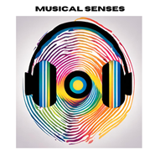
- Musical Senses 2025
Following the conclusion of the 2023-24 Musical Senses programme, we are pleased to share the finalised 4-page report that summarises the context, impact, legacy, barriers, testimonial quotes, and budget – click HERE. All information about the programme can be found on our updated webpage HERE. These film links show the impact of the work:
- Main Performance Film 2024 HERE (70 mins)
- Short Film about Musical Senses 2024 HERE (6 mins)
- Musical Senses Summary Film from 2023: short version HERE (3 mins)
- Musical Senses Summary Film from 2023: Long version HERE (5 mins)

Register for information about 2025
As a group of committed partner organisations, we will be continuing Musical Senses in 2025 and are currently in the planning stages. To help us ensure we are reaching the right young people and audiences, we are keen to develop a database of students/families who would like to be kept informed of future Musical Senses events and opportunities.

Therefore, if you would like to register for more information, we ask that this short form HERE is completed. We will then be in touch when we have new information to share about the 2025 programme.

- Musical Mondays: Primary and SEND
Working in partnership with Live Music Now, we were thrilled to offer all the Primary and SEND schools across the London West Music Hub, the chance to engage with the first of a series of 6 online concerts happening across the academic year. This is all FREE. Joined by Music Hubs from Essex and Nottinghamshire the concert on 14th Oct reached 4664 pupils watching the performance live. Anyone is able to rewatch the event – click HERE – but please note that the link to the first concert will disappear on 11 Nov.

Schools can register NOW for the upcoming December concert on 9th December, 11.15-12.00: Edward Robinson and Rachel Fright: Edward Robinson (baritone) and Rachel Fright (piano) perform a Christmas special with a programme including opera, musical theatre, folk songs and pop. Sign up here: https://zoom.us/webinar/register/WN_jjUpWGEGQIqurfLe87F8Bw

There are 4 other online concerts over the year that are targeted at all primary schools and SEND schools. This is provided free to every school by the London West Music Hub (LWMH). Concert dates:
- 14.10.24, 11.15-12.00, Musical Mondays 1: Blank Face (FINISHED)
- 09.12.24, 11.15-12.00, Musical Mondays 2: Edward & Rachel
- 03.02.25, 11.15-12.00, Musical Mondays 3: Borges Machado
- 03.03.25. 11.15-12.00, Musical Mondays 4: Mared Pugh-Evans
- 09.07.25, 11.15-12.00, Musical Mondays 5: Beat Technique
- 07.07.25, 11.15-12.00, Musical Mondays 6: Alex and Archie

After the concert has taken place, LMN will contact all schools that were registered with a link to the concert recording, which will be available for 28 days.

Please complete this very short form HERE to indicate if you would like to register your school to be a Musical Monday School.

- A Successful Primary Phase Day on 23rd Oct!
In partnership with the ENO, we were delighted to welcome over 70 colleagues from the seven local authorities representing the new London West Music Hub on 23rd October at our Primary CPD. There were a range of workshops led by some of the UK’s leading music education facilitators including Dr Ally Daubney, Aga Serugo-Lugo and some of the Tri-borough's new lead music school teachers. Sessions included singing, breathing, and composition workshops, school music development plans, curriculum development in practice, and teaching assistants in music.

Some feedback we received from the day:
- “Great workshops all round. Lots of activity ideas to take away and very hospitable staff at the ENO. Thanks for a great day!”
- “Super engaging useful activities, with teachers well-being in mind, delivered with great flare and professionalism”
- “Outstanding workshops that engaged participants, delivered by outstanding leaders and practitioners. Everything valuable to my practice.”

Photos from the day can be found in these social posts:
- Instagram HERE
- LinkedIn HERE
- BlueSky HERE
- Twitter/X HERE

- TBMH after school classes at the Lyric Theatre
There are many opportunities for students to access additional music learning opportunities outside of school. Please share this information with your families and students.

Applications are now open to join our ensembles, choirs and classes after school at the Lyric Theatre, Hammersmith. Remissions and sibling discounts available for all classes, more information here: https://www.triboroughmusichub.org/out-of-school-music-tuition-24-25/

Ensembles:
Symphonic Band - is an advanced ensemble for all instrumentalists who are playing at a minimum of Grade 5 level up to Grade 8 and beyond. The aim of this ensemble is to challenge pupils to develop the most intricate skills of playing in an ensemble.

Breakout Band - explores different genres of fun repertoire for all instrumentalists working as a continuer (knows 5 notes on their instrument) to instrumentalists working towards their Grade 5 exam. Pupils will be encouraged to develop ensemble skills such as balance, tuning and style through fun and accessible repertoire.

Large Group Guitar Class – is a group class for beginner and continuer students learning acoustic guitar.

Beginners Keyboard Class – is for pupils who are complete beginners. Pupils can expect to learn how to play simple pieces in a fun and supportive environment with a focus on learning the basics of technique, rhythm, and musical notation.

Continuers Keyboard Class - is for pupils who have been learning for a year. Pupils can expect to learn how to play simple pieces in a fun and supportive environment with a focus on learning the basics of technique, rhythm, and musical notation.

Choirs:
Next Level Voices – This secondary aged choir will learn a range of repertoire from contemporary to classical in largely three-part harmony, with tuition on music reading and sight singing included in the sessions.

Junior Voices – This choirs for years 3-6 will learn to sing in unison and in harmony, having fun singing together while learning a wide range of songs from folk to musical theatre to pop.

First Voices - Together you’ll learn a wide range of fun songs, rounds and musical games, and by the end of the term you will have increased confidence when singing and have developed your musical skills.

Classes:
Music Production using GarageBand – The main objective of this course is to learn how to confidently and efficiently use GarageBand for the IMac to create beats and compositions, and how to mix and balance the different instrumental elements into a final product.

Music Production using Logic Pro – The main objective of this course is to learn how to confidently and efficiently use Logic Pro X to create beats and compositions, and how to mix and master compositions into a final product.

- TBMH Virtual Music School – click this link
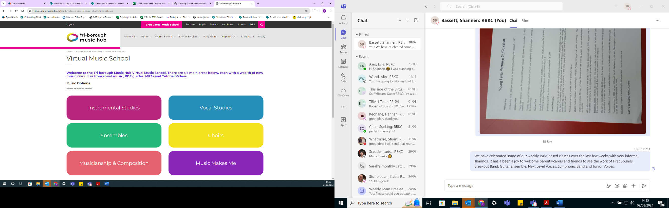
Originally set up for any child wanting access to free instrumental and vocal resources during lockdown, the Virtual Music School (VMS) is organised into 6 main areas. It has a wealth of free resources for students and facilitators. Whether you’re looking for ready-made worksheets for musicianship classes or a video with step-by-step instructions on how to put your instrument together – our VMS has it all. There are no schemes of work for curriculum or whole class learning, but the VMS does hold songs and music that could compliment your lesson plan.

- School WhatsApp groups
Here are the links to the WhatsApp groups for anyone teaching Music wanting to join.
- Primary: https://chat.whatsapp.com/FDVbTSl29Bl736p8bGpgQa
- SEND: https://chat.whatsapp.com/JKB9kQHA69mJDW6kyjNcpC

Please send any updated contact details for your music lead to musichub@rbkc.gov.uk.

Music Hub Contacts
- Sue Ling Chan, Schools’ Administrator, sueling.chan@rbkc.gov.uk
- Shannen Bassett, Senior Administrator, shannen.bassett@rbkc.gov.uk
- Rory Wilson, Saturday Music School Administrator Rory.Wilson@rbkc.gov.uk
- Hannah Keohane, Senior Service Lead, Instrumental Lead, hannah.keohane@rbkc.gov.uk
- Katie Stuffelbeam, SMS Manager & Fundraising Lead, katie.stuffelbeam@rbkc.gov.uk
- Evie Asio, Vocal Lead, evie.asio@rbkc.gov.uk
- Emily Stratford, SEND Strategic Lead Consultant, emily.stratford@triboroughmusichub.org
- Alex Wood, Business Manager, alex.wood@rbkc.gov.uk
- Louisa Roberts, Schools and Curriculum Leader louisa.roberts@rbkc.gov.uk
- Head, Stuart Whatmore stuart.whatmore@rbkc.gov.uk

Please contact the Music Hub with any questions or for more information; or to provide any feedback – good, bad, or otherwise – musichub@rbkc.gov.uk.

