**Musical Senses: Report July 2023**

Our ***Musical Senses*** programme – focused on young people who are blind/have a vision impairment, a multi-sensory impairment, or who are deaf/hard of hearing – was delivered across January 2022 to July 2023. The programme supported 15 students with bursaries, delivered training for the workforce, and culminated in a creative event at the Royal College of Music for 20 students.

Musical Boroughs Trust, registered charity no. 1183585, (working name *Tri-borough Music Trust - TBMT*) is committed to positive change and in supporting children and young people from all backgrounds to better access musical activity. Working in partnership with other organisations – Royal College of Music, ABRSM, and project-lead Tri-borough Music Hub – we have developed a specific focus on making what we do accessible to young people who receive sensory support.

Our Musical Senses programme covered 3 main areas:

1. Training and professional development for teachers
2. Working with and engaging positive role models into the roles of music leaders
3. Supporting this cohort of pupils with specific sensory needs to physically come to engage with high-quality musical activity

**Event information**

***Musical Senses*** Creative Workshops took place on Wednesday 12th July 2023 at the Royal College of Music, London from 9.45am – 4.15pm.

The event at the RCM on 12th July reflected the 3 points listed above, but the primary reason was to give young musicians an inspiring, engaging, and high-quality musical experience which included creative workshops and performance.

We aimed that all participants came to work collaboratively and creatively in an interactive music workshop where all the musicians – young people and professionals – are either vision impaired or hearing impaired.

All young people were accompanied by our fully trained staff and teachers throughout the day and parents/carers gave consent for their young person to take part. At the end of the day there was an informal sharing with parents and carers attending.

**Impacts and Outcomes**

Young musicians were represented from all three of our boroughs: Westminster, Kensington & Chelsea and Hammersmith & Fulham.

Planned outcomes of the programme achieved included:

* positively engaging pupils who need and receive sensory support
* providing progressive and engaging musical learning for pupils with sensory impairments that raised the bar for their personal achievements
* delivering inclusive weekly ensembles and choirs resulting in regular performances showcasing pupils’ engagement and skills
* making musical activity more accessible, inclusive and engaging so enabling meaningful participate for all
* providing financial support for families of pupils with sensory impairment to access the activity
* increasing the numbers of pupils participating in musical activity who have a sensory and/or other impairment
* raising organisational knowledge of deafness, vision impairment and multi-sensory impairment and the changes that we need to make to become more inclusive organisations
* providing employed opportunities for professional musicians who are deaf / hard of hearing or blind / have a vision impairment
* increasing the knowledge and understanding of the needs of these groups within the workforce

In summary Musical Senses programme helped young people by providing pupil bursaries for weekly ensembles and choirs, mentoring, bespoke resources, specialist teacher CPD, and access support over an extended period spanning 2 academic years from September 2021.

The culmination of the project took place at the Royal College of Music workshops and performance on 12th July this year with over 20 children and young people from 7 to 17 years old, some who have profound and complex needs.

**Legacy**

We aim to continue providing 8 bursaries with support for pupils with sensory differences into the next school year (from September 2023), and longer-term conditional on obtaining further funds in future.

**Testimonials/quotes from participants, parents/carers, and workshop leaders**

*“The workshop was an invaluable experience because it gave me the opportunity to socialise with other VI people who I do not normally come across in my mainstream school. I participate in many choirs and music classes and I am used to reading between the lines to interpret sighted information which teachers forget to disclose audibly. But it was so refreshing and enjoyable working in an environment where a VI and HI way of thinking was always front of mind and we could explore ways to work together.”* **Year 12 Participant who is blind**

*“Lily had an absolute ball with everyone at the Musical Senses event! We can’t thank you enough. She said when we picked her up at the end - “I realise I love workshops!” She learnt so much and was so happy to be playing with other musicians and learning about their instruments too. The gamelan workshop was wonderful she said. The day was a real treat for her.”* **Parent of participant**

*“Very many thanks for inviting me to co-lead yesterday’s workshop at the RCM. A hugely positive day, thanks to all the facilitators, and of course, the students. Particular thanks should go to the fantastic musicians from the RCM who showed us their instruments. They were totally professional, really open to hands-on and questions, and got involved with the afternoon workshops with real engagement and openness. Just so great to work with, the music profession is lucky to have them, whatever they go on to do! Tri-borough Music Hub is doing fabulous work in the field of access for students with a sensory impairment and it would be wonderful to see such work across other hubs, if it isn’t already happening.”* **Workshop Leader**

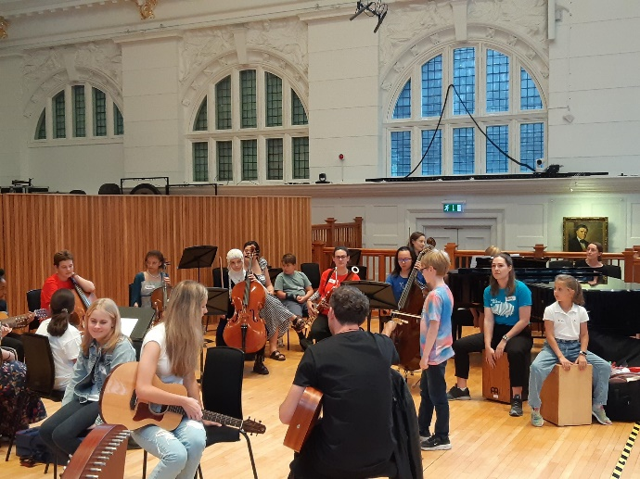 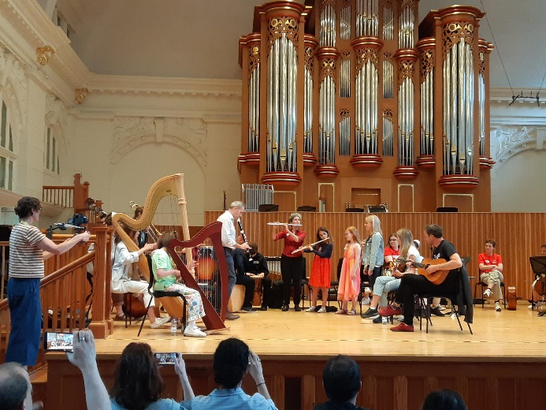

**Thank you to all the funders for their generous support – our programme would not have been possible without your help! If you would like to support us in the future, please contact Stuart Whatmore, Head TBMH,** [**stuart.whatmore@rbkc.gov.uk**](mailto:stuart.whatmore@rbkc.gov.uk)**.**

**APPENDIX**

**MUSICAL SENSES PROJECT SPEND 2022-23 (activity ran from 01/22 to 07/23)**

|  |  |
| --- | --- |
| **Training and development, strategic development** | |
| * CPD for workforce, organisations teachers and student mentors | £1,900 |
| **Employing specialist musicians to deliver programmes** | |
| * engaging 4 musicians who are deaf/hard of hearing or blind/visually impaired, to support weekly ensembles & choirs plus Saturday Music School | £6,000 |
| * professional musicians to perform and/or support rehearsals/sessions | £2,040 |
| **Supporting pupils/families to engage in activity and resources** | |
| * bursary support for 15 pupils per term, to attend a full Saturday Music School and/or weekday choir/ensemble | £7,500 |
| * student mentors from Royal College of Music within ensembles | £550 |
| * creation of bespoke resources and/or musical content, according to need | £1,000 |
| **Other costs** | |
| * supporting access (e.g. BSL Interpreters, one-to-one support, braille resources etc) | £3,500 |
| * extra costs for running event at RCM including travel, access, mentors, staff | £2,000 |
| * management costs allocated to TBMH to oversee the whole programme | £1,000 |
| TOTAL COSTS | **£25,490** |
|  | |
| Three Monkies Trust | £4,000 |
| The Casey Trust | £1,500 |
| St Giles and St George Trust | £3,000 |
| Birkdale Trust for Hearing Impaired Ltd | £2,500 |
| Scops Arts Trust | £7,990 |
| Lord Stevenson’s Charitable Trust | £2,500 |
| Musical Boroughs Trust (income from online donation appeals) | £2,000 |
| Tri-borough Music Hub | £2,000 |
| TOTAL RESOURCES SECURED | **£25,490** |

The Trustees of Musical Boroughs Trust, registered charity no. 1183585, [www.musicalboroughstrust.org.uk](http://www.musicalboroughstrust.org.uk)

*Musical Boroughs Trust, c/o Tri-Borough Music Hub, Lyric Hammersmith, London W6 0QL*

Stuart Whatmore, MBT Trustee (and Head of Tri-borough Music Hub): [stuart.whatmore@rbkc.gov.uk](mailto:stuart.whatmore@rbkc.gov.uk)