Summer Term Updates for Schools from the Music Hub
Headline summary of opportunities for all Subject Music Leaders to consider
(NB: more detailed info can be found later in this document):

Summer Term (April to July 2024)

Date / Time | Event | Audience | Venue | Booking link
Weds 8th May,  4.30-6.00pm | School Subject Music Leaders Network | Primary & Secondary phases | In-person, @ Marlborough Primary School | HERE
Tues 25th June, 9.30-2.00 | Infant Voices Festival  Musical Activity | KS1 | Kensington Town Hall | Registration closed
Tues 9th July | School Subject Music Leaders Network | Primary & Secondary phases | Larmenier & Sacred Heart Catholic Primary School | HERE

Advance Planning for 2024-25 academic year, key dates
To help with planning these dates may be helpful to add to your school dairies and seek permission to attend or be involved with.

CPD – Primary Phase and Secondary Phase focus days
Content is currently being developed and more details will be released soon. For now we ask that schools plan to release their music subject lead on either the Primary Phase or Secondary Phase day.
- Weds 23rd Oct 2024, daytime, at ENO Coliseum – Primary Music Leads Music Focus Day
- Fri 25th Oct 2024, daytime, venue tbc – Secondary Heads of Music Focus Day

Musical Activity 2024-25
- Christmas Festivals (KS2)
  - Inset: Weds 16th Oct (twilight)
  - Dress rehearsals: Tues 3rd and Weds 4th Dec @KTH
  - Event days: Tues 10th, Weds 11th, Thurs 12th Dec @KTH
- Instrumental Playing Days (KS2-3): all TBC Tues 1st, Weds 2nd, Thurs 3rd April 2025 @KTH
- Infant Voices Festival (KS1): Tues 1st July 2025 @KTH
- Future Sounds (KS3-5):
  - Prelims: TBC Thurs 30th Jan 2025
  - Event: TBC Weds 26th March 2025 @ Bush Hall

- This Is Not A Rehearsal – climate crisis via Music Mark

Earth Day 2024 marks the launch of Music Mark’s new campaign, This Is Not A Rehearsal!
This Is Not A Rehearsal is Music Mark’s newest campaign which aims to raise awareness and encourage action around the climate crisis within the music education sector, giving you the tools and knowledge to make climate-conscious changes that help protect our planet. We are at the start of our own sustainable journey, and we’d like you to join us!

Wondering why you should get involved? Our latest blog, An Introduction to the Climate Crisis, gives you the facts and explains why we need to take action now.

If you're interested in making sustainable changes, either individually or in your organisation, head to the This Is Not A Rehearsal webpage. This page is full of resources, blogs, training, events, and research to help you on your journey. You can also sign up to our new sustainability newsletter which will delve into a different sustainable topic each month.

We hope you'll join us on our journey and help make the music education sector a more sustainable place! Check out This Is Not A Rehearsal

- You don’t need to have an SLA with us to access our services!
This is a reminder that the Music Hub is here to support all schools and you don’t need to have an SLA with us to access our services. Click HERE to see the summary of what we offer. Therefore, please ask your Music Lead to contact musichub@rbkc.gov.uk to ensure we have their correct details.

To keep things straightforward for schools, we split our work with schools into two categories:
- Free services for every school. The free services are open to any state-maintained school and range from free groove'n'play whole-class teaching resources, access to the Virtual Music School, curriculum guidance documents, network meetings, performance events and wider partnership opportunities.
- Charged-for traded services. These include instrumental / vocal teaching in small groups and whole classes, ensembles, some CPD and performance events, and consultancy work
- Standard Rate £43 per hour: for individual, paired, small group teaching, or whole-class support teacher work.
- Lead Rate £45 per hour: for leading whole class instrumental teaching, curriculum, and/or ensemble leadership.
- Whole Day Music Teacher £300 per day: for Primary schools
- Half-day in Specialist Settings: £200: Up to 3.5 hours in a specialist/non-mainstream (e.g. Alternative Provision) setting for more bespoke work with specialist tutors
All details about the Traded Services can be found HERE in the Music Hub Schools Terms & Conditions 2024-25 document.

Registration for the 24-25 year has now closed, however, for any schools who would like to still make a booking please email us to indicate your current thinking so we can be aware of potential future contact. If you would have any questions about our free or traded services, or how to claim your free GnP programme, please email musichub@rbkc.gov.uk

All information about the 2024-25 academic year can be found HERE.

Timeline:
Registration for the 24-25 year has now closed, however, for any schools who would like to still make a booking please email us to indicate your current thinking so we can be aware of potential future contact. If you would have any questions about our free or traded services, or how to claim your free GnP programme, please email musichub@rbkc.gov.uk
- Music Hub Schools Summary 2024-25 (Word version HERE; PDF version HERE)
- Music Hub Schools Terms & Conditions 2024-25 (Word version HERE; PDF version HERE)
- Speed Admin Guide 24-25 (HERE)

- Claim your free Whole Class Instrumental Learning (KS1/2/3):

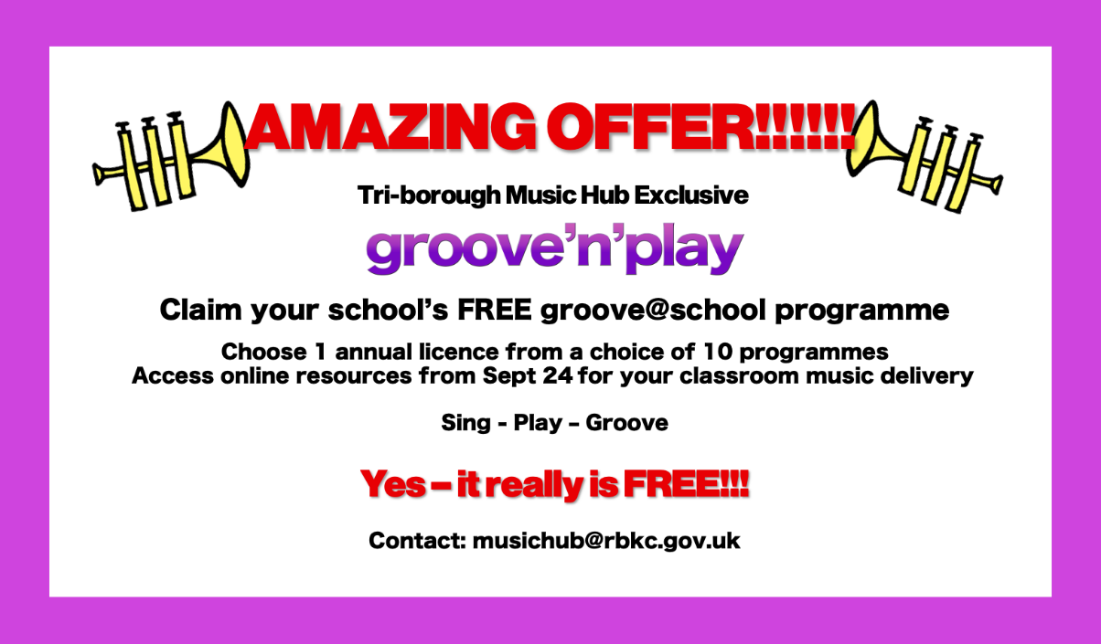

Composer Sally Greaves will be delivering G’n’P CPD in July on Zoom so if you have claimed your free licence for the 24-25 year, please check below when your CPD takes place and register your place. There is still time to claim your FREE lifetime licence for ONE G'n’P programme so please email musichub@rbkc.gov.uk if you are interested.
- MONDAY 8th JULY, 4:15-5:45pm, Rastamouse – Register HERE
- TUESDAY 9th JULY, 4:15-5:45pm, Ukuleles, Sticks, & Songs – Register HERE
- WEDNESDAY 10th JULY, 4:15-5:45pm, Recorders, Sticks, & Songs – Register HERE
- THURSDAY 11th JULY, 4:15-5:45pm, Fifths 1; and Fifths 2 – Register HERE
- FRIDAY 12th JULY, 4:15-5:45pm, Strings; and Fiddles, Sticks, & Songs – Register HERE

- School Subject Music Leader’s Networks
Focused on Primary and Secondary Teachers, please do encourage your music leader to attend:
- Weds 8th May, 4.30-6.00pm, in person @ Marlborough Primary School, book HERE. Focused on Maintaining Musical Pathways through progressive curriculums.
- Tues 9th July, 4.30-6.00pm, in person @ Larmenier & Sacred Heart Catholic School, book HERE. Focused on Curriculum Conversations - What Does Great Musical Learning Look Like?

- Ofsted Update on Music in Schools, 18th June, 4pm - 5pm
Join Ofsted's Christopher Stevens, HMI National Lead for Music as he returns to speak with Music Mark, this time reflecting on Ofsted's Subject Report in Music and 'teaching the curriculum'. During this session, Christopher will give a presentation, followed by time for your questions to be answered. Sign up here.

- Musical Senses – please promote to your students
Musical Senses (Hard of Hearing / Deaf; Partially Sighted / Blind): Year 6 to Year 13
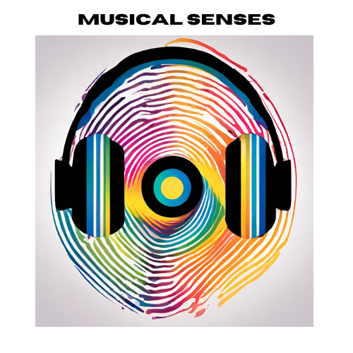
We have an exciting FREE opportunity for students in Year 6 to Year 13 who are Hard of Hearing / Deaf; Partially Sighted / Blind. Happening on Sunday 30^{th,} June, 7th July, and 14th July, these 3 consecutive Sundays of musical activity at the Royal College of Music will give young musicians an inspiring, engaging, and high-quality musical experience which includes creative collaboration, performance, and musical experiences.
- Secondary aged/phase students, aged 11-18, who play, sing, or compose music.
- 20 x Partially Sighted /Blind pupils / 20 x Hard of Hearing / Deaf pupils.
- Registrations close FRIDAY 30th April (More info HERE)
Please signpost this to suitable students so we can maximise this impact.

Films
All the films from last academic year’s programme have now been released and can be accessed using the links below. All films made by Claudia Lee, Videographer and Video Production Manager, ABRSM
- Musical Senses – overview film (long version, 4 mins), HERE
- Muscal Senses – overview film (short version, 2 mins), HERE

- ISM’s Breaking the Singing Barrier - ism.org/btsb
This is a free digital resource created in partnership with the charity Voices Foundation. It is aimed at helping teachers to understand and overcome the barriers to singing for children, young people and adults of all cultures and backgrounds. The resource will include webinars from leading voices in the music education sector and 20 bite-sized videos full of support from singing specialists and tips on topics such as:

- SEND barriers to singing
- Cultural barriers to singing
- Differing barriers between primary and secondary singing
- Psychological and personal barriers to singing

- #CanDoMusic
#CanDoMusic is a UK-wide project that aims to ensure all children and young people can access musical learning in school. The project was formed from a partnership between the Music Teacher's Association (MTA), The Independent Society of Musicians (ISM) and The UK Association for Music Education (Music Mark). It was created as a direct response to the Covid-19 pandemic which reduced the number of children and young people able to access music education in school.

#CanDoMusic has now evolved beyond its initial response by consolidating the best materials from the three organisations, making the #CanDoMusic website the go-to place for educators seeking a wealth of blogs and resources to enhance their classroom teaching.

Make sure to check out the #CanDoMusic website to discover resources, guidance and support to enhance your delivery of music education.

- Lead Schools update
Following the launch of our new Leads Schools programme (information HERE) we are now starting the process of visiting the Primary schools that have put themselves forward. More details will be released in the summer term. Secondary Schools are still to be identified.

- School Music Development Plan – have you got yours?
Every school should be able to articulate their plan for delivering high-quality music education and supporting pupils to progress, just as they would in any other curriculum subject. The new National Plan for Music Education (NPME) states that every school (including multi-academy trusts) should have a Music Development Plan that captures the curricular and co-curricular offer and sets out how it will be staffed and funded.

Whilst acknowledging that it is not a statutory requirement, the new NPME recommends that schools should have a music development plan in place by Sept 2024 at the latest. This TBMH document HERE might help all schools with planning for how they begin writing their school music development plan. Music Mark has developed template documents to help Primary Schools prepare their School Music Development Plan. Even if you have to follow a Trust or school format, we hope that this will prompt wider thinking. Versions for SEND Schools and Secondary Schools are in progress and will be published shortly. Find out more.

- DfE Annual Data Collection of school Music Delivery
Advance notice about changes to this year’s DfE annual data collection. In addition to the standard questions about each school’s music provision, there are new questions, summarised below:
- What stage of development is your establishment's School Music Development Plan?
Select one of the following:

  - Established
  - In Development
  - Development Pending
  - No intent
  - Not known

- How embedded is the Model Music Curriculum (or equivalent) in this establishment?
Select one of the following:

  - Established
  - Partially Established
  - In Development
  - No Intent
  - Not Known

The annual data collection will happen this summer term. More details to follow.

- Ensuring the Future of Music Education
Music Mark have announced the development of six calls to action which will be presented to all political parties ahead of the UK election this year. The purpose of the six calls to action is to make the case to any new UK government that it should understand the value of music education and appreciate the positive impact music can have on health, wellbeing, academic achievement, and soft skills. They have also put together a concise document that can be used as a resource for those who are advocating for music education and those who can talk to their MPs, local councillors and other key decision makers. Read more.

- Nominating Pupils for Bursary Schemes
London Music Fund applications are due 24th May. Please see attached documents and send any pupil nominations and applications to katie.stuffelbeam@rbkc.gov.uk by 3rd May. We will then send the nominations through to LMF by 24th May.

- Photos and Films from Musical Events
Performances with young people are a key aspect of our work. Below is a summary of photos and films from some of the events so far this academic year.

Event | Photos | Film(s)
Windrush, 8th Oct 2023  Celebration of the legacy of Windrush through music, collaboration, and community, featuring, Etienne Charles, Carnival Village Trust, City of London Sinfonia, Revere Arts, Tri-borough Symphonic Band, Justin Fung, and the UK All Steel Pan Orchestra. | - https://flic.kr/s/aHBqjAXUSB
Christmas Festivals December 2023  The Tri-borough Music Hub, in partnership with the Royal College of Music, with music from composer Sally Greaves, showcasing the extraordinary talents of local primary school singers across three separate events. | - Photos Day 1: https://flic.kr/s/aHBqjB7EGM  - Photos Day 2: https://flic.kr/s/aHBqjB7KkW  - Photos Day 3: https://flic.kr/s/aHBqjB7Gt1 | - Christmas Festival Vox Pops: https://vimeo.com/896566508  - Video Day 1: https://vimeo.com/907032230  - Video Day 2: https://vimeo.com/907033335  - Video Day 3: https://vimeo.com/907033936  - Santa Shuffle (SEND Schools): https://vimeo.com/908181698
Playing Days 2024  These are opportunity to bring together hundreds of pupils from multiple schools to play in a massed instrumental ensemble. | - Strings Day: https://flic.kr/s/aHBqjBmSQ5  - Wind/Brass/Percussion Day:  https://flic.kr/s/aHBqjBmSXV  - Guitar Day:  https://flic.kr/s/aHBqjBmUP7
Future Sounds 2024  Each year we jointly present Future Sounds with The Rhythm Studio – a Battle of the Bands style competition – that celebrates the best local young contemporary music talent across our three boroughs (Hammersmith & Fulham; Kensington & Chelsea; Westminster). Industry judges give feedback and advice to the 7 finalists | - All Photos can be found HERE | All films can be found in this Showcase HERE with some highlighted films below:  - This short video HERE provides Vox Pops (about Future Sounds).  - Winners:  - Genesis Brown, HERE, Star Performer  - Meg Banister, HERE, Overall Winner  - Elena (from The Crosswalks), HERE, Outstanding Vocalist
Weekday Sharings Spring 2024  Every week we run 12 separate after-school classes at the Lyric. End of term sharings happen for the groups. | - https://flic.kr/s/aHBqjBiPNW
Senior Ensembles Showcase @RCM March 2024  On Thursday 28th March, we celebrated our SMS Chamber Choir, Next Level Voices, SMS Orchestra, Symphonic Band, and piano student Laurence Mossner in an evening of performances at the RCM. This was a showcase supported by and in collaboration with the RCM, St Pauls Girls’ School, Royal Albert Hall, ABRSM, TBMH tutors, and James Brady Music. | - Photos on Flickr HERE | - Film on Vimeo HERE

- The why Music Festival (25-27 June) – Nate Holder
The Why Music Festival (HERE) is a free and enriching online experience aimed at fostering engagement and learning among primary and secondary school children. This festival creates a unique opportunity for young learners to broaden their horizons with book readings, and interviews with a diverse range of international musicians and educators including bassoonist and broadcaster Linton Stephens, City of London Sinfonia CEO Rowan Rutter, and multi award-winning composer and saxophonist Cassie Kinoshi. Teachers can dip in and out of the book readings and interviews, and recordings of the sessions will be available for up to 7 days after the event. Click this link to sign up for your free tickets.

- Create Day with Royal Opera House on 2nd July
The ROH are looking for Westminster Primary schools to join them on 2nd July for a free day of singing, dancing, and design, celebrating the UN Convention of the Rights of the Child in collaboration with UNICEF. KS2 classes across England will come together virtually, working towards a mass performance with dancers and singers from the Royal Ballet and Royal Opera Companies. To find out more, click HERE

- Wigmore Hall Schools Concert
The next upcoming concert, Schools Concert: Sing a Story, at Wigmore Hall is on Wednesday 22nd May, 11-12pm for KS2 pupils. Click HERE for further information, and HERE for forthcoming concerts. Resource packs are provided with ideas for teachers to plan classroom activities, building on the concert experience so pupils can explore different dimensions of music. For any enquiries, please email Isla Collins at ISLAC@WIGMORE-HALL.ORG.UK.
- Royal Academy of Music:
St Mark’s Sundays (Brass)
Any 13-17 year old Brass players working at ABRSM/Trinity Guildhall Grade 5 or above can join professional musicians from the RAM in a series of FREE projects at St Mark’s Church, Old Marylebone Rd, NW1 5BJ. The dates are all Sundays on 5th May, 2nd Jun, and 7th July, 10:30-13:30. This is a chance to play with other young musicians who are interested in developing their musical experience and skills, and to receive guidance in areas such as effective practice, health & wellbeing, and career options for professional musicians. Deadline is 30th April 10pm, and please email participation@ram.ac.uk to apply.

Springboard – To Grade 5 Theory and Beyond
This is a FREE opportunity for 11-14 year olds working at a strong Grade 3-4 standard with the intention of taking ABRSM Grade 5 Theory 2024-25. Taking place 27th – 31st August 9am-5pm at the RAM, Marylebone Rd, NW1 5HT. Spaces are limited to so email participation@ram.ac.uk to apply early with applicant’s name, age, instrument, grade, and school.

- Opera Holland Park Audio Description & Touch Tours
Anyone under the age of 18 who is VI are able to attend Discovery Matinees at Opera Holland Park for Tosca on 9th June, The Barber of Seville on 16th June, or The Yeomen of the Guard on 10th August, all at 2pm. Patrons are also able to attend Touch Tours one hour before the performance where they can touch scenery, props, and costumes on stage. Click the link HERE to book tickets, available for one adult and up to three children. Any VI patrons over 18 can attend at a discounted rate of £12.50 by using the code ALT24OHP but this offer is only available for the first 50 tickets purchased with the code. Link HERE.

Music Hub Contacts
Sue Ling Chan, Schools’ Administrator, sueling.chan@rbkc.gov.uk
Shannen Bassett, Ensemble’s Administrator, shannen.bassett@rbkc.gov.uk
Hannah Keohane, Instrumental Lead, hannah.keohane@rbkc.gov.uk
Katie Stuffelbeam, SMS Manager & Fundraising Lead, katie.stuffelbeam@rbkc.gov.uk
Evie Asio-Okwalinga, Vocal Lead, evie.asio-okwalinga@rbkc.gov.uk
Emily Stratford, SEND Strategic Lead Consultant, emily.stratford@triboroughmusichub.org
Alex Wood, Business Manager, alex.wood@rbkc.gov.uk
Louisa Roberts, Schools and Curriculum Leader louisa.roberts@rbkc.gov.uk
Head, Stuart Whatmore stuart.whatmore@rbkc.gov.uk

Please contact the Music Hub with any questions or for more information; or to provide any feedback – good, bad, or otherwise – musichub@rbkc.gov.uk.

We hope this update has been useful. Please let us know if there is any further support - all contacts are on the last page. Don’t forget to tag us into any socials:
- X / Twitter: @TBMHMusic
- Instagram: triboroughmusichub
- Facebook: https://www.facebook.com/TriBoroughMusicHub

Working with Schools and settings

To ensure your school can access the full range of free support and opportunities provided by the Music Hub and its partners for your pupils and staff, we ask that this message is shared with Senior Leaders, Music Leaders, and Governors.

The Tri-borough Music Hub has strong links with the schools/settings across the three LAs and we are continuing our support to enhance and amplify how each school delivers their own music curriculum. We have a proven track record of providing high-quality, progressive, and inclusive music education which has a direct and positive impact on school communities. We can provide opportunities that will enhance your school – the majority of which are free, or heavily subsidised – for your pupils, teachers, and wider community.

At a time of such challenge that we all find ourselves in, we strongly advocate that all schools maintain close and strong links with the Music Hub. We understand the pressures you face and are here to work with you and for you. Together we can make music remain a strong curriculum and extra-curricular subject that brings added value to every school.
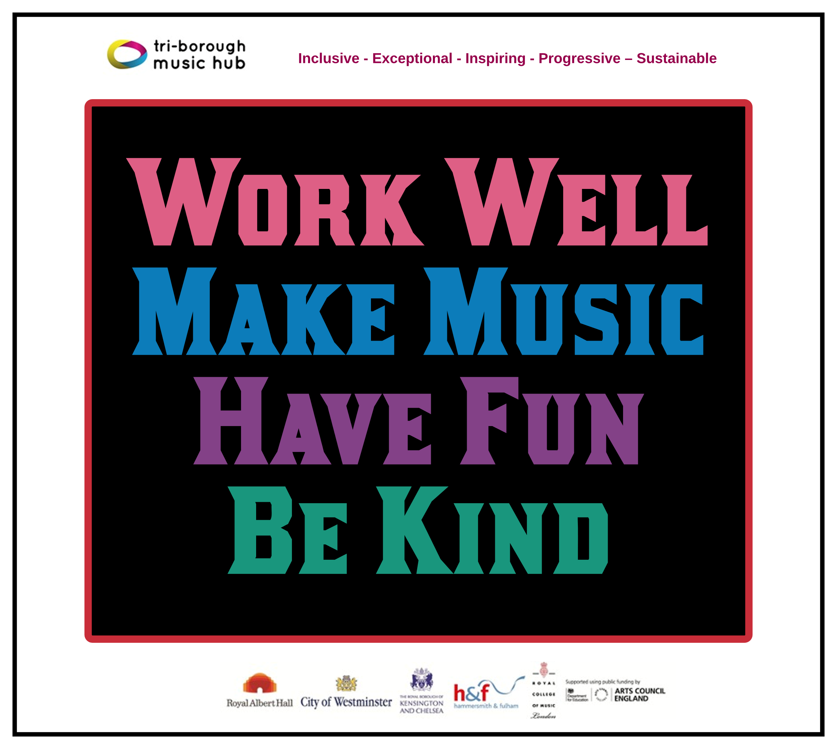
Due to the nature of the subject, music teachers can be some of the most isolated staff members in a school. The Music Hub is a community that brings together music teachers into a collective whole through network meetings, CPD programmes, and other opportunities. With this in mind, we ask that all schools actively connect with the Music Hub and encourage their music teacher(s) to engage in what we have to offer. We will also be able to help all schools navigate planning for the implementation of the new National Plan for Music Education. Please can the lead for music in each school directly contacts sueling.chan@rbkc.gov.uk (TBMH Schools’ Administrator) so we can update all contact records.

This update lists the support we provide and the opportunities that are open to all schools. We can assure all schools that we are only focused on providing high-quality music education support, guidance, and learning that actively helps schools with the delivery of outstanding music. We sincerely hope that all schools will engage with us in the 2024-25 academic year and that together we can forge ahead on the basis that together we are stronger.

Tri-borough Music Hub
Inclusive - Exceptional - Inspiring - Progressive – Sustainable

With thanks from the TBMH team

