Music Hub Traded Services for Schools, 2024-25 Academic Year
This document contains the Terms and Conditions for the traded services for schools for the 2024-25 academic year, provided by the Music Hub. To ensure a September start, all requests must be made by 28th March 2024, click on this link: Request Tuition. If you wish to discuss new Music Hub Service requests, please email MusicSLA@triboroughmusichub.org.

Music Hub Traded Services for Schools, 2024-25 Academic Year 1

Traded Services offered 2

1. Instrumental and Vocal tuition £43 per hour 2
2. Ensemble/Choir Leadership, or Enrichment £45 per hour 2
3. Whole Day Music Teacher for Primary schools, £300 per day 2
4. Whole Class Instrumental Learning (WCIL) programmes (Year 1 to Year 7) Buy in delivery from our tutors 3
Enhancing Whole Class Instrumental learning (WCIL) in your school 4
5. Buying a GnP groove@school Annual Programme Licence for in-house school delivery 4
6. Half-day in Specialist Settings: £200 for AM/PM up to (3½ hours) 4
7. Quality and Standards: Strategic advice on music provision in your school 5
8. Instrument Hire for schools 5
9. Professional Development 5
10. Performance Events 5
11. FREE Whole Class Instrumental Learning (WCIL) GnP licence 6
7
Tell me more about groovenplay 7
Tell me about groove@home 7
Terms and Conditions of the Music Hub Service Level Agreement 8
PARTIES 8
DURATION 8
INTENT 8
SERVICES OFFERED TO THE CLIENT 8
SPEEDADMIN (Management Information System) 8
COLLECTING DATA REQUIRED BY DFE 9
TRI-BOROUGH MUSIC HUB RESPONSIBILITIES 9
DELIVERING THE SERVICE 9
SCHOOL RESPONSIBILITIES 9
QUALITY AND REVIEW 10
CHANGE CONTROL 10
BILLING AND PAYMENT 10
CHARGING PRINCIPLES 11
RESOLVING DISAGREEMENTS 11
CONTACT DETAILS 11
APPENDIX A – SPEEDADMIN (MANAGEMENT INFORMATION SYSTEM) 12
APPENDIX B – STUDENT DATA 14

Traded Services offered
Summary of Charged Rates:
  - Standard Rate, £43ph: Instrumental / Vocal Individual, paired, small group teaching, or whole class support teacher.
  - Lead Rate, £45ph: Whole-class Instrumental Lead Teaching / Ensemble Leading In-school
N.B: The minimum time for a tutor to visit a school/setting is 1.5h.

Instrumental and Vocal tuition £43 per hour
Small group (up to 4 pupils), paired or one-to-one lessons depending on the needs of the school in 30-minute lesson slots:
- Lessons can be delivered in school by a tutor
- In school curriculum time, or in some cases after school
- Runs for 10 lessons per term (additional lessons available on request/subject to availability)
- Schools must provide adequate and appropriate teaching spaces
- It is at the discretion of each school if charges are passed to parents/carers, but please note that schools should consider PPG funding to support students.
Cost for independent schools is £51 per hour

Ensemble/Choir Leadership, or Enrichment £45 per hour
- Each separate ensemble must include an additional 30 minutes of paid non-contact time for the tutor to plan, set up and pack down.
- This applies to all provision where the tutor is working with five or more pupils. Includes Rock Band, String Ensemble, Singing Assembly, and Orchestra (other ensembles/choirs available on request).
- Runs for 10 lessons per term (additional lessons available on request/availability)
Cost for independent schools is £51 per hour

Whole Day Music Teacher for Primary schools, £300 per day
Cost: £300 per day costed at the Lead Rate so a saving of £15 / 5%; any additional hours at Lead tutor hourly rate of £45
Please note that this offer is subject to detailed agreement of a bespoke programme for the school, in advance. The school must provide a clear framework for the curriculum vision which the TBMH tutor/team will support. In some circumstances more than one tutor may fulfil this whole-day offer. Instrument hire is additional – please see point number 8.

Buy-in a music tutor from the Tri-borough Music Hub to deliver a bespoke package of school music. Where possible, the tutor(s) deployed will hold QTS, but this is not guaranteed.
- The teacher is in school for seven hours
  - Six hours of contact time*
  - 30 mins scheduled non-contact time (to include set up, pack down)
  - 30 mins PPA time (this may happen in school or off premises depending on arrangement)
  - Must include a total of one hour of breaks with 45 min minimum lunch (at no cost to school)
- Start and end times to be determined between school/tutor
- Runs for 10 lessons per term (additional lessons available on request subject to availability)

Schools may wish to pay an additional agreed amount of time per term (e.g. 3.5 hours) for the TBMH tutor to undertake additional above-and-beyond duties that the school may request, such as writing reports, assisting with formal assessments, creating bespoke school resources (SoW etc). This would need to be agreed at the start of each term with clarity of expectations.

*Contact time is tailored to school requirements and can include:
- Whole Class curriculum lessons
- Whole Class Instrumental Learning. N.B. Resources licences for our Groove‘n’Play and Rastamouse series are included when using our tutors
- Ensemble tuition and 1:1/paired/small group lessons (dependent on tutor skills/experience)
- Choir and/or singing assemblies
Cost to Independent Schools: £350 per day, £51 for additional hours.

Whole Class Instrumental Learning (WCIL) programmes (Year 1 to Year 7), Buy in delivery from our tutors

Cost: All costs are calculated at the tutor hourly rates of:
- Lead Teacher - £45ph plus additional 30 mins (15 mins PPA, and 15 mins set up/pack down)
- Support Teacher - £43ph additional 15 mins (set up/pack down)

Note:
All whole class teaching involves additional paid time for PPA + Instrument set-up/pack down:
- Lead teacher: 30 mins per week:
  - 15 mins per week for PPA, and
  - 15 mins set up/pack down
- 15 mins per week instrument maintenance and set-up/pack-down for the Support Tutor.
The additional paid set up/pack down time only applies once if teaching two (or more) of the same classes back-to-back. However, if there is a change of teaching resources between two classes a second set up/pack down charge would be applied.

Buying in TBMH tutors - indicative cost per ten-week term, per class
- 45 mins contact time:
  - £562.50 per ten-week term, per class – 1x tutor
    - Lead Tutor: 45 mins contact, plus 30 mins PPA/instrument set-up & pack down @£45ph
  - £992.50 per ten-week term, per class – 2x tutor
    - Lead Tutor: 45 mins contact, plus 30 mins PPA/instrument set-up & pack down @£45ph
    - Support Tutor: 45 mins contact, plus 15 mins PPA/instrument set-up & pack down @£43ph

- 60 mins contact time:
  - £675 per ten-week term, per class – 1x tutor
    - Lead Tutor: 60 mins contact, plus 30 mins PPA/instrument set-up & pack down @£45ph
  - £1,212.50 per ten-week term, per class – 2x tutor
    - Lead Tutor: 60 mins contact, plus 30 mins PPA/instrument set-up & pack down @£45ph
    - Support Tutor: 60 mins contact, plus 15 mins PPA/instrument set-up & pack down @£43ph

- Resource licence is free when buying in TBMH tutors for duration of SLA

WCIL Programme Delivery Options
- Programmes run 10 weeks per term in school curriculum time
- can be delivered in three different ways
  - by two TBMH tutors; or
  - by one TBMH tutor (working alongside a school-based adult); or
  - the resource licence can be purchased from the hub and delivered by the school.
- Some programmes need a minimum of two hub tutors, or school staff with the required instrumental skills.

Delivery model (and class length):
- 30 mins – suitable for KS1 only
- 45 mins – for KS1 or KS2
- 60 mins – for KS2 or KS3

Programmes
groove’n’play Programmes | Year Group | Delivery Focus | Minimum Tutors
Rastamouse (Rocksteady Reggae School) | 1/2 | Curriculum / Instrumental and voice | 1
Ukuleles, Sticks & Songs | 2/3 | Curriculum / Instrumental and voice | 1
Fiddles, Sticks & Songs | 2/3 | Curriculum / Instrumental and voice | 1
Recorders, Sticks & Songs | 3/4 | Curriculum / Instrumental and voice | 1
FIFTHS 1 | 4/5 | Curriculum/ multi-instrumental and voice | 1
FIFTHS 2 | 5/6 | Curriculum / multi-instrumental and voice | 1
Brass (mixed)* | 4/5/6/7 | Multi-instrumental | 2
Guitar and mini bass* | 4/5/6/7 | Multi-instrumental | 2
Strings (mixed)* | 4/5/6/7 | Multi-instrumental | 2
Woodwind (mixed)* | 4/5/6/7 | Multi-instrumental | 2

*Two tutors or staff members needed

Enhancing Whole Class Instrumental learning (WCIL) in your school
WCIL is most successful when the class or school-based music teacher plays an active part alongside our tutors to support the progression and development of the pupils. This also builds capacity for your staff. If a class teacher is not able to be involved in this learning, then another school-based adult (e.g. TA with the required instrumental skills) will be expected to actively participate in all learning alongside the pupils and assist with classroom management.
- The most appropriate programme for your school can be discussed with managers at the Hub.
- Encourage pupils to take their instruments home, where possible and appropriate.
- Internet access and classroom audio visual facilities are needed for all programmes.
- An appropriate teaching space is needed with room for pupils to play and handle instruments and where the sound will not disturb other pupils and staff. The teaching space set-up prior to a session is a school responsibility (i.e. TBMH tutors should not move hall/gym equipment). If multiple whole-class lessons are taking place within one day, considerations in this regard will need to be made when timetabling and using teaching space(s).
- A space where instruments can be safely stored between sessions if instruments are not going home with pupils.

Buying a GnP groove@school Annual Programme Licence for in-house school delivery
Schools can purchase an annual licence to deliver in-house. The cost of each licence is:
- School Single Programme Annual Licence £35
- School Multi-Programme Annual Licence £99
- CPD session via TBMH (highly recommended) £50
Note: There is no licence cost for schools buying-in Tri-borough Music Hub tutors to deliver the programmes. The licence expires at the end of the TBMH delivery period. If you choose to move to in-house delivery, a charge of £35 (Single Programme) or £99 (multi-programme) annual licence will need to be made.

Schools may also wish to purchase additional Groove@Home resources – more information HERE.

Half-day in Specialist Settings: £200 for AM/PM up to (3½ hours)
Up to 3.5 hours in a specialist/non-mainstream (e.g. Alternative Provision) setting for more bespoke work with specialist tutors that may be brough in to deliver curated commissioned programmes.
- Morning or Afternoon (up to 3.5 hours)
- The content may be a mixture of contact delivery as well as reviews, meetings, and reflections with practitioners in the setting
- This work may happen in Early Years settings, SEND schools, Alternative Provision settings, hospital schools etc
- The delivery may be by TBMH tutors or by other external consultants with expert specialisms.
Please note that this offer is subject to detailed agreement of a bespoke programme for the setting in advance.

Quality and Standards: Strategic advice on music provision in your school
Cost: Daily rate or pro rata, £400
Buy in the expertise of senior Tri-borough Music Hub staff (or associated consultants) to offer guidance on enhancing your music provision, e.g.
- Review of the quality and standards of school music curriculum and delivery;
- Support and advice on, or quality-assurance of, non-TBMH music provision;
- Deep Dive advice; or
- A bespoke package of support based on your school’s needs.
Cost to Independent Schools: £500 per day or pro rata

Instrument Hire for schools

The Tri-borough Music Hub has a stock of instruments that can be hired by state-maintained schools in the Tri-borough area. This heavily subsidised scheme is subject to availability, is not guaranteed. We only hire to Independent Schools in exceptional circumstances, with price negotiated based on request.

Cost | Class set (15-30 pupils) for WCIL programmes | Individual instruments for individual or small group lessons
When using TBMH tutors for delivery | £120 per class set per term | £20 per instrument per term
If not using TBMH tutors for delivery | £300 per class set per term | £30 per instrument per term

Professional Development

Some specific targeted CPD sessions may be charged for – details relating to each course will be published when events are programmed according to need and circumstance.
Independent Schools: may be able to engage with TBMH on a case-by-case basis depending on need. Some charges may apply depending on the specific training being delivered.

Performance Events

Throughout the year a range of Performance events will be programmed according to need and circumstance.
- Some are free to access to participate across all Key Stages (exact events to be determined), e.g. Infant Voices (KS1); Instrumental Playing Days (KS2/3); Future Sounds (KS3/4/5).
- Some events may involve a small participation charge (e.g. Christmas Festival (KS2) - £75 per school, plus optional support visit £50) – more details will be published when they are known.
Due to capacity, we are unable to invite independent schools to access the performance programme, unless through a specific strategic agreement.

- FREE Whole Class Instrumental Learning (WCIL) GnP licence
(for state-maintained schools)

Over many years, the TBMH has developed its own Whole Class Instrumental Learning (WCIL) resources through the commission of bespoke programmes from composer Sally Greaves. The groove‘n’play (https://www.groovenplay.com/) class ensemble series gives pupils the opportunity to develop their music skills, knowledge, language and understanding, as well as developing instrumental technique. See HERE for more information about GnP.

The TBMH will provide one Free Whole Class annual licence for ONE Groove’n’Play programme (to be delivered by the school) plus free CPD for one teacher (worth £85: £35 for the annual licence, and £50 for the CPD). The licence will be provided following attendance at CPD.
The programmes:
- are a progressive series of whole-class music learning resources for Years 1 to 7
- take a comprehensive approach to the initial stages of learning to play an instrument
- are the starting point of a long-term progression route and access to pathways beyond the programmes
- are online resources that include high-quality delivery content with a teachers’ eBook including session plans, teaching notes and learning outcomes
- are flexible resources that can be used according to the skill and experience of the person(s) delivering the programme.

Programme | Year Group | Delivery Focus | Minimum Tutors
Rastamouse | 1/2 | Curriculum / instrumental and voice | 1
Ukuleles, Sticks & Songs | 2/3 | Curriculum / instrumental and voice | 1
Fiddles, Sticks & Songs | 2/3 | Curriculum / instrumental and voice | 1
Recorders, Sticks & Songs | 3/4 | Curriculum / instrumental and voice | 1
FIFTHS 1 | 4/5 | Curriculum/ multi-instrumental and voice | 1
FIFTHS 2 | 5/6 | Curriculum / multi-instrumental and voice | 1
Brass (mixed)* | 4/5/6/7 | Multi-instrumental | 2
Guitar & Mini Bass* | 4/5/6/7 | Multi-instrumental | 2
Strings (mixed)* | 4/5/6/7 | Multi-instrumental | 2
Woodwind in C (mixed)* | 4/5/6/7 | Multi-instrumental | 2

N.B. Samples of each of these outstanding resources may be viewed at: groove'n'play programmes

* a minimum of two staff members with the required instrumental skills is required

To redeem your free GnP programme:

- Email musicsla@triboroughmusichub.org indicating which programme your school chooses

- Provide name of school, name and email of teacher user, and details of contact person that will be attending the training (if different to teacher user)

- Check that you have the requisite instrument resources to deliver the programme.
More details about this can be found here: https://www.triboroughmusichub.org/school-services/whole-class-instrumental-learning-programmes/

Tell me more about

groove‘n’play vocal and instrumental programmes, written and devised by Sally Greaves, provide a music curriculum that supports musical progression in line with the National Curriculum for Music.
.
New for 2024 - programmes are now available on the new groove@school e-learning platform.
Each programme includes:
- performance through playing and singing (sticks & songs, multi-instrumental programmes)
- reading and playing from notation with an understanding of the inter-related music dimensions (e.g. dynamics, tempo, structure)
- range of music styles, genres and traditions to increase knowledge and understanding of music
- extended listening and extension activities related to music and other curriculum areas

The high-quality curricular resources are intended to support the development of a child’s musical talents and skills as performer, creator, and listener. This is achieved through the scaffolded learning that groove ‘n’ play classroom programmes provide.

Children will be able to:​
- understand and demonstrate initial instrumental and playing technique
- sing in a range of musical styles both in unison and parts (sticks & songs, multi-instrumental programmes)
- respond to musical directions and notation linking sound and symbol
- perform as part of a whole-class ensemble

Children will also:​
- develop their ability to work effectively as part of a team
- build increased confidence and self-esteem through engagement in varied activities and performance
- gain experience in how to attain high standards of performance and an improved understanding of the process and the work that is necessary in order to achieve this
- through self-evaluation, analysis and increased musical understanding reach the attainable and challenging goals

groove‘n’play Annual Licences include:
- access to programme via GnP’s groove@school online digital platform
- teacher’s eBook with session plans, teaching notes, scheme of work and sheet music
- animated content for classroom delivery
- access to groove‘n’play planning and progression curriculum support materials

To see how groove’n’play relates to the National Curriculum, Music and The National Plan for Music Click here

Tell me about

groove@home provides additional resources to support a child’s learning beyond the groove‘n’play classroom in order to support individual independent practice. This will result in further raising music standards. It is recommended that groove@home be used by individual children as a follow up to work in the classroom

Annual licences for groove@home online include:
- access to easy to use online animated programme resources
- scaffolded imaginative and engaging learning tasks
- unlimited home access

Buying a groove@home Annual Licence
Schools can purchase an annual licence for £30 per programme – access for up to 100 pupils
N.B. Only available if your school has purchased a groove’n’play or groove@school licence, or TBMH tutors are delivering a GnP programme in your school.
For more information contact info@groovenplay.com

Terms & Conditions of the Music Hub Service Level Agreement

PARTIES
This Music Service Level Agreement (SLA) is made between the school (the Client) and the Tri-borough Music Hub (the service provider, TBMH). Both parties agree to act in good faith and in a reasonable and timely manner with regard to the operation of the Agreement.

DURATION
By signing to undertake this SLA with the TBMH, the school understands that tutors will be booked based on their requests, and must agree to honour the commitment. The TBMH provides a professional service for all involved – the school, the tutors who are booked to deliver the teaching, and the TBMH itself.

When the TBMH receives requests from school they will undertake timetabling of tutors, from which tutors are issued employment contracts. Schools must recognise that employment contracts must be adhered to and it is not possible to change the agreed teaching hours within a term. Any changes in provision can be made by the school by giving notice before the preceding half-term break, and these changes will come into effect at the start of the next term.

In the unlikely event the TBMH is unable to meet the SLA request with available tutors, they will engage in conversation with the school to find a resolution.

The duration of this SLA is effective for one academic year unless agreed otherwise between TBMH and school.

There will be 10 lessons taught per term, unless otherwise agreed in advance between the school, the Music Hub and the tutor.

Note: any additional teaching hours or weeks above the agreed service provision must be arranged in advance between schools and Tri-borough Music Hub Managers. Schools must not engage Hub tutors in private arrangements.

INTENT
The purpose of this arrangement is to provide schools with the opportunity to purchase additional high-quality instrumental/vocal tuition, support, training and/or advice on all aspects of music provision. The Tri-borough Music Hub will work collaboratively with schools to support the selection of instrumental tuition programmes that best meet the needs of the individual school.

SERVICES OFFERED TO THE CLIENT
- A full range of services offered to clients has been shown
- To ensure September start, all requests must be made by 28th March 2024. The programme of tuition selected will be agreed between the school and the service.
Note: Provision may be dependent on the availability of tutors with the appropriate lead or support skills necessary for the specific roles, and instrument stock.

SPEEDADMIN (Management Information System)
The TBMH uses a Management Information System, called Speed Admin, and this is how all services will be managed. There is a detailed guide as an Appendix in this document (HERE) that lists how schools access this and use their unique logon to manage all aspects of their SLA with us. The TBMH will ensure clarity of communication about all aspects of this new development.

COLLECTING DATA REQUIRED BY DFE
The TBMH is required by DfE to collect data on all students being taught in schools via the SLA. Information we require is:
- Pupil Premium
- Looked After Children
- SEND
- Ethnicity
- Gender
- Year Group
See Appendix B (HERE) for the full break down of information.

Schools should use SpeedAdmin to update pupil-level information throughout the year (e.g. information on SEND, EHCP, FSM etc) so that we can ensure the learners have the best experience.

TRI-BOROUGH MUSIC HUB RESPONSIBILITIES
The Tri-borough Music Hub shall:
- Ensure that all programmes will be planned and monitored.
- Ensure that the agreement between the school and the service provider with regard to the programme required is fully understood.
- Ensure that the school is kept fully informed of any changes or concerns that may arise in order that action can be taken as soon as possible. This is particularly important if it is perceived that additional support be needed.
- Provide the school with high quality instrumental tuition, support, advice and/or training through the provision of a well-trained, well-informed, and professional team.
- Commission additional services/providers if required to meet the needs of the school.
- Support rigorous self-evaluation and continuous improvement in each school.
- Promote high quality teaching and learning.
- Facilitate collaborative partnerships between schools which identify, build upon and disseminate excellent and effective practice.
- Ensure that all staff have satisfied the required safeguarding checks for work with children and young people.
- Ensure the school is notified, when a tutor is ill and unable to attend, by 9.30am on the named day.
DELIVERING THE SERVICE
The services will be delivered by Instrumental / Vocal Tutors from the Tri-borough Music Hub tutor pool, TBMH Lead Teachers or TBMH Provision Managers.
- The TBMH will attempt to provide cover when a tutor absence is known in advance (e.g. if they are self-isolating) but this cannot be guaranteed. The TBMH is not able to provide same-day cover / a deputising tutor in instances of last-minute illness.
- In most cases missed lessons can be made up by the usual tutor later in the same term, or the next term. In instances where this is not possible the school will only be billed for the lessons that took place.
- The TBMH will always strive to minimise impact on schools due to tutor illness / absence.

SCHOOL RESPONSIBILITIES
To enable the service provider to deliver a service of the highest quality, the Client shall:
- Ensure that the exact requirements of the service purchased are agreed in advance with the TBMH by at least the end of the term prior to the commencement of the provision.
- Agree all teaching dates in advance with the TBMH tutors – please refer to recommended TBMH teaching dates.
- Ensure that agreed dates are honoured, and that notification of essential cancellation is reported at least one week in advance via email to the TBMH and affected tutors. Schools will be charged for late cancellation (less than 7 calendar days).
- Ensure that SpeedAdmin is used to regularly update pupil-level information and to check accuracy of SLA arrangements. This will benefit both parties.
- Comply with any requests for information to enable the monitoring and evaluation of the service
- Ensure that the requirements of the tutor are met so that the service can be delivered effectively and efficiently. These requirements are listed below:
- a designated fixed school-adult (preferably a class teacher) with the required instrumental skills to be present at all times during delivery of whole class sessions and actively involved with the learning
- learning support assistants remain in the class during the session to support the music learning of their pupils
- a suitable room be provided for the delivery of the tuition, that is of adequate size for the activity, free from distraction and any obstacles, where it is appropriate to play music without disturbing other activities in school
- the room provided to be consistent every week, with prior notice of any room changes, and suitable alternatives provided if strictly necessary
- An interactive whiteboard (or computer linked to projector) and good quality sound system is needed for all programmes
- a suitable space be provided where instruments can be stored safely away from any risk of damage through heat, damp or obstruction. (NB: Schools will be expected to reimburse the cost of repairing or replacing loaned instruments or instrument parts that are either lost or damaged due to wilful neglect or poor handling by pupils, or inadequate storage arrangements.)
- follow-up tasks, as can be reasonably expected to be performed by the class teacher before the start of the next session, are completed on time to allow the smooth running of the next session. Some examples may be: labelling instruments; providing children’s name stickers; copying of written resources
- the school will undertake to meet the cost of replacement accessories (e.g. clarinet reeds, violin strings) incurred during the course of tuition
- the school will undertake to meet the cost of damage or repair to TBMH loan instruments caused by wilful neglect or inadequate storage arrangements during the period of the loan
- use of school Wi-Fi to access online teaching resources
- Respond as may reasonably be expected, to requests for the submission of data required for the purposes of monitoring and self-evaluation of the service, and for Arts Council returns for which continued central funding depends.
- Honour the agreement between the school and the Tri-borough Music Hub for the provision of tutors.
- Not inappropriately seek to employ the same TBMH tutors by private agreement to work directly for the school, within an 18-month period of the tutor(s) working in the school.

QUALITY AND REVIEW
Schools’ feedback is actively sought, and schools are encouraged to feedback directly to the Tri-borough Music Hub Leadership team.

CHANGE CONTROL
- This Service Level Agreement will be reviewed on an annual basis to ensure it remains appropriate for the service it provides and the requirements it places on the wider organisation.
- Further activities may be incorporated into the SLA as the needs of both parties develop, and the service has to adapt to accommodate changes in need, or to take on additional roles.

BILLING AND PAYMENT
- The school will be invoiced in advance on a termly basis.
- Invoices for additional services bought during the year, will be sent separately by the TBMH.
Any enquiries regarding school finance should be directed to the TBMH Business Manager, Alex Wood - alex.wood@rbkc.gov.uk

CHARGING PRINCIPLES
Please note that Tri-borough Music Hub charges cover all personal on-costs involved with recruitment of staff and reflect the specialist training, experience and skill of the tutors.

RESOLVING DISAGREEMENTS
Any concerns or complaints about the level or quality of the services should be made to:
- Hannah Keohane, Tri-borough Music Hub Instrumental Provision Lead
- Lyric Hammersmith, King Street, London, W6 0QL
- Tel: 07739315839 Email: hannah.keohane@rbkc.gov.uk

If the school wishes to, they can contact:
- Stuart Whatmore, Head, Tri-borough Music Hub
- Lyric Hammersmith, King Street, London, W6 0QL
- Tel: 07976060148 Email: stuart.whatmore@rbkc.gov.uk

Any concerns or complaints by school staff or children and young people about treatment by Tri-borough Music Hub staff should be made in the first instance to the TBMH Instrumental Provision Lead by a Senior member of School staff. If mutual confidence in the continuation of the SLA cannot be restored, either party may terminate it by giving three months’ notice (or have given notice by the half-term break).
CONTACT DETAILS
The Tri-borough Music Hub is based at the Lyric Theatre, Hammersmith and can be contacted at: musichub@rbkc.gov.uk

APPENDIX A – SPEEDADMIN (MANAGEMENT INFORMATION SYSTEM)

SpeedAdmin School Registration Guide
- If using SpeedAdmin for the first time, click ‘Forgotten Password’, enter your email address, and then create a new password. This will then give you access. If you have accessed SpeedAdmin before, please enter the same email and password that you used.
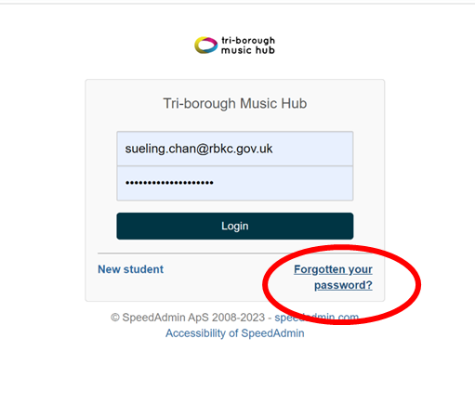
- When logged in, you will see your home page. Please click ‘School Year’ at the top to change it to ‘School year 24/25’:
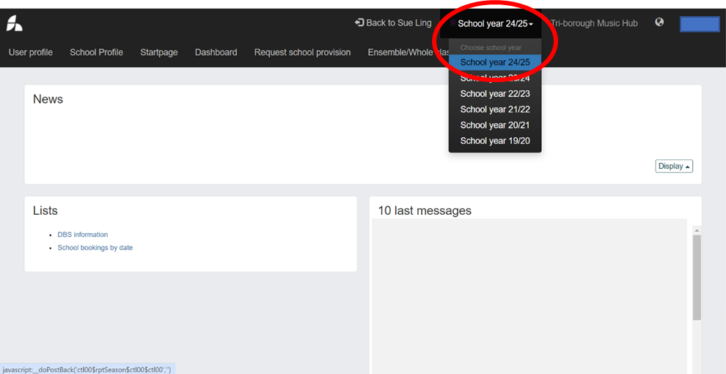

- Once ‘school year 24/25’ is selected, click on ‘Request school provision’ to book tuition:
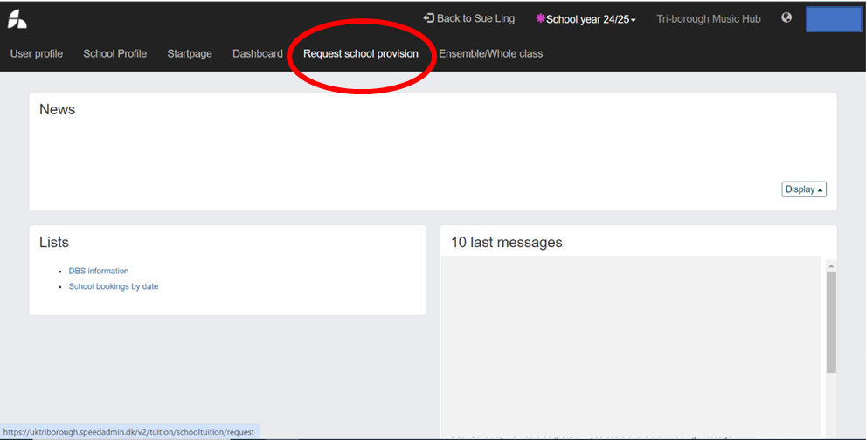

- You will then see all the provision available to request ranging from Curriculum, Whole Class, and Ensembles/Choir, Small group/Individual Tuition. To read in more detail about the provision you are interested in, click ‘SHOW MORE’. Click ‘Subject Area’ to view certain provision:
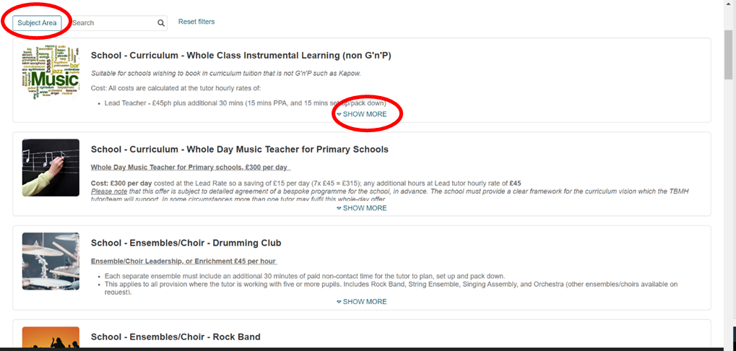

- Information on the clicked provision will appear. If interested in the provision, click ‘Request tuition’ and ensure it is for the 2024-25 academic year:
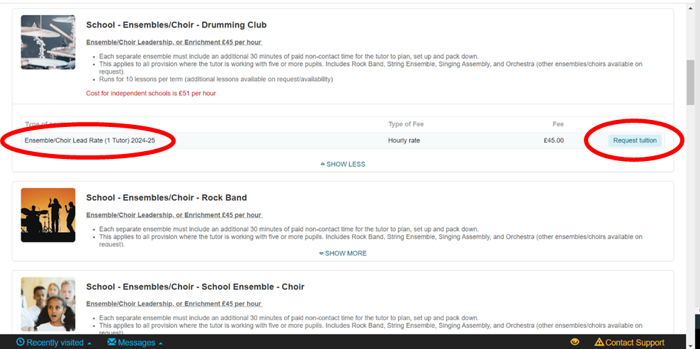

- This will then take you to the form as below. Ensure you fill in each field as accurately as possible and to summarise what you would like in the ‘Further Comment’ box at the bottom. Then click ‘Submit’ and your request will be sent to TBMH: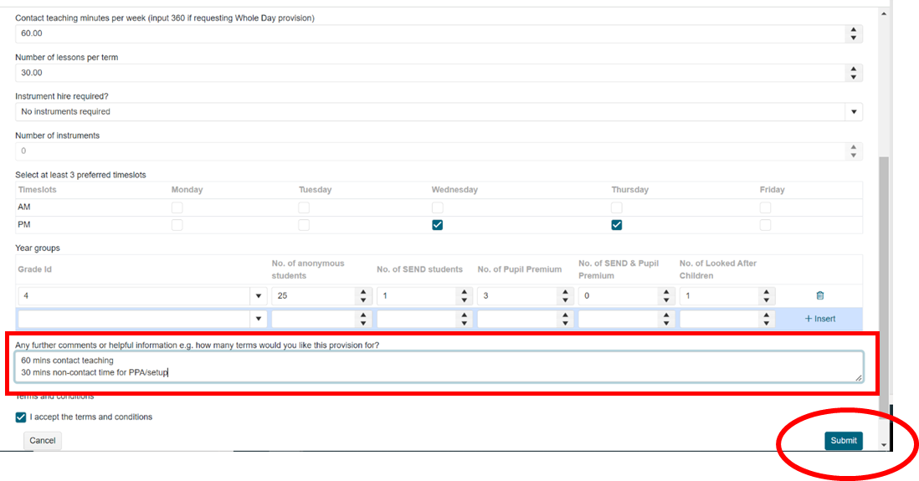
- TBMH will then receive your Request. If interested in booking another provision, follow from step 3 onwards again.

APPENDIX B – STUDENT DATA
Please complete the table below upon confirmation of your SLA. Data needs to be presented per provision so a column to the right of the table will need to be added.
School
Provision
Year group
Student numbers
Female
Male
Prefer Not To Say
Not Known
Pupils eligible for Pupil Premium
SEND
Pupil Premium AND SEND
Pupils with unknown SEND/Pupil Premium information
Pupils NOT eligible for Pupil Premium and NOT SEND
Looked After Children
White British
White Irish
Gypsy/Roma
Traveller of Irish Heritage
Any other White background
White & Black Caribbean
White & Black African
White & Asian
Any other Mixed background
Indian
Pakistani
Bangladeshi
Chinese
Any other Asian background
Black African
Black Caribbean
Any other Black background
Any other ethnic group
Prefer not to say
Not known

