Spring-Term Updates for Schools from the Music Hub

Headline summary of opportunities for all Subject Music Leaders to consider
(NB: more detailed info can be found later in this document):

Spring Term (January to March 2024)
Date / Time | Event | Audience | Venue | Booking link
Tues 16th Jan,  4.30-6.00pm | School Subject Music Leaders Network  NPME2 – How Are We Doing? Updates from the hub and a chance to share ideas. | Primary & Secondary phases combined | Online / Zoom | Register HERE to receive the Zoom link
Tues 30th Jan, 4.00-6.00pm | Future Sounds Prelims  Musical Activity | KS3-5 contemporary acts | Rhythm Studio | Register HERE by 26th Jan
Weds 13th Mar, 4.15-6.15pm | School Subject Music Leaders Network and combined Infant Voices Festival INSET | Primary & Secondary phases combined | In-person at Lyric | HERE
Weds 20th Mar, 7.00-9.30pm | Future Sounds Final  Musical Activity | KS3-5 contemporary acts | Bush Hall | Register HERE by 26th Jan
Mon 25th Mar, 9.30-3.00 | Strings Playing Day  Musical Activity | KS2-3  (Grades 1-4) | St. John’s Smith Square | Register HERE
Weds 27th Mar, 9.30-3.00 | Guitar Playing Day  Musical Activity | KS2-3  (Grades 1-4) | Kensington Town Hall | No places left
Weds 27th Mar, 9.30-3.00 | Wind, Brass & Percussion Playing Day  Musical Activity | KS2-3  (Grades 1-4) | Kensington Town Hall | Register HERE

Summer Term (April to July 2024)
Date / Time | Event | Audience | Venue | Booking link
Thurs 18th Apr  9.00 - 4.30 | Building Musical Pathways For All  CPD | All music educators | In-person at Lyric | Register for free HERE
Weds 8th May,  4.30-6.00pm | School Subject Music Leaders Network | Primary & Secondary phases combined | In-person, venue TBC | HERE
Tues 25th June, 9.30-2.00 | Infant Voices Festival  Musical Activity | KS1 | Kensington Town Hall | Register by Fri 28th Feb HERE
Tues 9th July | School Subject Music Leaders Network | Primary & Secondary phases combined | Larmenier & Sacred Heart Catholic Primary School | HERE

More CPD events will be added over the course of the year and we will update this page when more information is available

- CPD and Training Opportunities
Planning for the 2023-24 Academic year
All school music subject leaders are encouraged to attend the half-termly network meetings and other CPD events.

- Tuesday 16 January: Network meeting, online. The session titled, ‘How Are We Doing?’, is an opportunity for music leads in primary/secondary settings to share their ideas and progress in light of the National Plan for Music Education 2– The Power of Music to Change Lives. Places can be booked HERE.
- Wednesday 13th March: (at the Lyric) is the 2nd network meeting of the Spring term in two parts:
  - It is the INSET for the upcoming KS1 Infant Voices festival. To be involved in this performance event register by Fri 28th Feb HERE. This will be led by Evie.
  - We will also use it to network and share other updates/news. Depending on numbers we may split into two rooms. Use this link to book just for the network aspect HERE.
- Thurs 18th April: All-day Event – ‘Building Musical Pathways For All’ – Book HERE: Advance notice to book your place to kick-start the summer term for this event which has been designed for School Subject Music Teachers, TBMH Tutors, RCM Student Mentors, and Partners. It will run all day at the Lyric in Hammersmith and is FREE. We strongly encourage schools to release their teachers to attend, below is a summary (with full plan HERE).
- Session 1 – Preparing the whole body for musical learning (Beat Goes On)
- Session 2:
  - Option 1: Musical progression through Whole Class Instrumental Learning
  - Option 2: Designing a School Curriculum Map that includes all learners
- Session 3 – Groove’n’Play in action via Groove@School
- Session 4 – How the ISM supports freelance musicians
- Session 5 – Keynote: Reframing Neurodiversity, Michael Barton
https://www.michaelbarton.org.uk/about-me
- Session 6 – Inclusive communication pathways
  - Exploring communication pathways: Visuals/Vocalisations/Body language. This section will aim to equip teachers to support ALL learners with personalised communication strategies and build awareness of less well-known forms of communication signs from pupils with additional needs.
  - Singing and Signing- An introduction to basic signing including useful vocabulary for the music classroom, leading into signing lyrics.
- Session 7 – Signing in action: Performing ‘The Things We Do For Love’ by 10CC with the opportunity of song-writer Graham Gouldman joining us TBC
https://www.grahamgouldman.info/biography

- Reminder: Lead Schools for Music register by 15th Jan
A reminder that the lead school’s application deadline is fast approaching on Mon 15th January (the timeline may be flexible depending on response rate and school capacity, and we many adopt a phased approach to the recruitment). All details are below. Please direct any questions to Stuart Whatmore, Head TBMH stuart.whatmore@rbkc.gov.uk; or Louisa Roberts, School & Curriculum Music Lead louisa.roberts@rbkc.gov.uk.

Does your school:
- exemplify high-quality music provision and teaching?
- champion best practice music education in your LA area?
- show commitment to curriculum delivery with significant timetable time, co-curricular opportunities, inclusive provision, and teacher development?
- contribute to the development of a strategic approach to inclusion?
- advocate for music education and the work of the Music Hub to colleagues in other schools?

In accordance with the new DfE/ACE changes and the new National Plan for Music Education (NPME), from September 2024 Lead Schools for Music must be appointed in each Local Authority area.

We have now set out the criteria, role, and process for the selection of the Lead Schools/Settings within LBHF, RBKC, and WCC (there is also contextual information about the new Music Hub geographical areas coming into effect from September 2024).
- Read this Document (Word version) or this document (PDF version) to find out more information about the entire Lead Schools Programme.
- A summary of the key information can be found in this PDF Presentation.
- See our webpage HERE with all the information.

Timeline for Primary and Secondary Lead Schools:
- Launched to Schools/Settings in Nov 2023
- Submit online application by 5pm 15 January 2024 (HERE)
- Shortlisted schools and settings informed by 9 February 2024
- Shortlisted schools site visits and surveys by 28 March 2024
- Lead Schools/Settings informed and announced by 22 April 2024
- Contracting agreed and Lead Schools Initial meeting: week beginning 13 May
- Further meet ups to be agreed before end of term with CPD offerings TBC
NOTE: The entire timeline we have outlined may shift based on any changes or delays from DfE/ACE. We will communicate any changes with all schools/settings as and when these might happen.

- School Music Development Plan – have you got yours?
Every school should be able to articulate their plan for delivering high-quality music education and supporting pupils to progress, just as they would in any other curriculum subject. The new National Plan for Music Education (NPME) states that every school (including multi-academy trusts) should have a Music Development Plan that captures the curricular and co-curricular offer and sets out how it will be staffed and funded.

Whilst acknowledging that it is not a statutory requirement, the new NPME recommends that schools should have a music development plan in place by Sept 2024 at the latest. This TBMH document HERE might help all schools with planning for how they begin writing their school music development plan.

Music Mark has developed template documents to help Primary Schools prepare their School Music Development Plan. Even if you have to follow a Trust or school format, we hope that this will prompt wider thinking. Versions for SEND Schools and Secondary Schools are in progress and will be published shortly. Find out more.

- School Updates
Ofsted Music Report (September 2023)
The latest Ofsted subject report, looking at how music is being taught in England's schools, was released on 21st September. The report is HERE. The TBMH has produced a 2-page summary of the report which can be found HERE.

What does the Music Hub offer your school?
We offer a host of free opportunities, with specialist staff within the hub or with us bringing in external experts. To find out more about what the Music Hub can do to support your schools, see the document HERE.

Supporting holistic music teaching (curriculum and instrumental/vocal)

Read more about our Self-Reflection tool (click HERE) which supports a Teaching and Learning Review Process for quality assurance. It is focused on a teaching and learning matrix which follows the Tri-borough Music Hub’s interpretation of Ofsted guidance and music education best-practice. On request and via SLA, the TBMH can also quality assure schools’ own external provision.

Useful TBMH website pages to know about:
- Visit this page to access all TBMH’s free curriculum support documents.
- Visit this page to access all TBMH’s updates for schools about the 2023-24 academic year

- DfE Annual Data Collection of school Music Delivery
Advance notice about changes to this year’s DfE annual data collection. In addition to the standard questions about each school’s music provision, there are new questions, summarised below:
- What stage of development is your establishment's School Music Development Plan?
Select one of the following:
  - Established
  - In Development
  - Development Pending
  - No intent
  - Not known
- How embedded is the Model Music Curriculum (or equivalent) in this establishment?
Select one of the following:
  - Established
  - Partially Established
  - In Development
  - No Intent
  - Not Known

We expect the annual data collection to happen in summer term.

- Performance events for 2023-24 academic year
Future Sounds (KS3-5): Register HERE by 26th Jan – SECONDARY SCHOOLS, please promote to your students who play in bands, produce their own music, rap, sing etc.
- Tues 30th Jan – Future Sounds Prelims
- Weds 20th March – Future Sounds Final

Playing Days: Register HERE- due to full capacity for guitars, we are now only accepting players for the Strings Day, and Wind, Brass, & Percussion Playing Day.
- Mon 25th March: Strings Day @ St John’s Smith Square
- Weds 27th March: Wind, Brass & Percussion Playing Day @KTH

Infant Voices Festival (KS1, Lower KS2): Register by Fri 28th Feb HERE
- Weds 13th March for Infant Voices CPD @Lyric TBC
- Tues 25th June: Infant Voices performance day @KTH.

- Reminder: Curriculum Support T&L Resources | National Plan for Music Education
Below we are re-sharing the free curriculum guidance documents available to help support all schools.

Summary of the NPME for schools
The new NPME is a significant milestone in how music must be delivered in ALL schools.

The document direct link is HERE.

A host of supporting information has been prepared to help schools understand the implications by Music Mark (HERE) and the Music Teachers Association (HERE).

A summary of the NPME for schools can be found HERE.

We have prepared a TBMH video about how schools can approach inclusive music education linked to the NPME can be found – HERE

To note: All schools need to consider the guidance for implementation and aim to have a Music Development Plan in place for academic year 2023/2024. This will inform the areas for development and celebrate success. The Music Teachers’ Association and Music Mark have developed a self-reflection tool to support this process: HERE

Music Hub FREE Curriculum Support
To help all schools with curating a solid music curriculum, the Music Hub, already provides the following free support documents and teaching resources for all schools which we strongly recommend schools could use as a starting point in reviewing their current delivery.

  - Free access to TBMH Virtual Music School (1,500+ online resources)
  - Free guidance on Ofsted Inspection Framework and School Music Education Plan
  - Free guidance on writing your DfE School Music Development Plan
  - Free guidance about the DfE Model Music Curriculum
- This summary will help schools to see the progression within Year groups and Key Stages
- Free music education school Self-evaluation Tool
- Answer the prompt questions and you will be able to get a clearer picture of where your schools may sit within a framework of Silver/Gold/Platinum which tallies with the Artsmark framework.
- Free SEND-friendly Vocal Resource (20 songs)
- Free tools to create your own School / Setting Music Policy
  - Answer the prompt questions and you will be able to present a summarised description about how music is delivered in your school
- Reminder about Free KS3-5 T&L Resources:
- Music Production – T&L Resources (HERE)
- Song writing – T&L Resources (HERE)
- Hip-Hop – T&L Resources (HERE)
- Teaching young people with SEND additional resources (HERE)

- Update: new Music Hub Geographies from Sept 2024
The structure of Music Hubs is changing due to DfE policy (more info HERE). In September 2024, the new Music Hub geographies will come into effect which will see a newly formed ‘London-West Music Hub’ come into existence that covers Brent, Ealing, Harrow, Hillingdon, Hammersmith & Fulham, Kensington & Chelsea, and Westminster. The 7 LAs cover 5 existing Music Services:
- Brent Music Service
- Ealing Music Service
- Harrow Music Service
- Hillingdon Music Service
- Tri-borough Music Service/Hub
The agreed proposal between the 7 LAs is that Kensington and Chelsea (the Lead LA Grant holder for the Tri-borough Music Hub, TBMH) will be the Hub Lead Organisation on behalf of the London West Music Hub (LWMH), with the application submitted on 10th Oct 2023. DfE/ACE will announce the successful Hub Lead Organisation (HLO) in April 2024.

- Only a couple of places left on our Music Production Classes!
Please share this with your students/families. 8 out of 10 spots have been filled in our new beginner BandLab/GarageBand class which is aimed at pupils in years 5 to year 7 who are interested in music technology, production and composition. There is also just 1 spot remaining in our Logic Pro Class, a thorough course teaching all the technical skills required to master Apple’s Logic Pro X Music Production Software, aimed at pupils in secondary school from year 7 upwards all the way to those in Sixth Form who may be studying A Level Music or Music Technology.
- BandLab/GarageBand – Tuesdays 16:15-17:00 at Lyric, Hammersmith
- Logic Pro X – Tuesdays 17:00-18:00 at Lyric, Hammersmith
All participants will have weekly access to an Apple MacBook and all necessary equipment (headphones, etc.) as part of the class. If you have any questions please email patrick.cassidy1@rbkc.gov.uk.

- Joining First Voices
Please share this with your students/families. First Voices is a choir for children in Year 1 and 2 who love singing. Through a wide range of fun songs, rounds and musical games, the children are able to increase their confidence when performing and develop fundamental musical skills. We meet on Tuesdays 16:15-17:00 at the Lyric, Hammersmith. If you have any questions, please email evie.asio-okwalinga@rbkc.gov.uk.
- Join the TBMH Youth Voice Council!
We are looking for more young people from our secondary schools to join our Youth Voice Council - a group of musicians representing the voices of students from Hammersmith & Fulham, Kensington & Chelsea, and Westminster:
- Network with other musicians in the Tri-borough and nationally.
- Organise and take part in special events.
- Meet and have discussions with music industry professionals.
- Have a say on how the Tri-borough can improve to help young people.
Most importantly, the work of the Youth Voice Council is steered by young people, so they get to have a say in how they want to use it. The council meets on Fridays at 4:30pm online, approximately 4 times a term, and is free of charge. In-person events will also be organised throughout the year. To become a member, students can sign-up HERE. Further info and questions, please email evie.asio-okwalinga@rbkc.gov.uk

- Partner Opportunities
Southbank Sinfonia – Musical Carousel Free Family Workshops
Southbank Sinfonia at St John’s Smith Square is running free workshops for families and young people to try out a range of orchestral instruments in a fun, inclusive setting on Saturday 27th January. Musicians from Southbank Sinfonia will introduce participants to a selection of instruments before helping them to try some out for themselves. This is a fantastic, hands-on opportunity for young people to learn more about the orchestra, discover new skills and be inspired to start learning an instrument. The first opportunity to attend this year is on Saturday 27th January, at 11:00am. For more information, visit HERE.

London Sinfonietta
Composition Challenges:
- There are four Composition Challenges to get KS2/KS3 students creative music making in lessons, and we encourage you to try them all. Submit your compositions to us by 28 February 2024 and be in with a chance to see some of your musical works performed by London Sinfonietta at the Sound Out Schools Concert. Link to sign-up HERE.
Sound Out Schools Concert 2024:
- At the Royal Festival Hall, Southbank Centre, on Wednesday 27 March 2024, London Sinfonietta will perform compositions created by students in schools across the country and share more tips on how to create new music. Link to book tickets HERE

Being Musical Workshops for School Staff
School practitioners working within Tri-Borough Schools can get 25% off online CPD sessions covering a range of focused topics including:
- Maximising the Impact of Classroom Helpers in Music
- Learning Behaviours in Whole Class Music Teaching
- Singin' in Harmony
- Top Score (Music) Teaching
- Teaching 3-5 Year Olds Singing and Musicianship
Book HERE using the code TBMHSchools

- Music Mark Tuesday Teach Meet
Join Music Mark on 5th March 4-5pm for their online discussion group for classroom and instrumental music teachers. This is your opportunity to bring along a cup of tea and finish your day (or start your evening) meeting and chatting with colleagues around the country, sharing your experiences and advice and talking about the hot topics in music education. Book your place.

- Young Composers – Free Mentoring Opportunity for State Secondary Schools
Run by the award-winning ORA Singers, the programme will see 10 'Young Composers' each receive 10 hours of 1:1 mentoring from professional composers, helping them write a brand-new choral piece to be performed and recorded by ORA Singers in concert. The Young Composers also get to join ORA Singers for a Workshop, where they'll be able to hear their ideas and sketches sung by professionals, who will offer specialist tips and advice along with a Guest Composer.

The programme comes to a close with the Final Concert, where the Young Composers have their completed pieces performed by ORA Singers in front of a live audience and a panel of industry experts at the world-famous Three Choirs Festival in Worcester. Young Composers receive a video recording of the performance to kick-start their portfolios and are given feedback from the panel. Previous panels have included Stephen Fry, John Rutter, Katie Tearle, Gareth Malone, Bob Chilcott, Susanna Eastburn, Donna McKevitt, and several others.

This year, the scheme will also be welcoming 40 'Apprentices'. The Apprentice route runs alongside the Young Composers', and will see our Apprentices gain first-class coaching in composition through 9 in-depth, online Workshops, free of charge. Apprentices will fast-track their compositional development through sessions on harmony, melody, texture, writing for voices, history, and more, and they will get to meet professionals in the industry for Q&A sessions.

The deadline to apply is 5th February 2024, and full details can be found on our website.

15. Bring the Magic of Irish Culture and Creativity to Your Classroom
Award-winning percussionist, composer, filmmaker, and educator Ruairi Glasheen, is offering Irish drumming workshops in celebration of St Patrick’s Day this March. These workshops offer Key Stage 1 and 2 students a unique opportunity to delve into the enchanting world of traditional Irish music, focusing on the rhythms of the bodhrán, Ireland’s national drum. They are carefully designed with specific outcomes aligned with the core objectives of the UK National Curriculum for Music. This inclusive experience promises to foster connection and creative collaboration. Each session can accommodate up to 30 drummers, courtesy of my extensive collection of bodhráns!
For more details, please visit the following link:
https://www.ruairiglasheen.net/schools2024
16. Create Day with Royal Opera House on 2nd July
The ROH are looking for Westminster Primary schools to join them on 2nd July for a free day of singing, dancing, and design, celebrating the UN Convention of the Rights of the Child in collaboration with UNICEF. KS2 classes across England will come together virtually, working towards a mass performance with dancers and singers from the Royal Ballet and Royal Opera Companies. To find out more, click HERE

We hope this update has been useful. Please let us know if there is any further support - all contacts are on the last page.
Don’t forget to tag us into any socials:
- X / Twitter: @TBMHMusic
- Instagram: triboroughmusichub
- Facebook: https://www.facebook.com/TriBoroughMusicHub

Working with Schools and settings

To ensure your school can access the full range of free support and opportunities provided by the Music Hub and its partners for your pupils and staff, we ask that this message is shared with Senior Leaders, Music Leaders, and Governors.

The Tri-borough Music Hub has strong links with the schools/settings across the three LAs and we are continuing our support to enhance and amplify how each school delivers their own music curriculum. We have a proven track record of providing high-quality, progressive, and inclusive music education which has a direct and positive impact on school communities. We can provide opportunities that will enhance your school – the majority of which are free, or heavily subsidised – for your pupils, teachers, and wider community.

At a time of such challenge that we all find ourselves in, we strongly advocate that all schools maintain close and strong links with the Music Hub. We understand the pressures you face and are here to work with you and for you. Together we can make music remain a strong curriculum and extra-curricular subject that brings added value to every school.

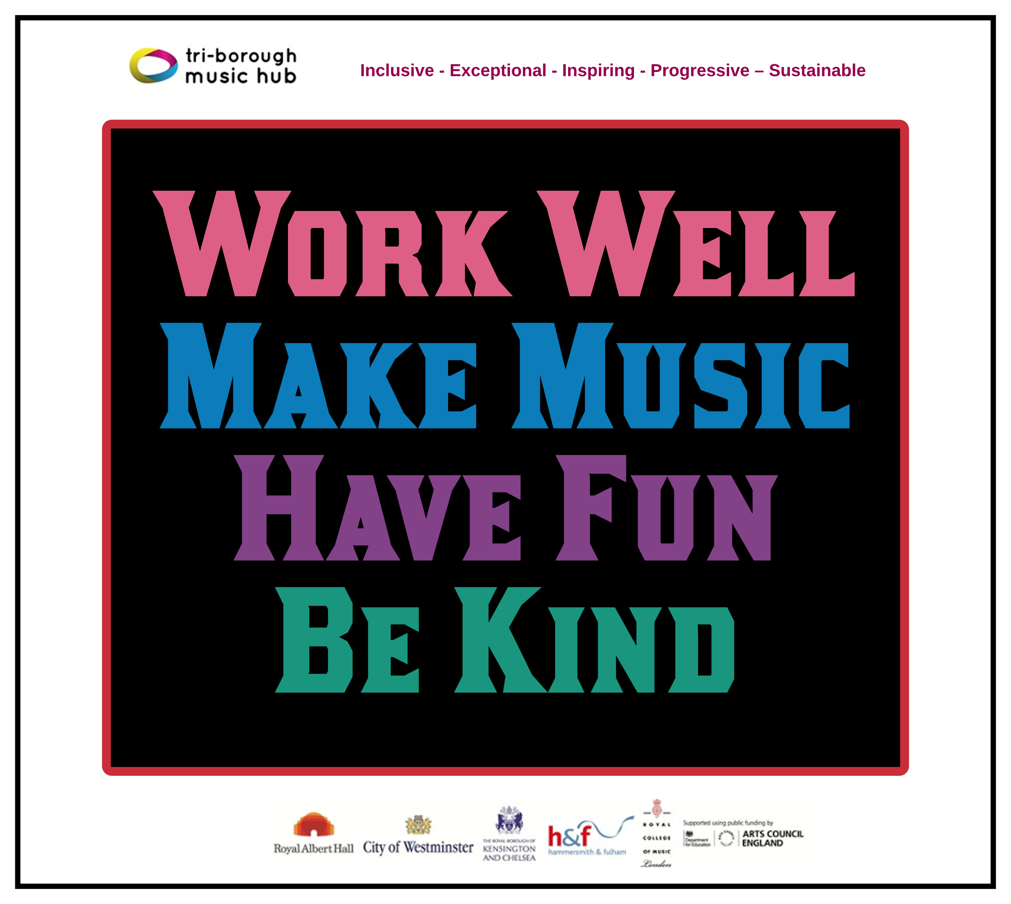
Due to the nature of the subject, music teachers can be some of the most isolated staff members in a school. The Music Hub is a community that brings together music teachers into a collective whole through network meetings, CPD programmes, and other opportunities. With this in mind, we ask that all schools actively connect with the Music Hub and encourage their music teacher(s) to engage in what we have to offer. We will also be able to help all schools navigate planning for the implementation of the new National Plan for Music Education. Please can the lead for music in each school directly contacts sueling.chan@rbkc.gov.uk (TBMH Schools’ Administrator) so we can update all contact records.

This update lists the support we provide and the opportunities that are open to all schools. We can assure all schools that we are only focused on providing high-quality music education support, guidance, and learning that actively helps schools with the delivery of outstanding music. We sincerely hope that all schools will engage with us in the 2023-24 academic year and that together we can forge ahead on the basis that together we are stronger.
Tri-borough Music Hub
Inclusive - Exceptional - Inspiring - Progressive – Sustainable

With thanks from the TBMH team

Music Hub Contacts
Sue Ling Chan, Schools’ Administrator, sueling.chan@rbkc.gov.uk
Shannen Bassett, Ensemble’s Administrator, shannen.bassett@rbkc.gov.uk
Kerensa Briggs, Interim Saturday Music School Administrator kerensa.briggs@rbkc.gov.uk
Hannah Keohane, Instrumental Lead, hannah.keohane@rbkc.gov.uk
Katie Stuffelbeam, SMS Manager & Fundraising Lead, katie.stuffelbeam@rbkc.gov.uk
Evie Asio-Okwalinga, Vocal Lead, evie.asio-okwalinga@rbkc.gov.uk
Emily Stratford, SEND Strategic Lead Consultant, emily.stratford@triboroughmusichub.org
Alex Wood, Business Manager, alex.wood@rbkc.gov.uk
Louisa Roberts, Schools and Curriculum Leader louisa.roberts@rbkc.gov.uk
Head, Stuart Whatmore stuart.whatmore@rbkc.gov.uk

Please contact the Music Hub with any questions or for more information; or to provide any feedback – good, bad, or otherwise – musichub@rbkc.gov.uk.

