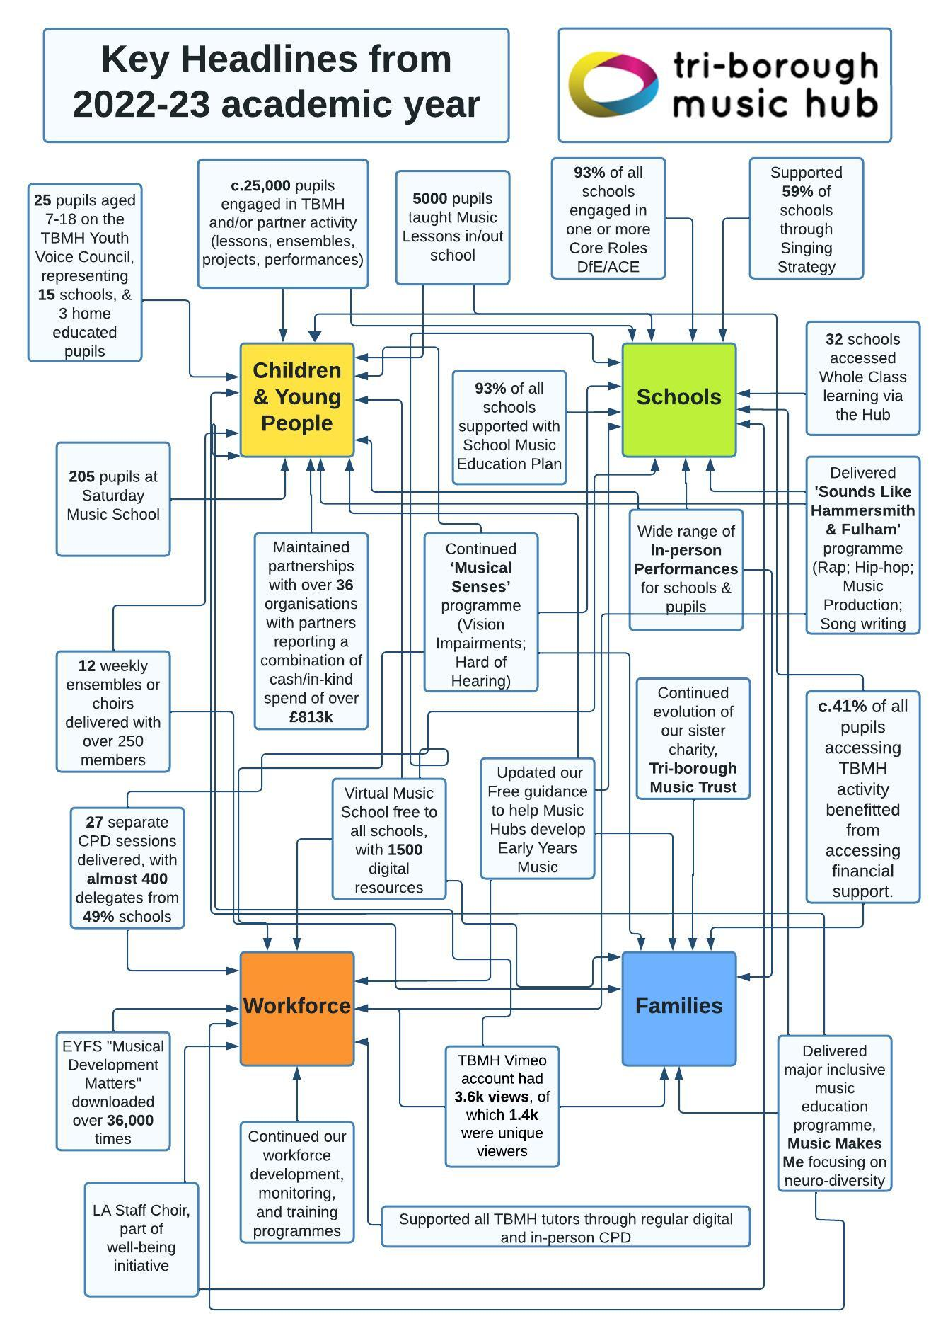

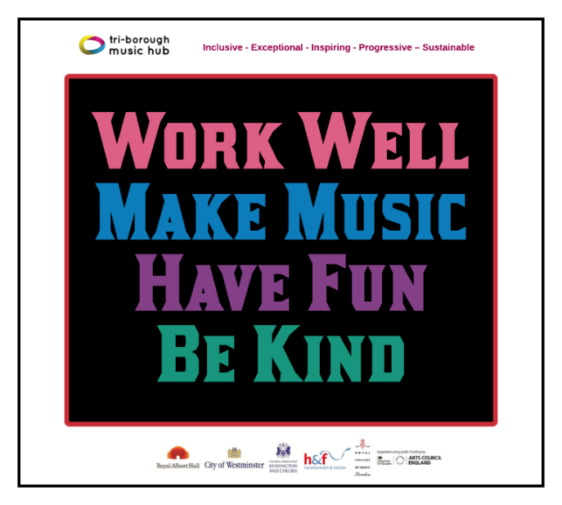
Tri-borough

Music Hub:

Annual Report for 2022-23

Academic Year

Montage of photos from the year

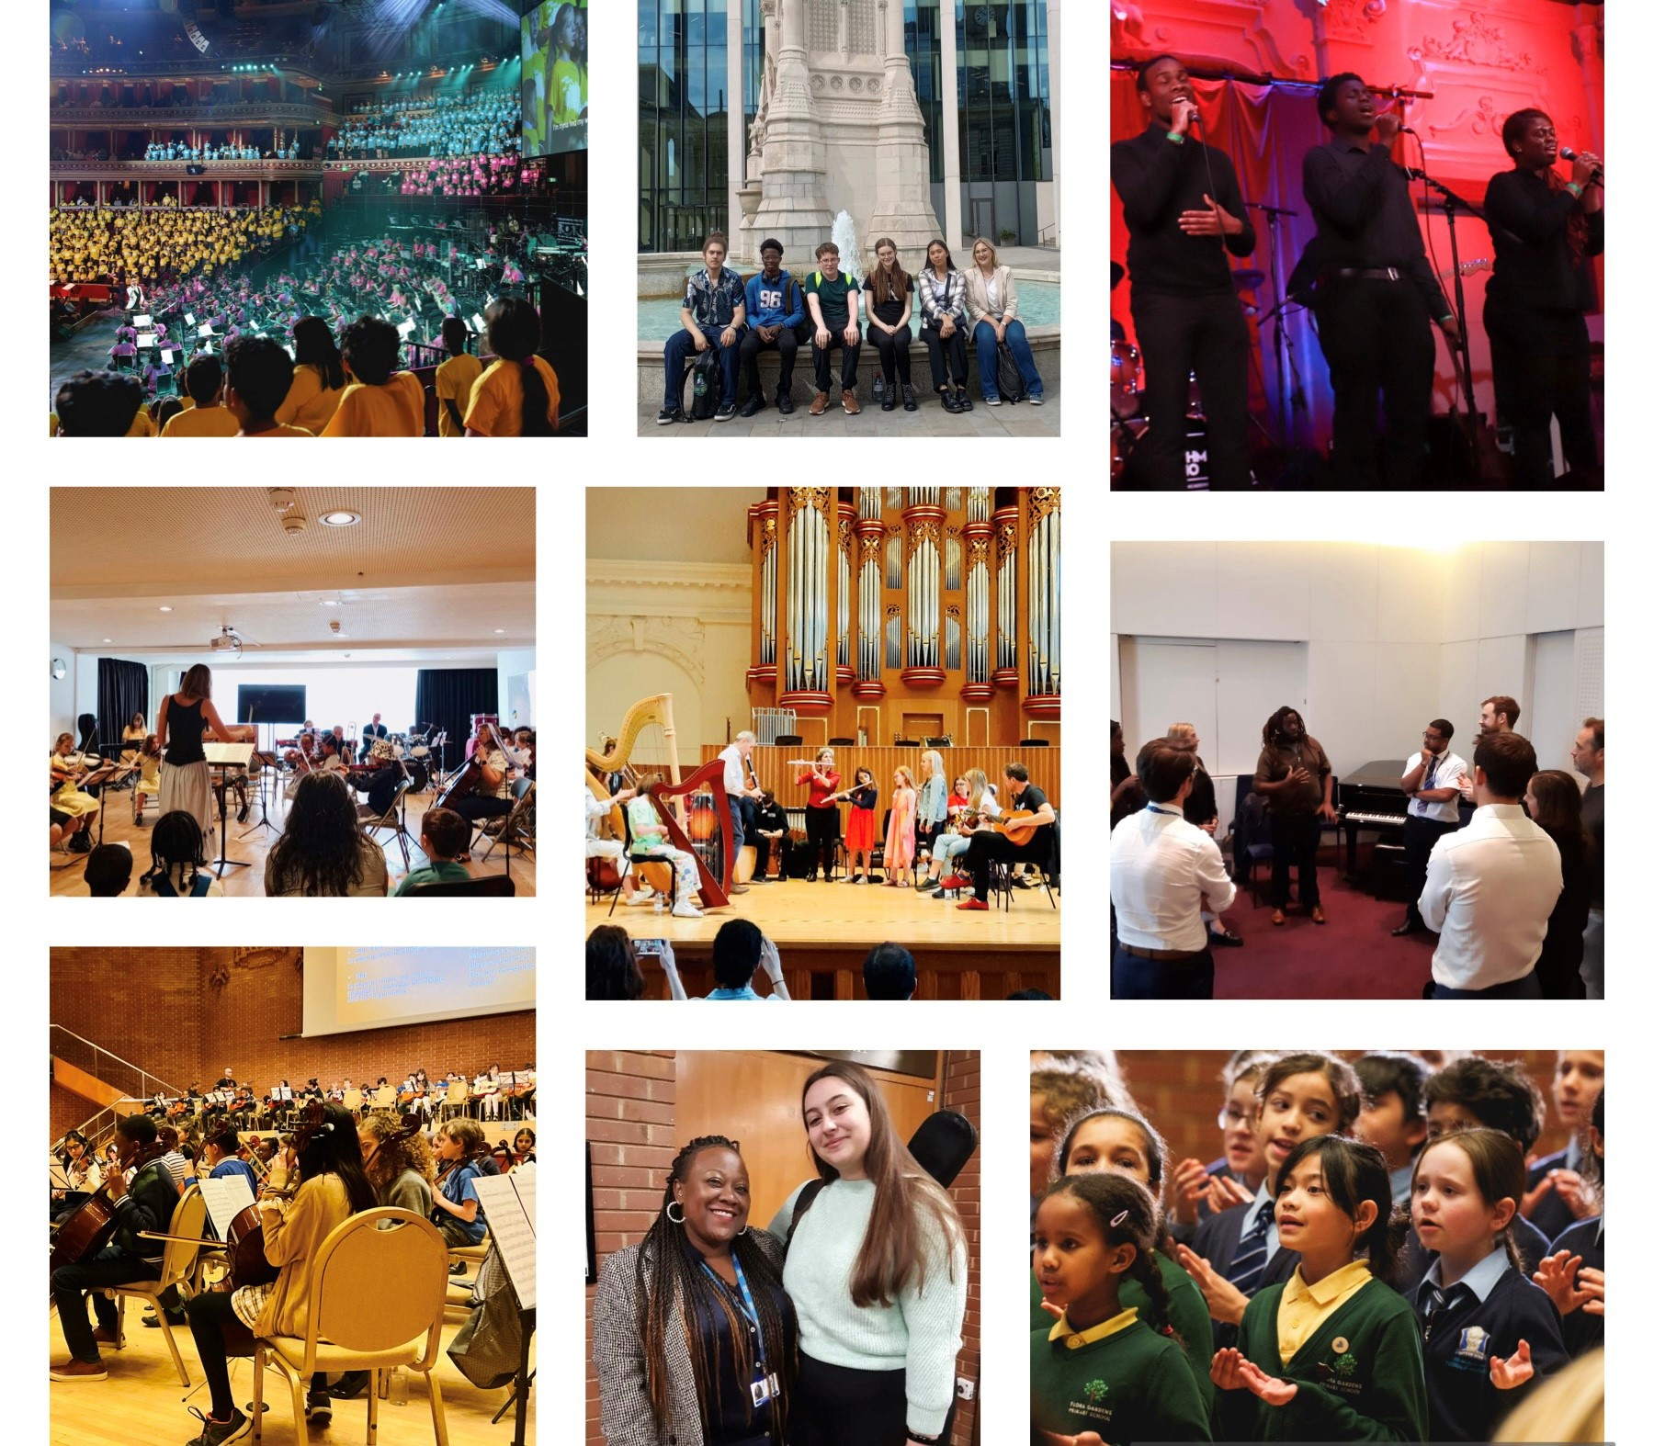
"The TBMH offers an outstanding range of services to schools and teachers - from training and network meetings, to free choral and instrumental events in exciting venues. All this, along with their Groove'n'Play Whole Class instrumental programme, enriches our school life. Every school should be lining up to be involved".
Music Subject Lead Teacher, Primary School

“We are absolutely blown away by the tremendous impact that this journey and performance has had on our daughter. She is a young person with significant mental health needs, undiagnosed autism, and other needs. Her experiences of school and life in general have been very challenging as a result of her needs. Thank you for giving her this platform. For giving her the bursary. Thank you for believing in her. Thank you for encouraging her. Giving a girl like her a platform in this majestic world stage has been life changing. We are beyond grateful. The staff at the TBMH are beyond amazing and supportive. Thanks for everything. Please keep doing what you are doing. We are 100 percent supporting you. This is changing the lives of sooo many people in such a positive way. We are completely blown away by this experience. It gave so many people a chance to visit the Royal Albert Hall. People who would’ve never been able to access it. Thank you for embracing inclusion, diversity, and celebrating neurodiversity. The play was also phenomenal. I work as an educational psychologist and the experiences of Aisha really resonated with me and reminded me of the pupils I work with. Thanks for raising this profile and helping us to think of us. One family member reflected on his interaction with his autistic son as a result of this. It’s all those little things which equate a massive massive impact. Congratulations, it was phenomenal. Blew our minds.”
Parent of pupil in TBMH Choir, performing at Music Makes Me

“I just wanted to say that since the wonderful concert we took part in at Kensington Town Hall, we have had a very enthusiastic sign up for this terms choir! I had children excitedly ask me in the corridor when it would be starting and if they could join.”
Teacher at school participating at TBMH Christmas Festival

“I wanted to share with you that my daughter was diagnosed with mild autism while rehearsing for Music Makes Me. The experience at TBMH helped her process and accept her being different and gave her confidence both in singing and performing and as a person. The performance at the RAH was a very emotional experience for us as a family and we’d like to thank you for giving our daughters this amazing opportunity and young people a voice.”
Junior Voices parent

“I just wanted to express my gratitude to you for allowing our School to take part in the Music Makes Me event on Tuesday. It was a magnificent evening and our students loved singing in the choir. I was in awe of your team's sense of togetherness and warmth when collaborating with the young people and musicians involved. My congratulations to you all!”
Head of Music, Secondary School

“Yesterday I had a day of meetings and I think I managed to bring up an example of how amazing Music Makes Me was in each. I’m so glad I could be there and it was truly brilliant. Of course I was moved by so many aspects, but I was also really impressed by the musical level. The orchestra was very strong and the diction of the singing is something that many professional choirs could do well to match. The different songs showcased a range of levels and skills, and the joy and commitment from the choirs was a joy to watch. The ongoing (and incredibly frustrating) preconception that high quality and inclusive music making are not compatible was well and truly busted!”
Ex-Trustee of TBMT, following Music Makes Me performance

Table of Contents

Executive Summary 5
Tri-borough Music Hub 6
Who we are: 6
Vision 6
Mission Statement 6
Music Education for All 6
Key Themes in the evolution of the TBMH 7
Core and Extension Roles (ACE/DfE) 8
2022-23: The Year in Numbers 9
Our work with Schools and Pupils 10
School Music Context 20
Hub Finances 21
Tri-borough Music Hub Turnover: Historic and Projected 21
Tri-borough Music Hub Income detail FY 2022-23 22
Tri-borough Music Hub Expenditure detail FY 2022-23 22
Musical Boroughs Trust / Tri-borough Music Trust 22
Quantifying the impact of Covid-19 24
Our Partner Organisations (2022-23) 25
The essence of the Tri-borough Music Hub: Working in Partnership 26
How well are our partners meeting our Strategic Aims? 26
Appendix: The work of our Partner Organisations 28
Strategic and Delivery Partner: Royal Albert Hall 28
Strategic and Delivery Partner: Royal College of Music 29
Partner Organisation: ABRSM 31
Partner Organisation: Creative Futures (UK) Ltd 31
Partner Organisation: Fulham Symphony Orchestra 32
Partner Organisation: HarrisonParrott 32
Partner Organisation: In - Deep 33
Partner Organisation: Inner Voices 33
Partner Organisation: Inspire-works 33
Partner Organisation: Lyric Hammersmith Theatre 34
Partner Organisation: Music Masters 34
Partner Organisation: Nucleo 35
Partner Organisation: Serious 38
Partner Organisation: Southbank Sinfonia at St John's Smith Square 38
Partner Organisation: The Classical Road Show 39
Partner Organisation: The Rhythm Studio 40

Executive Summary
The 2022-23 academic year was utterly epic on multiple fronts. We continued our rebuild from the pandemic with a significant amount of innovative and progressive music-making for our community. Over the course of the 2022-23 academic year, we:
- worked with approximately 25,000 children / young people (approx. 4.5k in schools, 500 out of school, 20k via partners)
- worked with 93% of all schools in some way across Hammersmith and Fulham, Kensington and Chelsea, and Westminster:
  - supported 140 schools (93%) through our holistic School Music Education Plan
  - engaged with 87% of all schools in a core Arts Council role (Primary 89%; Secondary 96%; 16 plus 20%; all others 69%).
  - supported 45% schools to access a large-scale high-quality musical performance event
  - supported 59% of schools through our Vocal Strategy and range of opportunities
  - offered 100% of all schools free musical opportunities including making the Virtual Music School available to every school; and gave every school free membership to Music Mark
- continued our bespoke ‘Musical Senses’ programme of work focused on supporting young musicians who are either blind/visually impaired or deaf/hard of hearing with 15 bursary places and a performance celebration event in July 2023.
- delivered 27 separate CPD training events with 400 delegates, from almost 74 different schools (49% schools)
- presented 30 separate performance events, featuring c.5k performers and c.10k audience members
- taught over 400 hours of weekly in-school delivery in 52 schools, teaching 4448 pupils; and in addition, delivered 120 workshops in Alternative Provision settings, SEND schools, and Secondary schools through our Sounds Like Hammersmith & Fulham Programme.
- delivered 12 weekly classes (choirs, ensembles, music production) running weekdays after-schools and a Saturday Music School for 378 pupils, including 62 vulnerable pupils.
- supported 171 pupils either through a scholarship, bursary, or remission.
- worked in partnership with 36 Delivery Partners and 5 Additional Providers, all with the benefit of bringing high-quality opportunities to pupils, schools, teachers, and families. These partners reported that they spent £1,364,625 hard cash on activity for TB schools, pupils, or teachers; and an in-kind spend of £196,831. This totals £1,561,456 of additional funding spent by the TBMH partners for the benefit of schools, pupils, and teachers in our area.
- Continued our Youth Voice Council culminating with five members of the YVC going to Birmingham in July to work with Lancashire and Sheffield Music Hubs to co-curate a citizen’s assembly as part of Music for Youth’s Annual Festival.
- Started our 3-year SEND Musical Access, Inclusion and Belonging Programme, funded by John Lyon’s Charity.
- Delivered our major Music Makes Me programme that culminated in a performance in the Royal Albert Hall in June 2023.
- You can check out photos and videos from the past year at all the links below:
- Photos – all photos (going back to 2014) can be found HERE.
  - Christmas Festivals 2022 - HERE & HERE
  - Future Sounds 2023 at Bush Hall – HERE
  - Music Makes Me – Rehearsal, Behind the Scenes, Reception
- Videos/Films – all our films (going back to 2014) can be found HERE:
  - Future Sounds 2023 - HERE
  - Music Makes Me – Performance, Documentary

I would like to thank everyone that has been involved with the Tri-borough Music Hub this past year, with a particular thanks to the full TBMH team; TBMH tutors; headteachers, teachers and schools; the Local Authorities; all partner organisations; the Arts Council; and Tri-borough Music Trust Trustees. Every single person has worked tirelessly and collaboratively to make a positive difference for music education in our community. Without this committed group of people, we would not have been able to achieve what we did.
Stuart Whatmore, Head, Tri-borough Music Hub, November 2023

Tri-borough Music Hub

Who we are:
The Tri-borough Music Hub (TBMH) is the award-winning lead organisation that oversees the delivery of music education in the three West London boroughs of Hammersmith and Fulham, Kensington and Chelsea, and the City of Westminster.

We work with schools, pupils, music educators and the community. We are a centralised Local Authority service which receives core funding from the Department for Education via Arts Council England. We operate a shared-services model across three Local Authorities to deliver an expansive programme of musical learning, in and out of school.

Alongside the three Local Authorities, the TBMH Strategic Partners are the Royal Albert Hall and the Royal College of Music. In addition, a quality-assured group of delivery partner organisations work to meet the TBMH’s strategic aims and positively contribute to our stakeholders. The TBMH is a music-specific service focused on high quality outcomes inclusive of all learners. It recognises the numerous benefits that music can bring to everyone from all backgrounds and in all circumstances. For more information about the work of the TBMH see annual reports HERE.

Vision
Our vision is for every child or young person – whatever their age, ability, or life circumstances – to have their voice heard, to feel included, and to be able to access enriching and relatable musical experiences.

Mission Statement
Our mission is to provide a broad range of progressive and inclusive musical pathways and opportunities for all Children and Young People to develop a life-long love of music and realise their musical potential whilst developing their personal and social identity. We aim to expose Children and Young People to a range of music that broaden horizons and provide holistic musical learning by making connections that support a sense of cultural identity and belonging in our community. We will work closely in partnership with outstanding music and education organisations that are committed to our ethos. Together we will strive to embed best-practice, and implement visionary and effective models of partnership work to ensure comprehensive routes of engagement, opportunity, and progression for learners.

Music Education for All
The TBMH works hard to provide a fully inclusive service to ensure that our outputs are embedded in representation, equity, diversity, and inclusion - we aspire to be REDI. We champion the importance of Youth Voice, respond to need, and support all our learners, including our most vulnerable SEND learners. We strive to ensure that Children and young people's music is HEARD:
- Holistic - emphasis on personal, social, and musical outcomes.
- Equitable - those facing the biggest barriers receive the most support.
- Authentic - developed with and informed by the people we do it for.
- Representative - participants and colleagues reflect our diverse society.
- Diverse - all musical genres, styles, practices are valued equally.
All TBMH activity will be equitable and inclusive across all protected characteristics, to allow our participants (children, young people, workforce) to genuinely feel like they belong. We will create a space where everyone has equal access to opportunities and can be themselves without fear of discrimination, prejudice, harassment, or bullying. This will ensure that a fully rounded, progressive, and innovative music education will be representative of all children, young people, families, and communities who live or go to school within our three boroughs, regardless of their backgrounds or circumstances.

Key Themes in the evolution of the TBMH
Four common themes have emerged from our 2021 stakeholder (HERE) consultation and research, which highlight the challenges that need to be overcome in order to deliver the best possible service.
- Access, diversity, and inclusion: Ensuring all children and young people who wish to access our services, can do so
- Children’s enjoyment and wellbeing: Providing enjoyable activities for children and young people and supporting their health and wellbeing as we emerge from the challenges of the pandemic
- Youth voice: Ensuring that young voices are at the heart of our offers and the decisions we make as a service
- Relationships and communication: The importance of listening to and communicating clearly with our audiences, partners, service users and workforce.

TBMH focus priority areas and strategic vision
The TBMH has devised a top-level music strategy which summarises the approach taken to meet all service priorities. To achieve this, the TBMH is committed to high-quality learning at all levels under-pinned by mutually beneficial partnerships which contribute to and support the music education within the three boroughs. This agreed and unified approach to music delivery has four key strands, each with four objectives, mapped to outcomes for shared responsibility across all partnerships.

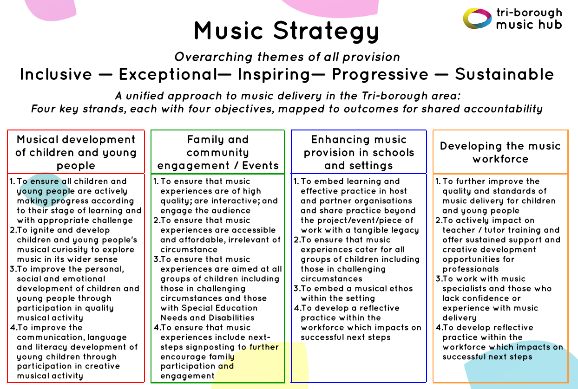

TBMH has its own locally agreed focus priority areas, which link to our overall music strategy (click HERE and see above), based on need, as laid out in the table below. Listed within each of the priorities below are the areas in which the TBMH and its partners contribute to.

Musical development of children and young people  - To support musical progression through a broad range of outstanding and fully inclusive musical pathways for children and young people with Youth Voice embedded in our work | Enhancing music provision in schools and settings  - To engage with all schools to enhance the delivery of an effective music curriculum by supporting access to high-quality music education opportunities
- Access to learning instruments for all pupils  - Whole Class Instrumental learning  - Ensemble and Singing opportunities  - Inclusive progression and pathway routes  - Youth Voice is heard and embedded  - Access to large-scale music experiences | - Support for School Music Development Plans with Support for curriculum delivery and CPD for school workforce  - Identifying Lead School Partners  - Ensemble and Singing opportunities  - Whole Class Instrumental Learning  - Diverse offer of activity  - Access to large-scale music experiences
Developing the music workforce  - To provide a broad range of effective continuing professional development opportunities for the wider workforce that enhances the quality of music education delivery for young people | Family and community engagement / Events  - To support families in our community by ensuring that financial access is not a barrier to pupils’ engagement in music education opportunities led by ourselves and our diverse range of partner organisations
- CPD for wider workforce (tutors, Higher Education students)  - Involvement in music education opportunities  - Representation across all protected characteristics | - Affordable access to music education for children  - Instrument loan service  - Families feel welcome, valued, and included
Everything above is underpinned by innovative music education
which ensures all TBMH, and partner, activity follows our values of:
Inclusive — Exceptional — Inspiring— Progressive — Sustainable
with representation, equity, diversity, and inclusion at the core of our work

Core and Extension Roles (ACE/DfE)
Every Music Education Hub in England must deliver against the core and extension roles as laid out in the National Plan for Music Education (HERE).

National Plan for Music Education – Core Roles
- Ensure that every child aged 5-18 has the opportunity to learn a musical instrument (other than voice) through whole-class ensemble teaching programme for ideally one year (but a minimum of one term) of weekly tuition on the same instrument.
- Provide opportunities to play in ensembles and to perform from an early stage.
- Ensure that clear progression routes are available and affordable to all young people.
- Develop a singing strategy to ensure that every pupil sings regularly, and that choirs and other vocal ensembles are available in the area.

National Plan for Music Education – Extension Roles
- Offer CPD to school staff, particularly in supporting schools to deliver music in the curriculum.
- Provide an instrument loan service, with discounts or free provision for those on low incomes.
- Provide access to large scale and/or high-quality music experiences for pupils, working with professional musicians and/or venues. This may include undertaking work to publicise the opportunities available to schools, parents/carers and students.

In addition, each MEH must have a School Music Education Plan:
- Every school is supported to deliver and monitor a high-quality music curriculum.

2022-23: The Year in Numbers

Who we serve
Our main client group is children and young people attending state-funded schools or settings (Year Groups Nursery to Year 13) in the Tri-borough area comprising the Royal Borough of Kensington and Chelsea, the London Borough of Hammersmith and Fulham, and the City of Westminster.

Other children who benefit from hub provision include those who are resident in the Tri-borough area but attend school elsewhere and those that are elective home educated or schooled independently. We also have a large programme of Early Years work for birth to 5-year-olds. 55,742 five to 18-year olds attended state-maintained education settings in the Tri-borough area in 2022-23.
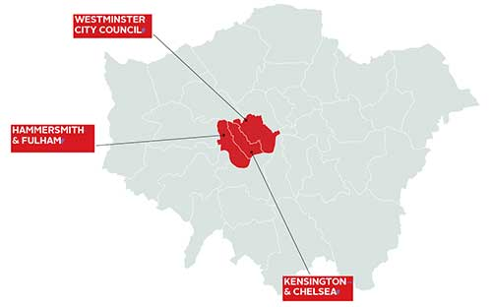
Image source: http://www.kcwtoday.co.uk
In 2022-23 there were:-
- 166 maintained schools and settings, including:-
  - 16 EYFS settings or maintained schools with EYFS provision
  - 102 mainstream primary schools and 27 mainstream secondary schools
  - 2 all-through schools with primary and secondary provision
  - 5 Sixth Form colleges
  - 5 Alternative Provision settings
  - 10 special schools and settings including 1 Non-Maintained Special School (NMSS)
- 55,742 children and young people on roll (Yr R0 to 13) at state schools in the Tri-borough
- 49% female and 51% male
- 559 Looked After Children

Census contextual data (Summer 2023)
Borough | Pupil Premium* | English as an Additional Language | Education Healthcare Plan | SEN Support
Hammersmith and Fulham | 35% | 41% | 6% | 12%
Kensington and Chelsea | 41% | 46% | 6% | 13%
Westminster | 45% | 53% | 5% | 13%
*NC Year R0 to 11

Our work with Schools and Pupils

Successes and challenges in delivering core and extension roles
The Arts Council specifies four Core Roles for music hubs and an additional three Extension Roles. The degree to which we engaged schools in each role is specified in the table below. Every single school and setting was offered free music support of some kind. The main headline is that we engaged 130 of our Hub Schools (87%) in a Core Role, and 140 of our Hub Schools (93%) in a Core or Extension Role or via our School Music Engagement Plan (SMEP).

 | ACE Core role | ACE Core or Extension role | Whole Class Instrumental learning | Ensembles | Lessons | Singing | CPD | Instrument Hire | Large Scale Events | School Music Education Plan | Meaningful Engagement
Core schools supported | 130 | 140 | 32 | 98 | 96 | 88 | 74 | 22 | 67 | 140 | 132
Core schools not supported | 20 | 10 | 118 | 52 | 54 | 62 | 76 | 128 | 83 | 10 | 0
Core schools total | 150 | 150 | 150 | 150 | 150 | 150 | 150 | 150 | 150 | 150 | 150
Other schools supported♪ | 40 | 42 | 0 | 23 | 27 | 15 | 4 | 0 | 2 | 5 | 2
Percentage of Core schools supported | 87% | 93% | 21% | 65% | 64% | 59% | 49% | 15% | 45% | 93% | 88%
Breakdown of engagement by school type
Mainstream Primary ♫ engagement | 92/103 = 89% | 99/103 = 96% | 30/103 = 29% | 68/103 = 66% | 72/103 = 70% | 55/103 = 53% | 40/103 = 39% | 21/103 = 20% | 38/103 = 37% | 99/103 = 96% | 92/103 = 89%
Mainstream Secondary ♫ engagement | 27/28 = 96% | 27/28 = 96% | 0/28 = 0% | 24/28 = 86% | 22/28 = 79% | 24/28 = 86% | 24/28 = 86% | 0/28 = 0% | 19/28 = 68% | 27/28 = 96% | 27/28 = 96%
Sixth Forms / colleges engagement | 1/5 = 20% | 2/5 = 40% | 0/5 = 0% | 0/5 = 0% | 1/5 = 20% | 0/5 = 0% | 0/5 = 0% | 0/5 = 0% | 1/5 = 20% | 2/5 = 40% | 2/5 = 40%
Special Schools engagement | 9/11 = 82% | 10/11 = 91% | 1/11 = 9% | 5/11 = 45% | 2/11 = 18% | 8/11 = 73% | 8/11 = 73% | 0/11 = 0% | 7/11 = 64% | 10/11 = 91% | 9/11 = 82%
Alternative Provision engagement | 2/5 = 40% | 3/5 = 60% | 1/5 = 20% | 2/5 = 40% | 0/5 = 0% | 2/5 = 40% | 3/5 = 60% | 1/5 = 20% | 3/5 = 60% | 3/5 = 60% | 3/5 = 60%

♪ Includes schools outside of the Tri-borough area and independent schools.
♫ There are two all-through schools, which are included in both the Mainstream Primary and Mainstream Secondary totals.

Heat map of out of school pupil engagement against the indices of deprivation

Kensington and Chelsea; and Westminster (Bi-Borough):
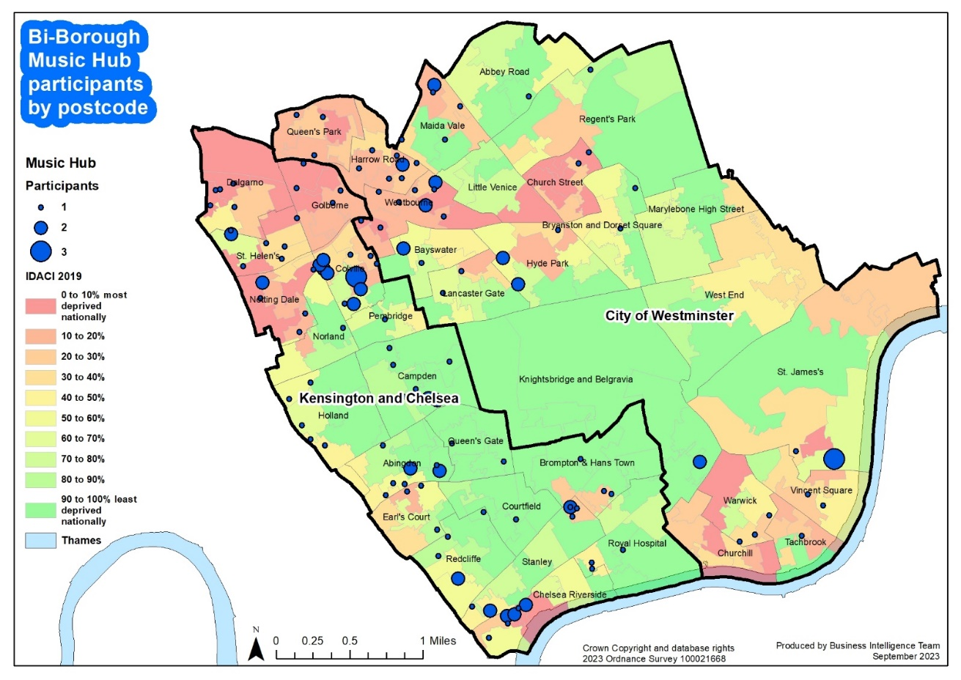
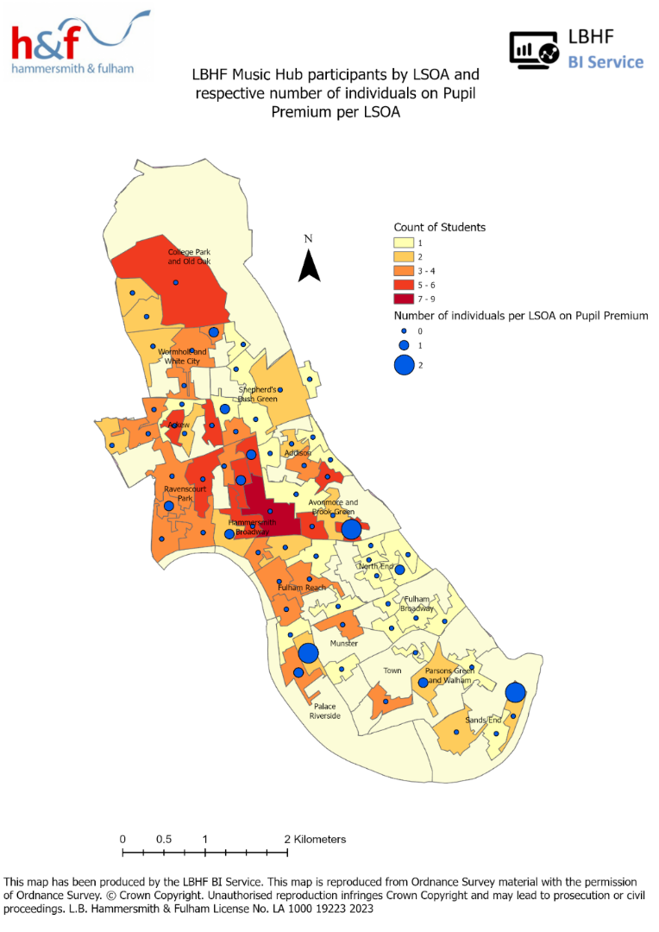
Hammersmith and Fulham:
NB: Lower Layer Super Output Area (LSOA) boundaries

Whole Class Ensemble Teaching (WCET)
Whole Class Instrumental Learning stats remain low but are improving (21%, up slightly from 20% last year); Many schools are still rebuilding their own music curriculums and are not ready to re-engage with this particular strand. Of the 32 schools (up from 30) who did run this, they accepted our ongoing FREE support for schools to access high-quality resources by receiving a free license of one of our Groove’n’Play programme (HERE) to deliver themselves. 3,727 pupils engaged in the Rastamouse or GnP programmes in 2022-23, up from 3,402 in 2021-22.

In addition to Rastamouse Rocksteady Reggae School, devised by Sally Greaves, the TBMH delivered our specially commissioned ‘groove ‘n’ play’ programmes, written and devised by Sally Greaves. The groove’n’play series, available under licence to other music hubs, includes:
- KS1 Rastamouse Rocksteady Reggae School
- KS1 groove’n’play Ukuleles, Sticks and Songs
- KS1 groove’n’play Fiddle, Sticks and Songs
- KS1 groove’n’play Recorders, Sticks and Songs
- KS2/3 groove’n’play FIFTHS (multi-instrumental)
- KS2/3 groove’n’play FIFTHS 2 (multi-instrumental)
- KS2/3 groove’n’play Strings (violin, viola, cello, double bass)
- KS2/3 groove’n’play Woodwind (flutes and clarinets in C)
- KS2/3 groove’n’play Brass (trumpets and trombones)
- KS2/3 groove’n’play Guitar and Mini Bass (guitars and mini-basses)

The programmes are varied and progressive across KS1-KS3 which can be delivered in three ways. The school buys in either:
- Lead & Support TBMH tutors to deliver WCET in partnership with the class teacher; or
- Lead TBMH tutor to deliver WCET in partnership with the class teacher; or
- the TBMH resources and they deliver it themselves.

Many schools deliver their own programme, using TBMH historic resources, but have not reported this to us.

Core roles delivered via out of school activities
Outside of school the TBMH offered an equally massive programme of opportunity in areas that cover the core roles - Playing in ensembles and performing; Musical Progression; and Singing.

The full programme involved 378 pupils (up slightly from 376) in after-school weekday activity and / or Saturday Music School; and covered ensembles, singing, and musical progression and pathways. The programme included:-
- First Sounds: Ensemble for instrumentalists up to Grade 1
- Breakout Band: Ensemble for instrumentalists from Grade 2-4
- Cello Maestros: 1:1/paired lessons
- First Voices: Choir for Pupils in R, Yr 1, Yr 2
- Next Level Voices: Choir for Pupils in Yr7-Yr13
- Symphonic Band: Ensemble for instrumentalists from Grade 5-8+
- Junior Voices: Choir for Pupils in Yr3-Yr6
- Keyboard Beginner Class 1: Open access keyboard for pupils in Yr4-Yr9
- Keyboard Beginner Class 2: Open access keyboard ensemble for pupils in Yr4-Yr9
- BandLab Music Technology: For pupils in Yr4-Yr7
- Garage Band Music Technology: For pupils in Yr 5-Yr13
- Keyboard Lessons: continuers to intermediate
- Online digital lessons: all levels

The number of different ensembles, bands and choirs available via our hub and those of our partners who submitted a data return increased to 289 (up from 179 in the previous year).

Progression, in all guises, remains integral to our approach and ethos. Our tutor workforce was digitally monitored by members of the core TBMH team through a daily rota to ensure quality remained high, and to support with any digital delivery issues. Formal tutor observations were not carried out as there was no capacity to do so.

Singing Strategy in schools
Following the huge impact that Covid-19 had on singing, we had a greater focus this year on supporting secondary and special schools with singing. We supported 88 schools (59%, down from 70%) through our Vocal Strategy and range of opportunities – this represented 53% of primary schools (down from 75%), 86% of secondary schools (up from 68%) and 73% of of special schools (up from 55%). 40% of Alternative Provision settings were also engaged (down from 60%). Again, we offered every school free access to our SEND-Friendly Vocal Resource, ‘Singing with Meaning’, with 20 original songs focused on emotional regulation and anxiety on school return (link HERE).

The 59% engagement of schools with our overall singing strategy marked a decrease from 70% in the previous year, reflecting a deeper engagement with fewer schools involved in larger projects such as Music Makes Me.

Music Makes Me was a major focus for the year which was significant re the singing strategy and also instrumental progression. This large-scale multi-school music education and performance programme highlighted the importance of inclusive practice and celebrating everyone for who they are. This brand-new new work by Emily Stratford and Gabriel Krchnavek creates a gateway into the world of music, regardless of who you are, and it draws on music as a strength in how we communicate with others. The narrative of the story charts a day in the life of a neuro-divergent young person, and it shows how music helps her emotionally regulate, socially interact, and build her independence for adulthood.

On stage there were 1,127 performers:
- 940 in the massed choir from 40 schools
- 81 pupils in the TBMH Chorus
- 107 in the orchestra
- 16% of all participants had an additional or special educational needs
- 6% of children and young people had an autism diagnosis
- 1% were wheelchair users.

Music lessons (small group and individual) in schools
The percentage of hub schools with pupils taking hub-led individual or small group lessons was 64% (up from 55.9%). The total number of pupils learning with TBMH tutors at school was 721, a significant increase on the previous year’s figure of 617. This figure excludes whole-class teaching (3,727 pupils).

Delivering on the Music Education Hub Extension Roles
The Extension roles have continued to be an important part of our work. In summary:
- We supported 140 schools (93%) (previously 144 or 94.7%) through our holistic School Music Education Plan (SMEP)
- 49% (previously 64.5%) of schools engaged in our CPD programme
- 15% (previously 7.9%) of schools hired an instrument through a charged SLA
- 119 (previously 150) pupils hired an instrument outside of school
- 67 schools (45%) took part in one of our large-scale high-quality musical performance events (up from 60 schools, or 39.5% previously).

School engagement is one of our main priorities for the single reason that this is where the majority of children and young people will engage in educational learning, and as such have a statutory right to music education within the curriculum. We have high levels of engagement with our schools and positive relationships with both music teachers and senior leaders. By engaging schools, we can influence the music education that pupils receive through the curriculum. This is where an equitable music education progression starts. A genuine joined-up music education progression is a shared and equal responsibility between schools and a MEH. This is why schools and MEHs must work together.

Our School Music Engagement Plan (SMEP)
Our SMEP consists of multiple elements of strategic support available to every school – it is up to them if they choose not to engage. Of the total 140 (prev. 144) schools we supported through SMEP, this was 96% (unchanged) of all Primary schools, 96% (prev. 100%) of all Secondary schools, 40% (prev. 50%) of 16 plus, and 81% (prev. 93.8%) of SEND/other.

Our support in 2022-23 was focused on ensuring that all schools could deliver music in the curriculum in a way that worked for them. We offered multiple free programmes and opportunities either ourselves or via partners.

Continuing Professional Development (CPD)
CPD is a large part of our work – schools; tutors; early years; partners; Higher Education – and we believe in the importance of professional development. It supports individuals and brings increased opportunities for children and young people. The overall CPD programme was developed in response to emerging needs caused by the pandemic and supported many different stakeholders.

Workforce training & CPD for 2022-23 was programmed under multiple strands:
- Safeguarding
- Phase-specific Network meetings
- Curriculum training opportunities
- SEND focus
- Whole Hub staff meetings including open discussion platform
- The Head and Deputy Head also delivered content as part of the Undergrad and postgrad courses for RCM students, supporting the links between HR and the industry and helping to shape the next generation of music teachers.

During 2022-2023 the TBMH hosted 27 different CPD training workshops and events online with 400 attendees representative of our workforce including tutors, core team, partners, school teachers and other music educators, including over 74 different schools.

Large-scale, high-quality performance events
We were delighted to be able to once again stage in person events, and these included:
- Two Christmas Festival featuring 29 schools and 639 pupils (videos HERE & HERE)
- Future Sounds final 7 contemporary artists aged 11-18 at Bush Hall (Vox Pops video HERE)
- End term informal sharings for all classes and ensembles/choirs/SMS (throughout the year)
- Wind, Brass, and Percussion Playing day; and Strings/Guitars Playing Day
- Next Level Voices performed at London Jazz festival in Nov 2022
- Music Makes Me, our groundbreaking SEND-focused flagship event staged at the Royal Albert Hall in June 2023, featuring 1,100 pupils from 40 schools (performance video HERE).
- Musical Senses event in July 2023 at the Royal College of Music for our cohort of young musicians who are blind/vision impaired, or who deaf/hard of hearing.

Sounds Like Hammersmith & Fulham
A major partnership programme (started Jan 2022 and ended in Dec 2022) was realised in the ‘Sounds Like Hammersmith and Fulham’ project which the TBMH was the lead partner in the LBHF GLA Cultural Impact Award (details HERE). This delivery was focused on 14-18 music working with every 14-18 setting in LBHF. This has brought in £180k of funding in – c.£40k management fee, and £140k on delivery.

Sounds like Hammersmith & Fulham is the springboard for the delivery of a ten-year programme of cultural development in the borough. The focus is young people, creating the opportunity for long-term change through social integration and by countering knife crime through innovative arts and cultural provision, using music as a medium. The programme will be a catalyst for change, providing opportunities to foster and facilitate collaboration between music professionals and lay people of all ages, backgrounds and abilities. It will be delivered in two phases – the first for 14-18 year olds, the second for 18-25 year olds, which will be delivered by HQI. Sounds like Hammersmith & Fulham is funded by a cultural Impact Award as part of the Mayor’s London Borough of Culture programme.
Phase One was an ambitious music programme throughout 2022 available for all 14-18 year olds who live or go to school in LBHF focussing on 3 genres: Music Production & Technology; Hip-hop & Rap; & Song-writing. The programme focused on the following areas:
- Youth Voice & empowerment
- Educational settings provision
- Musical opportunities & mentoring for young people out of school time
- Provision, mentoring, accreditation & pathways for young people not in education, employment, or training
- Performance opportunities and celebration of talent
Importantly, all of the opportunities provided were free to young people, schools and teachers.

Phase 1 worked across multiple settings: workshops within formal and alternative educational settings; specialist music workshops in secondary SEND classroom settings; musical opportunities for young people outside of school time; and mentoring and accredited pathways for young people not in education, employment or training performance opportunities to celebrate local talent, all underpinned by youth engagement. A series of music curriculum schemes of work were also produced to enhance formal and informal learning.
- Music Production – T&L Resources (HERE)
- Song writing – T&L Resources (HERE)
- Hip-Hop – T&L Resources (HERE)
- Teaching young people with SEND additional resources (HERE)
TBMH set high standards for the programme, aiming to engage with all schools in the borough and opening up access for young people to engage in music workshops outside the school setting. The programme aimed to bring young people, professional musicians, specialist educators, schools, teachers and the local community together to encourage, promote and celebrate the diverse musical creativity of young people in the borough. Ultimately, the vision was to inspire young people and kickstart a new sustainable arts programme in the borough.

These three short videos summarise the impact of the SLHF programme delivered by TBMH
- Impact stories | Emily Stratford | Sounds like H&F - YouTube
- Impact stories | Chloe Armstrong | Sounds Like H&F - YouTube
- Impact stories | Tri-borough Music Hub | Sounds Like H&F - YouTube

Using technology to deliver for our stakeholders
From the Autumn Term 2021, we opened up free access to our Virtual Music School meaning that in theory 150 schools (c.56k pupils) could have free access to the site. The VMS has over 1500 bespoke digital resources, PDFs and videos from aural practice and instrumental tutorials to music technology and composition courses, suitable for all ages.

Through the hub’s continued partnership with Charanga, take up of the hub’s digital learning support for core and extension roles continues to grow. Charanga is a multi-hub online learning platform through which schools, instrumental teachers, and children and young people access a variety of online musical digital technology support programmes, as well as training and CPD. In 2022-23:
- We have continued our development partnership with Charanga supporting. Charanga assists the hub in supporting schools and instrumental teachers with online digital resources and CPD for teaching the music curriculum and instrumental learning.
- 35 Primary and Special Schools and 4 instrumental teachers regularly accessed the Charanga Platform, using its musical digital technology in 5,026 hours of teaching.
- Engagement with Yumu, the children’s online learning part of the Charanga Platform, has been strong with an additional 396 children having been provided with individual online access over the academic year.
- There were 2862 teacher login days in the last 12 Months

For music technology, we continued to deliver weekly BandLab and Logic classes outside of school time. This has been a really positive development for the TBMH and is now part of the regular offer of music production.

The TBMH has seen benefits from digital developments and embraced this progressive approach to engagement (social media, digital delivery, teaching and learning resources). Vimeo analytics show our TBMH Vimeo account had 3.6k views, of which 1.4k were unique viewers, and Music Makes Me being the most watched film of the year (1392 views).

We also used (and continue to use) Vimeo to host all the teaching and learning resources for the SLHF programme with 34 videos made and shared, so far.

Social media platforms have continued to be a useful communication tool – Twitter and Instagram being the main vehicle, with Facebook, and also using our website; MailChimp for e-newsletters.

Supporting Access, Inclusion, Representation, Equity and Diversity
The TBMH is committed to positive change and to ensure that our service is accessible by, and accessible to, as many young people, schools, teachers, and the community as possible. We have invested significant time and resources over the last 5 years on improving and developing the work that has been happening in relation to the wide spectrum of Representation, Equity, Diversity, and Inclusion. A key focus of what we do is the approach of: Listen / Hear / Respond in a cycle of continuous learning.

We designed our Access, Inclusion and Belonging Strategy (HERE) to ensure that EDI is embedded across all areas of Hub delivery, including our commitment to:
- ensuring equity of opportunity for all pupils,
- regardless of race, gender, where they live, their levels of talent, parental income, whether they have special educational needs or disabilities, and whether they are looked after children or care experienced.

Partnerships
We have done a lot of this by working in partnership with other organisations who share our ambitions. Partnerships remain an absolutely core feature of our work and these have formed the backbone of two major music education programmes that we have been working on recently. One being a major performance event called Music Makes Me which culminated in June 2023 in the Royal Albert Hall with 1100 young people with a focus on neurodiversity; and one being Musical Senses, our ongoing programme of work that supports young musicians who are blind/have a vision impairment (VI), or who are deaf/hard of hearing (HoH).

Approach
At the core of both these programmes and also how we approach most of our work in general, is a 3-pronged approach:
- Training and professional development for teachers to upskill and equip them.
- Working with and engaging positive role models into the roles of music leaders to promote representation.
- Targeted Music activity for young people that helps support engagement with high-quality musical activity.

Challenges Faced by Visually Impaired Musicians in Orchestras
As part of our commitment to growing representation we have been fortunate to work with Paula Chavez (and her sister, Fabiana) for the past two years, both of whom are blind musicians and music educators. They teach curriculum music in schools, piano lessons at our Saturday Music School, and support our out of school ensembles. Paula has written a really candid and insightful piece of work which we feel is important for us to share more widely in order to raise awareness and build inclusivity in the work of music education. You can read Paula’s article by clinking on this link Word Version.

Youth Voice
During the year, we continued to develop our Youth Voice Council which had 25 members representing 15 schools and 3 home educated pupils, as well as TBMH Young Ensemble Leaders. A further 6 students made up the Young Music Producers Board from 6 different schools. See our YVC film “What does music mean to me?” to hear directly from them. We also continued our cross-country work with the Youth Voice Council groups from other MEHs (Kingston, Lancashire, Cornwall, Sheffield) with the national Youth Voice event in Birmingham in July 2023. Read the blog written by Pedro, Jack, Rebecca, Melissa, and Ethan who went to represent TBMH:

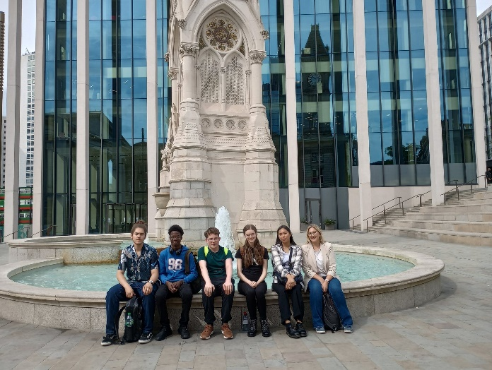
“We, the youth voice council, attended the citizens assembly on Saturday 8th July in Birmingham, for the promotion of diversity and inclusion within musical education. We met with the youth voice group from Lancashire music hub, overseas musicians and special guests on the panel who are professionals in music education.

The assembly consisted of a panel that were questioned on the current situation involving music education around the UK. To begin, the assembly asked various questions on different topics related to diversity in music. Members of the assembly asked personal questions to the panel. We subsequently assembled into round table discussions to evaluate any possible solutions to the issues young people face in accessing music provisions and services.

These roundtable discussions gathered all opinions into a collective manifesto which were later presented to the panel.
- Children should be willingly exposed to music at a young age as it can be psychologically and socially beneficial in their development.
- It is also important for all ages to have access to musical education & provisions, especially those who began their musical journeys later in life.
- Music is a medium that has the capacity to heal and bring together communities that otherwise share nothing in common.
- All people should have the freedom to express themselves and have equal representation in the musical space.”

See our tweet and more photos HERE.

Tutor Diversity Ambassador programme
Our Tutor Diversity Ambassador helped lead and steer work related around equity, diversity, inclusion, and representation. She led whole tutor CPD at the start of the academic year focusing on gender and race in music education. We have refreshed our statement regarding ‘Music for all’; and all team members have either been on the RBKC Unconscious Bias training, plus engaging in ongoing dialogue as a team about improvements to be made.

Financial Access and Support
The TBMH continues to use core DfE funds to enable remissions for the families of our pupils. On top of our already heavily subsidised prices for outside of school activity in 2022-23 we applied a further £29,534 of concessions (up from £21,978 in 2021-22) to parents/carers of pupils in receipt of free school meals, and/or with siblings attending the same activity. There were 109 individual pupils (up from 104) accessing TBMH remissions (29%, up from 25%). A further 45 pupils benefitted from full scholarship fees (12%). Collectively over 41% of the 372 (up from 36%) pupils engaging in TBMH-led programmes of activity benefitted from accessing financial support.

Hub Workforce Diversity survey, comparison with national data, and trends over time
This year we again carried out a diversity survey of our core hub team, tutors and governance and oversight stakeholders. Not every member submitted a response to this anonymous survey, so this summary necessarily only compares respondents to the TBMH survey rather than the whole workforce. With three consecutive years of data we are able to indicate whether the hub is becoming more or less representative of the broader population over time (by comparison to national averages garnered from a range of sources).

Becoming more representative | Green means that, relative to the previous year’s figure, this year’s figure is converging with the national average used as a comparator. In these categories the survey indicates that the hub is becoming more representative.
Becoming less representative | Pink means that, relative to the previous year’s figure, this year’s figure is diverging from the national average used as a comparator. In these categories the survey indicates that the hub is becoming less representative.
Neither more nor less representative | Orange means that the figure for this year is neither moving towards nor away from being representative of the national population.

Please note that no value judgement is attached to these colours, they simply indicate whether the difference between the hub workforce and the population in terms of representation has closed or widened statistically since the previous year.

Gender identity
 | TBMH |  |  | England & Wales (2021 census)
 | 2020-21 | 2021-22 | 2022-23 | Comparator
Female | 68.2% | 68.8% | 77.4% | 51.0%
Male | 31.8% | 31.3% | 22.6% | 49.0%

Men are under-represented, and women over-represented within the hub, compared to the national picture in the 2021 census. No one in the respondent cohort identified as other than Male or Female. “Prefer Not to Say” responses (PNTS) are excluded in these figures.

Gender identity different to sex registered at birth
1 survey respondent identified as having a different gender to their sex registered at birth (3.2% of respondents), compared to a 0.55% figure from ONS (Census 2021, England figure).

Sexual Orientation
 | TBMH |  |  | ONS data (UK 2022)
 | 2020-21 | 2021-22 | 2022-23 | Comparator
Heterosexual / Straight | 74.5% | 84.8% | 79.3% | 93.4%
Lesbian or Gay | 10.6% | 4.4% | 6.9% | 1.8%
Bisexual | 6.4% | 4.3% | 10.3% | 1.5%
Queer / Other | 2.1% | 6.5% | 3.4% | 0.6%

Gay Men and Women, Bisexual and Queer people are over-represented in the hub compared to 2019 ONS data, whereas Heterosexual people are under-represented.

Ethnicity
 | TBMH (excluding PNTS) |  |  | England and Wales working age population (2021 Census)
 | 2020-21 | 2021-22 | 2022-23 | Comparator
White ethnic groups | 84.7% | 87% | 76.7% | 80.7%
Asian ethnic groups | 6.5% | 6.5% | 6.7% | 10.1%
Black ethnic groups | 2.1% | 2.2% | 3.3% | 4.4%
Mixed ethnic groups | 2.1% | 4.3% | 13.3% | 2.5%
Other ethnic groups | 4.3% | 0% | 0% | 2.3%

White, Asian, Black and Other ethnic groups are all under-represented, whereas Mixed ethnic groups are over-represented in the hub.

Disability
 | TBMH (excluding PNTS) |  |  | ONS Labour Force Survey (Q1 2023)
 | 2020-21 | 2021-22 | 2022-23 | Comparator
D/deaf and Disabled | 7.1% | 8.5% | 29% | 23%

D/deaf and Disabled people are now over-represented in the hub compared to the working age population, and the percentage of D/deaf and Disabled people working for the hub is now significantly closer to being representative of the working-age population.

Supporting Grenfell
In the years following the Grenfell tower tragedy, the TBMH has supported the most affected schools and pupils in a number of ways – directing targeted work delivered by partners to North Kensington; providing additional support to schools; training and advice to TBMH tutors re: working with affected schools and pupils; linking with the Children’s Services support network to focus the most appropriate response. The 2022-23 academic year allowed for re-engagement with between the Grenfell Team and the TBMH, and Strategic Partners but by our own admission more work should happen here to support bereaved and survivors.

School Music Context

Performance in Public Exams data
We maintain our absolute commitment to engaging all secondary schools to support the teachers and their pupils through CPD, performance events, and partner opportunities to enrich the curriculum. The TBMH is committed to working with the secondary schools to ensure that KS4 and KS5 provision is maintained and developed.

Partner Opportunities
In addition to our centrally organised provision, the children and young people of the Tri-borough area benefitted from a wide range of tuition, ensemble, and performance opportunities via our delivery partner organisations. These opportunities, with a breakdown of pupils and staff benefits, are detailed in the appendix to this document. We are fortunate to have this support through partnerships with several organisations, working with professionals, allowing pupils to develop their skills, repertoire and help raise standards.

Hub Finances

Tri-borough Music Hub Turnover: Historic and Projected
Financial Year | DfE / ACE  Core Grant | Turnover History | Non-Core Grant Turnover | Income Generation percentage | Partners Reported Spend  (For information only)
2012-13 | £411,982 | £436,164 | £24,182 | 6% | In-kind Spend | Cash Spend | Total Spend
2013-14 | £511,488 | £692,943 | £181,455 | 26% |  | £605,938 | £605,938
2014-15 | £419,967 | £824,644 | £404,677 | 49% | £250,539 | £764,295 | £1,014,834
2015-16 | £527,054 | £1,069,452 | £542,398 | 51% | £240,576 | £1,263,856 | £1,504,432
2016-17 | £527,761 | £1,165,755 | £637,994 | 55% | £369,191 | £1,200,555 | £1,569,746
2017-18 | £525,350 | £1,293,622 | £768,272 | 59% | £223,750 | £1,208,793 | £1,432,543
2018-19 | £519,212 | £1,278,848 | £759,636 | 59% | £173,920 | £969,658 | £1,143,578
2019-20 | £518,377 | £1,504,150 | £985,773 | 66% | £336,287 | £688,765 | £1,025,052
2020-21 | £511,450 | £1,258,333 | £746,883 | 59% | £174,771 | £875,356 | £1,050,127
2021-22 | £502,902 | £1,635,123 | £1,132,221 | 69% | £179,382 | £633,886 | £813,268
2022-23 | £493,973 | £1,582,229 | £1,088,256 | 69% | £196,831 | £1,364,625 | £1,561,456

The 2022-23 Financial Year remained challenging for all the reasons connected to the continued recovery from the pandemic, however, we maintained successful financial resilience with a turnover of c.£1.5m. A detailed breakdown of the financial situation has been provided in all quarterly reporting documents.

The 2022-23 Financial Year brought challenges for fundraising activities but both Tri-borough Music Hub and its sister charity, Musical Boroughs Trust (“MBT”, established in May 2019) were able to make progress. Several grant applications were made to Trusts and Foundations, with existing relationships (e.g. John Lyon’s Charity and the Ingles Charitable Trust) further developed, and new ones (ACE National Lottery) established.

MBT was successful with securing 3-years funding (£94k) from JLC towards TBMH’s SEND Access, Inclusion & Belonging programme. This allows to appoint a 2-dpw Strategic SEND Lead, targeted activity, and bursary support.

MBT maintained public fundraising campaigns using the charity’s website, text donations, a tailored DonorBox platform on MBT and TBMH internet sites. TBMH continued to receive generous support from several student Scholars and Bursary schemes to help disadvantaged young musicians gain access to our music education programmes. The HMRC Gift Aid status on top of donations from individual donors has enhanced income received. Trustees continued networking with local high-net-worth-individuals as potential future donors and advocates.

In relation to Music Makes Me, there has been a joint effort between TBMH, MBT, and the RAH Philanthropy team to make applications and approaches to multiple trusts, charities, and foundations. The event cost £110k in hard cash to make it happen (we fundraised £106k); and there was further £132k of in-kind costs (£44k RAH-waived costs; and £88k of staff time across TBMH/RAH/RCM).
In 2022-23 the TBMH received the following additional income:
- £153,000 via LBHF to fund the SLH&F project
- £42,000 towards building costs/room hire from the Tri-borough LAs
- £30,000 from RBKC (use of Gifted & Talented fund)
- £23,490 from MBT/TBMT towards the Musical Senses project
- £20,382 from LMF for scholarships
- £13,504 from Thomas’ Foundation for scholarships
- £10,800 from John Lyon’s Charity for scholarships
- £10,000 from ABRSM
- £6,880 from the Royal Albert Hall to fund the Maestros scheme
- £6,411 from Access to Work for Support Worker refunds
- £5,021 from LMF towards our Brass is Back project
- £2,500 from Ingles & Hayday
- £2,500 via Musical Boroughs Trust/Tri-borough Music Trust towards brass instruments
- £1,725 from the Royal College of Music for the Get Set Play scheme
- £500 from The Wrightson Trust
- £198 from The Amber Trust

Tri-borough Music Hub Income detail FY 2022-23
Source | Income
DfE / ACE Core Grant | £493,973
Local authority grants/contributions | £175,886
Other Arts Council grants | £29,500
School contribution: | £441,774
Parental contribution (including via schools) | £102,316
Charitable foundations/trusts | £88,056
Other earned/generated income | £18,752
Other income | £231,972
Total | £1,582,229

Tri-borough Music Hub Expenditure detail FY 2022-23
Cost | Amount
Delivery costs - core roles | £1,040,823
Delivery costs - extension roles | £161,493
Instrument costs (repairs, renewals, storage) | £13,106
Administrative costs | £302,047
Other expenditure | £12,023
Total | £1,529,493

Musical Boroughs Trust / Tri-borough Music Trust
TBMH established a sister charity in May 2019 (Musical Boroughs Trust is the legal name but currently operates under Tri-borough Music Trust) https://www.triboroughmusichub.org/support-us/about-tri-borough-music-trust/ to generate additional income strands. Tri-borough Music Trust / Musical Boroughs Trust (TBMH’s charity) will help amplify the work of TBMH and raise extra funds.
Together, MBT and TBMH have taken on responsibilities in coordinating the ways in which we support local music education, to avoid a duplication of effort. Supported by its Trustees who have a wide range of professional expertise, MBT has begun a new phase of its existence. We are raising funds for activities to provide high-quality music making opportunities for around 20,000 children and young people each year. The local authorities have always generously supported our excellent Music Hub. But recent cuts to central government grants mean that we urgently need the help of parents, trusts, foundations, businesses, and individual donors, to sustain the hugely valued inclusive work which has been pioneered in our three boroughs in offering opportunities to disadvantaged young people.

Our target is to raise c.£50k per year to help fund music programmes across our boroughs.
We aim to achieve this through grant applications to charitable trusts and foundations, such as Three Monkies Trust and The Casey Trust, and the generosity of our donor community and corporate supporters. However, more support is urgently needed. We are raising funds for:
- Bursaries and music scholarships to cover the costs of music lessons for highly talented children living below the poverty line.
- Inclusive music programmes that fully reflect the diversity of our three boroughs.
- Musical instruments of all types to support young musicians.
- Running costs of TBMH’s Saturday music school, weekday youth ensembles and choirs (covering multiple genres), and holiday courses, which build confidence, develop skills and consolidate learning].
- Salaries of specialist music staff who work with disadvantaged children and enable them to access new opportunities and develop life chances they wouldn’t otherwise have.
- Performance events that inspire children and encourage them to aim really high, such as Convo and Music Makes Me at the Royal Albert Hall.
We want every child in our area to be able to access and enjoy music making - because we know it’s more than music. Music helps educational development and wellbeing. Through music, the foundations of learning are strengthened, helping to build confidence and sociability as well as academic achievement and creativity. In this way, aspirations are raised, and children's life chances open up.

We believe that music is an essential part of the school curriculum to reach and engage all children equally, regardless of challenging circumstances. In our area, where almost half of children live in poverty, we help enable access for all by funding a broad range of inclusive music programmes delivered by TBMH.

Our trustees are:

- Ian Adams
- Caroline Hansen
- Grace Lee
- Catherine Marris
- Edward McGovern
- Eva Morrison
- Socorro Torres-Duarte
- Milica Vukovic-Smart
- Susan Whiddington
- Chloe Armstrong
- Tim Garrard
- Linlin Jin
- Jonathan Chambers (volunteer)
- Stuart Whatmore (adviser)

The Musical Boroughs Trust will open up doors to different possible future collaborators and connections for extending the scope and impact of our work. Additionally, by gaining access to new sources of funding via the charity, the income that TBMH can devote to partnership working can increase moving forward. This is a long-term approach.

Quantifying the impact of Covid-19
The SARS‐CoV‐2 pandemic is referenced many times in this report, but its effects have been felt, so far, across three academic years. This means that many of the facts and figures herein, which have been compared – as is customary – to the previous academic year, do not show the full impact of Covid-19 on musical learning and teaching for our stakeholders.

To address this, we present the following table comparing data in 2022-23 to the most recent pre-pandemic reporting year, 2018-19. Our intention is to highlight, using previously reported data, the impact, positive or negative, of the pandemic and the changes in behaviour that have followed.

Data point | 2018-19 | 2022-23 | Change
Percentage of schools engaged in a DFE / ACE Core Role capacity | 82.6% | 87% | +5.3%
Number of pupils taking part in hub-led or supported WCET | 3,989 | 3,727 | -6.6%
Number of pupils taking part in small group or individual hub lessons, face to face | 1815 | 970 | -47%
Percentage of hub schools engaged with Singing Strategy | 50.3% | 59% | +17%
Percentage of hub schools sending teachers to any hub CPD | 30.1% | 49% | +63%
Total number of vulnerable pupils accessing TBMH's out of school provision | 55 | 62 | +13%
Total number of Youth Voice Council members | 13 | 19 | +46%
Percentage of hub schools buying in to SLA | 67.3% | 35% | -49%
Total number of followers across all social platforms, newsletter, etc | 2,453 | 4,858 | +98%
Turnover excluding Core Grant from ACE / DfE | £759,636 | £1,088,256 | +43%
Total number of scholarships + pupils accessing hub with remissions | 213 | 171 | -20%
Total Strategic Aim ‘impacts’ from partner organization analysis | 462,781 | 305,104 | -34%

Our Partner Organisations (2022-23)
Partner Organisations
Name of Organisation | NPO? | Partner
ABRSM | No | Yes
Aurora Orchestra | Yes | Yes
Bi-Borough (RBKC/WCC) Local Authorities – STRATEGIC PARTNER | No | Yes
Charanga | No | Yes
Creative Futures (UK) Limited | No | Yes
English Folk Dance and Song Society | Yes | Yes
English National Ballet | Yes | Yes
English National Opera | No | Yes
Fulham Symphony Orchestra | No | Yes
Go Live Theatre Projects | No | Yes
Groove'n'Play | No | Yes
HarrisonParrott Foundation | No | Yes
Imperial School Of Medicine Music Society | No | Yes
In - Deep | No | Yes
Inspire-Works | No | Yes
Kensington and Chelsea Council Culture Service | No | Yes
Latymer Upper School | No | Yes
LBHF Local Authority – STRATEGIC PARTNER | No | Yes
Live Music Now | No | Yes
Malombo Music Association | No | Yes
Music House for Children | No | Yes
Music Masters | No | Yes
Musical Boroughs Trust | No | Yes
Nucleo | No | Yes
Revere Arts | No | Yes
Royal Academy of Music | No | Yes
Royal Albert Hall – STRATEGIC PARTNER | No | Yes
Royal College of Music – STRATEGIC PARTNER | No | Yes
Royal Philharmonic Orchestra | Yes | Yes
Serious Events Ltd | Yes | Yes
Sound Connections | Yes | Yes
Southbank Sinfonia at St John's Smith Square | No | Yes
TEA films Ltd | No | Yes
The Bach Choir | No | Yes
The Rhythm Studio | No | Yes
Turtle Key Arts | No | Yes
Voices Foundation | No | Yes
Westminster Council | No | Yes
Wigmore Hall | Yes | Yes
Wider Network
Name of Organisation | NPO?
Carnival Village Trust | Yes
Inner Voices | No
LBHF Culture | No
LBHF Learning Partnership | No
Lyric Hammersmith | Yes
Opera Holland Park | No
The Bhavan Institute | ?
The Classical Roadshow | No
Westminster City Lions | No

The essence of the Tri-borough Music Hub: Working in Partnership
Partnerships remain a core component to the wider programme of activity that the TBMH can co-ordinate and maintain. Of the 36 named delivery partners during 2022-23, we only had 21 (61%) of partners respond to our annual data survey to report their activity. We think this may reflect capacity within smaller teams in arts organisations. We also worked with other organisations within wider cultural partnership. We ran a termly partner meeting with a specific focus for each one.

We further developed our innovative ‘Musical Senses’ programme aimed at supporting students who receive sensory support because they have either a vision impairment, or who are deaf or hard of hearing. The whole team and tutors participated in CPD from Bi-Borough Sensory team, a blind musician, and a hard of hearing musician. We also employed two registered blind tutors who are active in primary curriculum delivery, SMS, and weekday day ensembles – and we have secured additional funding via Access To Work. Through the Musical Senses programme we rolled out our bursary programme with 15 pupils benefitting. We culminated the year with a celebration event for 20 students at the RCM on 12th July which was incredibly successful and positive. This programme is delivered with RCM and ABRSM.

Our major partnership programme (started Jan 2022 and ended in Dec 2023) was the ‘Sounds Like Hammersmith and Fulham’ project which the TBMH was the lead partner in the LBHF GLA Cultural Impact Award.

We have continued our development partnership with Charanga supporting 35 Primary and Special Schools and 4 instrumental teachers with access to the Hub's custom Charanga platform. Charanga assists the hub in supporting schools and instrumental teachers with online digital resources and CPD for teaching the music curriculum and instrumental learning.

Of the partners that did respond, reported in the 2022-23 academic year they spent £1,364,625 hard cash on activity for Tri-borough schools, pupils, or teachers; and an in-kind spend of £196,831. This totals £1,561,456 of additional funding spent by the TBMH partners for the benefit of schools, pupils and teachers in our area. These figures are accounted for through each partner’s own accounts.

Another major music education partnership programme that culminated in June 2023 was Music Makes Me, which was our large-scale multi-school music education programme that was delivered with RAH, RCM, ABRSM, ENO, Cultural Inclusion Manifesto, and The Rhythm Studio. This was a huge success.

How well are our partners meeting our Strategic Aims?
In 2022-23 we continued to measure our partners’ success against 16 strategic aims in four strands, namely:
- Musical development of children and young people
- Family and community engagement / Events
- Enhancing music provision in schools and settings
- Developing the music workforce.

By gathering provision data from our partners, demonstrating how the provision met each of the strategic aims, and combining this with the numbers of service users, it was possible to estimate the number of children and young people who had quality experiences aligned with our strategic aims. For details of this, please see the table on the next page.

Through analysis and reviewing the partner organisations’ reach in the Tri-borough, we are able to focus and target future partner work. Whilst the figures below are estimates (as they don’t take into account, for example, overlapping service user groups) we are able to make year-on-year comparisons as we have maintained the same strategic aims for a number of consecutive years.

The work of each of our Partner Organisations is described in detail in the appendix to this document.

Table showing how many service users benefit from our partners’ work under each of our Strategic Aims

Number of service users benefitting  Strategic Aim | 2014-15 | 2015-16 | 2016-17 | 2017-18 | 2018-19 | 2019-20 | 2020-21 | 2021-22 | 2022-23 | Year-on-year change
Strand 1: Musical development of children and young people
To ensure all children and young people are actively making progress according to their stage of learning and with appropriate challenge | 20,571 | 17,439 | 21,539 | 28,191 | 29,325 | 20,276 | 13,052 | 12,866 | 19,046 | 48.0%
To ignite and develop children and young people's musical curiosity to explore music in its wider sense | 25,316 | 40,944 | 28,830 | 54,091 | 50,152 | 54,246 | 14,647 | 16,088 | 20,012 | 24.4%
To improve the personal, social and emotional development of children and young people through participation in quality musical activity | 22,283 | 22,570 | 23,388 | 51,072 | 35,118 | 37,778 | 13,908 | 16,058 | 20,062 | 24.9%
To improve the communication, language and literacy development of young children through participation in creative musical activity | 19,194 | 18,520 | 24,665 | 33,182 | 33,446 | 31,967 | 13,511 | 15,838 | 19,306 | 21.9%
Strand 2: Family and community engagement / Events
To ensure that music experiences are of high quality; are interactive; and engage the audience | 31,983 | 36,748 | 25,435 | 53,629 | 43,038 | 48,978 | 13,772 | 15,968 | 19,550 | 22%
To ensure that music experiences are accessible and affordable, irrelevant of circumstance | 28,325 | 34,998 | 25,436 | 43,209 | 32,760 | 43,859 | 12,962 | 14,817 | 19,550 | 32%
To ensure that music experiences are aimed at all groups of children including those in challenging circumstances and those with Special Education Needs and Disabilities | 24,199 | 25,780 | 24,001 | 46,454 | 34,520 | 29,882 | 12,685 | 16,088 | 17,475 | 9%
To ensure that music experiences include next steps signposting to further encourage family participation and engagement | 17,353 | 20,544 | 23,439 | 46,358 | 40,270 | 25,990 | 11,354 | 12,106 | 15,459 | 28%
Strand 3: Enhancing music provision in schools and settings
To embed learning and effective practice in host and partner organisations and share practice beyond the project/event/piece of work with a tangible legacy | 17,441 | 10,826 | 20,684 | 11,075 | 15,444 | 10,295 | 11,789 | 8,416 | 19,316 | 130%
To ensure that music experiences cater for all groups of children including those in challenging circumstances | 20,080 | 31,386 | 28,735 | 53,680 | 28,287 | 24,191 | 12,793 | 14,667 | 20,022 | 37%
To embed a musical ethos within the setting | 16,504 | 29,501 | 27,301 | 44,865 | 27,566 | 18,497 | 4,497 | 12,392 | 20,022 | 62%
To develop a reflective practice within the workforce which impacts on successful next steps | 13,883 | 16,167 | 21,010 | 48,084 | 23,315 | 15,241 | 10,664 | 14,327 | 18,357 | 28%
Strand 4: Developing the music workforce
To further improve the quality and standards of music delivery for children and young people | 17,698 | 26,522 | 21,821 | 43,455 | 21,710 | 18,632 | 11,508 | 16,058 | 19,972 | 24%
To actively impact on teacher / tutor training and offer sustained support and creative development opportunities for professionals | 8,806 | 11,819 | 21,425 | 19,850 | 12,350 | 14,951 | 10,799 | 7,862 | 18,626 | 137%
To work with music specialists and those who lack confidence or experience with music delivery | 11,890 | 8,328 | 19,788 | 15,239 | 14,394 | 20,050 | 11,512 | 10,933 | 19,433 | 78%
To develop reflective practice within the workforce which impacts on successful next steps | 10,184 | 19,490 | 19,683 | 27,144 | 21,086 | 16,719 | 11,837 | 8,182 | 18,896 | 131%

Appendix: The work of our Partner Organisations
The following pages detail the work carried out by our partner organisations in the Tri-borough area and how they benefitted our key client groups: children and young people and their families and the music workforce. Our key Strategic Partners are listed first, followed by our other partner organisations listed alphabetically.

Strategic and Delivery Partner: Royal Albert Hall
royalalberthall.com

Working with the hub
The Royal Albert Hall are very proud to have been strategic partners of the Tri-borough Music hub since it's inception in 2012, and our close relationship with the Hub is invaluable to the Hall's Engagement work. We have worked on many projects together in 2022/2023 but the highlight has to be our co-production of Music Makes Me which was an enormous success.

Projects
Orchestral Encounters These interactive school workshops use the Hall’s eclectic calendar of events to introduce the children to the orchestra, its sections and its versatile repertoire. Inspired by music from films, video games, musicals, military events and classical concerts, each class will be divided into 5 teams and take rhythms from the featured pieces to create their own brand-new masterpiece.
Royal Albert Hall Maestro Award During the Orchestral Encounters workshops, our professional musicians work with class teachers to identify children who demonstrate musical potential, but who aren’t already engaged in instrumental lessons. These children and their families are invited to a further special concert at the Hall where instruments are introduced in an intimate and interactive setting, after which each child is given a year of music tuition on their favourite instrument completely free.
Music Makes Me As part of our partnership with the Tri-borough Music Hub, we hosted Music Makes Me on Tuesday 27 June 2023. Music Makes Me follows in the footsteps of award-winning TBMH and RAH collaborative productions Seven Seeds and Convo and featured over one thousand pupils performing original songs which were co-designed by young people with special educational needs, alongside specialist musicians. The narrative of the work presents a day in the life of a neuro-divergent young person and shows how music helps her emotionally regulate, socially interact, and build her independence for adulthood. Music Makes Me truly shows how music is for all.
Future Makers Launched in 2022, Future Makers is an exciting annual schools concert showcasing talented young musicians from across London. Schools and Music Hubs are invited to submit acts aged 14-18 who are creating their own new music and shortlisted acts are invited to perform at live auditions. Following the auditions, 8-10 acts are selected to perform in the showcase event at the Hall. 2022’s concert was presented by two of the Hall’s Associate Artists; LionHeart and Jess Gillam, and the audience is made up of younger school children with the hope of inspiring them to be the next generation of Future Makers, supported by a specially written resource pack.
Sensory Journeys & Experiences Led by a specialist facilitator and accompanied by Albert’s Band's musician, students with multiple and profound learning difficulties are immersed in an exciting journey around the Hall. Young people travel around a collection of Hall spaces and engage with a range of sensory stimulation including visual, auditory, olfactory, gustatory, tactile, and vestibular. The spaces are transformed into imaginative environments, focussing on different habitats, using set design, lighting and sound.
Give it a Go! Students with SEND participate in four bespoke workshops designed in collaboration with a Special School partner. Facilitated by a specialist practitioner and our team, hands-on workshops offer students the unique opportunity to learn more about operations and health & safety, stage lighting and stewarding within the live events industry.
Storytelling & Music for 0-4s Seasoned storytellers Paul Rubinstein and Samantha Sutherland deliver a series of sessions for babies and toddlers, aiming to engage and encourage interaction between parents/carers and their little ones using musical instruments, singing, movement and stories. Developing coordination, self-confidence and awareness using songs, sounds, rhythms and rhymes, we explore the Hall’s story of diverse musical history. £1 subsidised tickets available for those that qualify.
Albert's Band Presents Our resident Engagement ensemble, Albert’s Band, present fun and interactive mini-orchestra concerts in the Elgar Room each half term, based on a theme linked to the Hall’s history or main stage performances. This is a chance to see exceptionally high-quality musicians in a relaxed environment which is welcoming for all the family! £1 subsidised tickets available for those that qualify.
Classical/Jazz/Opera for Kids Members of Albert’s Band present these more intimate concerts in the Elgar Room throughout the year, showcasing classical chamber ensembles, solo opera singers and lively jazz bands! Buggies, babies and budding musicians are all welcome. £1 subsidised tickets available for those that qualify.
Discover Music and Maths or Science These 75-minute interactive cross-curricular workshops link directly to the KS2 / KS3 curriculums and offer school groups a completely free visit to the RAH to enhance their subject delivery. The sessions use the unique characteristics of the Hall to look at mathematical and Scientific principals and then the students apply those principals to create a piece of music.
Friendship Matinee Friendship Matinee is a specially programmed performance presented each year by the Royal Albert Hall, designed to welcome elderly and hard to reach members of the community who would not normally be able to come to the Hall to see a world-class show for just £5. Tickets are available to people who are supported by their local authority or a charity, or those who consider themselves to be more isolated members of the community.

Benefits of partnership work…
…for Royal Albert Hall
The Royal Albert Hall are very proud to be strategic partners of the Tri-borough Music hub and our close relationship with the Hub is invaluable to the Hall's Engagement work. It is great to have the ability to discuss ideas with the TBMH team, and use their expertise and knowledge to ensure that our projects and events are developed to have maximum impact and are delivered to the schools that will gain the most benefit.
…for the Tri-borough Music Hub
The Royal Albert Hall is able to provide specialist advice through our role as strategic partner and as a TBMH delivery partner can offer unforgettable and unique experiences which the TBMH would not otherwise be able to provide, but that complement the excellent work that the TBMH are doing.
…for stakeholders
An estimated 9145 stakeholders in the Tri-borough area (children, family members, pupils, or members of the musical workforce) benefitted.

Quotes from service users
"Inclusivity, dynamism, hands on music making. It provided invaluable connection to 'real' musicians, the children were empowered that they could join in and do what the experts were doing (Teacher, Orchestral Encounters Project)
“Where the Royal Albert Hall have been truly remarkable is...they very much came to the schools and said we want to be led by you. To bring our students, who find accessing the arts very difficult, into a setting that is safe...you can really see the very best in them. And to do that in the Royal Albert Hall was arguably one of the most remarkable things that any pupil could ever experience.” (Teacher, Sensory Journey Project)

Strategic and Delivery Partner: Royal College of Music
rcm.ac.uk/sparks

Working with the hub
RCM Sparks is the Royal College of Music's learning and participation programme, providing inspiring opportunities for families, schools and young people to engage with music education. With a varied and engaging series of activities for schools at the Royal College of Music and beyond, as well as a specialist community programme in our local area, RCM Sparks aims to provide the benefits of high-quality music education where it is needed most.

The particular focus is on children, young people and families from low income-households, groups underrepresented in higher education and children and young people with disabilities. As a strategic partner of the Tri-Borough Music Hub, RCM Sparks is delighted to supporting a variety of different engagement projects. During 2022-23 years RCM Sparks has offered regularly musical-making to early years, families, primary and secondary aged children. These projects vary from in-school workshops, live performances at the RCM, Indonesian Gamelan sessions, teacher training, the Musical Senses project and community setting projects. RCM students also have been working with the weekly instrumental ensembles - this year, supporting the innovative Music Make Me project.

Projects
Lunchtime Concert for Schools Termly concerts at the RCM for local schools - including workshops and resources
Primary Partner KS1 project Bespoke classroom resources projects for Year 1 - including performance at the RCM
Secondary Partner projects Bespoke projects for local secondary school partners
Springboard Young Composers A year long, free project to support young people to develop their composition skills
Gamelan Termly practical workshops to introduce schools to the Indonesian Gamelan
Sparks Juniors A free weekly music learning programme for children from the Tri-Borough as part of the RCM Junior Department.
Community activity Various activity to support community engagement with families based at the RCM and at TBMH community settings

Benefits of partnership work…
…for Royal College of Music
The RCM Sparks partnership with TBMH importantly offers vibrant training and experience opportunities for RCM students - connecting the young people of the Tri-Borough with inspiring role models and allowing the RCM students to gain first-hand experience.
…for the Tri-borough Music Hub
TBMH benefit from a responsive partnership - where Sparks can respond to direct need throughout the year as well as plan needs-based projects to support the excellent opportunities on offer as part of the in-school, after-school and Saturday-school TBMH programmes.
…for stakeholders
An estimated 1625 stakeholders in the Tri-borough area (children, family members, pupils, or members of the musical workforce) benefitted.

Quotes from service users
They had such a GREAT TIME!!!! Thankyou so much - I think they enjoyed the museum tour as much as the gamelan. Honestly, thank you, it was a proper experience for them and came back buzzing!
Thank you for the fantastic brass ensemble concert yesterday. The performances were outstanding - of course one would anticipate that being the case - but also the way the students and ensemble leader introduced their instruments was so engaging, interesting and fun. It really gave you an insight into the musicians as well as the instruments. My music Intent at Marlborough is "to nurture and develop the musicians and audiences of the future". Your concert fulfilled the whole of that.
Just wanted to send a quick thank you for the workshop on Friday which I thought was brilliant! The student response was also really positive, and I overheard several of them saying how much they were looking forward to their GCSE Music lessons next year. It also gave me loads of ideas for their compositions too which is always useful!

Partner Organisation: ABRSM
abrsm.org

Working with the hub
Our partnership with TBMH this year focused on two major programmes of their inclusion work: Music Makes Me and Musical Senses. We provided £10,000 as an Associate Funder for the Music Make Me initiative and collaborated on a blog post about the event and music. We were a key partner, alongside the Royal College of Music, for the Musical Senses programme, an immersive day of workshops for visually-impaired and hearing-impaired young musicians. One of the workshop leaders was a member of ABRSM staff, and two further staff members attended to capture video content from the day. ABRSM also sponsored lunch for students and staff.

Projects
Musical Senses An immersive day of workshops for visually-impaired and hearing-impaired young musicians from the Tri-Borough area and further afield, held at the Royal College of Music.
Music Makes Me Musical extravaganza at the Royal Albert Hall showcasing a day in the life of a neurodivergent teenager through music.

Benefits of partnership work…
…for ABRSM
ABRSM's partnership work continues to grow and evolve, and our work with TBMH is a strong example of how a global organisation and local organisation can collaborate to enhance the music education offer for children and young people at a local level. Supporting the Musical Senses and Music Makes Me initiative has helped enrich ABRSM's own understanding of what it means to be diverse and inclusive and we are delighted to have been able to play our part in opening up high quality music education experiences for so many young people.
…for the Tri-borough Music Hub
We hope our partnership has been beneficial to TBMH in a number of ways, including financially through our sponsorship of Music Makes Me and more broadly through our shared comms and commitments around inclusive music-making opportunities for young people. As a global music education organisation, we have a significant platform and so our support for TBMH activities via our social channels comes with a wide reach.
…for stakeholders
An estimated 1250 stakeholders in the Tri-borough area (children, family members, pupils, or members of the musical workforce) benefitted.

Partner Organisation: Creative Futures (UK) Ltd
creativefuturesuk.com

Working with the hub
Creative Futures' 'Community Families' project reaches around 500 families in north Westminster through 8 free music drop-in sessions per week. Some sessions are for families referred by Family Centres or St Mary's Hospital, to support those with mental health and other challenges. The sessions reduce isolation, build confidence and community cohesion, and support multiple areas of children's early development including pro-social skills, communication and language development, and wellbeing.

Projects
Community Families 8 free music drop-in sessions per week for families with pre-school aged children.
Sound Communities An early years music and workforce development project exploring music and communication
Other projects

Benefits of partnership work…
…for Creative Futures (UK) Ltd
Our long-standing partnership with the TBMH is a cornerstone of our organisation's partnerships. It provides strong leadership to a fantastic network of like-minded partners, professional development opportunities, and useful meetings. We are proud to be associated with it.
…for the Tri-borough Music Hub
Creative Futures provides particular expertise, research and delivery in the field of early years, particularly in the deprived northwest Westminster area.
…for stakeholders
An estimated 1050 stakeholders in the Tri-borough area (children, family members, pupils, or members of the musical workforce) benefitted.

Quotes from service users
"The sessions are the best part of my week". (Parent)
“The quality of care is at the heart of the programme’s success… where parents are welcomed from the moment they step in, and leave with a smile on their face.” (Evaluator)
“The Nurture Group sessions helped my child's communication and self-expression skills” (Parent)
"This exceptional initiative addresses some of our society’s most fundamental challenges ... it has the power to radically shift life chances of children from vulnerable backgrounds." (Evaluator)

Partner Organisation: Fulham Symphony Orchestra
fso.org.uk

Working with the hub
We were unable to provide free concert tickets this year to Tri-Borough music students as we have been unable to play in the Borough. As Hammersmith Town Hall is still closed and there are very few other venues that are large enough, we have been forced to perform outside LBHF. We hope to be back in Borough soon.

Partner Organisation: HarrisonParrott
harrisonparrott.com

Working with the hub
The highlight of the HarrisonParrott Foundation and Tri-Borough Music Hub's partnership in 22/23 was the Symposium, which took place in November 2022. The Symposium focussed on the New National Plan for Music Education and the suggestion contained therein that the Music Industry should be doing more to support Music Education. The Symposium brought together key stakeholders from industry, education, and local authorities to listen, discuss, advocate and reflect on how this might work practically, and consider the importance of working together to co-design sustainable programmes that benefit the most amount of young people for the most amount of time.

Projects
Symposium Half-day colloquium focussed on the NPME, bringing together music industry leaders and music education providers to discuss the plan's suggestions that industry become more involved in music education.

Benefits of partnership work…
…for HarrisonParrott and for the Tri-borough Music Hub
The knowledge-sharing has been absolutely invaluable. We tackle problems from 'both sides of the coin' and having the insights from 'boots on the ground' music educators has been invaluable as we work to design and shape programmes to benefit young people.
…for stakeholders
An estimated 50 stakeholders in the Tri-borough area (children, family members, pupils, or members of the musical workforce) benefitted.

Quotes from service users
We truly cherish our partnership with the Tri-Borough Music Hub and wouldn't be where we are without them!
Working with Stuart is a pleasure and a joy!

Partner Organisation: In - Deep
in-deep.org.uk

Working with the hub
In - Deep has expanded our work the past year to run its first ever holiday workshop. It was a real highlight to see the children performing on the last day and to see their gifts highlighted. We have also begun running regular music therapy sessions in Queensmill Kensington and Chelsea which has been a long term goal and is an expansion to our regular music therapy sessions we run in the community.

Projects
Free Music Therapy for Children with SEND Monthly face to face and online music therapy in age appropriate groups with qualified music therapists for children and young people with SEND
Holiday workshop for children with SEND 3 day arts based holiday workshop themed around the greatest showman for children and young people with SEND
Regular music therapy in Queensmill K and C Music therapy twice a month for an hour by qualified experienced music therapist in special school
Sing and sign sessions Children with SEND learn songs with makaton online once a month with qualified music therapist trained up to Level 4 Makaton
Parent and child relaxation sessions Children and young people with SEND do half hour online session with storytelling, relaxation exercises and music to calm emotions

Benefits of partnership work…
…for In - Deep
We have got to know different organisations and schools and it has enabled us to build up links to build our work. It has also increased awareness of our work and has helped with funding.
…for the Tri-borough Music Hub
I think the tri borough has benefitted as there is now more services both in the community and in schools for children with SEND and there is more music therapy provision across all age ranges through us. This however would not have been possible without the links we built up.
…for stakeholders
An estimated 539 stakeholders in the Tri-borough area (children, family members, pupils, or members of the musical workforce) benefitted.

Quotes from service users
I loved performing at the workshop
My child is accepted at the music therapy
Music is fun

Partner Organisation: Inner Voices
www.innervoices.co.uk

Projects
Inner Voices Weekly chamber choir
An estimated 50 stakeholders in the Tri-borough area (children, family members, pupils, or members of the musical workforce) benefitted.

Partner Organisation: Inspire-works
inspire-works.co.uk

Working with the hub
We have facilitated one-off global arts workshops to schools including West African drumming, Brazilian samba drumming, South African gumboot dance, Cuban salsa music, Brazilian samba dance and Indian dhol drumming workshops. We have also facilitated Beat the Odds programmes which are an 8-10 week programme which integrates activities from group drumming and group counselling to build core social emotional strengths. Lastly, we have delivered CPD via our Zoom Webinars which focus on how to teach various global arts styles in the classroom.

Projects
One-off global arts workshops Workshops for whole-class in West African drumming, Brazilian samba drumming, Cuban Salsa Drumming, South African Gumboot Dance, Japanese Taiko Drumming & Brazilian Samba Dance.
Beat the Odds An 8-week programme of drumming which integrates activities from group drumming and group counselling to build core social emotional strengths.
Webinar CPD Live Zoom webinars focusing on various aspects of teaching global arts styles in the classroom.
HealthRHYTHMS Presentation A presentation for United Learning national conference at Paddington Academy on using drumming to improve mental health and wellbeing.

Benefits of partnership work…
…for Inspire-works
Networking with other partner organisations to develop work (our Beat the Odds programme was commissioned by West London Zone as a result of developing TBMH partnership relationships.
…for the Tri-borough Music Hub
Offering a unique range of workshops in many global arts styles and an in depth knowledge of how studies in neuroscience has proven group drumming activities can improve mental health and wellbeing.
…for stakeholders
An estimated 462 stakeholders in the Tri-borough area (children, family members, pupils, or members of the musical workforce) benefitted.

Partner Organisation: Lyric Hammersmith Theatre
lyric.co.uk/

Projects
Lyric Schools workshops Wokrshops based on our productions for schools
Lyric Springboard actor training actor training programme
Lyric classes after school acting classes

Benefits of partnership work…
…for Lyric Hammersmith Theatre
Our partnership with TBMH is of huge value to us and enriches the lives of countless young people across both organisations
…for the Tri-borough Music Hub
Use of our spaces and partnership offer
…for stakeholders
An estimated 270 stakeholders in the Tri-borough area (children, family members, pupils, or members of the musical workforce) benefitted.

Partner Organisation: Music Masters
musicmasters.org.uk

Working with the hub
As one of our Flagship Schools in London, we work with St Barnabas' CE Primary School to provide a holistic and broad music provision that includes: instrumental learning in whole groups, pairs, and individuals; foundational musicianship lessons; concert and performance opportunities inside and out of school; creative workshops and the chance to work with inspiring and diverse musicians; and visits from world-renowned artists. Students from the school graduate and become members of our Champions programme, getting further opportunities to meet musicians from other schools and support our fundraising and advocacy through performance.

Projects
Schools Programme Regular violin and musicianship lessons for Reception to Year 6 students at St Barnabas' CE Primary School (one of five Flagship Schools in London)
Teacher Training Programme Termly teacher training as well as additional ad hoc training projects
We have a number of cross-schools projects such as our Pathways programme, large-scale events and smaller ad hoc events and activities.

Benefits of partnership work…
…for Music Masters
We have always relished in the opportunity to meet with like-minded individuals and organisations to share best practice and connect on new ideas. We have also hugely benefited from sharing training and CPD opportunities available to our freelance practitioners through Tri-Borough.
…for stakeholders
An estimated 196 stakeholders in the Tri-borough area (children, family members, pupils, or members of the musical workforce) benefitted.

Partner Organisation: Nucleo
thenucleoproject.org

Working with the hub
In Nucleo's tenth anniversary year we have worked with 532 children, 80% of whom either live or go to school in the Tri-borough area. After a year of ensemble rehearsals, instrumental lessons and musicianship classes, that happen as part of our immersive programme which runs six days a week, we celebrated our anniversary at Opera Holland Park in a concert which culminated with over 200 children and young people on stage!

Projects
The Nucleo Project Immersive, free, instrumental music programme for children and young people aged 0-19
Young Leaders Programme 4-day residential for young advanced musicians from across the UK to play music and grow leadership skills

Benefits of partnership work…
…for Nucleo
We have really enjoyed being part of the network, attending some of the partner meetings both for the value of the content itself and for the networking opportunity with other partnership organisations, and learning about other work that goes on in the area. They put us forward to Westminster School as the charity to benefit from their collection at their concert, which was a really generous thought. Stuart has also kindly agreed to act as a referee for us for a funding application to a trust who requires references. We often get asked about whether we work with the music hub, or how our work fits in with what they do. The ability to say that we are working in partnership with them and contributing to their success is a real positive. It shows that we are part of a bigger picture of action and success and that we are outward looking and collaborative. They are also a very nice team of people who are always ready to provide advice, expertise and introductions!
…for the Tri-borough Music Hub
As we continue to develop a reputation as a high-quality delivery organisation, we are engaging a high number of students from within TBMH's catchment area, which we hope adds to their already impressive reputation!
…for stakeholders
An estimated 532 stakeholders in the Tri-borough area (children, family members, pupils, or members of the musical workforce) benefitted.

Quotes from service users
'Music makes me feel really happy and calm. Thank you for giving me a chance to have a scholarship.' (Nucleo trombone player, aged 10)
'I have watched [my daughter] to grow in confidence and really come out of her shell. She is naturally a shy girl but Nucleo really helped her with her confidence.' Parent of 9-year-old student
'I have gained valuable leadership skills, become more confident as a musician and as a person, and made memories I won’t forget.' Participant in Young Leaders Programme, Age 17
'[The student] has gone from not being able to play to being someone that can guide the younger ones in those mass, orchestral pieces for the entire age range. I would imagine some of the younger ones will look up to her, which is quite nice.' Teacher quo
have helped my self by practicing my songs and practicing my teaching points in music lessons and at home.' Nucleo Student, age 7

Partner Organisation: Open Academy, Royal Academy of Music
ram.ac.uk/study/departments/open-academy

Working with the hub
This year we have worked with a range of participants in the Tri-borough area, both on site at the Academy and out in the community. All of our projects have been delivered in partnership with education establishments, charities, arts organisations or healthcare settings. Projects we have delivered include concerts for families and people living with dementia, participatory projects in care homes and homeless centres, performance-focused projects for primary schools and an online project for people live-in with dementia across the UK. We were also able to support visits to the Academy this year for the first time since the pandemic, and we welcomed five groups over the course of the year.

Projects
60 Penfold Street Julian West ran a series of four pilot sessions with a new setting, 60 Penfold Street – a care home close to Edgware Road. These sessions marked a return to the research and development of the co-creative multi-arts approach that Julian began through the Wellcome Trust funded Created Out of Mind project. This approach investigates improvisation and play as a way for people living with dementia to connect and communicate, thereby supporting agency and sense of wellbeing.
Age UK Westminster Dementia Cafes Across the year, Academy students visited Age UK Westminster's dementia cafe sessions at Regent Hall. The ensembles gave a 30-minute performance to attendees as part of their regular memory café session for local people living with dementia.
Awards for Young Musicians Award for Young Musicians (AYM) support talented young musicians from low-income families to overcome barriers in their musical journeys. In the Autumn term, AYM ran a series of Sunday sessions for a small group of young musicians at the Academy, led by Paul Sherman, supported by three OA postgraduate elective students. This project culminated in an informal performance for family and friends.
The Choir with No Name The Choir with No Name runs choirs and builds joyful singing communities with homeless and marginalised people around the UK. Sessions are led by choir leader Sam Chaplain and take place weekly in Kensington. Each week, the sessions include refreshments, a 1.5hr rehearsal and then everyone shares a meal together afterwards. Four OA students joined the London choir for regular rehearsals and concerts this term. This not only involves musical support, but also meeting and greeting participants, assisting with refreshments and providing general support to choir members throughout the evening.
City Lit Percussion Orchestra - Academy visit A group of participants, friends, family and staff from the City Lit Percussion Orchestra visited the Academy for a day. They spend the morning on a guided tour of the museum, and the afternoon sitting in on the symphony orhchestra rehearsal.
CLS Sound Young Minds - Lavender Walk Sound Young Minds is a bespoke programme run in partnership with City of London Sinfonia, Bethlem and Maudsley Hospital School and funded by Youth Music. The sessions aim to build confidence and self-esteem in young people living with severe mental health and psychiatric conditions through music-making and sharing. Open Academy Fellows support the City of London Sinfonia artistic team and workshop leader Jackie Walduck.
For Crying Out Loud 'For Crying Out Loud' is an informal concert series for parents and carers, and their babies under 1 at the Wigmore Hall. There were three concerts this year that featured performances from Academy students.
Hold the Drama with Netley Primary School Hold the Drama (HTD) are a collective of six Academy alumni who work together to create inclusive performances that help audiences make sense of thoughts and feelings that might not always be easy to put into words. This year, they worked with two classes of Year 3 children at Netley Primary School to devise a new musical supported by Academy Fellows and OA elective students. The project culminated in a performance of their work in the Susie Sainsbury Theatre at the Academy to family, friends and other classes from the school, which was followed by a careers Q&A.
Multi Story Orchestra This January, Open Academy supported the Artist Development department’s project with The Multi-Story Orchestra. The project involved three days of workshops with players from the Multi-Story Orchestra that engage with how students, as performers, frame the work that they are presenting, particularly for new audiences. Open Academy arranged a visit from a Year 5 class and two teachers from St Mary’s Bryston Square Primary School to take part and supported with the smooth running of their visit on the day.
Music for the Moment Music for the Moment is a free monthly concert series for people living with dementia and their friends, family and carers, held at St Marylebone Parish Church and the Wigmore Hall. The concerts feature performances from Academy musicians, as well as refreshments for audience members before and afterwards. There were 9 concerts across the 22-23 academic year.
Music for Thought Music for Thought is a project run in partnership with the Wigmore Hall and Resonate Arts. Music for Life workshop leaders work creatively with a group of people who have recently been diagnosed with dementia and their carers, over a series of sessions at the Wigmore Hall, supported by OA Fellows and students.
Out of the Ordinary This year, Hermione Jones and Caroline Welsh have delivered a series of online sessions for people living with dementia. The sessions aimed to nature wellbeing through music and the expressive arts. OA students and Fellows supported these sessions, exploring and playing with words, music, images, personal life stories and imaginations.
Recorder project with Camden Music Service Two Academy recorder players visted Camden Learning Centre (CLC) to meet the classes of children and to show them their instruments. The staff at the CLC then work with the children to produce short original compositions for the ensemble using the sequencing and recording software Logic. The pieces were then performed for the classes at the Academy in March 23.
Silver Sunday Silver Sunday is an afternoon of creative activities for people living with dementia and their families, run in partnership with the Wigmore Hall's 'Music for Life' team and Resonate Arts. OA Fellows visited the Wallace Collection to assist with creative workshops.
Singing with Friends Singing with Friends is a weekly choir for people living with dementia, and their families and carers, led by Issy Adams. Sessions alternate between in-person sessions the Wigmore Hall, and in-person sessions followed by an online session for remote participants. OA students visited the project throughout the term as special guests to play a piece of music to the group and support the sessions.
The Connection at Academy of St Martin in the Fields The Connection at St. Martin Project supports homeless people to manage and rebuild their lives, through resettlement, health and creative programmes. The Academy of St. Martin in the Fields chamber orchestra has run creative workshops there, led by Jackie Walduck, for nearly 25 years. These are open to anyone accessing the centre, and often lead to public performances and recording of new work.
Edith Neville Primary School visit In July, a class of Year 3 children came to visit the Academy to watch a symphony orchestra rehearsal.

Benefits of partnership work…
…for Open Academy, Royal Academy of Music
The TBMH termly network meetings have had a positive impact on our team. Being able to attend remotely or in person means that all members of our team have the opportunity to stay informed of emerging issues, hear from partner organizations about their work and network with professionals in the field.
…for the Tri-borough Music Hub
Open Academy meets all the costs of the work and projects we deliver in Tri-borough communities. We strive to maintain the highest possible artistic standards in our work and hope that the standard of musicianship that our students bring to the hub makes a distinctive and valuable contribution.
…for stakeholders
An estimated 2075 stakeholders in the Tri-borough area (children, family members, pupils, or members of the musical workforce) benefitted.

Quotes from service users
'we have had fantastic feedback from clients on how much they enjoyed the performance' (Staff member from Age UK about dementia cafe performance)
'the children were so enthused and inspired by the visit and couldn't believe what they saw!' (Teacher on visit to the Academy)
'such amazing professional development for me, as well as being so enjoyable - true collective joy for everyone involved' (workshop leader on Hold the Drama with Netley Primary School)
'The children absolutely loved the session. It was interesting, engaging and something new for them to experience.' (teacher on Multi-Story Orchestra visit'

Partner Organisation: Serious
serious.org.uk

Working with the hub
We worked with TBMH to facilitate a live performance opportunity for young musicians accessing the service, as part of the EFG London Jazz Festival in November 2022. TBMH were given a slot in The London Lineup, where they performed to an audience of 800. Serious covered all costs of production of this event, and endouvered to give young people an exciting and inspiring experience through their visit to our Festival.

Projects
The London Lineup Facilitating The London Lineup showcase event inside the EFG London Jazz Festival, giving young musicians from TBMH the chance to perform on stage in front of a large audience.

Benefits of partnership work…
…for Serious
We greatly appreciate being a partner of TBMH, working together annually on performance opportunities for young musicians. Working with TBMH allows us to reach out and engage with more young people across the year, in an area we ourselves don't have our own network.
…for the Tri-borough Music Hub
We have been able to provide a quality performance opportunity for the young people using TBMH, covering the production costs of this event in entirety. Our reputation as a Festival also provides young people with a sense of pride and of being part of something big and exciting.
…for stakeholders
An estimated 40 stakeholders in the Tri-borough area (children, family members, pupils, or members of the musical workforce) benefitted.

Partner Organisation: Southbank Sinfonia at St John's Smith Square
sjss.org.uk
www.southbanksinfonia.co.uk/

Working with the hub
Southbank Sinfonia @St John’s Smith Square began a partnership with St Mary’s Bryanston Square in September 2022. Southbank Sinfonia players worked with students in year 5 across the academic year to support their musical learning – the children had the opportunity to watch and be part of live performances and improvisation workshops. One visit also included a performance to the whole school. We are looking forward to continuing this relationship next year. We have also produced a number of family events which have been well attended by Tri-borough resident communities. These introduced children and their parents to the instruments of the orchestra, and to a number of diverse composers. We had a number of families who came to several different events. We are looking forward to expending our work with Tri-borough pupils and teachers through the use of our spaces at St John’s Smith Square in the 23-24 academic year.

Projects
Musical Zoo One hour session introducing children and parents to the instruments of the orchestra. Includes participatory elements.
Family Concert Family concert aimed at 5-11 year olds. Featured the music of 7 non-white conductors and was inspired by the Windrush 75th Anniversary.
Partnership with St Mary’s Bryanston Square We visited SMB three times. Groups of players worked with the year 5 children. This included a performance by our players, an improvisation workshop with the students and a performance to the upper school.
Musical Zoos We ran 6 Musical Zoos at St John's Smith Square over the course of the 22-23 academic year. These one-hour sessions allow children to meet instruments from the different families of the orchestra, and try some of them too. They also learn an easy piece - such as a nursery rhyme - and everyone has the opportunity to take part in a performance using either their own instrument or a percussion instrument provided by SBS@SJSS.

Benefits of partnership work…
…for Southbank Sinfonia at St John's Smith Square
We are proud to be part of an organisation which promotes music for all. We are able to signpost our events to the community and have been able to make a difference to the musical life of the children of St Mary's Bryanston Square. We are excited to build on our relationship with St Mary's and the wider Tri-borough Music Hub during the 23-24 academic year and provide our players with as many outreach opportunities as possible.
…for the Tri-borough Music Hub
We have produced a number of family/ community events which we have signposted to the Tri-borough Music Hub community through the newsletter, and school relationships. The Family Concert and Musical Zoo workshops were well attended by participants from across the Tri-borough (and beyond). Also, our partnership with St Mary's Bryanston Square aimed to give some of the children who had been most impacted by the Covid-19 Pandemic the opportunity to create live music alongside professional musicians, and to also watch and listen to live performances of works they had previously only heard as recordings. We are looking forward to continuing this partnership next year.
…for stakeholders
An estimated 420 stakeholders in the Tri-borough area (children, family members, pupils, or members of the musical workforce) benefitted.

Quotes from service users
'Our children loved learning about the different instruments of the orchestra' (Parent at Musical Zoo)
'This was a brilliant family concert. It was great to learn about different composers'. (Audience member at Family Concert)
'The children have gained so much from the partnership' (Teacher, St Mary's Bryanston Square)
'I want to learn the bassoon now!' (Child participant at Musical Zoo)

Partner Organisation: The Classical Road Show
classicalroadshow.org

Working with the hub
Children and teachers from primary schools in the Tri-borough area took part in all 3 of the Classical Road Show participatory concerts in the 2022-23 school year, joining children from schools across other London Boroughs. In particular almost 900 children from 15 Tri-borough primary schools came for the performance of Battle of Britain – The Turning Point with Royal Philharmonic Orchestra in Cadogan Hall in March 2023.

We were particularly pleased to work with 6 new schools i.e. those who had not previously attended a concert. Two schools had the additional opportunity to lead the audience singing in their role as stage choir and joined the professional orchestral musicians on stage. We also arranged for the composer to visit the stage choir schools for a rehearsal which included the chance for the children to hear first-hand about the life of a composer. 90 children benefitted from free concert tickets funded by our hardship fund which aims to ensure that no child is prevented from taking part due to social or financial circumstances.

Projects
FIRE! - The Story of the Great Fire of London Concert, Milton Court Concert performance with LMP and GSMD including audience songs (learnt in schools using teaching material from Classical Road Show)
Battle of Britain - The Turning Point Concert, Cadogan Hall Concert performance with Royal Philharmonic Orchestra including audience songs (learnt in schools using teaching material from Classical Road Show)
FIRE! - The Story of the Great Fire of London, Holy Sepulchre Church Concert performance with LMP including audience songs (learnt in schools using teaching material from Classical Road Show)

Benefits of partnership work…
…for The Classical Road Show
As an additional provider organisation Classical Road Show has benefitted from the reach of the Music Hub into schools offering us the opportunity to promote our concerts through the Music Hub newsletter. We have also found it useful to understand about the other organisations offering musical opportunities in the boroughs so that we know we are still offering unique experiences through our concert activites.
…for the Tri-borough Music Hub
Classical Road Show concerts offer a unique participatory concert experience for children in primary schools in particular providing a large scale concerts with professional orchestras such as Royal Philharmonic Orchestra. The opportunity to take part is available to all the Tri-borough area primary schools and concerts complement other activities run by the Music Hub providing a focus for in school music activities such as group singing. Some of the schools attending the concerts may not have other contacts with the Music Hub.
…for stakeholders
An estimated 926 stakeholders in the Tri-borough area (children, family members, pupils, or members of the musical workforce) benefitted.

Quotes from service users
'What a magnificent project you enabled us to be part of. Thank you. The children and their families have been buzzing ever since. You provided them with an experience many will never forget' - Music teacher after attending concert
"Congratulations on this outstanding learning tool. It will significantly assist our children. I am SO impressed." (Music teacher about learning videos for audience songs
"Huge thanks for offering us the opportunity to sing at yesterday's Classical Roadshow. The children felt so empowered - and they had worked hard to get performance ready." (Music teacher, stage choir school)

Partner Organisation: The Rhythm Studio
therhythmstudio.co.uk/

Working with the hub
The Rhythm Studio has worked with the Triborough Music Hub across a wide variety of activities during the 2022-23 academic year. Our established activities - extra-curricular classes, holiday camps, school workshops, hospital workshops and full-time sixth form programme have continued and grown. Our partnership activity with the Tri-Borough Music Hub has also grown this year. In addition to our established Future Sounds competition, The Rhythm Studio played a significant role in Sounds Like Hammersmith & Fulham, designing new contemporary music curriculum for secondary schools and organising live performance opportunities and workshops for local young people. We were also proud to be a partner organisation in the delivery of Music Makes Me at the Royal Albert Hall.

Projects
Private lessons and band sessions Weekly instrumental lessons and band sessions in person at The Rhythm Studio
Sixth Form Course A full time two year diploma course (equivalent to 3 A-Levels) for 16-18 year olds.
The Rhythm Studio Foundation - School Workshops 10 week courses of band and music production sessions at The Rhythm Studio and at schools.
The Rhythm Studio Foundation - Scholasrhip Scheme Means based scholarship scheme providing weekly lessons for instrumental lessons, band session or music production courses.
The Rhythm Studio Foundation - Young Patients Programme Weekly online lessons for vulnerable / immunocompromised children who have limited access to music lessons.
Rock & Roll Boot Camp 5 day courses of band sessions and music production sessions in the school holidays. These consist of rehearsals at our studio and a performance at the end of the week at Pizza Express Live.
The Rhythm Studio Foundation - Hospital Visits Weekly visits to the paediatric wards at St Mary's and Chelsea & Westminster Hospitals where tutors visit children on the wards to do music making activities.
The Rhythm Studio Foundation - Referrals Weekly lessons for refugees referred for lessons by the charity West London Welcome who works in the our building (West London College).
The Rhythm Studio Foundation - Scholarship Scheme Meet Up Termly meet up for scholarship holders with alumni students to gain insight on what they can access during their scholarship.
Future Sounds Competition in partnership with Tri-borough Music Hub Yearly competition for bands and soloists to perform at Bush Hall with a finalist prize to record at a professional recording studio.
Burlington House - Band Sessions & Music Production Course Weekly band session and A-Level music production course for students from Burlington House Sixth form (Independent school with student who have SpLDs).
Sounds Like Hammersmith & Fulham - Big Gig 2 Video project concluding year long music project where our teachers providing schemes of work for songwriting and hip hop courses.
Chelsea & Westminster - Lunchtime Performances Sixth form classes visiting Chelsea & Westminster performance space to perform for a lunchtime gig for patients and staff.
Love West Ken - St Mary's Church Community focused event where local businesses and charities represented their work. We have a showcase of performances all afternoon of bands and soloists.
Parsons Green Fair Annual family event with a large outdoor stage, students from our sixth form performed on stage.
North End Road Festival Community festival with 3 live music stages where bands and soloists from The Rhythm Studio performed.

Benefits of partnership work…
…for The Rhythm Studio
The Rhythm Studio benefits each year from its partnership work with the Tri-Borough Music Hub. It is of great value for us to be part of a professional network that allows us to share ideas and pool resources in order to deliver musical outcomes that would otherwise be beyond our reach. Our students have been lucky enough to be involved at events such as The Big Gig Take 1 at Westfield, Future Sounds at Bush Hall, Future Makers at Royal Albert Hall and Music Makes Me at Royal Albert Hall. As an organisation, we benefit from CPD opportunities, introductions to schools and local music organisations, as well as a sounding board for project and organisational development.
…for the Tri-borough Music Hub
I believe that our partnership offers the Tri-Borough Music Hub expertise in contemporary music provision, as well as useful links into our music industry network.
…for stakeholders
An estimated 1796 stakeholders in the Tri-borough area (children, family members, pupils, or members of the musical workforce) benefitted.

Quotes from service users
"Let me take this opportunity to thank you for the great experience [my son] has had at the Rhythm Studio - it has been so good for him." - Sixth Form parent
"To gain one smile a day makes the job so worthwhile, but when the Rhythm Studio are around the patients are smiling ear to ear for the whole session. Thank you from the bottom of our hearts.” - Sharon Charane, Senior Health Play Specialist, Chelsea & Westminster Hospital.
“The children maintain focus and persevere through the challenges, learning new skills that we could not develop at the level which The Rhythm Studio provides. It is a truly inspirational project, opening opportunities to young people and support collaboration and cooperation.” Head St Pauls CE Primary School.

