Mid-Term Updates for Schools from the Music Hub

Headline summary of opportunities for all Subject Music Leaders to consider
(NB: more detailed info can be found later in this document):

Autumn Term (November to December 2023)
Date / Time | Event | Audience | Venue | Booking link
22nd Nov | Online Resources: ENO & Aurora Orchestra CPD | SEND & Primary phases combined | Online | HERE
Thurs 30th Nov, 4.30-6.00pm | School Subject Music Leaders Network  Curriculum focus with Jenetta Hurst, Beat Goes On, Charanga Musical School and Sing Up Music | Primary & Secondary phases combined | Online / Zoom | HERE

Spring Term (January to March 2024)
Date / Time | Event | Audience | Venue | Booking link
Tues 16th Jan,  4.30-6.00pm | School Subject Music Leaders Network  NPME2 – How Are We Doing? Updates from | Primary & Secondary phases combined | Online / Zoom | HERE
Tues 30th Jan, 4.00-6.00pm | Future Sounds Prelims  Musical Activity | KS3-5 contemporary acts | Rhythm Studio | Register HERE by 26th Jan
Weds 13th Mar, 4.15-6.15pm | School Subject Music Leaders Network | Primary & Secondary phases combined | In-person at Lyric | HERE
Weds 20th Mar, 7.00-9.30pm | Future Sounds Final  Musical Activity | KS3-5 contemporary acts | Bush Hall | Register HERE by 26th Jan
Mon 25th Mar, 9.30-3.00 | Strings Playing Day  Musical Activity | KS2-3  (Grades 1-4) | St. John’s Smith Square | Register by 15th Dec  HERE
Weds 27th Mar, 9.30-3.00 | Guitars Playing Day  Musical Activity | KS2-3  (Grades 1-4) | Kensington Town Hall | Register by 15th Dec  HERE
Weds 27th Mar, 9.30-3.00 | Wind, Brass & Percussion Playing Day  Musical Activity | KS2-3  (Grades 1-4) | Kensington Town Hall | Register by 15th Dec  HERE

Summer Term (April to July 2024)
Date / Time | Event | Audience | Venue | Booking link
Week 15th Apr TBC | SEND Event TBC  CPD | All music educators | TBC | TBC
Weds 8th May,  4.30-6.00pm | School Subject Music Leaders Network | Primary & Secondary phases combined | In-person, venue TBC | HERE
Tues 25th June, 9.30-2.00 | Infant Voices Festival  Musical Activity | KS1 | Kensington Town Hall | Register by Fri 28th Feb HERE
Tues 9th July | School Subject Music Leaders Network | Primary & Secondary phases combined | In-person, venue TBC | HERE

More CPD events will be added over the course of the year and we will update this page when more information is available

- CPD and Training Opportunities
Planning for the 2023-24 Academic year
All school music subject leaders are encouraged to attend the half-termly network meetings and other CPD events. All details are on the front page, more information about 30th Nov is below.

- Thurs 30th Nov 4.30-6.00pm (Zoom): School Subject Music Leaders Network,
Register HERE. We have a packed session with 4 external presenters covering primary and secondary phase music learning:
  - Beat Goes On: Warm up and musicianship session – Ollie Tunmer
  - Jenetta Hurst – Key Points and Top Tips in planning a broad curriculum TBC
  - Sing Up Music overview – Shelly Ambury TBC
  - Charanga overview – Timothy Bond

- School Updates
Ofsted Music Report (September 2023)
The latest Ofsted subject report, looking at how music is being taught in England's schools, was released on 21st September. The report is HERE. The TBMH has produced a 2-page summary of the report which can be found HERE.

What does the Music Hub offer your school?
We offer a host of free opportunities, with specialist staff within the hub or with us bringing in external experts. To find out more about what the Music Hub can do to support your schools, see the document HERE.

Supporting holistic music teaching (curriculum and instrumental/vocal)

Read more about our Self-Reflection tool (click HERE) which supports a Teaching and Learning Review Process for quality assurance. It is focused on a teaching and learning matrix which follows the Tri-borough Music Hub’s interpretation of Ofsted guidance and music education best-practice. On request and via SLA, the TBMH can also quality assure schools’ own external provision.

Useful TBMH website pages to know about:
- Visit this page to access all TBMH’s free curriculum support documents.
- Visit this page to access all TBMH’s updates for schools about the 2023-24 academic year

- DfE Annual Data Collection of school Music Delivery
Thank you to every school/music leader who provided their data regarding music delivery in the 2022-23 academic year. This has helped contribute to the annual DfE/Arts Council survey about the broad range of music education delivery in the three LAs.

The headlines from the 22-23 data are (based on state-maintained school engagement/activity with the Music Hub and/or its partner organisations):
- 87% = Schools engaged in any DfE/ACE Core Role
- 23% = DfE/ACE Core Role 1: Whole Class Ensemble Teaching (WCET)
- 65% = DfE/ACE Core Role 2: Students in Ensembles and bands
- 64% = DfE/ACE Core Role 3: Student Progression via lessons
- 59% = DfE/ACE Core Role 4: Schools supported through the TBMH Singing Strategy
- 49% = DfE/ACE Extension Role 5: Schools engaged with CPD/training
- 15% = DfE/ACE Extension Role 6: Instrument Loans
- 45% = DfE/ACE Extension Role 7: Schools engaged with Large scale, high quality work with professionals
- 93% = DfE/ACE return: Schools supported via TBMH School Music Education Plan (SMEP)
- 93% = Any core or extension role
- 88% = Meaningful engagement, challenging conversations, peer learning, etc

- Performance events for 2023-24 academic year
Christmas Festivals (Upper KS2):
We are delighted to have 32 schools confirmed as taking part (12 LBHF; 14 RBKC; 6 WCC – 899 pupils) in the three performance events on Tues 12th, Weds 13th, Thurs 14th Dec.

Future Sounds (KS3-5): Register HERE by 26th Jan – SECONDARY SCHOOLS, please promote to your students who play in bands, produce their own music, rap, sing etc.
- Tues 30th Jan – Future Sounds Prelims
- Weds 20th March – Future Sounds Final

Playing Days: Register HERE By 15th Dec
- Mon 25th March: Strings Playing Day @St. John’ Smith Square
- Weds 27th March: Wind, Brass, Percussion, & Guitar Playing Day @KTH

Infant Voices Festival (KS1, Lower KS2): Register by Fri 28th Feb HERE
- Weds 13th March for Infant Voices CPD @Lyric TBC
- Tues 25th June: Infant Voices performance day @KTH.

- Update: new Music Hub Geographies from Sept 2024 / Lead Schools
The structure of Music Hubs is changing due to DfE policy (more info HERE). In September 2024, the new Music Hub geographies will come into effect which will see a newly formed ‘London-West Music Hub’ come into existence that covers Brent, Ealing, Harrow, Hillingdon, Hammersmith & Fulham, Kensington & Chelsea, and Westminster. The 7 LAs cover 5 existing Music Services:
- Brent Music Service
- Ealing Music Service
- Harrow Music Service
- Hillingdon Music Service
- Tri-borough Music Service/Hub
The agreed proposal between the 7 LAs is that Kensington and Chelsea (the Lead LA Grant holder for the Tri-borough Music Hub, TBMH) will be the Hub Lead Organisation on behalf of the London West Music Hub (LWMH), with the application submitted on 10th Oct 2023. DfE/ACE will announce the successful Hub Lead Organisation (HLO) in April 2024.

Lead Schools
In accordance with the new DfE/ACE changes and the new National Plan for Music Education, from September 2024 Lead Schools must be appointed. The NPME2 guidance advises that there should be at least one primary and one secondary lead school within each local authority area.

The TBMH is aiming to extend the group of lead schools to include Alternative Provision, SEND and EYFS settings so that the hub can reach a wider range of schools and settings with specialist support placing inclusion at the centre of good practice.

In addition to supporting the TBMH, the chosen schools/settings will play a distinct and additional role in supporting other schools/settings to improve their music provision as key collaborators in the creation of place-responsive programmes and initiatives that connect schools.

This could include (but is not limited to):
- learning networks
- CPD courses
- mentoring
- peer support activity
- collaborative music projects
- practice and resource sharing.

The lead schools/settings will help to ensure the TBMH understands and is able to respond to the present challenges and opportunities within our local provision and can adapt our offers and ways of working to achieve maximum impact in these settings. This should include contributing to the development of a strategic approach to inclusion.

The TBMH will start of the process of defining the roles and selecting lead schools during the late Autumn 2023. Over the course of the coming year more information will be shared with HTs/SLTs/Governors. Please contact Head, Stuart Whatmore, stuart.whatmore@rbkc.gov.uk if you have any questions about music in your school, or about the DfE changes.

- Reminder: Curriculum Support T&L Resources | National Plan for Music Education
Below we are re-sharing the free curriculum guidance documents available to help support all schools.

School Music Development Plan
Every school should be able to articulate their plan for delivering high-quality music education and supporting pupils to progress, just as they would in any other curriculum subject. The new National Plan for Music Education (NPME) states that every school (including multi-academy trusts) should have a Music Development Plan that captures the curricular and co-curricular offer and sets out how it will be staffed and funded.

Whilst acknowledging that it is not a statutory requirement, the new NPME recommends that schools should have a music development plan in place by 2023/24. This TBMH document HERE might help all schools with planning for how they begin writing their school music development plan.

Music Mark has developed template documents to help Primary Schools prepare their School Music Development Plan. Even if you have to follow a Trust or school format, we hope that this will prompt wider thinking. Versions for SEND Schools and Secondary Schools are in progress and will be published shortly. Find out more.

Summary of the NPME for schools
The new NPME is a significant milestone in how music must be delivered in ALL schools.

The document direct link is HERE.

A host of supporting information has been prepared to help schools understand the implications by Music Mark (HERE) and the Music Teachers Association (HERE).

A summary of the NPME for schools can be found HERE.

We have prepared a TBMH video about how schools can approach inclusive music education linked to the NPME can be found – HERE

To note: All schools need to consider the guidance for implementation and aim to have a Music Development Plan in place for academic year 2023/2024. This will inform the areas for development and celebrate success. The Music Teachers’ Association and Music Mark have developed a self-reflection tool to support this process: HERE

Music Hub FREE Curriculum Support
To help all schools with curating a solid music curriculum, the Music Hub, already provides the following free support documents and teaching resources for all schools which we strongly recommend schools could use as a starting point in reviewing their current delivery.

  - Free access to TBMH Virtual Music School (1,500+ online resources)
  - Free guidance on Ofsted Inspection Framework and School Music Education Plan
  - Free guidance on writing your DfE School Music Development Plan
  - Free guidance about the DfE Model Music Curriculum
- This summary will help schools to see the progression within Year groups and Key Stages
- Free music education school Self-evaluation Tool
- Answer the prompt questions and you will be able to get a clearer picture of where your schools may sit within a framework of Silver/Gold/Platinum which tallies with the Artsmark framework.
- Free SEND-friendly Vocal Resource (20 songs)
- Free tools to create your own School / Setting Music Policy
  - Answer the prompt questions and you will be able to present a summarised description about how music is delivered in your school
- Free KS3-5 Resources
- Music Production – T&L Resources HERE
- Song writing – T&L Resources HERE
- Hip-Hop – T&L Resources HERE
- Teaching young people with SEND additional resources HERE

- Out of school opportunities for your pupils, please share with families
The Music hub provides a range of opportunities for young people to engager with outside of their school time. All info here. We are particularly keen to have new members join:
- Next Level Voices: Choir for Pupils in Yr7-Yr13
- First Sounds: Ensemble for instrumentalists up to Grade 1
- Breakout Band: Ensemble for instrumentalists from Grade 2-4
- Guitar Ensemble: Ensemble for guitarists from beginner to Grade 4
- Symphonic Band: Ensemble for instrumentalists from Grade 5-8+
- Music Production GarageBand: Open to learners aged 7-11
- Music Production Logic Pro X: Open to learners aged 12-18

We ask that school music leaders share this information with their families via any school communications:
“The Tri-borough Music Hub is the local place that supports musical learning, in and of school, across Hammersmith & Fulham, Kensington & Chelsea, and Westminster. Our choirs, ensembles and music production classes run after school at the Lyric in Hammersmith and our Saturday Music School (based at Latymer Upper School) offers instrumental/vocal lessons, musicianship, choirs and ensembles.

If your child has been learning an instrument for at least a term, an ensemble is the ideal way to reinforce what is being learnt in lessons, develop group playing skills and boost self-confidence by regular performances. It’s a great way to make friends from other schools too!

Children interested in joining our choirs do not need to be having vocal lessons, only a passion to sing and desire to experience the positive benefits of singing in a group: connecting with others, releasing endorphins, and reducing stress to name a few!

Please explore our online brochure here for more information and apply now to avoid disappointment. Any queries can be sent to info@triboroughmusichub.org. We look forward to welcoming new pupils from September.”

- Join the TBMH Youth Voice Council!
We are looking for more young people from our secondary schools to join our Youth Voice Council - a group of musicians representing the voices of students from Hammersmith & Fulham, Kensington & Chelsea, and Westminster:
- Network with other musicians in the Tri-borough and nationally.
- Organise and take part in special events.
- Meet and have discussions with music industry professionals.
- Have a say on how the Tri-borough can improve to help young people.
Most importantly, the work of the Youth Voice Council is steered by young people, so they get to have a say in how they want to use it. The council meets on Fridays at 4:30pm online, approximately 4 times a term, and is free of charge. In-person events will also be organised throughout the year. To become a member, students can sign-up HERE. Further info and questions, please email evie.asio-okwalinga@rbkc.gov.uk

- Partner Opportunities
Royal Academy of Music – Upcoming Projects
St Mark’s Sundays (Strings):
- 12th Nov & 3rd Dec. Deadline 3rd Nov
- For young musicians playing string instruments – an opportunity to come together with professional musicians and peers to hone your musical craft at the beautiful St Marks Church, Paddington.
- See attached document for further information and to express your interest.

St Mark’s Sundays (Woodwind):
- Spring Term 2024 - dates TBC. Deadline 7th Jan
- For young musicians playing woodwind instruments – an opportunity to come together with professional musicians and peers to hone your musical craft at the beautiful St Marks Church, Paddington.

Beyond the Dots
- Spring Term 2024 - dates TBC. Deadline 7th Jan
- An opportunity for young musicians with jazz and/or classical training to develop core practical musicianship skills that pave the way towards confident improvising. Learn with professional improvising musicians, honing your musical craft at the beautiful St Marks Church.

London Sinfonietta
Composition Challenges:
- There are four Composition Challenges to get KS2/KS3 students creative music making in lessons, and we encourage you to try them all. Submit your compositions to us by 28 February 2024 and be in with a chance to see some of your musical works performed by London Sinfonietta at the Sound Out Schools Concert. Link to sign-up HERE.
Sound Out Schools Concert 2024:
- At the Royal Festival Hall, Southbank Centre, on Wednesday 27 March 2024, London Sinfonietta will perform compositions created by students in schools across the country and share more tips on how to create new music. Link to book tickets HERE

- Peter & the Wolf: The Animated Film – Live in Concert
Join composer Stuart Hancock on Saturday 18th Nov at Regent Hall, 275 Oxford St, London for a performance of Prokofiev’s classic Peter & the Wolf. There are performances at 1pm, 3pm, and 5pm lasting around 45 mins. Stuart Hancock will be conducting and presenting an expanded introduction to the orchestra (St Paul’s Sinfonia) and themes in the score, and the performance will be accompanying the Oscar-winning film. The event is raising funds for the Music education charity, UK Music Masters. For more information and to book tickets, please click HERE. There are 100 tickets available at a 10% discount if you use promo-code TBMHPETER. Link to the trailer HERE.

Working with Schools and settings

To ensure your school can access the full range of free support and opportunities provided by the Music Hub and its partners for your pupils and staff, we ask that this message is shared with Senior Leaders, Music Leaders, and Governors.

The Tri-borough Music Hub has strong links with the schools/settings across the three LAs and we are continuing our support to enhance and amplify how each school delivers their own music curriculum. We have a proven track record of providing high-quality, progressive, and inclusive music education which has a direct and positive impact on school communities. We can provide opportunities that will enhance your school – the majority of which are free, or heavily subsidised – for your pupils, teachers, and wider community.

At a time of such challenge that we all find ourselves in, we strongly advocate that all schools maintain close and strong links with the Music Hub. We understand the pressures you face and are here to work with you and for you. Together we can make music remain a strong curriculum and extra-curricular subject that brings added value to every school.

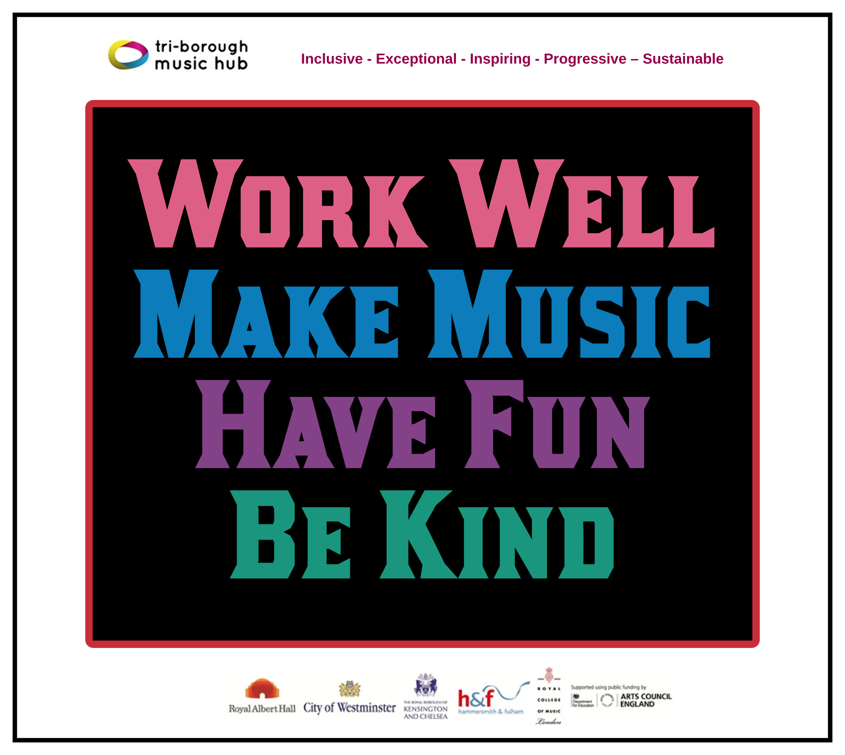
Due to the nature of the subject, music teachers can be some of the most isolated staff members in a school. The Music Hub is a community that brings together music teachers into a collective whole through network meetings, CPD programmes, and other opportunities. With this in mind, we ask that all schools actively connect with the Music Hub and encourage their music teacher(s) to engage in what we have to offer. We will also be able to help all schools navigate planning for the implementation of the new National Plan for Music Education. Please can the lead for music in each school directly contacts sueling.chan@rbkc.gov.uk (TBMH Schools’ Administrator) so we can update all contact records.

This update lists the support we provide and the opportunities that are open to all schools. We can assure all schools that we are only focused on providing high-quality music education support, guidance, and learning that actively helps schools with the delivery of outstanding music. We sincerely hope that all schools will engage with us in the 2022-23 academic year and that together we can forge ahead on the basis that together we are stronger.
Tri-borough Music Hub
Inclusive - Exceptional - Inspiring - Progressive – Sustainable

With thanks from the TBMH team

Music Hub Contacts
Sue Ling Chan, Schools’ Administrator, sueling.chan@rbkc.gov.uk
Shannen Bassett, Ensemble’s Administrator, shannen.bassett@rbkc.gov.uk
Kerensa Briggs, Interim Saturday Music School Administrator kerensa.briggs@rbkc.gov.uk
Hannah Keohane, Instrumental Lead, hannah.keohane@rbkc.gov.uk
Katie Stuffelbeam, SMS Manager & Fundraising Lead, katie.stuffelbeam@rbkc.gov.uk
Evie Asio-Okwalinga, Vocal Lead, evie.asio-okwalinga@rbkc.gov.uk
Emily Stratford, SEND Strategic Lead Consultant, emily.stratford@triboroughmusichub.org
Alex Wood, Business Manager, alex.wood@rbkc.gov.uk
Louisa Roberts, Schools and Curriculum Leader louisa.roberts@rbkc.gov.uk
Head, Stuart Whatmore stuart.whatmore@rbkc.gov.uk

Please contact the Music Hub with any questions or for more information; or to provide any feedback – good, bad, or otherwise – musichub@rbkc.gov.uk.

