Tri-borough Music Hub
Inclusive - Exceptional - Inspiring - Progressive – Sustainable

Each school will have their own way of delivering the music curriculum and extra-curricular music, either through in-house subject specialists or via external music providers.

Irrelevant of how a school delivers its music activity, the Music Hub is here to support and work with all schools.

Engaging with the Music Hub will be advantageous for all schools as there are many FREE opportunities we can provide in partnership with the brilliant arts organisations we collaborate with in the three boroughs including the Royal Albert Hall and the Royal College of Music, and many more.

There is also the opportunity for your students to participate in multi-school performance events, and all teachers to access CPD and networks.

It is the aim of the Tri-borough Music Hub to have a meaningful relationship with 100% of all state-maintained schools. Please do contact us, get involved, and help us help you enhance your school’s music education provision.

This document has a of summary of key information in four sections:
- Free Curriculum Support Documents
- Performances / Musical Activity
- Programme of Professional Development for the workforce
- Communication Channels
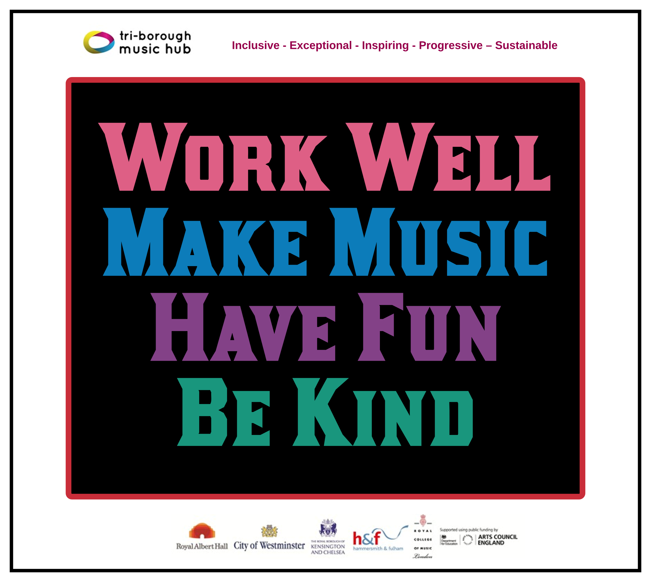

We look forward to working with your school!
Please email Sue Ling Chan, Schools’ Administrator, sueling.chan@rbkc.gov.uk
to give us the contact details of your School’s Subject Music Leader.

- Free Curriculum Support Documents
To help all schools with curating a solid music curriculum, the Music Hub, already provides the following free support documents and teaching resources for all schools which we strongly recommend schools could use as a starting point in reviewing their current delivery.
- Free access to TBMH Virtual Music School (1,500+ online resources)
- Free guidance on Ofsted Inspection Framework and School Music Education Plan
- Free guidance on writing your DfE School Music Development Plan
- Free guidance about the DfE Model Music Curriculum
  - This summary will help schools to see the progression within Year groups and Key Stages
- Free music education school Self-evaluation Tool
  - Answer the prompt questions and you will be able to get a clearer picture of where your schools may sit within a framework of Silver/Gold/Platinum which tallies with the Artsmark framework.
- Free tools to create your own School / Setting Music Policy
  - Answer the prompt questions and you will be able to present a summarised description about how music is delivered in your school
  - Separate interactive EYFS self-assessment is HERE
- Free Singing Assembly Resource (HERE) for KS1, KS2, KS3
- Free KS3-5 Resources
  - Music Production – T&L Resources (HERE)
  - Song writing – T&L Resources (HERE)
  - Hip-Hop – T&L Resources (HERE)
  - Teaching young people with SEND additional resources (HERE)
- Free SEND-friendly Vocal Resource (20 songs)

Music Makes Me - Additional Teaching & Learning Song-writing Resource (Main page HERE)
- (Click HERE to download PDF of the resource)
The purpose of this resource is to look at how song writing can be brought into every classroom/school and can be accessed by teachers and students. By using this resource, schools will be able to co-create brand new song(s) that could represent a school anthem, class anthem, Year group anthem etc. This resource covers five song strands: Social Story Songs; Transition Songs; Emotional Regulation songs; Topic Songs; Celebration Songs.

- Performances / Musical Activity
Christmas Festivals (Upper KS2): Register HERE by 25th Sept
- Weds 18th Oct twilight: Christmas Fest CPD session @Lyric 16:15-18:00
- Mon 27th and Tues 28th Nov: rehearsal dates @Kensington Town Hall (KTH)
- Tues 12th, Weds 13th, Thurs 14th Dec: performance days @KTH
- NB: More information about the festival can be found in this document - click HERE

Future Sounds (KS3-5): Register HERE by 26th January
This a school-focused contemporary music event open to any 11-18 years olds who live or go to school in one of the three LAs.
- Tues 30th Jan – Future Sounds Prelims @The Rhythm Studio
- Weds 20th March – Future Sounds Final @Bush Hall

Playing Days: Register HERE by 26th January
These are targeted at any students who are circa Grade 1-4, either coming from schools or from TBMH Saturday Music School. Students come together to play in a massed ensemble and experience the joy of massed ensemble playing with students from multiple schools. The playing days usually attract c.100-150 students per event coming from c.30 schools and elective home educated pupils.
- Mon 25th March: Strings Playing Day at St. John’s Smith Square
- Weds 27th March: Wind, Brass, Percussion @KTH
- Weds 27th March: Guitar Playing Day @KTH
Infant Voices Festival (KS1, Lower KS2): Register HERE by 28th March
This is a school focused event. We aim to have 15 schools, c.350 students performing.
- Weds 13th March for Infant Voices CPD @Lyric
- Tues 25th June: Infant Voices performance day @KTH.

Makaton Choir Pilot:
We hope this pilot will be a blueprint for a wider scope Makaton Choir that will involve both SEND and Mainstream schools within the hub. The focus will be on the journey of music making, communication, relationship building and creating opportunities for in-house/meaningful/accessible performance opportunities. For more information contact emily.stratford@triboroughmusichub.org.

- Programme of Professional Development for the workforce
We deliver a large amount of professional development for the workforce whether it is for our tutors, subject music leaders in schools, students at the Royal College of Music, Early Years professionals, or our Partner Organisations. Below is a summary of the training programmed in 2023-24.

School Music Teachers Network Meetings
We run a network meeting every half-term for School Subject Music Leaders, both Primary and Secondary Phases together. Each meeting has a specialist focus and time for colleagues to network:
- 21st September – at RCM with a focus on writing School Music Development Plans, and a session from Inspire-Works, book HERE
- 30th November – online, book HERE
- 16th January – online, book HERE
- 13th March – at Lyric, in conjunction with Infant Voices festival INSET, book HERE
- 8th May – in person, venue TBC, book HERE
- 9th July – in person, venue TBC, book HERE

SEND Focus CPD:
- 28th September: Singing Hands CPD, book HERE
As part of our SEND focused CPD sessions, we start the year with this session looking at Makaton signing and hot to better incorporate it into regular musical activity.
- 22nd November: Online resources from ENO and Aurora Orchestra, book HERE
A focus on supporting non-specialist teachers as well as providing a broad curriculum offer, focusing on Opera and Classical genres.

Tues 17th October CPD:
We are running two separate sessions in conjunction with external providers for tutors, school teachers, RCM student mentors:
  - 10.00-1.00 Identifying Musical Talent & Potential, book HERE, led by Awards for Young Musicians.
  - 2.00-4.00 Intro to Choral Leadership in the Primary & Secondary School, book HERE, led by Voices Foundation
School Performance event INSET:
For our two massed-school performance events we deliver a specific INSRT session where we share all teaching and learning resources, go through the repertoire, and discuss top tips for making it successful with the children.
- 18th October: Christmas Festival INSET
- 13th March: Infant Voices INSET / School Music Teachers Network Meeting

Groove’n’Play Training for Whole Class Instrumental Learning Programmes
Each year we programme a series of CPD sessions for tutors and school teachers based on the nine different programmes. These tend to happen in June/July but this might move in 2023-24.

- Communication channels

WhatsApp groups:
- Primary Phase: Join HERE
- Secondary Phase: Join HERE
- SEND: Join HERE

Social media:
- Instagram: https://www.instagram.com/triboroughmusichub/
- X / Twitter: https://twitter.com/TBMHMusic
- Facebook: https://www.facebook.com/TriBoroughMusicHub

E-newsletters:
- All past editions: HERE
- Sign-up here: HERE

Music Hub Contacts
- Sue Ling Chan, Schools’ Administrator, sueling.chan@rbkc.gov.uk
- Shannen Bassett, Ensemble’s Administrator, shannen.bassett@rbkc.gov.uk
- Kerensa Briggs, Interim Saturday Music School Administrator kerensa.briggs@rbkc.gov.uk
- Hannah Keohane, Instrumental Lead, hannah.keohane@rbkc.gov.uk
- Katie Stuffelbeam, SMS Manager & Fundraising Lead, katie.stuffelbeam@rbkc.gov.uk
- Evie Asio-Okwalinga, Vocal Lead, evie.asio-okwalinga@rbkc.gov.uk
- Emily Stratford, SEND Strategic Lead Consultant, emily.stratford@triboroughmusichub.org
- Alex Wood, Business Manager, alex.wood@rbkc.gov.uk
- Louisa Roberts, Schools and Curriculum Leader louisa.roberts@rbkc.gov.uk
- Head, Stuart Whatmore stuart.whatmore@rbkc.gov.uk

Please contact the Music Hub with any questions or for more information; or to provide any feedback – good, bad, or otherwise – musichub@rbkc.gov.uk.

