Start of Year Updates for Schools from the Music Hub

Headline summary of opportunities for all Subject Music Leaders to consider
(NB: more detailed info can be found later in this document):

Autumn Term (September to December 2023)
Date / Time | Event | Audience | Venue | Booking link
Thurs 21st Sept, 4.00-6.00pm | School Subject Music Leaders Network | Primary & Secondary phases combined | Royal College of Music | HERE
Thurs 28th Sept, 4.00-6.00pm | Singing Hands  CPD | SEND Music Teachers | Queensmill School | HERE
Tues 17th Oct, 10.00-1.00 | Identifying Musical Talent & Potential  CPD | School Subject Music Leaders | Royal College of Music | HERE
Tues 17th Oct, 2.00-4.00 | Intro to Choral Leadership in the Primary & Secondary School  CPD | School Subject Music Leaders | Royal College of Music | HERE
Thurs 30th Nov, 4.30-6.00pm | School Subject Music Leaders Network | Primary & Secondary phases combined | Online / Zoom | HERE
Tues 12th Dec | Christmas Singing Festival A  Musical Activity | KS2 pupils | Kensington Town Hall | Register HERE by 25th Sept
Weds 13th Dec | Christmas Singing Festival B  Musical Activity | KS2 pupils | Kensington Town Hall | Register HERE by 25th Sept
Thurs 14th Dec | Christmas Singing Festival C  Musical Activity | KS2 pupils | Kensington Town Hall | Register HERE by 25th Sept

Spring Term (January to March 2024)
Date / Time | Event | Audience | Venue | Booking link
Tues 16th Jan,  4.30-6.00pm | School Subject Music Leaders Network | Primary & Secondary phases combined | Online / Zoom | HERE
Tues 30th Jan, 4.00-6.00pm | Future Sounds Prelims  Musical Activity | KS3-5 contemporary acts | Rhythm Studio | Register HERE by 26th Jan
Weds 13th Mar, 4.15-6.15pm | School Subject Music Leaders Network | Primary & Secondary phases combined | In-person at Lyric | HERE
Weds 20th Mar, 7.00-9.30pm | Future Sounds Final  Musical Activity | KS3-5 contemporary acts | Bush Hall | Register HERE by 26th Jan
Mon 25th Mar, 9.30-3.00 | Strings Playing Day  Musical Activity | KS2-3  (Grades 1-4) | St. John’s Smith Square | Register by 15th Dec  HERE
Weds 27th Mar, 9.30-3.00 | Guitars Playing Day  Musical Activity | KS2-3  (Grades 1-4) | Kensington Town Hall | Register by 15th Dec  HERE
Weds 27th Mar, 9.30-3.00 | Wind, Brass & Percussion Playing Day  Musical Activity | KS2-3  (Grades 1-4) | Kensington Town Hall | Register by 15th Dec  HERE

Summer Term (April to July 2024)
Date / Time | Event | Audience | Venue | Booking link
Week 15th Apr TBC | SEND Event TBC  CPD | All music educators | TBC | TBC
Weds 8th May,  4.30-6.00pm | School Subject Music Leaders Network | Primary & Secondary phases combined | In-person, venue TBC | HERE
Tues 25th June, 9.30-2.00 | Infant Voices Festival  Musical Activity | KS1 | Kensington Town Hall | Register by Fri 28th Feb HERE
Tues 9th July | School Subject Music Leaders Network | Primary & Secondary phases combined | In-person, venue TBC | HERE

More CPD events will be added over the course of the year and we will update this page when more information is available
- New Schools and Curriculum Music Leader
We are pleased to confirm that Louisa Roberts has now joined the team in the post of Schools and Curriculum Music Leader, working 3-days per week for an initial 12-monty period. Louisa has a wealth of knowledge and will be here to support all music subject leaders in schools. She can be contacted on louisa.roberts@rbkc.gov.uk.

- CPD and Training Opportunities – Sept & Oct
Planning for the 2023-24 Academic year
Thurs 21st Sept, School Subject Music Leaders Network at RCM, 4.00-6.00pm, book HERE
This event, hosted at the Royal College of Music, is for all School Subject Music Leaders (Primary and Secondary phases combined). We will:
- Focus on how to approach writing/forming School Music Development Plans
Led by Dr Mary Stakelum (Area Leader in Music Education, Royal College of Music),
and Nicole Latham (Music teacher, Wendell Park primary school)
- Participate in a practical session with Inspire-works Led by Mike Simpson (Founder and Director of Inspire-works)
- Share current best practice happening in schools.

Tues October 17th CPD at RCM, 10.00-4.00
We strongly recommend subject music leaders request release from their school to attend this day of training at the Royal College of Music. We have organised for two external specialist organisations to deliver this training with direct impact on teaching practice. This training day is aimed at TBMH tutors, Subject Music Leaders in Schools, and RCM Student Mentors.
- 10.00-1.00 Identifying Musical Talent & Potential, book HERE, led by Awards for Young Musicians.
Identifying Musical Talent and Potential exists to make music education fairer. It tackles one of the biggest obstacles to young people’s musical progress - identifying those with talent and potential, especially in whole class or larger group settings. This interactive session will take us through the 8 facets of musical potential and help us consider how they approach their learners.
- 2.00-4.00 Intro to Choral Leadership in the Primary & Secondary School, book HERE, led by Voices Foundation
Delivery: 2 hours of Choral leadership training & delivery led by Voices Foundation’s Choral Director, Charles MacDougall. Core skills to be explored through sessions may include:
  - Voice knowledge
  - Effective & healthy warm-ups
  - Healthy singing
  - Gesture and getting started at leading group singing
  - Suitable repertoire
  - How to develop students further and the introduction of aspirational repertoire

- DfE Annual Data Collection of school Music Delivery
Each year, all schools are expected by the DfE to provide data about how they deliver their music education, curriculum, and any other connected aspects of instrumental/vocal teaching. Music Hubs are asked to collect this on their behalf, and this is then submitted as a central set of date covering all three LAs. Every state-maintained school in the three LAs was sent a unique link in July via Survey Monkey requesting your school’s data to be completed. A reminder was sent on 1st September with the request to complete this by Fri 22nd September, even if the answers are guestimates, or unsure. Your help will be greatly appreciated.

- Performance events for 2023-24 academic year
Christmas Festivals (Upper KS2): Register HERE by 25th Sept
- Weds 18th Oct twilight: Christmas Fest CPD session @Lyric 16:15-18:00
- Mon 27th and Tues 28th Nov: rehearsal dates @Kensington Town Hall (KTH)
- Tues 12th, Weds 13th, Thurs 14th Dec: performance days @KTH
More information about the festival can be found in this document - click HERE

Future Sounds (KS3-5): Register HERE by 26th Jan
- Tues 30th Jan – Future Sounds Prelims
- Weds 20th March – Future Sounds Final
Playing Days: HERE
- Mon 25th March: Strings Playing Day @SJSS
- Weds 27th March: Wind, Brass, Percussion, & Guitar Playing Day @KTH

Infant Voices Festival (KS1, Lower KS2): Register by Fri 28th Feb HERE
- Weds 13th March for Infant Voices CPD @Lyric TBC
- Tues 25th June: Infant Voices performance day @KTH.
- Reminder: Curriculum Support T&L Resources | National Plan for Music Education
We will be looking at School Music Development Plans in the CPD session on 21st Sept (HERE). In the meantime, below we are re-sharing the free curriculum guidance documents available to help support all schools.

School Music Development Plan

Every school should be able to articulate their plan for delivering high-quality music education and supporting pupils to progress, just as they would in any other curriculum subject. The new National Plan for Music Education (NPME) states that every school (including multi-academy trusts) should have a Music Development Plan that captures the curricular and co-curricular offer and sets out how it will be staffed and funded.

Whilst acknowledging that it is not a statutory requirement, the new National Plan recommends that schools should have a music development plan in place by 2023/24. This document HERE might help all schools with planning for how they begin writing their school music development plan.

Summary of the NPME for schools
The new NPME is a significant milestone in how music must be delivered in ALL schools.

The document direct link is HERE.

A host of supporting information has been prepared to help schools understand the implications by Music Mark (HERE) and the Music Teachers Association (HERE).

A summary of the NPME for schools can be found HERE.

We have prepared a TBMH video about how schools can approach inclusive music education linked to the NPME can be found – HERE

To note: All schools need to consider the guidance for implementation and aim to have a Music Development Plan in place for academic year 2023/2024. This will inform the areas for development and celebrate success. The Music Teachers’ Association and Music Mark have developed a self-reflection tool to support this process: HERE

Music Hub FREE Curriculum Support
To help all schools with curating a solid music curriculum, the Music Hub, already provides the following free support documents and teaching resources for all schools which we strongly recommend schools could use as a starting point in reviewing their current delivery.

  - Free access to TBMH Virtual Music School (1,500+ online resources)
  - Free guidance on Ofsted Inspection Framework and School Music Education Plan
  - Free guidance on writing your DfE School Music Development Plan
  - Free guidance about the DfE Model Music Curriculum
- This summary will help schools to see the progression within Year groups and Key Stages
- Free music education school Self-evaluation Tool
- Answer the prompt questions and you will be able to get a clearer picture of where your schools may sit within a framework of Silver/Gold/Platinum which tallies with the Artsmark framework.
- Free SEND-friendly Vocal Resource (20 songs)
- Free tools to create your own School / Setting Music Policy
  - Answer the prompt questions and you will be able to present a summarised description about how music is delivered in your school
- Free KS3-5 Resources
- Music Production – T&L Resources (HERE)
- Song writing – T&L Resources (HERE)
- Hip-Hop – T&L Resources (HERE)
- Teaching young people with SEND additional resources (HERE)
- Music Mark School Invite for the 23-24 Year
As part of the TBMH’s FREE support of schools, all schools have now received an invitation email from us on becoming a Music Mark school for this year. This is FREE. The benefits of joining include discounted rates when using the vacancy advertising service, access to an extensive library of member-only resources, newsletters to stay updated with national and regional news, and many more. We encourage schools to sign up as early as possible so they can benefit from the resources sooner rather than later. Please email sueling.chan@rbkc.gov.uk for any questions or issues.

- Out of school opportunities for your pupils, please share with families
The Music hub provides a range of opportunities for young people to engager with outside of their school time. All info here. We are particularly keen to have new members join:
- Next Level Voices: Choir for Pupils in Yr7-Yr13
- First Sounds: Ensemble for instrumentalists up to Grade 1
- Breakout Band: Ensemble for instrumentalists from Grade 2-4
- Guitar Ensemble: Ensemble for guitarists from beginner to Grade 4
- Symphonic Band: Ensemble for instrumentalists from Grade 5-8+
- Music Production GarageBand: Open to learners aged 7-11
- Music Production Logic Pro X: Open to learners aged 12-18

We ask that school music leaders share this information with their families via any school communications:
“The Tri-borough Music Hub is the local place that supports musical learning, in and of school, across Hammersmith & Fulham, Kensington & Chelsea, and Westminster. Our choirs, ensembles and music production classes run after school at the Lyric in Hammersmith and our Saturday Music School (based at Latymer Upper School) offers instrumental/vocal lessons, musicianship, choirs and ensembles.

If your child has been learning an instrument for at least a term, an ensemble is the ideal way to reinforce what is being learnt in lessons, develop group playing skills and boost self-confidence by regular performances. It’s a great way to make friends from other schools too!

Children interested in joining our choirs do not need to be having vocal lessons, only a passion to sing and desire to experience the positive benefits of singing in a group: connecting with others, releasing endorphins, and reducing stress to name a few!

Please explore our online brochure here for more information and apply now to avoid disappointment. Any queries can be sent to info@triboroughmusichub.org. We look forward to welcoming new pupils from September.”

- Join the TBMH Youth Voice Council!
We are looking for more young people from our secondary schools to join our Youth Voice Council - a group of musicians representing the voices of students from Hammersmith & Fulham, Kensington & Chelsea, and Westminster:
- Network with other musicians in the Tri-borough and nationally.
- Organise and take part in special events.
- Meet and have discussions with music industry professionals.
- Have a say on how the Tri-borough can improve to help young people.
Most importantly, the work of the Youth Voice Council is steered by young people, so they get to have a say in how they want to use it. The council meets on Fridays at 4:30pm online, approximately 4 times a term, and is free of charge. In-person events will also be organised throughout the year. To become a member, students can sign-up HERE. Further info and questions, please email evie.asio-okwalinga@rbkc.gov.uk

- Partner Opportunities
Royal Albert Hall Future Makers Concert – Tues 17 October
The RAH have an exclusive ticket offer for all TBMH schools to their upcoming concert hosted by Jess Gillam and LionHeart. Children tickets are £1 each and teachers can attend for free. Future Makers is a new schools concert which showcases incredible young musicians from across London and inspires your students on their musical journey to become the next generation of Future Makers. This features a specially written resource pack created to support your students both in the classroom and at home. To access the tickets, please click HERE. Questions and more info, contact engagement@royalalberthall.com.

Free Art Therapy for Two Schools in RBKC and/or WCC With In-Deep
In-Deep is a registered charity that works with young people with SEND and isolated older people. They have been running for 22 years and their activities and services include music therapy, art therapy, and holiday arts-based workshops. In-Deep are offering free art therapy twice a month for one hour in one year; schools must either be a special school or have a specialist unit. For further info, please see flyer attached or email emma.chapman@in-deep.org.uk.

Maxim VR – Pilot for Secondary and SEND Schools
We are able to bring an exciting pilot program to your attention from Maxim VR: creating non-toxic virtual reality spaces for children and teenagers with the mission to improve the health and wellbeing of young people worldwide. They are looking for Secondary (mainstream/SEND/resource provisions) to participate in a pilot to improve mental health and wellbeing using Virtual Reality (VR). Below is some general information, you can watch a short video (click HERE), you can read the pilot project plan (click HERE) explaining in more detail about the pilot, and you can register (click HERE) if you are interested.

Timeline
- 3-month period, starting in October 2023

Study Group
- 40 London-based school
- One class (approx 30 students) of each school Age between 14-16
- Overall around 1.200 students

Resources and Instructions
- The study will help Maxim VR to collect data and generate evidence on how Maxim VR is improving the mental health and well-being of young people. It will also help us to better understand the impact of mental health struggles on the learning performance of students.
- Meta is going to donate 2-3 meta oculus quest 2 glasses to each school
- There will be no costs involved for participating schools
- Maxim VR will be pre-installed on VR glasses for easy app access
- The glasses will be delivered with clear instructions.
- In-person support is available if needed
- Each participating student will log in with their first name, email and the year they were born. A password will protect users' login information
- Each student is required to attend a minimum of 3 sessions per week.
- Each session is around 5min
- We will also provide additional resources and training materials for attendees provided by mental health organisations

Please email lisa@maxim-app.com if you have any questions

- Royal Albert Hall presents Elye Cuthbertson – TBMH Alumni
On 17th September, the first-ever winner of the RAH’s Future Makers event, Elye Cuthbertson, will be performing his compositions on Melodeon that were written during the Covid-19 pandemic. Elye will perform the compositions in person for the first time, and he will be joined by featured artists who will bring their own style to the pieces. The RAH are offering £5 tickets for any students and teachers in the Tri-borough who would like to attend. Please use the promotional code FolkOffer23 in the link HERE.

Working with Schools and settings

To ensure your school can access the full range of free support and opportunities provided by the Music Hub and its partners for your pupils and staff, we ask that this message is shared with Senior Leaders, Music Leaders, and Governors.

The Tri-borough Music Hub has strong links with the schools/settings across the three LAs and we are continuing our support to enhance and amplify how each school delivers their own music curriculum. We have a proven track record of providing high-quality, progressive, and inclusive music education which has a direct and positive impact on school communities. We can provide opportunities that will enhance your school – the majority of which are free, or heavily subsidised – for your pupils, teachers, and wider community.

At a time of such challenge that we all find ourselves in, we strongly advocate that all schools maintain close and strong links with the Music Hub. We understand the pressures you face and are here to work with you and for you. Together we can make music remain a strong curriculum and extra-curricular subject that brings added value to every school.

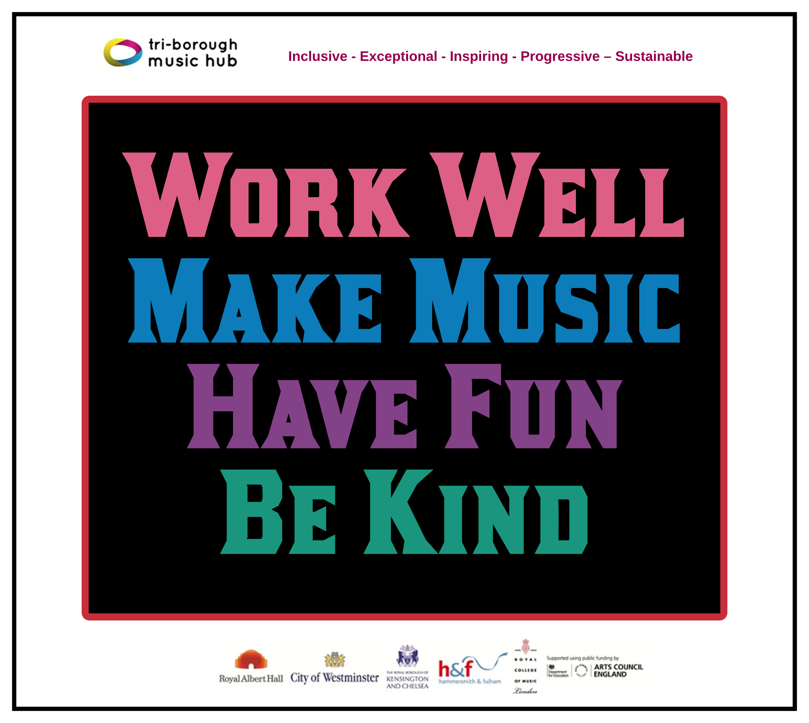
Due to the nature of the subject, music teachers can be some of the most isolated staff members in a school. The Music Hub is a community that brings together music teachers into a collective whole through network meetings, CPD programmes, and other opportunities. With this in mind, we ask that all schools actively connect with the Music Hub and encourage their music teacher(s) to engage in what we have to offer. We will also be able to help all schools navigate planning for the implementation of the new National Plan for Music Education. Please can the lead for music in each school directly contacts sueling.chan@rbkc.gov.uk (TBMH Schools’ Administrator) so we can update all contact records.

This update lists the support we provide and the opportunities that are open to all schools. We can assure all schools that we are only focused on providing high-quality music education support, guidance, and learning that actively helps schools with the delivery of outstanding music. We sincerely hope that all schools will engage with us in the 2022-23 academic year and that together we can forge ahead on the basis that together we are stronger.
Tri-borough Music Hub
Inclusive - Exceptional - Inspiring - Progressive – Sustainable

With thanks from the TBMH team

Music Hub Contacts
Sue Ling Chan, Schools’ Administrator, sueling.chan@rbkc.gov.uk
Shannen Bassett, Ensemble’s Administrator, shannen.bassett@rbkc.gov.uk
Kerensa Briggs, Interim Saturday Music School Administrator kerensa.briggs@rbkc.gov.uk
Hannah Keohane, Instrumental Lead, hannah.keohane@rbkc.gov.uk
Katie Stuffelbeam, SMS Manager & Fundraising Lead, katie.stuffelbeam@rbkc.gov.uk
Evie Asio-Okwalinga, Vocal Lead, evie.asio-okwalinga@rbkc.gov.uk
Emily Stratford, SEND Strategic Lead Consultant, emily.stratford@triboroughmusichub.org
Alex Wood, Business Manager, alex.wood@rbkc.gov.uk
Louisa Roberts, Schools and Curriculum Leader louisa.roberts@rbkc.gov.uk
Head, Stuart Whatmore stuart.whatmore@rbkc.gov.uk

Please contact the Music Hub with any questions or for more information; or to provide any feedback – good, bad, or otherwise – musichub@rbkc.gov.uk.

