Updates for Schools from the Music Hub – July 2023

- CPD for School Music Teachers / Leaders – Register now
We strongly encourage school music teachers to sign-up to these opportunities to maximise the benefit and impact on work back in schools. These have been organised specifically with school music teachers in mind.

- Thurs 21st Sept, School Subject Music Leaders Network at RCM, 4.00-6.00pm, book HERE
This event, hosted at the Royal College of Music, is for all School Subject Music Leaders (Primary and Secondary phases combined). We will:
- Focus on how to approach writing/forming School Music Development Plans
Led by Dr Mary Stakelum (Area Leader in Music Education, Royal College of Music),
and Nicole Latham (Music teacher, Wendell Park primary school)
- Participate in a practical session with Inspire-works
Led by Mike Simpson (Founder and Director of Inspire-works)
- Share current best practice happening in schools.

- Tues October 17th CPD at RCM, 10.00-4.00
This training day is aimed at TBMH tutors, Subject Music Leaders in Schools, and RCM Student Mentors.
- 10.00-1.00 Identifying Musical Talent & Potential, book HERE, led by Awards for Young Musicians.
Identifying Musical Talent and Potential exists to make music education fairer. It tackles one of the biggest obstacles to young people’s musical progress - identifying those with talent and potential, especially in whole class or larger group settings. This interactive session will take us through the 8 facets of musical potential and help us consider how they approach their learners.
- 2.00-4.00 Intro to Choral Leadership in the Primary & Secondary School, book HERE, led by Voices Foundation
Delivery: 2 hours of Choral leadership training & delivery led by Voices Foundation’s Choral Director, Charles MacDougall. Core skills to be explored through sessions may include:
  - Voice knowledge
  - Effective & healthy warm-ups
  - Healthy singing
  - Gesture and getting started at leading group singing
  - Suitable repertoire
  - How to develop students further and the introduction of aspirational repertoire

We are currently planning lots more CPD sessions covering a range of specific subjects. More information to follow next term.

- SLA School Confirmations for 2023-24
We have now sent confirmation emails to all schools that requested any traded service teaching and learning via the Service Level Agreement for the 2023-24 academic year. If you are expecting SLA work and have not yet received a confirmation email, please contact sueling.chan@rbkc.gov.uk as soon as possible. Please note that as stated in the SLA, schools will be invoiced in advance in the first week of each term.

- DfE Annual Data Collection of school Music Delivery
Each year, all schools are expected by the DfE to provide data about how they deliver their music education, curriculum, and any other connected aspects of instrumental/vocal teaching. Music Hubs are asked to collect this on their behalf, and this is then submitted as a central set of date covering all three LAs. Every state-maintained school in the three LAs will this week have been sent a unique link via Survey Monkey requesting your school’s data to be completed by the end of the summer term. Please do complete this, even if the answers are guestimates, or unsure. Your help will be greatly appreciated.

- Sign up for TBMH Christmas Singing Festival 2023
Each year, as part of our large-scale performance events offer to state-maintained Primary/SEN
schools, the Tri-borough Music Hub presents its highly successful annual Christmas Singing
Festivals.
- Performance dates: Tuesday 12th December; Wednesday 13th December; Thursday 14th December – all at Kensington Town Hall
- More information about the festival can be found in this document - click HERE
- To register please complete the digital form by 25th September
- School Application form: HERE

- Save the dates! Performance events for 2023-24 academic year
We are already planning for a busy and packed performance programme for the 2023-24 academic year. These dates are being shared now to help plan ahead.

Christmas Festivals (Upper KS2):
See earlier item
Future Sounds 2024 (KS3-5): register now, HERE
- Tues 30th Jan – Future Sounds Prelims
- Weds 20th March – Future Sounds Final
Playing Days 2024: (sign-up info to come in September)
- Mon 25th March: Strings Day @ St. John’s Smith Square
- Weds 27th March: Wind, Brass & Percussion; and Guitar playing days @KTH
Infant Voices Festival 2024 (KS1, Lower KS2): (sign-up info to come in September)
- Weds 13th March for Infant Voices CPD @Lyric TBC
- Tues 25th June: Infant Voices performance day @KTH.
NB: This will also involve TBMH’s First Voices choir.

- REMINDER: FREE Curriculum Support T&L Resources | National Plan for Music Education
We will be looking at School Music Development Plans in the CPD session on 21st Sept (HERE). In the meantime, below we are re-sharing the free curriculum guidance documents available to help support all schools.

School Music Development Plan

Every school should be able to articulate their plan for delivering high-quality music education and supporting pupils to progress, just as they would in any other curriculum subject. The new National Plan for Music Education (NPME) states that every school (including multi-academy trusts) should have a Music Development Plan that captures the curricular and co-curricular offer and sets out how it will be staffed and funded.

Whilst acknowledging that it is not a statutory requirement, the new National Plan recommends that schools should have a music development plan in place by 2023/24. This document HERE might help all schools with planning for how they begin writing their school music development plan.

Summary of the NPME for schools
The new NPME is a significant milestone in how music must be delivered in ALL schools.

The document direct link is HERE.

A host of supporting information has been prepared to help schools understand the implications by Music Mark (HERE) and the Music Teachers Association (HERE).

A summary of the NPME for schools can be found HERE.

We have prepared a TBMH video about how schools can approach inclusive music education linked to the NPME can be found – HERE

To note: All schools need to consider the guidance for implementation and aim to have a Music Development Plan in place for academic year 2023/2024. This will inform the areas for development and celebrate success. The Music Teachers’ Association and Music Mark have developed a self-reflection tool to support this process: HERE

Music Hub FREE Curriculum Support
To help all schools with curating a solid music curriculum, the Music Hub, already provides the following free support documents and teaching resources for all schools which we strongly recommend schools could use as a starting point in reviewing their current delivery.

  - Free access to TBMH Virtual Music School (1,500+ online resources)
  - Free guidance on Ofsted Inspection Framework and School Music Education Plan
  - Free guidance on writing your DfE School Music Development Plan
  - Free guidance about the DfE Model Music Curriculum
- This summary will help schools to see the progression within Year groups and Key Stages
- Free music education school Self-evaluation Tool
- Answer the prompt questions and you will be able to get a clearer picture of where your schools may sit within a framework of Silver/Gold/Platinum which tallies with the Artsmark framework.
- Free SEND-friendly Vocal Resource (20 songs)
- Free tools to create your own School / Setting Music Policy
  - Answer the prompt questions and you will be able to present a summarised description about how music is delivered in your school
- Free KS3-5 Resources
- Music Production – T&L Resources (HERE)
- Song writing – T&L Resources (HERE)
- Hip-Hop – T&L Resources (HERE)
- Teaching young people with SEND additional resources (HERE)

- Future Sounds – Winners A.M.B. record at Abbey Road Studios
Following their success as being named the winners of TBMH’s Future Sounds 2023, we are thrilled that A.M.B. have used their incredible prize of recording at Abbey Road Studios. Read this item from Westminster City School about their day (click HERE).

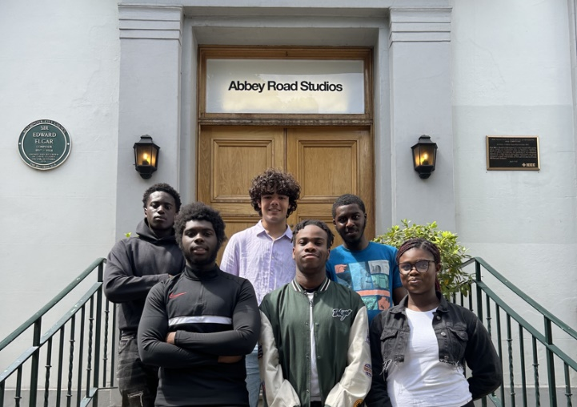
Sign-up for Future Sounds 2024 now: register HERE

- Maxim VR – Pilot for Secondary and SEND Schools
We are able to bring an exciting pilot program to your attention from Maxim VR: creating non-toxic virtual reality spaces for children and teenagers with the mission to improve the health and wellbeing of young people worldwide.

They are looking for Secondary (mainstream/SEND/resource provisions) to participate in a pilot to improve mental health and wellbeing using Virtual Reality (VR). Below is some general information, you can watch a short video (click HERE), you can read the pilot project plan (click HERE) explaining in more detail about the pilot, and you can register (click HERE) if you are interested.

Timeline
- 3-month period, starting in October 2023
Study Group
- 40 London-based school
- One class (approx 30 students) of each school Age between 14-16
- Overall around 1.200 students
Resources and Instructions
The study will help Maxim VR to collect data and generate evidence on how Maxim VR is improving the mental health and well-being of young people. It will also help us to better understand the impact of mental health struggles on the learning performance of students.
- Meta is going to donate 2-3 meta oculus quest 2 glasses to each school
- There will be no costs involved for participating schools
- Maxim VR will be pre-installed on VR glasses for easy app access
- The glasses will be delivered with clear instructions.
- In-person support is available if needed
- Each participating student will log in with their first name, email and the year they were born. A password will protect users' login information
- Each student is required to attend a minimum of 3 sessions per week.
- Each session is around 5min
- We will also provide additional resources and training materials for attendees provided by mental health organisations
Please email lisa@maxim-app.com if you have any questions.

- Survey: Delivery of SEND Music in your SEND Setting
We want to learn more about your SEND provision and how we can best support you as a Music Hub. This survey is designed for the allocated person delivering music in your setting. We ask that they fill out this survey below to the best of their knowledge. https://tbmh.wufoo.com/forms/zh5auql1w8a50z/
We appreciate that this is quite a lengthy form and want to assure you that your feedback will directly inform the planning of upcoming CPD and will address the areas of need in your SEND setting. Outcomes include the hub supporting areas of development in the delivery of music in your setting through CPD and facilitating partnerships. We will also aim to up-skill staff and support in creating ambitious and robust Music curriculum for the best possible music education for your young people.
Please aim to have it completed before the end of the academic year (July 21st). Thank you in advance for your input. For more information contact
emily.stratford@triboroughmusichub.org
Emily Stratford, SEND Strategic Lead Consultant

- Music Makes Me – Media now available
Presenting Music Makes Me was a huge collaborative team effort, and we are thankful to every single person who helped to make it happen. We are now able to share with you the media collection from the event. Everything can be found in one place on our website (https://www.triboroughmusichub.org/school-services/music-makes-me/) and also we have collated it into this document (MMM – Media and Links).

Films, Photos, and Media
All the media is provided free, at no cost to anyone. This is part of our ongoing financial support to our families, schools, and community. Follow all links to explore the available media.
- Full Performance: click HERE
- Event Day Documentary: click HERE
- All songs as separate music videos can be accessed: click HERE
- Digital Programme: click HERE
- PDF of the programme: click HERE
- Photo Gallery: click HERE
NB: you will need to register (for free) to access the photos. Low-res photos are free, high-res photos are charged.
- Behind the scenes photos: click HERE

Please share with your students/families
- Nominate a pupil in your school to join TBMH Youth Voice Council
Please sign-post any keen pupils to take part in the TBMH Youth Voice council from September, sign up here https://tbmh.wufoo.com/forms/zifvb1e0wf85kr/.

- Join TBMH out-of-school Classes from September
Want to join a choir, ensemble, learn about music production, or come to our Saturday Music School? Well lucky for you, applications are now open for a September start. You can browse our e-brochure to see classes we offer after-school and at our Saturday Music School here: https://online.fliphtml5.com/gojxt/juyu/#p=1

We ask that school music leaders share this information with their families via any school communications:
“The Tri-borough Music Hub is the local place that supports musical learning, in and of school, across Hammersmith & Fulham, Kensington & Chelsea, and Westminster. Our choirs, ensembles and music production classes run after school at the Lyric in Hammersmith and our Saturday Music School (based at Latymer Upper School) offers instrumental/vocal lessons, musicianship, choirs and ensembles.

If your child has been learning an instrument for at least a term, an ensemble is the ideal way to reinforce what is being learnt in lessons, develop group playing skills and boost self-confidence by regular performances. It’s a great way to make friends from other schools too!

Children interested in joining our choirs do not need to be having vocal lessons, only a passion to sing and desire to experience the positive benefits of singing in a group: connecting with others, releasing endorphins and reducing stress to name a few!

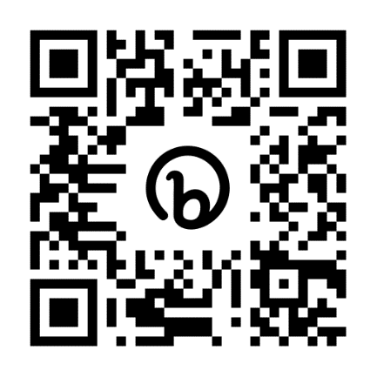
Please explore our online brochure here for more information and apply now to avoid disappointment. Any queries can be sent to info@triboroughmusichub.org. We look forward to welcoming new pupils from September.”

Apply now by scanning the QR code:

Please note you will automatically be placed on our waiting list. Once a place has been allocated to you, we will email you with further information.

Music Hub Contacts
- Sue Ling Chan, School’s Administrator, sueling.chan@rbkc.gov.uk
- Shannen Knutsen, Ensemble’s Administrator, shannen.knutsen@rbkc.gov.uk
- Kerensa Briggs, Interim Saturday Music School Administrator kerensa.briggs@rbkc.gov.uk
- Hannah Keohane, Instrumental Provision Manager, hannah.keohane@rbkc.gov.uk
- Katie Stuffelbeam, Saturday Music School and Fundraising Lead, katie.stuffelbeam@rbkc.gov.uk
- Evie Asio-Okwalinga, Vocal Provision Manager, evie.asio-okwalinga@rbkc.gov.uk
- Alex Wood, Business Manager, alex.wood@rbkc.gov.uk
- Head, Stuart Whatmore stuart.whatmore@rbkc.gov.uk

Please contact the Music Hub with any questions or for more information; or to provide any feedback – good, bad, or otherwise – info@triboroughmusichub.org.

