Media and Links
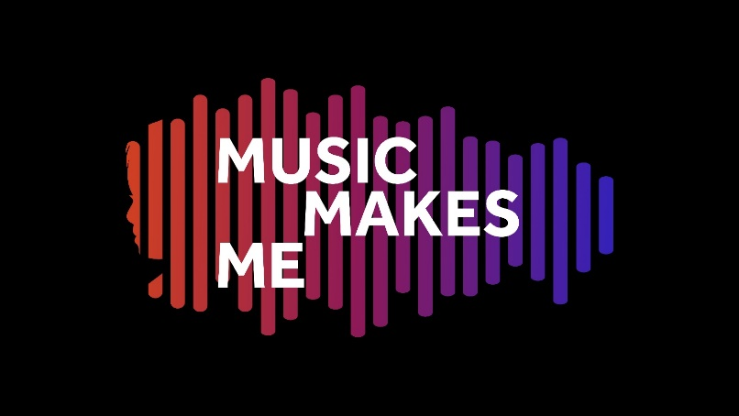
Original Music by:
Emily Stratford and Gabriel Krchnavek

Arranged and Orchestrated by:
Leigh Phillips and Charlotte Harding

Additional Music (Share the Load) by:
Alice Poppleton and Joe Cummings
“(An English National Opera composition in collaboration with New City College Students in July 2022)”

Films, Photos, Media, Programme, and other resources

- Full Performance Film: click HERE
- Event Day Documentary Film: click HERE
- All songs as separate music videos can be accessed: click HERE - see next page for more links
- Performance event Photo Gallery: click HERE
NB: you will need to register (for free) to access the photos. Low-res photos are free, high-res photos are charged.
- Behind the scenes photos: click HERE
- Watch film of famous faces and local students signing the words "Music Makes Me" - CLICK HERE
- MMM Event Page (hosted by Royal Albert Hall): click HERE
- Digital Programme (hosted by Royal Albert Hall): click HERE
- PDF of the programme: click HERE
- Relaxed Visual Story Guide: click HERE
- Lyric Sheet with symbols: click HERE
- Read the press release about the event: Word format (HERE) / PDF format (HERE)

Music Makes Me - Additional T&L Song-writing Resource
The purpose of this resource is to look at how song writing can be brought into every classroom/school and can be accessed by teachers and students. We hope that by using this resource, schools will be able to co-create brand new song(s) that could represent a school anthem, class anthem, Year group anthem etc. This resource covers five song strands:
- Social Story Songs
- Transition Songs
- Emotional Regulation songs
- Topic Songs
- Celebration Songs

- Click HERE to download (PDF of the resource)
- Click HERE to download 5.2 Body Percussion Activity (WORD)

The Music Videos
We were fortunate to work with the amazing Whitestone Media who produced original music videos for each of the songs. They were enhanced by cartoons of Aisha drawn by the talented Jadore. Additional footage was taken from College Park and QE2 schools, Sally Greaves, Groove’n’Play, and Tri-borough Music Hub. Below is a link to each song as an individual video with the full animations.

No. | Title | Vimeo Link | Topic / theme / focus
1 | Overture | https://vimeo.com/844616129?share=copy | (Instrumental only)
2 | In The Morning | https://vimeo.com/844616508?share=copy | Hello / Welcome
3 | Colours Song | https://vimeo.com/844616902?share=copy | Topic / Environment
4 | It’s Music Time | https://vimeo.com/844617200?share=copy | Music Lesson / Hello
5 | Can You Feel the Beat | https://vimeo.com/844617466?share=copy | Music Lesson / Pulse
6 | Shake Your Body | https://vimeo.com/844617905?share=copy | Warm up song
7 | Music is my Medicine | https://vimeo.com/844618320?share=copy | Hearing Impairments / Anthem
8 | It’s Finished | https://vimeo.com/844618811?share=copy | Transition Song
9 | Time for Lunch | https://vimeo.com/844619119?share=copy | Transition Song
10 | Something’s Wrong | https://vimeo.com/844619368?share=copy | (Instrumental only)
11 | Feelings Song | https://vimeo.com/844619673?share=copy | Emotional Regulation / Zones of regulation
12 | Across the City | https://vimeo.com/844611320?share=copy | Topic / Transport
13 | Sushi Song | https://vimeo.com/844611883?share=copy | Topic / Food
14 | Communication Song | https://vimeo.com/844612532?share=copy | Communication / Listening / Social Interaction
15 | Piece of Gold | https://vimeo.com/844612945?share=copy | Visibility / Invisibility / Mental Health Wellbeing
16 | Calm Down | https://vimeo.com/844613377?share=copy | Emotional Regulation / Mindfulness
17 | *Share the Load | https://vimeo.com/844613843?share=copy | Mental Health and Wellbeing
18 | My Own Melody | https://vimeo.com/844614434?share=copy | Vision Impairments / Anthem
19 | Reflections | https://vimeo.com/844615055?share=copy | (Instrumental only)
20 | Music Makes Me | https://vimeo.com/844615492?share=copy | Celebration / Anthem

Music Makes Me is presented by the Tri-borough Music Hub, in co-production with the Royal Albert Hall, and in partnership with the Royal College of Music.

Music Makes Me has been generously supported by many organisations,
charities, trusts, foundations, and personal donors.

ASSOCIATE FUNDERS:
ABRSM
Arts Council England
John S Cohen Foundation
David Soanes
John Lyon’s Charity
London Music Fund

WITH GENEROUS SUPPORT FROM:
Chapman Charitable Trust
Charlotte Stevenson
Diana Salazar
Debbie Beckerman
Ian Adams
Ingles Charitable Trust
John Illsley
Lucille Graham Trust

DELIVERY PARTNERS:
Cultural Inclusion Manifesto
ENO
JK Cartoon Studios
The Rhythm Studio
Tri-borough Music Trust

LOCAL AUTHORITIES:
Hammersmith and Fulham
Kensington and Chelsea
Westminster

To every single person or organisation that has supported our vision, we are eternally grateful, and our thanks go to each of you.

All information correct at time of publication

