Original Music by:
Emily Stratford and Gabriel Krchnavek

Tuesday 27th June 2023 @ Royal AlbertHall
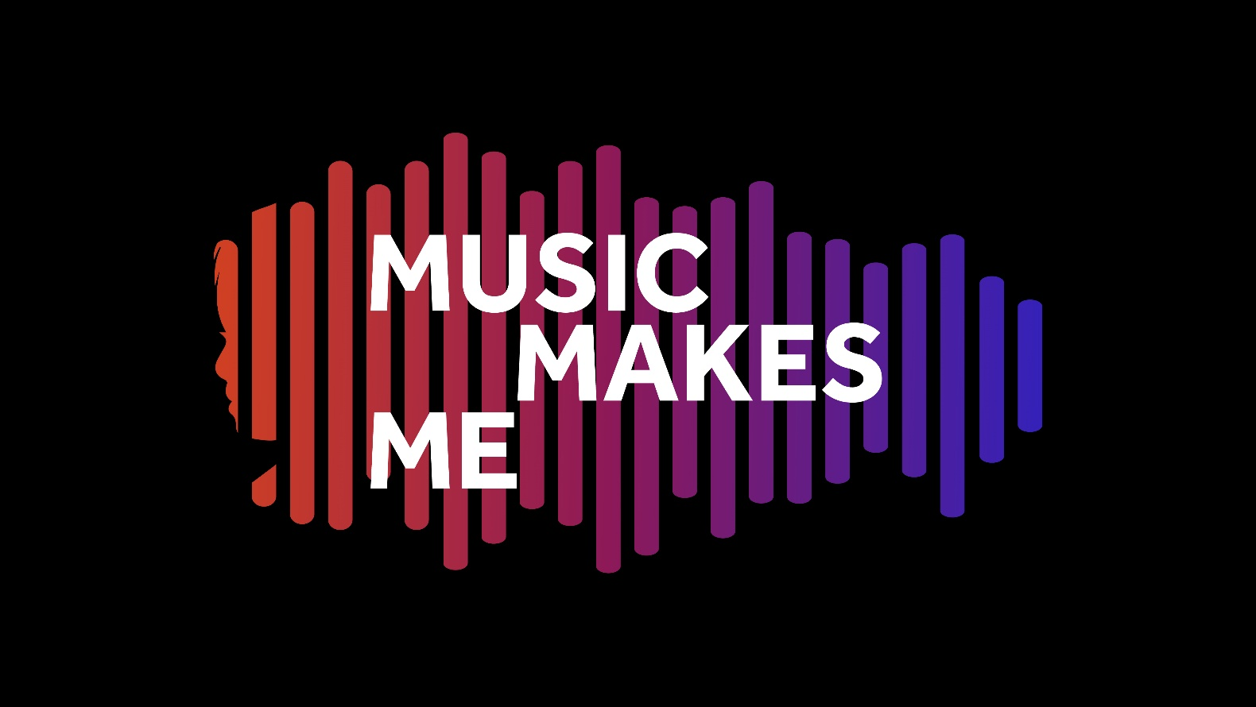

Arranged and Orchestrated by:
Leigh Phillips and Charlotte Harding

Additional Music (Share the Load) by:
Alice Poppleton and Joe Cummings
“(An English National Opera composition in
collaboration with New City College Students in July 2022)”

Tickets for the performance are now on sale HERE:

- £7.50 – Arena, Stalls, Circle
- £15.00 – Loggia Boxes, 2nd Tier Seats

#MusicMakesMeTBMH

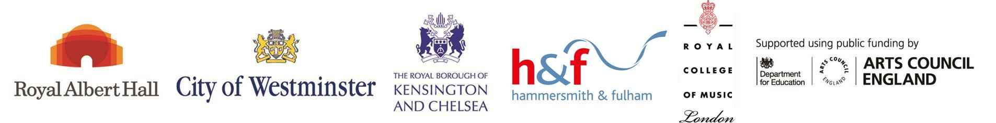
Tri-borough Music Hub presents important new work
Music Makes Me
On Tuesday 27th June 2023 we will be giving the world premiere of Music Makes Me at the iconic Royal Albert Hall. The Tri-borough Music Hub (TBMH), in co-production with the Royal Albert Hall, and in partnership with the Royal College of Music have created this large-scale multi-school music education and performance programme which shines a light on the importance of inclusive practice and celebrating everyone for who they are.

This event follows in the footsteps of previous award-winning TBMH productions, Seven Seeds and Convo, and is a brand-new new work by Emily Stratford and Gabriel Krchnavek. Music Makes Me is a gateway into the world of music, regardless of who you are, and it draws on music as a strength in how we communicate with others.

The narrative of the story charts a day in the life of a neuro-divergent young person, and it shows how music helps her emotionally regulate, socially interact, and build her independence for adulthood. The performance event is the culmination of months of work by pupils in schools and TBMH ensembles, and more than 2-years of behind the scenes planning and preparation from the creative and partnership teams involved.

This production is not shy in its aspirations. There are 21 pieces of original music, 17 of which are songs that have been co-designed with young people. This is a fully relaxed performance with BSL interpreters, it is semi-staged with 7 actors, and there are music videos and animations which accompany the music. On stage there are 1,062 performers combined of 872 in the mased choir from 40 schools; 81 in the TBMH Chorus; and 109 in the orchestra, all led by Principal Conductor, Avi Taler; with a further 28 working backstage. So a total of 1090 people involved, with countless more having engaged with learning the songs back in multiple schools.
Music Education is a vital part of a rounded education that should be provided for every single child, irrelevant of their circumstance. At the TBMH, we focus on maximising the positive impact on all children and young people by working with outstanding people and organisations; supporting all schools; offering joined-up progressive pathways; and hopefully, giving life-changing experiences. For all the people on stage in the performance, there are also many more who have been involved with learning the songs in schools and engaging with the song-writing resources. We celebrate everyone.

Presenting Music Makes Me has only been achieved by working with superb partners and collaborating with people who have been fully committed to the vision of placing students front and centre. This visionary event is supported by our key delivery partners at the Royal Albert Hall, Royal College of Music, English National Opera, Cultural Inclusion Manifesto, The Rhythm Studio, JK Cartoon Studios, and the three Local Authorities that we serve and represent.

This event would not be possible without the generous support of many organisations, charities, trusts, foundations, and personal donors – we would like to make special mention of the associate funders ABRSM, Arts Council England, David Soanes, John S Cohen Foundation, John Lyon’s Charity, London Music Fund, and Tri-borough Music Trust.

We are really excited about this programme, how it can help contribute to positive change around issues of representation and inclusion. It has been designed to push the boundaries of creative and contemporary practice to amplify the stories and the lived experiences of D/deaf, disabled, and neurodiverse young people though high-quality music-making and celebration. We hope that it will demonstrate how all pupils can access, participate, and be seen.

It truly has been a joy and privilege to present this entire programme and to see the world of Music Makes Me come to life. We encourage people to come along to watch the show, so please visit the website HERE for tickets.

Music Makes Me – Synopsis
The world can be a scary place for all of us to navigate. Music Makes Me invites us to see what a day can be like through the eyes of a neuro-divergent young person and how music can be a miraculous comfort, support, and reminder that we are not alone.

Our story features Aisha, a 16-year-old girl on the verge of adulthood. She enjoys reggae music, buttery bagels, Pokémon, and her Star Wars night light. She doesn’t enjoy escalators, the smell of burnt toast, changes in her timetable, and being last off the bus. Today is a big day for Aisha. Today is her first day of work experience at Galaxy Greens – a café and organic grocery store.

So many challenges lie ahead: the bus ride, sushi for lunch (what’s sushi??!!), customers ordering at the speed of a horse race commentator… not to mention the change in Aisha’s usual timetable.

Watch, sing, and sign as Aisha draws on the strategies she has learnt through musical songs to help her emotionally regulate, socially interact, and build her independence for adulthood.

The power of music can be felt in all of our lives, in every kind of situation. Music Makes Me will encourage each of us reflect on how music narrates our everyday lives, and to embrace the joy and euphoria of music.
Hear what people are saying about the Music Makes Me programme:

Emily Stratford, composer: “Music Makes Me is an opportunity for ALL young people to access, enjoy, and celebrate the special place that music has in all our lives. I’m beyond excited to be a part of this inclusive programme with the Tri-borough Music Hub and to share the music at the prestigious Royal Albert Hall.”

Gabriel Krchnavek, composer: “Music Makes Me highlights music’s unique ability to help young people navigate and make sense of the world that can often be a scary place. Music brings light, hope, sense of safety, familiarity, and awe into many young people’s hearts; and I feel honoured and privileged to be part of this truly special programme.”

Stuart Whatmore, Head TBMH: “The TBMH is proud to maintain the push for musical inclusion in all ways. We are delighted to help influence, and be influenced by, a range of outstanding partner organisations and individuals to disseminate best practice through the Music Makes Me programme of high-quality teaching and learning, training, and performance.

Matthew Todd, Acting Director of Programming & Engagement, Royal Albert Hall: “We are delighted to be partnering with the Tri-borough Music Hub on this innovative and ground-breaking project. We are passionate about opening up the Royal Albert Hall to everyone, and Music Makes Me is a leading example of inclusive practice which will have ramifications far beyond the performance day, creating a more open conversation around inclusion in the arts at a time when it is urgently needed.”

Professor Colin Lawson, Director, Royal College of Music: “The Royal College of Music is delighted to be collaborating with our longstanding partner the Tri-borough Music Hub on ‘Music Makes Me’. This year-long project, culminating in a large-scale celebration at the Royal Albert Hall, exemplifies our shared ambitions to increase access to high-quality music-making and to raise awareness of diverse voices in music. We are excited that RCM students will have an opportunity to contribute to this ambitious and imaginative project, which promises to be transformational for all involved.”

Chris Hodges, Director The Rhythm Studio: “We are proud to be working with the Tri-borough Music Hub on the delivery of Music Makes Me. As well as a learning opportunity for all around the power of music and the role of music within inclusive education, the event promises an unforgettable opportunity for young people to come together to perform at the iconic Royal Albert Hall.”

James Welburn, Partnerships Manager, ABRSM: “ABRSM is delighted to be supporting Music Makes Me, led by the Tri-Borough Music Hub and its wonderful team of composers and teachers. This programme, culminating in the opportunity of a lifetime to perform at the Royal Albert Hall, will enrich the lives of everyone involved, showcasing and celebrating the power and joy of music. Music is for everyone, and we’re excited to be part of this very special initiative.”

Sarah Newman, Bi-borough Director of Education (Kensington and Chelsea; and Westminster): “Music is an incredible tool to bring people together and aid learning, togetherness, and development, as well as providing an enjoyable outlet. The Children’s Services teams in Kensington and Chelsea and Westminster recognise the important role of music education in supporting our SEND work, inclusion, emotional health and wellbeing for our children. Music Makes Me will be a beacon for our schools and community to engage with.”
Jacqui McShannon, Strategic Director of Children’s Services, Hammersmith and Fulham: “The Music Makes Me programme meets many of our Hammersmith & Fulham strategic priorities around community engagement, social cohesion, and developing cultural capital for our children and young people. We firmly support the work of the Music Hub and look forward to seeing schools engaged with this outstanding opportunity.”

Beth Warnock, Head of ENO Engage: “ENO is delighted to be creating a song for the Music Makes Me Project. ENO Engage is passionate about making music education accessible for everyone and this programme provides an incredible opportunity for ENO to use its forces to open up conversations about inclusion and representation in music”.
Paul Morrow, Founder Cultural Inclusion Manifesto: "The Cultural Inclusion Manifesto is proud to support the Music Makes Me initiative alongside our signatories the Tri-borough Music Hub, The Royal College of Music, the Royal Albert Hall, and other cultural partners. This hugely ambitious project will push the boundaries of creative and contemporary practice to amplify the stories and the lived experiences of D/deaf, disabled, and neurodiverse young people though high-quality music making and celebration at one of our nation’s leading cultural institutions.”

Susan Whiddington, Chair Tri-borough Music Trust: “Tri-borough Music Trust, the charitable arm of the Tri-Borough Music Hub, is hugely proud to support this first-of-its-kind initiative to bring the story of the power of music on the life of a neuro-diverse young person to the stage of the Royal Albert Hall. The opportunity to engage so many special schools and 1,000 young people, both on stage and in the orchestra, makes this a particularly exciting venture and we are delighted to partner with some of the UK’s most prestigious musical organisations to bring this unique event to fruition next June.”

Music Makes Me has been generously supported by many organisations,
charities, trusts, foundations, and personal donors.

ASSOCIATE FUNDERS:
ABRSM
Arts Council England
John S Cohen Foundation
David Soanes
John Lyon’s Charity
London Music Fund

WITH GENEROUS SUPPORT FROM:
Chapman Charitable Trust
Charlotte Stevenson
Diana Salazar
Debbie Beckerman
Ian Adams
Ingles Charitable Trust
John Illsley
Lucille Graham Trust

DELIVERY PARTNERS:
Cultural Inclusion Manifesto
ENO
JK Cartoon Studios
The Rhythm Studio
Tri-borough Music Trust

LOCAL AUTHORITIES:
Hammersmith and Fulham
Kensington and Chelsea
Westminster

To every single person or organisation that has supported our vision, we are eternally grateful, and our thanks go to each of you.

All information correct at time of publication

www.triboroughmusichub.org
@TBMHMusic
triboroughmusichub
@TriBoroughMusicHub

