Updates for Schools from the Music Hub – April 2023

In this April update:
- Reminder: Traded Services for 2023-24 academic year
  - Reduced charges to help support music in schools.
  - Book provision using Speed Admin
- Music Teacher Network meetings, CPD, and Surveys
  - Primary & Secondary Teacher’s Network: Thurs 4th May, 4:30-6pm, threesixzero Ladbroke Grove
  - Groove’n’Play CPD with Sally Greaves: Mon 3rd – Thurs 13th Jul, Zoom
  - Identifying Musical Talent and Potential: Tues 17th Oct, 10am-1pm, RCM
  - Intro to Choral Leadership in the Primary/Secondary School: Tues 17th Oct, 2-4pm, RCM
- Music Hub Performance events for schools 2022-23:
  - 27th June: Music Makes Me – get tickets for your school and access the FREE song-writing resource
  - 12th July: Musical Senses Day at RCM for HI/VI students
- Curriculum Support T&L Resources | National Plan for Music Education
  - ISM Primary Singing Toolkit
  - Secondary School Questionnaire for Abram Wilson Foundation
- Partner Opportunities
  - ENO Finish This… Online Information Session: Tues 25th April, 2pm, online
  - RAH Future Maker’s Concert for Y10-13: Live auditions in July, and concert 17th Oct.
  - RCM Festival of Percussion: Sun 7th May, 11am and 7:15pm
- Jane Da Costa - Moving on from TBMH
- Films and Photographs from recent events

Music Hub Contacts
Sue Ling Chan, School’s Administrator, sueling.chan@rbkc.gov.uk
Shannen Knutsen, Ensemble’s Administrator, shannen.knutsen@rbkc.gov.uk
Kerensa Briggs, Interim Saturday Music School Administrator kerensa.briggs@rbkc.gov.uk
Hannah Keohane, Instrumental Provision Manager, hannah.keohane@rbkc.gov.uk
Katie Stuffelbeam, Interim Instrumental Provision Manager, katie.stuffelbeam@rbkc.gov.uk
Evie Asio-Okwalinga, Vocal Provision Manager, evie.asio-okwalinga@rbkc.gov.uk
Alex Wood, Business Manager, alex.wood@rbkc.gov.uk
Jonathan Chambers, Development and Fundraising, jonathan.chambers@rbkc.gov.uk
Jane Da Costa, Deputy Head, jane.dacosta@rbkc.gov.uk
Head, Stuart Whatmore stuart.whatmore@rbkc.gov.uk

Please contact the Music Hub with any questions or for more information; or to provide any feedback – good, bad, or otherwise – info@triboroughmusichub.org.
- Reminder: Traded Services for 2023-24 academic year
Charges are reducing
In relation to our traded services, we are reducing our charges to schools to reflect the financial challenges all schools are currently facing. In the current 2022-23 Service Level Agreement, the hourly charge to schools is £44 per hour across the board. From September 2023, the hourly rates will be reduced and separated out as follows:
- Standard Rate £41 per hour: for individual, paired, small group teaching, or whole-class support teacher work. From the 2022-23 current arrangement, this is a reduction of £3 per hour (7%).
- Lead Rate £43 per hour: for leading whole class instrumental teaching and / or ensemble leadership. From the 2022-23 current arrangement, this is a reduction of £1 per hour (2%).

Book 23-24 Provision on Speed Admin
Thank you to schools who have requested their SLA for 23-24. If you have yet to submit your request, please book HERE for repeat or new provision by Friday 19th May, after which we will start the timetabling process. Any requests made after this date will be considered but cannot be guaranteed, and confirmations of bookings will then be sent by early July.
  - Music Hub Schools Summary 2023-24 (HERE)
  - Music Hub Schools Terms & Conditions 2023-24 (HERE)
  - 2023-24 schools Webpage (HERE)
Please email sueling.chan@rbkc.gov.uk is you have any questions about this process.

- Music Teacher Network meetings, CPD, and Surveys
We programme termly network meetings and several additional training sessions based on need. Further CPD will be added, and this will be communicated when known. Below is what is currently programmed.

Primary and Secondary Music Teacher's Network / CPD at threesixzero Recording Studios, Ladbroke Grove
Thurs 4th May, 4:30-6pm
This joint Primary and Secondary Phase music teacher’s network will be in person and is the final one for this academic year. To attend, please register HERE by today (Fri 21st April) 5pm.

Groove’n’Play free resource and CPD with Sally Greaves
The TBMH continues to provide one FREE Whole Class lifetime licence for ONE groove’n’play programme (to be delivered by the school), plus free CPD for one teacher online or at a centralised venue, and the programme resource. This is worth £200 to the school (£150 for the license, and £50 for the CPD). The resource will only be provided following attendance at CPD. All CPD is online and runs 4:15-5:45pm, led by programme creator and composer, Sally Greaves:
Woodwind: Mon 3rd July. Book HERE
Rastamouse: Tues 4th July. Book HERE
Guitar & Mini Bass: Wed 5th July. Book HERE
Fiddle, Sticks, & Songs: Thurs 6th July. Book HERE
Fifths 1 & Fifths 2: Mon 10th July. Book HERE
Recorder, Sticks, & Songs: Tues 11th July. Book HERE
Ukulele, Sticks, & Songs: Thurs 13th July. Book HERE

Advance booking for Identifying Musical Talent and Potential CPD at RCM
Tuesday 17th October, 10.00-1.00 – book HERE
This session, led by Awards for Young Musicians (https://www.a-y-m.org.uk/), is aimed at:
- Primary school class music teachers
- TBMH Tutors (especially those delivering Whole Class Instrumental Learning)
- RCM Student Mentors linked to Sparks
Identifying Musical Talent and Potential (ITP) exists to make music education fairer. It tackles one of the biggest obstacles to young people’s musical progress - identifying those with talent and potential, especially in whole class or larger group settings. This interactive session will take us through the 8 facets of musical potential and help all delegates to consider how they approach their learners.

Introduction to Choral leadership in the Primary/Secondary School at RCM
Tuesday 17th October, 2-4pm – book HERE
Following the morning session with AYM at RCM, the Voices Foundation (https://www.voices.org.uk/) will be running a singing focused CPD in the same space.

- Music Hub Performance events for schools 2022-23:
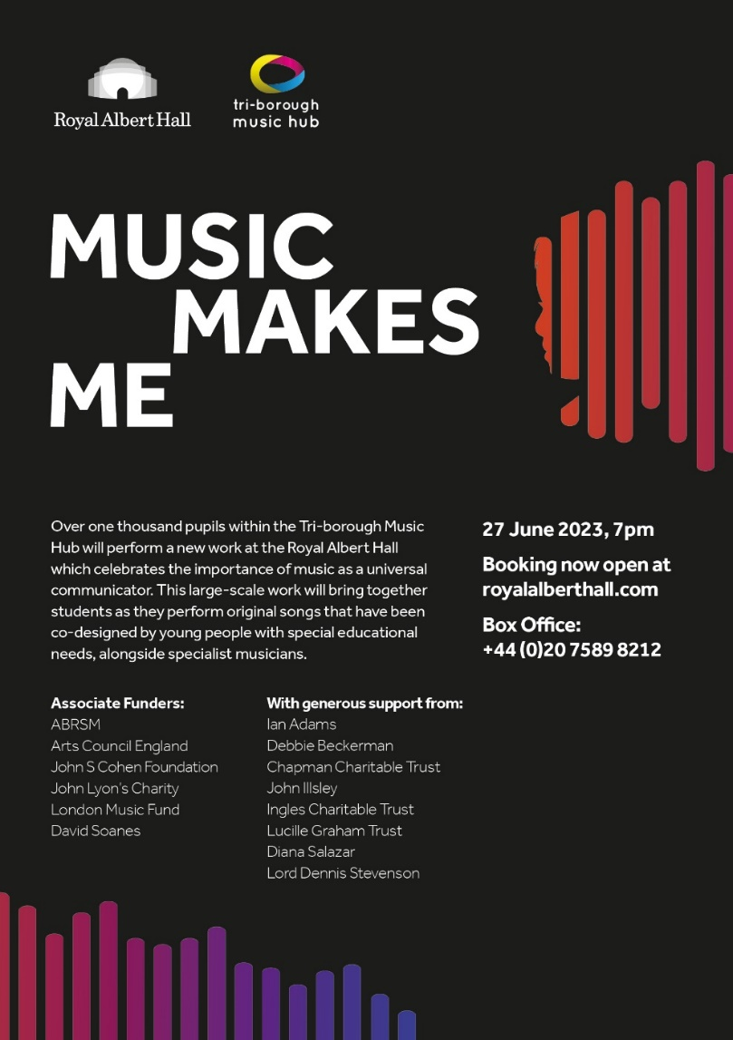
Music Makes Me – performance and song-writing resource
Our Music Makes Me programme is now well underway –all 40 schools involved are busy learning the songs, and the Music Hub ensembles are now learning all the repertoire. Tickets for the performance are now on sale, and we have released our additional song-writing resource that goes with it.

We would like to strongly encourage all schools to come along to watch or signpost the ticket information to their families. Ticket information can be found HERE and in the poster.

Even if a school is not directly involved as a performing school, every school is able to access a totally free song-writing resource (HERE).

The purpose of this resource is to look at how song writing can be brought into every classroom/school and can be accessed by teachers and students.
- We hope that by using this resource, schools will be able to co-create brand new song(s) that could represent a school anthem, class anthem, Year group anthem etc.
- The primary aim of this resource is to provide a practical tool and guidance for music teachers and classroom practitioners in mainstream and SEND settings, who would like to unlock natural musical creativity of their students but might feel that they lack the confidence or practical know-how to do so.
- This resource covers five song strands:
  - Social Story Songs
  - Transition Songs
  - Emotional Regulation songs
  - Topic Songs
  - Celebration Songs

Musical Senses – event day at RCM, Weds 12th July, 10.00am-4.15pm,
The Music Hub is continuing its Musical Senses programme, which is providing music education opportunities for young musicians who are either blind/visually impaired or deaf/hard of hearing. In partnership with the Royal College of Music and ABRSM, we are running a day of Creative music workshops at the RCM, for this cohort of HI/VI pupils who are in Years 4/5 and above.

Come to work collaboratively and creatively in a series of interactive music workshops where all the musicians – young people and professionals – are either blind/visually impaired or deaf/hard of hearing. The day will include:
- Explore workshop
- Gamelan workshop
- Creative song-writing workshop
- Informal performance at end of day

All sign-up details are HERE. Please can you share this opportunity with any students/families who would be suitable for this opportunity.

- Curriculum Support T&L Resources | National Plan for Music Education
ISM Primary Singing Toolkit
The Independent Society of Musicians (https://www.ism.org/) recently launched the Primary Singing Toolkit which is a free digital guide to teaching singing. Link HERE for access.

Secondary Schools Questionnaire for Abram Wilson Foundation
The Abram Wilson Foundation (https://abramwilson.com/) are looking for Secondary school Heads of Music to complete a questionnaire on Music provision and needs in school. This is on the basis that Heads of Music could have a future project in school if interested. Please see document attached for further information and link to the form.

- Partner Opportunities
ENO Finish This… Online Information Session
Tuesday 25th April 2pm, the ENO (https://www.eno.org/) are presenting a 45 minute Zoom session on how schools can be involved in the free Finish This… programme for Autumn and/or Spring terms 23-24. Link to book HERE

RAH Future Maker’s Concert for Y10-13
Any London-based musicians in Y10-13 who likes writing music can sign-up to the Royal Albert Hall’s concert, Future Makers. Live auditions at RAH in July and then 8 selected acts to perform in front of an audience with a panel of music industry experts on Tuesday 17th Oct. The winner will receive a year of tailored support from RAH and it’s industry partners. Link for further info and to register HERE

RCM Festival of Percussion, Sunday 7th May at RCM:
The Royal College of Music are hosting a Day Festival from 11am and an Evening Concert from 7:15pm to celebrate the Festival of Percussion. This will be filled with world class musicians, talks and lessons, and a family concert in addition to the evening concert. Link for further info and to book tickets HERE

- Jane Da Costa - Moving on from TBMH
At the end of the academic year we are going to be saying goodbye to one of our valued team members, Jane Da Costa, Deputy Head of the TBMH, as she moves on from the Tri-borough Music Hub to return to the classroom as Head of Music of a large 3-18 International School in Dubai, whilst continuing her masters in International Education Leadership and Management. Jane joined TBMH in 2017 and since then she has been a power-house of industry, leading new initiatives, and in general making a significant positive impact on the lives of young people and also fellow colleagues. We are sure school colleagues will join us in thanking Jane for all that she has done and in wishing her well for the new position. Jane’s last working day will be Friday 14th July 2023.

- Films and Photographs from recent school events
Future Sounds Final 2023:
On Wednesday 22nd March, seven talented acts from Secondary schools in RBKC, WCC, & LBHF and The Rhythm Studio performed at Bush Hall in front of an audience and a panel of judges. Congratulations to A.M.B (Always Making Breakthroughs) from Westminster City School for winning the competition. They will now get the opportunity to record their music at Abbey Road Studios.
- Photos from the event: HERE

Strings & Guitar Playing Day 2023:
Around 150 pupils from RBKC, WCC, & LBHF schools and TBMH ensembles participated in the Strings & Guitar Playing on Monday 27th March at Kensington Town Hall. The young players all did a fantastic job at the end performance on only three hours of rehearsal! Link to view some photos and a video from day HERE

Working with Schools and settings

To ensure your school can access the full range of free support and opportunities provided by the Music Hub and its partners for your pupils and staff, we ask that this message is shared with Senior Leaders, Music Leaders, and Governors.

The Tri-borough Music Hub has strong links with the schools/settings across the three LAs and we are continuing our support to enhance and amplify how each school delivers their own music curriculum. We have a proven track record of providing high-quality, progressive, and inclusive music education which has a direct and positive impact on school communities. We can provide opportunities that will enhance your school – the majority of which are free, or heavily subsidised – for your pupils, teachers, and wider community.

At a time of such challenge that we all find ourselves in, we strongly advocate that all schools maintain close and strong links with the Music Hub. We understand the pressures you face and are here to work with you and for you. Together we can make music remain a strong curriculum and extra-curricular subject that brings added value to every school.

Due to the nature of the subject, music teachers can be some of the most isolated staff members in a school. The Music Hub is a community that brings together music teachers into a collective whole through network meetings, CPD programmes, and other opportunities. With this in mind, we ask that all schools actively connect with the Music Hub and encourage their music teacher(s) to engage in what we have to offer. We will also be able to help all schools navigate planning for the implementation of the new National Plan for Music Education. Please can the lead for music in each school directly contacts sueling.chan@rbkc.gov.uk (TBMH Schools’ Administrator) so we can update all contact records.
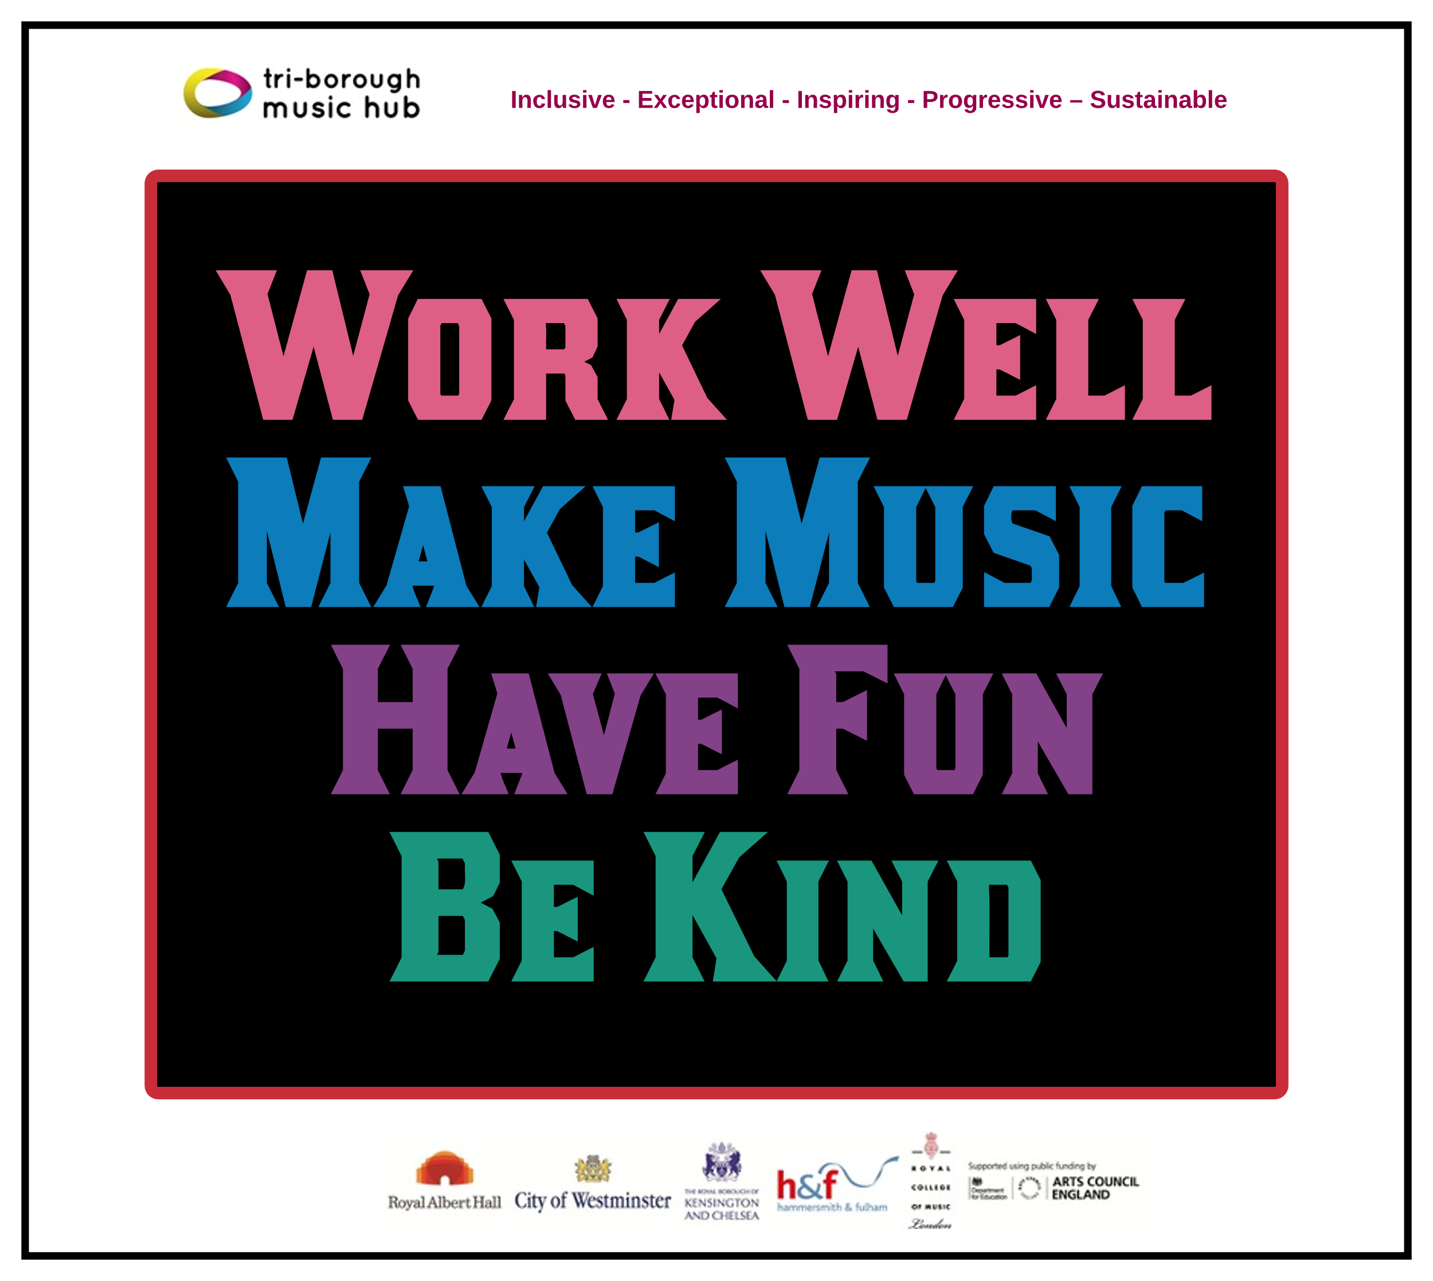
This update lists the support we provide and the opportunities that are open to all schools. We can assure all schools that we are only focused on providing high-quality music education support, guidance, and learning that actively helps schools with the delivery of outstanding music. We sincerely hope that all schools will engage with us in the 2022-23 academic year and that together we can forge ahead on the basis that together we are stronger.

Tri-borough Music Hub
Inclusive - Exceptional - Inspiring - Progressive – Sustainable

With thanks from the TBMH team

