Body Percussion Activity
Rhythm Activity: Pupils can choose between: Stomp, Clap or tap to build a beat
(you may want to extend these depending on the needs of your pupils).

Move the component parts into the table below to create a rhythmic pattern.

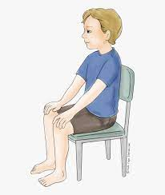
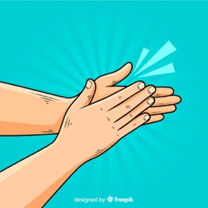
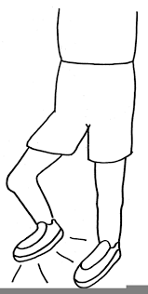

Clap Tap Stomp

