Updates for Schools from the Music Hub – November 2022
To ensure your school can access the full range of free support and opportunities provided by the Music Hub and its partners for your pupils and staff, we ask that this message is shared with Senior Leaders, Music Leaders, and Governors.

The Tri-borough Music Hub has strong links with the schools/settings across the three LAs and we are continuing our support to enhance and amplify how each school delivers their own music curriculum. We have a proven track record of providing high-quality, progressive, and inclusive music education which has a direct and positive impact on school communities. We can provide opportunities that will enhance your school – the majority of which are free, or heavily subsidised – for your pupils, teachers, and wider community.

At a time of such challenge that we all find ourselves in, we strongly advocate that all schools maintain close and strong links with the Music Hub. We understand the pressures you face and are here to work with you and for you. Together we can make music remain a strong curriculum and extra-curricular subject that brings added value to every school.

Due to the nature of the subject, music teachers can be some of the most isolated staff members in a school. The Music Hub is a community that brings together music teachers into a collective whole through network meetings, CPD programmes, and other opportunities. With this in mind, we ask that all schools actively connect with the Music Hub and encourage their music teacher(s) to engage in what we have to offer. We will also be able to help all schools navigate planning for the implementation of the new National Plan for Music Education. Please can the lead for music in each school directly contacts sueling.chan@rbkc.gov.uk (TBMH Schools’ Administrator) so we can update all contact records.
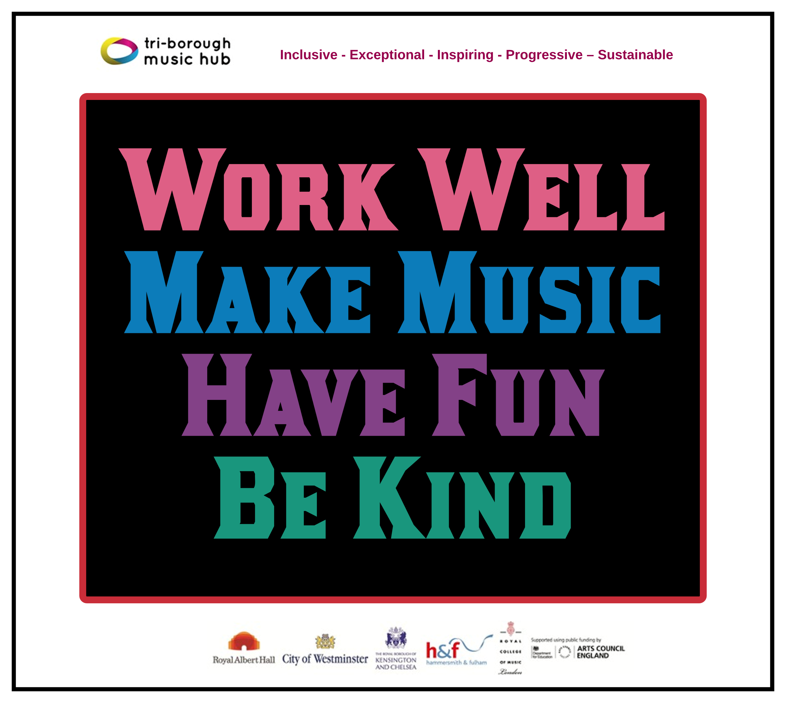
This update lists the support we provide and the opportunities that are open to all schools. We can assure all schools that we are only focused on providing high-quality music education support, guidance, and learning that actively helps schools with the delivery of outstanding music. We sincerely hope that all schools will engage with us in the 2022-23 academic year and that together we can forge ahead on the basis that together we are stronger.

Tri-borough Music Hub
Inclusive - Exceptional - Inspiring - Progressive – Sustainable

In this November update:

- Music Teacher Network meetings and CPD
  - Primary Teacher’s Network: Tues 22nd Nov, 4pm-5pm, Zoom
  - Secondary Teacher’s Network: Mon 28th Nov, 4:15pm-5:15pm, Zoom
- Music Hub Performance events for schools 2022-23:
  - Future Sounds (Secondary Phase)
  - Playing Days (Upper Primary Phase, Lower Secondary Phase)
  - Infant Voices Festival (Lower Primary Phase)
  - Other opportunities for secondary schools
- Reminder: National Plan for Music Education & all Music Hub Curriculum Support Documents
  - Summary of the NPME for schools
  - Summary of all the Music Hub’s free support guidance documents, teaching and learning resources across all Key Stages
- Partner Opportunities
  - Royal College of Music, Opportunities for Schools
  - London Sinfonietta – Sound Out Schools Concert 2023
  - Primary Teacher Late at ENO
  - Orchestras for All – ‘Mixed-Ability Ensembles: Finding Unity’ webinar
- Schools Printed Music Licence with Every Copy Counts
- Reminder: Pupil Progression – Pupil Opportunities outside of school
  - Bursary opportunity for Musical Senses pupils
  - Ensembles, Choirs, Music Production, Saturday Music School

Music Hub Contacts
Sue Ling Chan, School’s Administrator, sueling.chan@rbkc.gov.uk
Shannen Knutsen, Ensemble’s Administrator, shannen.knutsen@rbkc.gov.uk
Katie Stuffelbeam, Senior Administrator, katie.stuffelbeam@rbkc.gov.uk
Evie Asio-Okwalinga, Vocal Provision Manager, evie.asio-okwalinga@rbkc.gov.uk
Emily Hall, Instrumental Provision Manager (maternity cover), emily.hall@rbkc.gov.uk
Alex Wood, Business Manager, alex.wood@rbkc.gov.uk
Jonathan Chambers, Development and Fundraising, jonathan.chambers@rbkc.gov.uk
Jane Da Costa, Deputy Head, jane.dacosta@rbkc.gov.uk
Head, Stuart Whatmore stuart.whatmore@rbkc.gov.uk

Please contact the Music Hub with any questions or for more information; or to provide any feedback – good, bad, or otherwise – info@triboroughmusichub.org.

- Music Teacher Network meetings and CPD
Over the course of the year we will programme termly network meetings and several additional training sessions based on need. Further CPD will be added, and this will be communicated when known. Below is what is currently programmed.

TBMH Primary Music Teacher's Network / CPD on Zoom,
Tues 22nd Nov, 4pm-5pm
Our second bespoke Primary Phase music teacher’s network will be online on Zoom. The session will include a talk on printed music licensing (see later section about this), ABRSM’s free online resource ‘Classroom 200’, teacher knowledge exchange, and TBMH updates. To sign-up to attend please register HERE by Mon 21st Nov.

TBMH Secondary Music Teacher's Network / CPD on Zoom,
Mon 28th Nov, 4:15pm-5:15pm
Our second bespoke Secondary phase music teacher’s network of the academic year will be held online on Zoom. The session will include a talk on printed music licensing (see later section about this), ABRSM’s free online resource ‘Classroom 200’, opportunities from Morley College, future information on Future Sounds, and TBMH updates.
To book your place, please click HERE and register by Sun 27th Nov.

- Music Hub Performance events for schools 2022-23:
Future Sounds (KS3/4/5)
Our contemporary music competition returns for 2023 with confirmed dates as follows:
- Tuesday 31st Jan, 4.30-6.30pm: Prelims at The Rhythm Studio
- Wednesday 22nd March: Performance at Bush Hall
Please strongly encourage your students to enter (HERE) and take part in this amazing opportunity linked to the music industry. More details will follow but we hope that Secondary schools will promote this to students.
Playing Days (KS2/3)
The instrumental playing days will happen in March 2023 at Kensington Town Hall. Dates below:
- Monday 27th March 2023: Strings & Guitars Playing Day
- Tuesday 28th March 2023: Wind, Brass & Percussion Playing Day
These are an opportunity to bring together pupils from multiple schools who are learning instruments circa at Grade 1-4 levels. More details will be sent about how to register but please note these days and plan to attend. To register interest in this, or for any questions, please email emily.hall@rbkc.gov.uk.

Infant Voices Festival (KS1/Lower KS2)
Due to the production of Music Makes Me the Music Hub will not be directly delivering the normal annual Infant Voices Festival. However, at the request of Primary Music Leaders in the July 2022 network meeting, the TBMH will pull together a festival resource pack, allowing schools to then prepare and deliver themselves, potentially in localised clusters. Evie will send more info when ready, but we hope schools will be happy with this. To register interest in this, or for any questions, please email evie.asio-okwalinga@rbkc.gov.uk.

Other opportunities for Secondary schools
Morley College North Kensington
The Sixth Form college have a vast range of courses and are interested in recruiting more pupils from local secondary schools for Level 2 and 3 Music. They also have brand new music facilities including a large performance space. Email Programme Area Manager Emmanuel Vass for more info emmanuel.vass@morleycollege.ac.uk
- Reminder: National Plan for Music Education and all Music Hub Curriculum Support Documents
The new NPME was released on 25th June and is a significant milestone in how music must be delivered in ALL schools.
- The document direct link is HERE.
- A host of supporting information has been prepared to help schools understand the implications by Music Mark (HERE) and the Music Teachers Association (HERE).
- A summary of the NPME for schools can be found HERE.
- We have prepared a TBMH video about how schools can approach inclusive music education linked to the NPME can be found – HERE

To note: All schools need to consider the guidance for implementation over the next academic year (from Sept 2022 onwards) and aim to have a Music Development Plan in place for academic year 2023/2024. This will inform the areas for development and celebrate success. The Music Teachers’ Association and Music Mark have developed a self-reflection tool to support this process: www.musicteachers.org/npme.

The TBMH will help all schools work though this in the coming term(s). We will begin these conversations at our two music teachers network meetings.

To help all schools with curating a solid music curriculum, the Music Hub, already provides the following free support documents and teaching resources for all schools which we strongly recommend schools could use as a starting point in reviewing their current delivery.

Music Hub FREE Curriculum Support
TBMH documents to help schools with their own curriculum delivery – these can all be found HERE in Word and PDF formats.
- Free guidance on School Music Education Plan read the front page to understand TBMH’s approach to SMEP.
- Creating your own school/setting music policy (EYFS to post-16) – HERE
  - Answer the prompt questions and you will be able to present a summarised description about how music is delivered in your school
- Self-evaluation tool for music (EYFS to post-16) – HERE
  - Answer the prompt questions and you will be able to get a clearer picture of where your schools may sit within a framework of Silver/Gold/Platinum which tallies with the Artsmark framework.
- Model Music Curriculum - Overview – Teaching Music in Schools – HERE
  - This summary will help schools to see the progression within Year groups and Key Stages
- Music Education Recovery Curriculum framework

Music Hub FREE Teaching Resources
- Free access to TBMH Virtual Music School (more than 1500 resources)
- Free SEND-Friendly Vocal Resource (20 songs)
- Free Singing Assembly resource
  - We have released 4 teaching resources for KS3-5 Music Production & Technology, Hip-hop & Rap & Song-writing, that can all be found here. The direct resource links are here:
- Music Production – T&L Resources (HERE)
- Songwriting – T&L Resources (HERE)
- Hip-Hop – T&L Resources (HERE)
- Teaching young people with Special Educational Needs & Disabilities additional resources (HERE)
- Plus don’t forget that the Music Hub will provide that every school one FREE lifetime licence for ONE Whole Class Instrumental Learning groove’n’play KS1-3 programme (for school’s own delivery), plus free centralised CPD for 1 teacher, and programme resource, worth £200. Complete this form to select your programme. NB: this excludes Rastamouse.

- Partner Opportunities
Royal College of Music, Opportunities for Schools
Visit this website https://www.rcm.ac.uk/sparks/schools/ to see the amazing opportunities offered by the RCM.

London Sinfonietta – Sound Out Schools Concert 2023
Taking place on Thursday 9th March 2023 at Royal Festival Hall, Southbank Centre, the concert will guide pupils through the building blocks of composition and introduce them to contemporary classical music. Ideal for KS2/3 students and is £5 per pupil with accompanying school staff attending for free. To secure your place, please complete the booking and photo forms attached and email getinvolved@londonsinfonietta.org.uk

Primary Teacher Late at ENO
Taking place on Tuesday 29 November from 4.30 – 6pm, with the option extend your visit and join the ENO to watch the performance of It's a Wonderful Life, and attend a pre-show talk with the Director, Aletta Collins. More info and to book is HERE.

Orchestras for All - ‘Mixed-Ability Ensembles: Finding Unity’ webinar
Hosted by Artistic Director, Emma Oliver-Trend, the Zoom session is on Wednesday 30th Nov 4-5pm with a live Q&A. For info on the content of the webinar, please click HERE. To book your free ticket, please click HERE

- Schools Printed Music Licence (SPML) with Every Copy Counts
SPML allows all UK schools to copy & arrange hard copy/digital music for students. The licence is funded by the education departments for all state-funded schools/academies in England and independent schools currently pay individually. The licence is administered by Printed Music Licensing Limited (PMLL).
- Schools need to report data on music printed music they have copied/arranged using the PMLL online portal. Schools to create an account on the portal and submit data if they have not done so already.
- For printed music, schools need to submit:
- Title of song/piece
- Title of book
- Print publisher
- Music publisher (song or piece)
- Composer/arranger

- For digital downloads, school need to submit:
- Title of song/piece
- Music publisher
- Website purchased from
- Composer/arranger
- Schools need to submit data at the end of each academic term before the deadline.
- For more info and to create an account, please click HERE.

- Reminder: Pupil Progression – Pupil Opportunities outside of school
Musical Senses – Bursaries
The Music Hub is continuing its programme, Musical Senses, which is providing music education opportunities for young musicians who are either blind/visually impaired or deaf/hard of hearing. We have 11 places for new students to join our bursary programme from September. All details and pupil nomination form is here https://tbmh.wufoo.com/forms/zqa4kc21fixj1y/. Please share with your students/families.

Ensembles, Choirs, Music Production, Saturday Music School
We run a huge range of music-making outside of school which is available to anyone who lives or goes to school in any of the three boroughs. All details can be found HERE in our e-brochure or HERE to apply. Some classes may have a waiting list.

With thanks from the TBMH team

