Music Makes Me: Music Hub Ensembles Involvement

The purpose of this document is to outline how four Tri-borough Music Hub out-of-school ensembles will be involved in our next major music education programme which will be happening across the 2022-23 academic year, mainly from January to June 2023, leading to a performance in the Royal Albert Hall on Tues 27th June 2023.

The TBMH groups involved are:
- Breakout Band – approximately 30 students
  - Rehearse Mondays at Lyric, 5.15-6.15pm
  - Students who are approximately Grades 2-4, all instruments
- Symphonic Band – approximately 40 students
  - Rehearse Wednesdays at Lyric, 5.00-6.15pm
  - Students who are approximately Grades 5-8, all instruments
- Junior Voices – approximately 50 students
  - Rehearse Thursdays at Lyric, 4.30-5.30pm
  - Students who are confident singers in Years 3-6 (primary)
- Next Level Voices – approximately 40 students
  - Rehearse Tuesdays at Lyric, 5.15-6.30pm
  - Students who are confident singers in Years 7-13 (secondary)

More information about the Instrumental Ensemble:
  - Symphonic Band and Breakout Band will form one large mixed instrumental ensemble made up of young instrumentalists and this group will act as the main musical accompaniment to the event.
  - They will be supported by a small number of professional musicians from the RAH (circa 10), conservatoire students from the RCM (circa 10), TBMH tutors (circa 10). This will provide a side-by-side opportunity for pupils.
  - The parts will be differentiated according to ability.
More information about the Choral Groups:
  - Next Level Voices and Junior Voices will form one large mixed voices choir and they will act as the core vocal group to provide extended vocal harmony lines that extend beyond the massed school choir (circa 900 singers coming from almost 50 schools across all phases in SEND schools, Primary Schools, and Secondary Schools).
  - This core vocal group will be supported by a small professional group of singers from English National Opera
More information about Music Makes Me
- Link to the Music Hub’s MMM page - HERE
- Link to the Royal Albert Hall’s MMM page - HERE
- Tweet about MMM - HERE
- Instagram message about MMM - HERE
- Facebook post about MMM – HERE

This announcement coincides with the release of the DfE’s new National Plan for Music Education (HERE) and the messaging around the five strategic functions of a Music Hub being Partnership; Schools; Progression and Musical Development; Inclusion; and Sustainability. We can evidence all of these things within Music Makes Me and we hope that schools and families will recognise and engage with the TBMH and this programme.

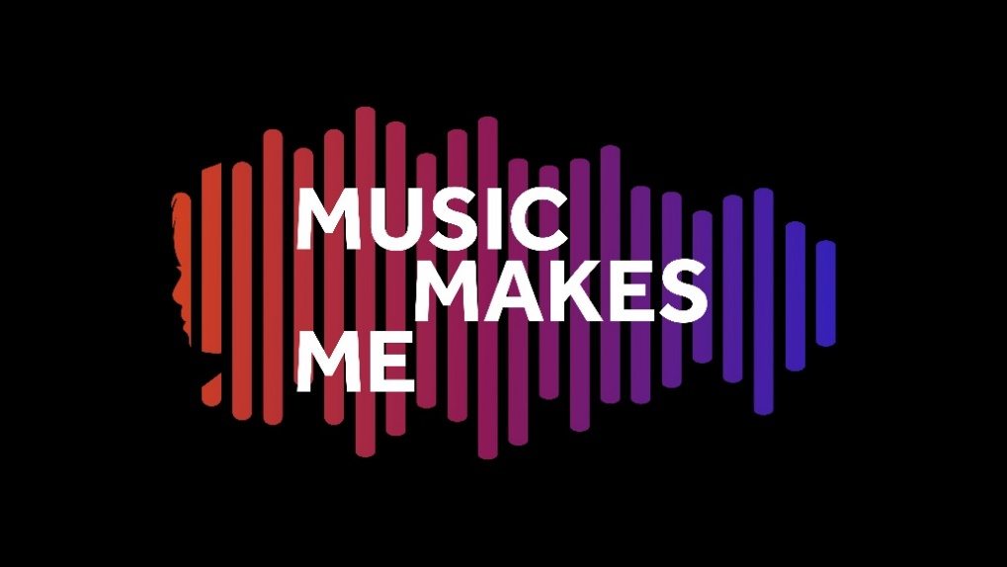
Synopsis
Our story features Aisha, a 16-year-old girl on the verge of adulthood. She enjoys reggae music, buttery bagels, Pokémon, and her Star Wars night light. She doesn’t enjoy escalators, the smell of burnt toast, changes in her timetable, and being last off the bus. Today is a big day for Aisha. Today is her first day of work experience at Galaxy Greens – a café and organic grocery store.

So many challenges lie ahead: the bus ride, sushi for lunch (what’s sushi??!!), customers ordering at the speed of a horse race commentator… not to mention the change in Aisha’s usual timetable.

Watch, sing, and sign as Aisha draws on the strategies she has learnt through musical songs to help her emotionally regulate, socially interact, and build her independence for adulthood.

The power of music can be felt in all of our lives, in every kind of situation. Music Makes Me will encourage each of us reflect on how music narrates our everyday lives, and to embrace the joy and euphoria of music.

How has this programme come to be?
The starting point for the creation of Music Makes Me was an initial conversation between Stuart Whatmore, Head of the TBMH, and Emily Stratford and Gabriel Krchnavek, the composers of the TBMH’s existing SEND-friendly vocal resource (HERE), about how we could take an inclusive approach to a major music education programme. It was essential that our new programme for 2022-23 celebrated inclusivity, with all that is good in our community, and which represents the strengths of diversity in all aspects of the word.

Emily and Gabriel are outstanding musicians and songwriters, and highly experienced SEND Music Specialists. Between them they have over 20 years’ experience of working with pupils with complex needs, including autism, speech and communication needs, and profound multiple learning disorders. They created the Music Makes Me synopsis based on their experiences of working with SEND pupils, and then set about writing songs both with, and for, this cohort of pupils. The key driver is that the songs represent pupils who traditionally are not represented, and they tell a story that puts them front and centre; all within a high-profile and professional level programme at a leading cultural institution.

What is the musical content?
The musical content consists of a series of 16 original songs written by Emily and Gabriel. The songs have been written through a process of co-design with young people:
- half of the songs have been written through bespoke creative workshops, including sessions in the Vision Impairment Unit at Edward Wilson Primary School, and the Hearing Impairment Unit at St. Augustine’s High School.
- half of them have been written based on pupil need and with pupil feedback as a direct result of Emily and Gabriel’s first-hand experiences of pupils in their work at schools.

One further song will be written by our partners at English National Opera through their English to Speakers of Other Languages (ESOL) programme, and this will fit the story narrative of the programme as curated by Emily and Gabriel.

The songs will be orchestrated for a massed instrumental ensemble made up of young musicians from the TBMH, supported by professional musicians. This instrumental ensemble will accompany a massed school choir made up of pupils from SEND, Primary and Secondary schools, and choirs from the TBMH.

TBMH Ensembles Participation Overview
This performance event in the Royal Albert Hall on Tues 27th June 2023 will feature a vast number of performers representing the reach of the work of the Tri-borough Music Hub. The role of the TBMH ensembles is high-profile and we will expect commitment from all pupils.

Music Makes Me – Ensembles Timeline
Initial Planning Phase
Spring to Autumn terms 2021

Phase 1: Creation and Preparation
Spring and Summer terms 2022

Phase 2: Recruitment and Engagement
Summer and Autumn terms 2022
- 27th June 2022: One-year-to-go press release and programme launch
- 1st July 2022: SEND settings, AP settings, Resource Units all approached and invited to participate
- Fri 2nd Sept – closing date for all applications (HERE) to join TBMH ensembles

Phase 3: Learning and Exploring
Spring term 2023
- January onwards: All 4 TBMH ensembles begin learning the repertoire

Phase 4: Final Push and Performance
Summer term 2023:
- April onwards: Continuation of all rehearsals, workshops, and resource support
- TBC Sunday 14th May: TBMH Ensembles special rehearsal
  - 10.00-12.30 & 1.30-4.00 rehearsal for TBMH Ensembles
- TBC Sunday 18th June: TBMH Ensembles special rehearsal
  - 10.00-12.30 & 1.30-4.00 rehearsal for TBMH Ensembles
- Monday 26th June: Technical rehearsal
  - 4.30-7.30pm: Final technical rehearsal for all TBMH groups and partners (minus massed school choir)
- Tuesday 27th June: Performance Day at RAH
  - 11.00 - TBC Arrive at RAH
  - 12.00-1.00 – TBC rehearsal for ensemble
  - 2.00-5.00 – Full Dress Rehearsal
  - 5.00-6.30 – Break
  - 7.00-8.15 – Performance
  - 8.15-8.45 – Leave
- July: Evaluation and legacy work with schools, performers, and ensembles

The Tri-borough Music Hub will:
- Provide full learning resource pack
  - Sheet Music (printed format and e-versions)
  - Audio recordings (online)
- Organise all logistics for the performance event and liaise with schools and families about their pupils’ needs
- Provide t-shirts for each performer that they can keep
- Be responsible, along with colleagues from the RAH and RCM, to produce a professional-level performance event in one of the world’s leading venues
- Securely submit all child licensing paperwork to the Local Authority, with accurate details for each pupil performer
- Promote the event through publicity with colleagues from the RAH and RCM, including the use of social media platforms
- Offer early-bird discounted ticket offers for parents/carers of the pupils performing at the participating schools/ensembles.
- Produce a cross-curricular resource pack with Schemes of Work that can be used by the whole school featuring content by Emily Stratford and Gabriel Krchnavek focused on composition, song-writing, and other music education resources.
- Document the project and performance through photographs/film and make these available to participating schools/performers (a small fee will apply to purchasing high resolution photos)
- Evaluate the programme focusing on outcomes and ambitions

In return, the TBMH expects all ensembles members to:
- Commit to all weekly rehearsals with full attendance
- Learn their parts through the Spring and Summer terms
- Attend all additional weekend rehearsals as outlined in the timeline. All dates will be confirmed by January 2023.
- Act as ambassadors of the Music Hub, themselves, and their families.
- Help to promote the event to support ticket sales

A note about pupils with GCSE / A Level exam pressures
The TBMH fully understands the many different pressures faced by students who will be entering into their Yr 11 or Yr 13 examinations in and around the June 2023 time period. We want as many young people as possible to benefit from this experience and we hugely value the long-term commitment of so many of our older pupils who have progressed through the TBMH. Therefore, we will fully support any students who require flexibility from us about rehearsal attendance in the run-up to the event; however, the key thing will be clarity of advanced communication to allow us to plan accordingly. We hope that this reassures any pupils/families who may have concerns.

If you would like to discuss any of the details about participating in Music Makes Me, please contact stuart.whatmore@rbkc.gov.uk.

