One year to go until
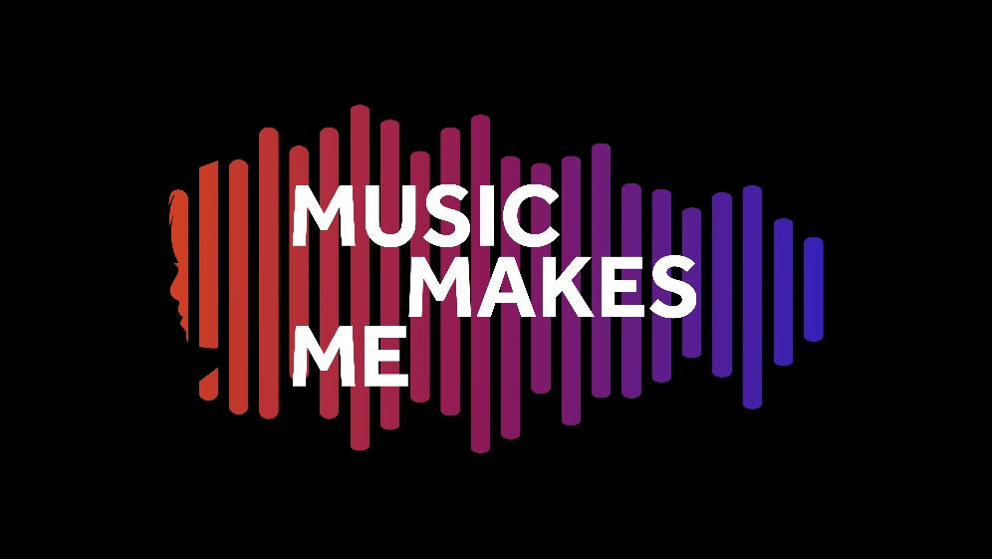
Our next large-scale multi-school
performance programme

Tues 27th June 2023

Working with, on behalf of, and representing…
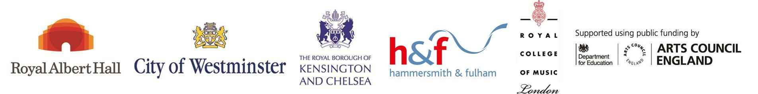
…and also in partnership with
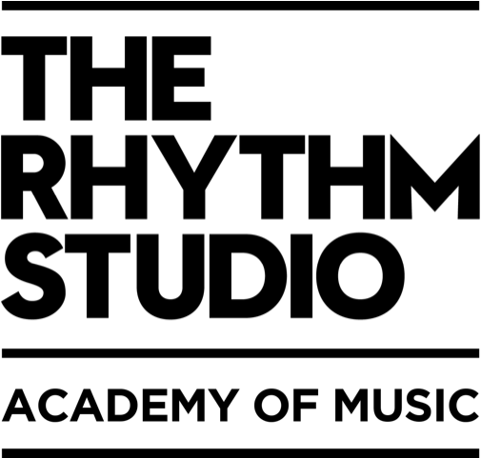
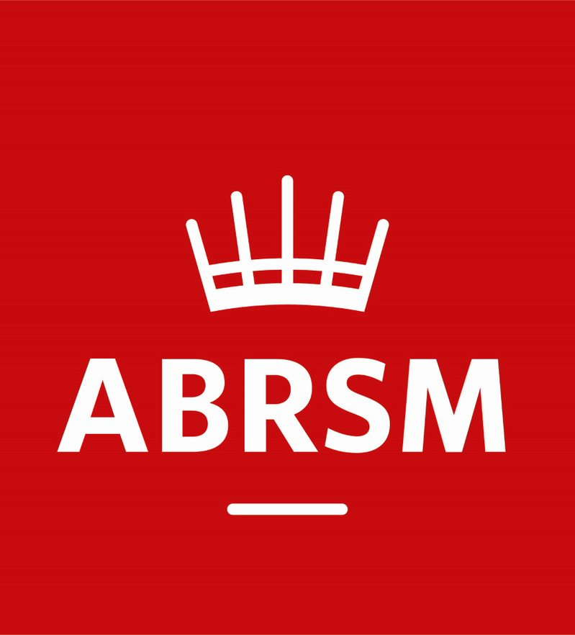
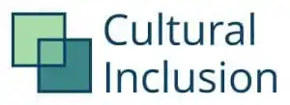
www.triboroughmusichub.org
@TBMHMusic
triboroughmusichub
@TriBoroughMusicHub

Tri-borough Music Hub Commissions Ambitious New Work
Music Makes Me

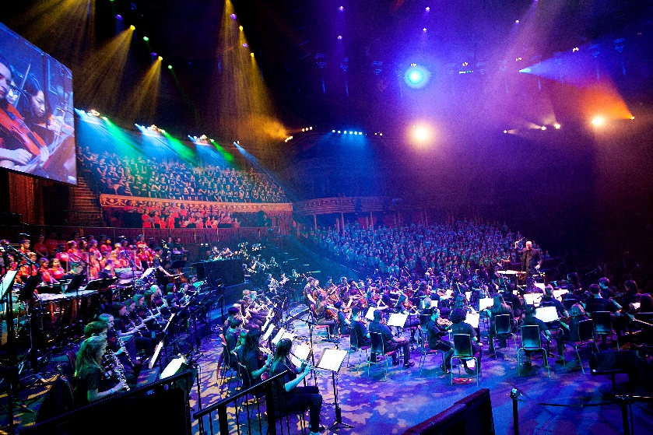
The Tri-borough Music Hub (TBMH), in co-production with the Royal Albert Hall (RAH), is thrilled to publicly announce the launch of Music Makes Me, our next large-scale multi-school music education and performance programme; following closely in the footsteps of previous award-winning productions, Seven Seeds in 2015 and Convo in 2019. Music Makes Me’s innovative approach is rooted in inclusive musical practice and will happen in the 2022-23 academic year (TBMH’s 10th anniversary year), culminating in a performance in the RAH on Tues 27th June 2023.

The highly ambitious performance programme is focused solely on championing those people who may struggle to have their voice heard within society. Music Makes Me looks at the world through a divergent and creative viewpoint, and will push the boundaries of creative and contemporary practice to amplify the stories and the lived experiences of D/deaf, disabled, and neurodiverse young people through high-quality music-making and celebration. It will demonstrate how all pupils can access, participate, and be seen.
Music Makes Me invites us to see what a day can be like through the eyes of Aisha, a neuro-divergent young person. It will demonstrate how she uses a range of strategies that she has learnt through musical songs to help her emotionally regulate, socially interact, and build her independence for adulthood. The power of music can be felt in all of our lives, in every kind of situation. Music Makes Me will encourage each of us to reflect on how music narrates our everyday lives, and to embrace the joy and euphoria of music.
The programme consists of original songs written by Emily Stratford and Gabriel Krchnavek through co-design with young people, with one song coming from our partners at ENO, and all orchestrated by a team led by Charlotte Harding. The music will be performed by a choir of over one thousand young people, accompanied by a 100-piece instrumental ensemble made up of young people alongside professional musicians.
Every SEND School, Resource Provision, and Alternative Provision Setting in each of our three boroughs will automatically be offered a place to perform; with a further c.20 mainstream schools being selected in September 2022. More information will be shared in due course.
The TBMH, along with its strategic partners the Royal College of Music and Royal Albert Hall, are committed to ensuring that all of our collective and respective work continues the drive towards an inclusive music education for all learners. Together, we are really excited about this programme, how it can help contribute to positive change around issues of representation and inclusion.

We do hope that our community will engage with Music Makes Me by spreading the word, offering their support, and in amplifying the message. More detailed information about the programme can be found in Appendix A of this document, and more information about the TBMH can be found in Appendix B.

CONTACT: stuart.whatmore@rbkc.gov.uk for any further information about the programme.
Hear what people are saying about the Music Makes Me programme:

Emily Stratford, composer: “Music Makes Me is an opportunity for ALL young people to access, enjoy, and celebrate the special place that music has in all our lives. I’m beyond excited to be a part of this inclusive programme with the Tri-borough Music Hub and to share the music at the prestigious Royal Albert Hall.”

Gabriel Krchnavek, composer: “Music Makes Me highlights music’s unique ability to help young people navigate and make sense of the world that can often be a scary place. Music brings light, hope, sense of safety, familiarity, and awe into many young people’s hearts; and I feel honoured and privileged to be part of this truly special programme.”

Stuart Whatmore, Head TBMH: “The TBMH is proud to maintain the push for musical inclusion in all ways. We are delighted to help influence, and be influenced by, a range of outstanding partner organisations and individuals to disseminate best practice through the Music Makes Me programme of high-quality teaching and learning, training, and performance.

Lucy Noble, Artistic Director, Royal Albert Hall: “We are delighted to be partnering with the Tri-borough Music Hub on this innovative and ground-breaking project. We are passionate about opening up the Royal Albert Hall to everyone, and Music Makes Me is a leading example of inclusive practice which will have ramifications far beyond the performance day, creating a more open conversation around inclusion in the arts at a time when it is urgently needed.”

Professor Colin Lawson, Director, Royal College of Music: “The Royal College of Music is delighted to be collaborating with our longstanding partner the Tri-borough Music Hub on ‘Music Makes Me’. This year-long project, culminating in a large-scale celebration at the Royal Albert Hall, exemplifies our shared ambitions to increase access to high-quality music-making and to raise awareness of diverse voices in music. We are excited that RCM students will have an opportunity to contribute to this ambitious and imaginative project, which promises to be transformational for all involved.”

Chris Hodges, Director The Rhythm Studio: “We are proud to be working with the Tri-borough Music Hub on the delivery of Music Makes Me. As well as a learning opportunity for all around the power of music and the role of music within inclusive education, the event promises an unforgettable opportunity for young people to come together to perform at the iconic Royal Albert Hall.”

James Welburn, Partnerships Manager, ABRSM: “ABRSM is delighted to be supporting Music Makes Me, led by the Tri-Borough Music Hub and its wonderful team of composers and teachers. This programme, culminating in the opportunity of a lifetime to perform at the Royal Albert Hall, will enrich the lives of everyone involved, showcasing and celebrating the power and joy of music. Music is for everyone, and we’re excited to be part of this very special initiative.”

Sarah Newman, Bi-borough Director of Education (Kensington and Chelsea; and Westminster): “Music is an incredible tool to bring people together and aid learning, togetherness, and development, as well as providing an enjoyable outlet. The Children’s Services teams in Kensington and Chelsea and Westminster recognise the important role of music education in supporting our SEND work, inclusion, emotional health and wellbeing for our children. Music Makes Me will be a beacon for our schools and community to engage with.”
Jacqui McShannon, Strategic Director of Children’s Services, Hammersmith and Fulham: “The Music Makes Me programme meets many of our Hammersmith & Fulham strategic priorities around community engagement, social cohesion, and developing cultural capital for our children and young people. We firmly support the work of the Music Hub and look forward to seeing schools engaged with this outstanding opportunity.”

Beth Warnock, Head of ENO Engage: “ENO is delighted to be creating a song for the Music Makes Me Project. ENO Engage is passionate about making music education accessible for everyone and this programme provides an incredible opportunity for ENO to use its forces to open up conversations about inclusion and representation in music”.
Paul Morrow, Founder Cultural Inclusion Manifesto: "The Cultural Inclusion Manifesto is proud to support the Music Makes Me initiative alongside our signatories the Tri-borough Music Hub, The Royal College of Music, the Royal Albert Hall, and other cultural partners. This hugely ambitious project will push the boundaries of creative and contemporary practice to amplify the stories and the lived experiences of D/deaf, disabled, and neurodiverse young people though high-quality music making and celebration at one of our nation’s leading cultural institutions.”

Susan Whiddington, Chair Musical Boroughs Trust: “Musical Boroughs Trust, the charitable arm of the Tri-Borough Music Hub, is hugely proud to support this first-of-its-kind initiative to bring the story of the power of music on the life of a neuro-diverse young person to the stage of the Royal Albert Hall. The opportunity to engage so many special schools and 1,000 young people, both on stage and in the orchestra, makes this a particularly exciting venture and we are delighted to partner with some of the UK’s most prestigious musical organisations to bring this unique event to fruition next June.”

APPENDIX A - Further Information
How has this programme come to be?
The starting point for the creation of Music Makes Me was an initial conversation between the Head of the TBMH, (Stuart Whatmore), and the two composers (Emily Stratford and Gabriel Krchnavek) of the TBMH’s existing SEND-friendly vocal resource (HERE) about how we could take an inclusive approach to a major music education programme. It was essential that our new programme for 2022-23 celebrated inclusivity, with all that is good in our community, and which represents the strengths of diversity in all aspects of the word.

Emily and Gabriel are both outstanding musicians and songwriters, as well as being highly experienced SEND Music Specialists. Between them they have over 20 years’ experience of working with pupils with complex needs, including autism, speech and communication needs, and profound multiple learning disorders. Given their wealth of knowledge, Emily and Gabriel created the Music Makes Me synopsis based on their real experiences of working with SEND pupils, and then set about writing songs both with, and for, this cohort of pupils. The key driver is that the songs represent pupils who traditionally are not represented, and they tell a story that puts them front and centre; all within a high-profile and professional level programme at a leading cultural institution.

What is the musical content?
The musical content consists of a series of 16 original songs written by Emily and Gabriel. The songs have been written through a process of co-design with young people:
- half of the songs have been written through bespoke creative workshops, including sessions in the Vision Impairment Unit at Edward Wilson Primary School, and the Hearing Impairment Unit at St. Augustine’s High School.
- half of them have been written based on pupil need and with pupil feedback as a direct result of Emily and Gabriel’s first-hand experiences of pupils in their school work, over a period of time.

In addition, there is one further song in the programme that will be written by our partners at English National Opera through their English to Speakers of Other Languages (ESOL) programme, and this will fit the story narrative of the programme as curated by Emily and Gabriel.

The songs will be orchestrated for a massed instrumental ensemble made up of young musicians from the TBMH, supported by professional musicians. This instrumental ensemble will accompany a massed school choir made up of pupils from SEND, Primary and Secondary schools, and choirs from the TBMH.
What are the musical forces of the programme?
- Instrumental Ensemble:
  - A large mixed instrumental ensemble made up of young instrumentalists (circa 70) from two of the TBMH’s out-of-school ensembles (Symphonic Band, Breakout Band) will form the main musical accompaniment to the event.
  - They will be supported by a small number of professional musicians from the RAH (circa 10), conservatoire students from the RCM (circa 10), TBMH tutors (circa 10). This provides a side-by-side opportunity for pupils, and also provides music education experience for the adult musicians.
  - We are currently exploring the option to further engage professional disabled-led musicians (c.5), with discussions ongoing.
- Choral Groups:
  - There will be a core vocal group of singers (c.100) from two of the TBMH’s out-of-school choirs (Next Level Voices, Junior Voices) to provide extended vocal harmony lines.
  - There will be a massed school choir made up of c.900 pupils from c.45 schools from across the 3 LAs, coming from all phases in SEND schools, Primary Schools, and Secondary Schools.
  - There also be a small professional group of singers from TBMH Partner organisations (Singers from the ENO) to support the vocal element with discussions currently happening.
- Narrators/Actors: To tell the story being celebrated, Music Makes Me will be semi-staged using young people, providing the opportunity to place under-represented pupils front and centre.
- Visual: Using a big screen, Music Makes Me will feature animations that support the musical story and inter-weave live show footage.
Who will be involved – partnerships?
The Music Makes Me programme is led by the TBMH with the full support of its Strategic Partners – the three Local Authorities (LAs), Royal Albert Hall (RAH) and Royal College of Music (RCM) – with fundraising support coming from its sister charity, Musical Boroughs Trust, and the Philanthropy team at the RAH. In addition, the TBMH is working alongside other partner organisations – the ABRSM, Cultural Inclusion Manifesto, English National Opera, and The Rhythm Studio to bring expertise in differing ways to ensure that everything we do is focused on the best inclusive outcomes for the children and young people.
- Cultural Inclusion Manifesto
The Cultural Inclusion Manifesto will support the Music Makes Me initiative by amplifying the message to key organisations and high-profile decision makers.
- English National Opera
ENO Engage and singers from the ENO will support this programme in different ways – in co-designing a new wellbeing song (‘Share the load’) that will be featured in the performance through the ESOL Programme; potentially supporting the learning process in schools; and with singers from the ENO potentially supporting the choirs in the performance itself.
- ABRSM
ABRSM will support Music Makes Me through financial support toward the event and in return TBMH will support the ABRSM’s growing access, diversity, and inclusion programmes.
- The Rhythm Studio
The Rhythm Studio will be involved in the large instrumental ensemble with some of their young contemporary musicians joining the group.
Why is Music Makes Me needed, and what are its ambitions?
As we all start to emerge from the impact of the Coronavirus pandemic, Music Makes Me will galvanize our school communities, the TBMH’s out of school ensembles, and our wider community. There is no question that Covid has negatively affected the delivery of music (and arts) in schools, and that there has been a significant drop-off in pupil engagement with the TBMH’s out-of-school instrumental ensembles and choirs. Our programme will give a focus:
- for schools, their pupils, their teachers, and their community
- for pupils engaged in TBMH’s instrumental ensembles and choirs

Music Makes Me will push the boundaries and ensure that the programme celebrates all children, and therefore pupils with sensory impairments, additional needs, and special educational needs will be front and centre. We will celebrate pupils for being themselves by programming a major performance event that is rooted in inclusion and demonstrates how all pupils can access, participate, and be seen.

This programme and performance event will support every school in LBHF, RBKC, and WCC through a well-crafted resource pack that will cover musical learning/knowledge (i.e. musical resources); as well as how music positively contributes to Mental Health and Wellbeing, social and personal identity, and a general approach to inclusion. This will support schools to position music centrally despite the challenges of the past two years through the pandemic.

- We want to support a cultural shift that all pupils can access music without having to limit their expectations or choices.
- We will promote the idea of “see it, be it” by having role models in place.
- We will ensure the voices of young people and families are heard through co-design and sounding board.
- We will challenge issues of structural inclusion.

APPENDIX B - Tri-borough Music Hub, Strategic Overview

Who we are:
The Tri-borough Music Hub (TBMH) is the award-winning lead organisation that oversees the delivery of music education in the three West London boroughs of Hammersmith and Fulham, Kensington and Chelsea, and the City of Westminster. We work with schools, pupils, music educators and the community to provide engaging music activities for children and young people across the three boroughs. We are a centralised Local Authority service which receives core funding from the Department for Education via Arts Council England. We operate a shared-services model across three Local Authorities to deliver an expansive programme of musical learning, in and out of school.

Alongside the three Local Authorities, the TBMH Strategic Partners are two internationally renowned organisations - the Royal Albert Hall and the Royal College of Music. In addition, a dedicated and quality-assured group of delivery partner organisations, with evidence of a successful track record, work to meet the TBMH’s strategic aims and positively contribute to our stakeholders. The TBMH is a music-specific service focused on high quality outcomes inclusive of all learners. It recognises the numerous benefits that music can bring to everyone from all backgrounds and in all circumstances. For more information about the work of the TBMH see annual reports HERE.

Vision
Our vision is for every child or young person to be able to access enriching and relatable musical experiences, whatever their age, ability, or life circumstances.

Mission Statement
Our mission is to provide a broad range of progressive musical pathways and opportunities for all to develop a life-long love of music and realise their musical potential whilst developing their personal / social identity. We will do this by working closely in partnership with outstanding music and education organisations that are committed to our ethos. Together we will embed best-practice and implement visionary and effective models of partnership work to ensure comprehensive routes of engagement, opportunity, and progression.

Music Education for All
The TBMH works hard to provide a fully inclusive service to ensure that our outputs are embedded in representation, equity, diversity, and inclusion - we aspire to be REDI. We champion the importance of Youth Voice, respond to need, and support all our learners, including our most vulnerable SEND learners. We strive to ensure that Children and young people's music is HEARD:
- Holistic - emphasis on personal, social, and musical outcomes.
- Equitable - those facing the biggest barriers receive the most support.
- Authentic - developed with and informed by the people we do it for.
- Representative - participants and colleagues reflect our diverse society.
- Diverse - all musical genres, styles, practices are valued equally.
All TBMH activity will be equitable and inclusive across all protected characteristics, to allow our participants (children, young people, workforce) to genuinely feel like they belong. We will create a space where everyone has equal access to opportunities and can be themselves without fear of discrimination, prejudice, harassment, or bullying. This will ensure that a fully rounded, progressive, and innovative music education will be representative of all children, young people, families, and communities who live or go to school within our three boroughs, regardless of their backgrounds or circumstances. The TBMH is focused on 'Positive Action' and will actively challenge behaviour that threatens our values.

Key Themes in the evolution of the TBMH
Four common themes have emerged from our 2021 stakeholder consultation (HERE) and research which reinforce the necessary direction of travel for the hub, and which highlight the challenges that need to be overcome in order to deliver the best possible service. The themes are:
- Access, diversity, and inclusion: Ensuring all children and young people who wish to access our services, can do so
- Children’s enjoyment and wellbeing: Providing enjoyable activities for children and young people and supporting their health and wellbeing as we emerge from the challenges of the pandemic
- Youth voice: Ensuring that young voices are at the heart of our offers and the decisions we make as a service
- Relationships and communication: The importance of listening to and communicating clearly with our audiences, partners, service users and workforce.

