VOCAL STRATEGY

“I don’t sing because I’m happy. I’m happy because I sing” –
William James
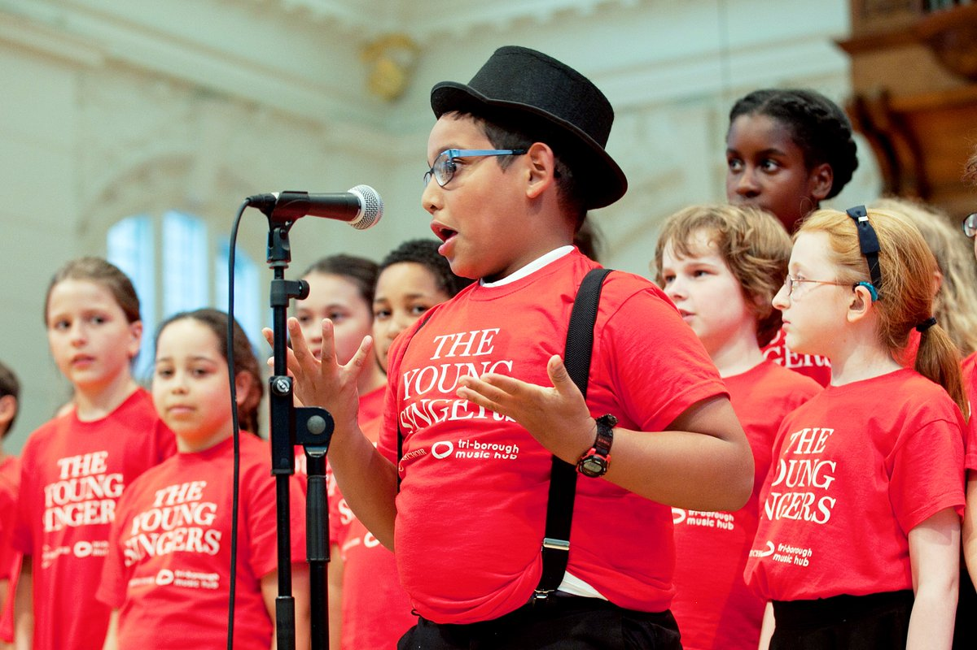

THE VISION
Singing is a unique form of self-expression accessible to all. It promotes self-esteem and emotional well-being, and is a fundamental means of communication. Singing together builds a sense of community, and it is evident in most cultures, celebrations and key moments of life. It is an important part of early learning and development, and is the natural starting point for music-making.

“Our vision is to enable children from all backgrounds and every part of England to have the opportunity to make music with others; to learn to sing; and to have the opportunity to progress to the next level of excellence.”
The Importance of Music – a National Music Plan for Education (2011),
Department for Education

OUR AIMS
- To raise the standards and the profile of singing within all schools and the local community, supporting the promotion and development of high quality singing across the three boroughs
- To raise awareness of the importance and benefits of singing
- To provide school-based staff with the skills to teach and develop high quality singing in their schools and to support schools in writing their own singing strategies
- To provide opportunities to share effective practice
- To reflect the diverse community represented in the Tri-Borough
- To support schools in achieving arts awards
- To provide access and inclusion for all children, including disengaged or vulnerable young people, Looked After children and those with Special Education Needs or Disabilites
- To provide a comprehensive vocal and conducting CPD training programme
- To provide in-school support where necessary to improve or enhance existing provision
- To provide identifiable and clear progression routes for singing through in-school provision and ensembles
- To identify three areas of special focus within the Vocal Strategy and to closely monitor progress in these areas

FOCUS AREA 1: DEVELOPING SKILLS OF THE WORKFORCE
- Providing a comprehensive programme of vocal and conducting CPD to meet the needs of school staff, Hub tutors and partners
- Increase the confidence of both specialist and non-specialist music coordinators to deliver high quality singing
- Providing bespoke vocal resources to support singing assemblies, whole school singing the music curriculum
- Giving resource advice and guidance, signposting and networking opportunities
- Assisting schools in mapping a school/ departmental vocal plan, including whole staff INSET sessions, support with setting up staff choirs
- Giving advice and guidance to support schools in achieving accreditation and recognition for high standards reached
- Providing opportunities to share effective practice with peer to peer observation, shadowing, coaching/mentoring, and network workshops
- Providing training and opportunity for the use of sign language in singing
- Develop mentoring schemes with primary and secondary student volunteers and RCM students, and provide training for emerging young vocal leaders and outreach leaders
- Encouraging pupil singing leaders in schools

FOCUS AREA 2: PROGRESSION
- Developing children’s skills to allow them to progress from singing in-tune/in-time, to unison singing, then quality part-singing, in different languages and musical styles
- Opportunities for children and young people to join a range of choirs with progressive pathways leading through – Little Singers (Y1-3), The Young Singers Y4-6), AKA Singers (Y7-13), Chamber Choir (Y7 – 13)
- Developing musical projects linked to Transition between key stages

FOCUS AREA 3: SINGING FOR ALL
- Promoting and maintaining a strong culture of singing in all our schools and educational settings: Nurseries and Foundation, Primary Schools, Secondary Schools, Special Schools, Hearing Impaired, Vision Impaired, and those with disabilities, Alternative Provision, Looked After Children, vulnerable and disengaged children and young people
- Promoting whole school singing such as playground singing using all staff and children
- Staff Choirs and Teachers’ Choirs

DELIVERY OF VOCAL PROVISION IN THE TRI-BOROUGH
- In-school vocal tuition and choirs led by Music Hub vocal tutors
- First Access/Whole Class instrumental programmes for schools incorporating singing
- Tri-borough choirs:
Little Singers (Y1-3), The Young Singers (Y4-6), Tri-borough Chamber Choir (Y7-13), AKA Singers (Y7-13)
- Large scale vocal projects and events for schools, including an annual sovereign performance event for each borough
- Projects with Delivery Partners to enhance and support school provision

POSITIVE OUTCOMES FOR CHILDREN AND YOUNG PEOPLE FROM EFFECTIVE SINGING DELIVERY

- Musical learning
- Development/improvement of the voice as an instrument
- Creativity
- Aural perception, communication and language skills
- Development of literacy skills
- Aural and visual memory
- Spatial reasoning and mathematical performance
- Intellectual development
- General attainment
- Personality
- Educational motivation and re-engagement for the disaffected
- Social cohesion and inclusion
- Social behaviour and team work
- Empathy and emotional intelligence
- Psychological well-being
- Personal development and self-belief
- Music and health
- Physical development

Strategy devised by Sara Feldmann Brummer, Vocal Provision Manager, Tri-borough Music Hub, January 2017. Reviewed December 2017. Next review January 2019

GUIDANCE FOR SCHOOLS TO DEVISE THEIR OWN
SINGING STRATEGY
Schools can find their own singing strategy priorities by answering the questions below:
- Is there whole school singing, how regularly, and what form does it take?
- Is there classroom singing time on a regular basis?
- Are there whole class instrumental programmes incorporating singing?
- Is there a before-school choir, a lunchtime choir or an after-school choir?
- Is there a boys’ choir?
- Does the school engage with vocal provision and CPD from the Tri-borough Music Hub and partners?
- Does the school signpost singers to the Tri-borough choirs?

What does high quality singing provision look like?
- Singing in parts
- Singing in different languages
- Singing a range of genres and styles
- Singing with a sense of ensemble and able to follow a conductor
- Communicating both musically and with emotional meaning and expression
- Singing with an understanding of good posture and breath support
- Excellent performance and presentation skills

DOES SINGING HAVE A PROGRESSION ROUTE IN SCHOOL?
H
I
G
H

Q
U
A
L
I
T
Y

S
I
N
G
I
N
G

