Musical Senses: FREE Creative Music Workshops
Sundays: 30th June, 7thJuly and 14th July 2024 at the Royal College of Music
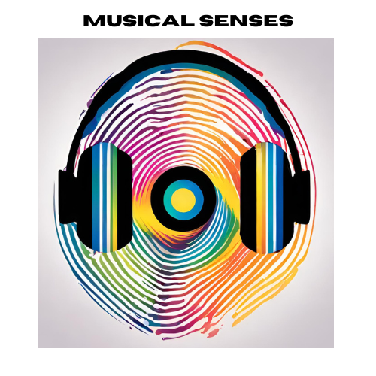

Register
Please REGISTER HERE or scan the QR code

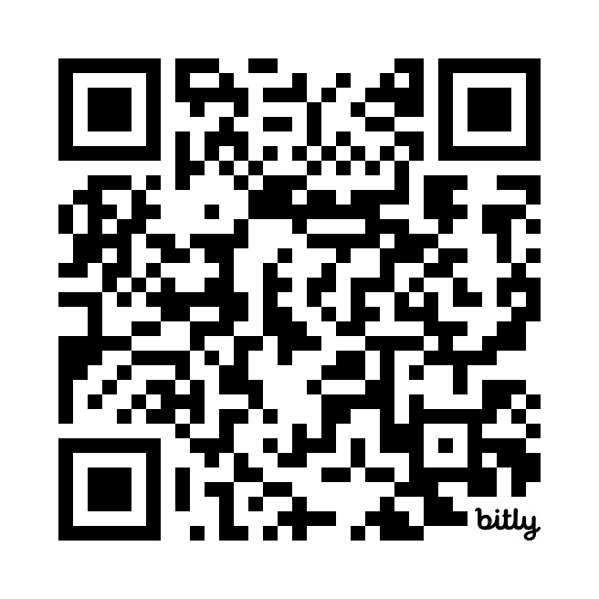
BY FRIDAY 30th April
Welcome
The Tri-borough Music Hub (TBMH) is committed to positive change and in supporting children and young people from all backgrounds to better access musical activity. Working in partnership with; other organisations – Royal College of Music, ABRSM, Tri-borough Music Trust, Awards for Young Musicians, Audiovisibility, and Local Authority Specialist Teachers – we have developed a specific focus on making what we do accessible to young people who receive sensory support – young people who are blind/have a vision impairment (VI), or who are deaf/hard of hearing (HoH).

Building on the past 2 years, our Musical Senses programme aims to cover 3 main areas:
- Training and professional development for teachers.
- Working with and engaging positive role models into the roles of music leaders.
- Supporting this cohort of pupils with specific sensory needs to physically come to engage with high-quality musical activity.

Event information (Sunday 30th June, 7th, July, 14th July)
We are running 3 free consecutive weekends of musical activity at the RCM to give young musicians an inspiring, engaging, and high-quality musical experience which includes creative collaboration, performance, and musical experiences. We are aiming for all participants to come to work collaboratively and creatively in interactive music sessions where all young people and workshop leads – are either vision impaired or hard of hearing.

- We are focusing on working with Secondary aged/phase students, aged 11-18, who play, sing, or compose music.
- We are hoping to work with 20 x VI pupils and 20 x HoH pupils.
- Pupils will be expected to attend all 3 weeks.

We hope that every young person will be inspired and will know that their aspirations are achievable. Alongside these musical outcomes for the pupils, we hope that this will be a positive experience for their families and that they will feel included, welcomed, and valued.

Come to work collaboratively and creatively in a series of interactive music workshops. The sessions will include:
- Interactive Games
- Collaborative Composition
- Learning Musical Repertoire
- Developing Performance skills
- Sharing Concert on the final Sunday

Session Plans

Sunday 30th June
12.15-12:30 Arrive at the RCM at the Main Entrance – a member of the Musical Senses team will be there to greet you, give you a name badge, and direct you to the East Parry Room (HoH group) or the Principal Room (VI group)

12:30-1:45 Session 1

1:45-2:15 Break

2:15-3:30 Session 2

Sunday 7th July
12.15-12:30 Arrive at the RCM at the Main Entrance – a member of the Musical Senses team will be there to greet you, give you a name badge, and direct you to the East Parry Room (HoH group) or the Principal Room (VI group)

12:30-1:45 Session 1

1:45-2:15 Break

2:15-3:30 Session 2

Sunday 14th July

11:45-12:00 Arrive at the RCM at the Main Entrance – a member of the Musical Senses team will be there to greet you, give you a name badge, and direct you to the Main Concert Hall.

12:00-1:30 Session 1

1:30-2:15 Break

2:15-2:30 Take places for performance.

2:30-3:30 Performance

3:30-4:00 Social Interactions with participants and families

Getting to the RCM - Prince Consort Road, London SW7 2BS
The Royal College of Music is easy to reach on foot from nearby attractions in South Kensington, from Kensington High Street and from Kensington Gardens.
- South Kensington: 0.5 miles
- Gloucester Road: 0.6 miles
- High Street Kensington: 0.8 miles
- Paddington: 1.5 miles
- Victoria: 2 miles
Santander Cycles docking station and public cycle locking facilities adjacent to RCM
Royal College of Music, +44 (0)20 7591 4300

CLICK HERE FOR FULL DETAILS OF HOW TO GET TO THE RCM

View of the front of the RCM looking down from the Royal Albert Hall
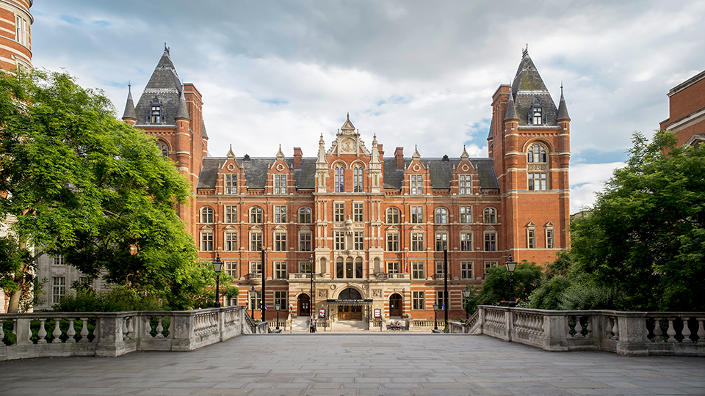

Main entrance on Prince Consort Road SW7 2BS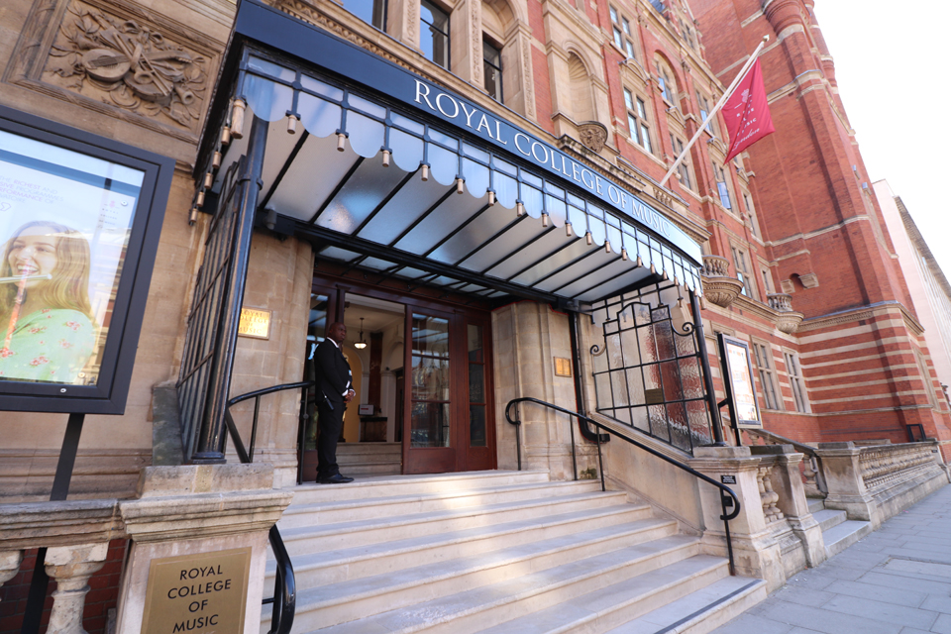
Main entrance hall where the Musical Senses team will greet you
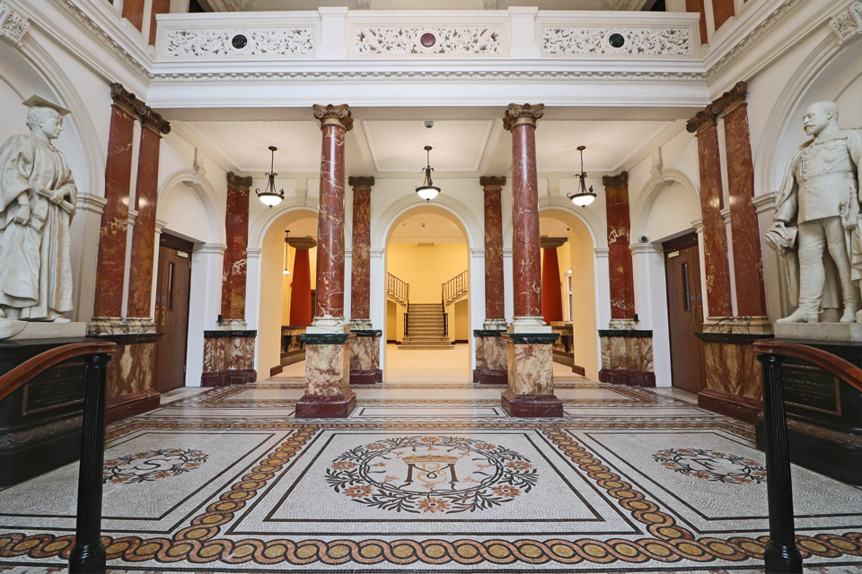

Useful information and what to bring

- Students should bring their instruments with them.
NB: Please note that we may have a high number of pupils with piano as their first study instrument. Because of this and the practicalities of not being able to provide multiple separate pianos, if a piano pupil also plays a second instrument, please can they bring their second study instrument to play. We will also have tuned and untuned percussion instruments available to play.
- Please bring a snack and drink to have in the breaks.
NB: Please do not bring any nut-based snacks due to allergies.
- Please wear comfortable clothes – there is no dress code.
- Toilets are located directly outside the 'Inner Parry Room’ and the Recital Hall, RCM staff will be available to direct visitors.
- Parents/Carers are very welcome to stay with their child during the workshops or are welcome to drop them off and wait in the RCM café which has tables to work at/WIFI available. The main cafe will be open until 5.30pm should parents wish to be based/get their own refreshments from there whilst the workshops take place.

Partners
ABRSM
In partnership with four Royal Schools of Music, ABRSM carry on a long legacy of musical excellence. More than an awarding organisation, they support learners from the first note they play, and empower teachers who help build musical skills and encourage progress around the world.
As a charity, ABRSM also make significant donations towards music education initiatives globally. They advocate for music and its many forms, playing their part to ensure the future of music education and its place in society.
Together with their partners, teachers and others around the world, ABRSM have been nurturing the future of music since 1889—to help people start or continue their journey. https://www.abrsm.org/en-gb

Audiovisibility (Ruth Montgomery, Founder and Artistic Director)
Ruth was born deaf into a musical family. She studied at the Royal Welsh College of Music and Drama, achieving her BMus Honours degree in music and flute performance. She is not only a professional flautist, but also a music teacher and workshop practitioner. As a visionary artist and creative Ruth proves through all aspects of her work that music is not just auditory in nature. Having become a Clore Leadership Fellow, Ruth has developed a worldwide network of professional relationships with arts, music, and media organisations.
In 2016 Ruth founded Audiovisibility https://www.audiovisability.com/ to bridge the gap between deaf and hearing artists, primarily by using visual arts and music. Audiovisibility is a charity that brings the highest quality of classical and non-western traditional music to deaf people. It recognises the innate talent of deaf musicians and artists through the forging of partnerships, music education, and innovative thinking.
Awards for Young Musicians
Musical talent is everywhere but opportunity isn’t: family finances and other obstacles too often get in the way. AYM is here to change this is two keyways.
- Supporting young musicians from low-income families, with funding and other help
- Supporting music education through training, advocacy and research.
This combination creates real impact. See their website for more: www-a-y-m.org.uk

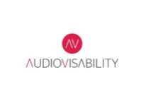
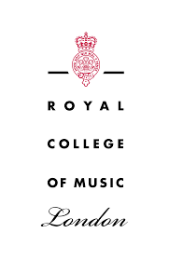
Royal College of Music
The Royal College of Music's learning and participation programme, RCM Sparks, has been providing inclusive opportunities for young people to engage with music education since 2007 https://www.rcm.ac.uk/sparks/.
We actively recruit participants facing barriers to participating in music education and provide a pathway of high-quality long-term engagement in line with the RCM's Access and participation plan.
We strive towards the Royal College of Music being a place where everyone feels welcome and represented.
We collaborate with a broad and diverse range of professionals and organisations to deliver a wide range of opportunities from targeted projects to large-scale events.
We train Royal College of Music students in the field of music education, developing a vibrant new generation of educators with relevant and meaningful practical experience, who in turn, are aspirational role models for our participants.
Tri-borough Music Hub
Our vision is for every child or young person – whatever their age, ability, or life circumstances – to have their voice heard, to feel included, and to be able to access enriching and relatable musical experiences.

The Tri-borough Music Hub (TBMH) is the award-winning lead organisation that oversees the delivery of music education in the three West London boroughs of Hammersmith and Fulham, Kensington and Chelsea, and the City of Westminster.

We work with schools, pupils, music educators and the community. We are a centralised Local Authority service which receives core funding from the Department for Education via Arts Council England. We operate a shared-services model across three Local Authorities to deliver an expansive programme of musical learning, in and out of school.

Alongside the three Local Authorities, the TBMH Strategic Partners are the Royal Albert Hall and the Royal College of Music. In addition, a quality-assured group of delivery partner organisations work to meet the TBMH’s strategic aims and positively contribute to our stakeholders. The TBMH is a music-specific service focused on high quality outcomes inclusive of all learners. It recognises the numerous benefits that music can bring to everyone from all backgrounds and in all circumstances. For more information about the work of the TBMH see annual reports HERE.

Tri-borough Music Trust
Tri-borough Music Trust is the charitable arm of the Tri-Borough Music Hub (TBMH). We promote and support music activities for all children and young people across the three boroughs of Kensington and Chelsea, Hammersmith and Fulham, and the City of Westminster, but particularly target those young people experiencing inequalities or disadvantage – more information here: https://www.triboroughmusichub.org/support-us/about-tri-borough-music-trust/

