Appointing Lead Schools / Settings for TBMH
*Timeline may shift based on DfE/ACE changes
How many Lead Schools/Settings?
In line with DfE/ACE guidance, from Sept 2024 there must be named Lead Schools for Music in each LA:
- 1 x Primary
- 1 x Secondary
Tri-borough Music Hub aims to extend the group of lead schools to also include (where possible):
- Alternative Provision
- SEND
- EYFS
- Further Education

What is the role for?
The Lead Schools/Settings will play a distinct role supporting other schools / settings to improve their music provision.

In collaboration with the TBMH, they will be expected to support and develop other schools / settings through the following:
- learning networks
- CPD courses
- mentoring
- peer support activity
- collaborative music projects
- practice and resource sharing

(NB: this list is just illustrative and is not limited to these areas)

Does your school:
- exemplify high-quality music provision and teaching?
- champion best practice music education in their LA area?
- show commitment to curriculum delivery with significant timetable time, co-curricular opportunities, inclusive provision, and teacher development?
- contribute to the development of a strategic approach to inclusion?
- advocate for music education and the work of the Music Hub to colleagues in other schools?
Context and Appointment of Lead Schools
In accordance with the new DfE/ACE changes and the new National Plan for Music Education (NPME), from September 2024 Lead Schools must be appointed in each Local Authority area.
- The Tri-borough Music Hub (TBMH) will start of the process of defining the roles and selecting Lead Schools/Settings during late Autumn 2023.
- This document sets out the criteria, role, and process for the selection of the Lead Schools/Settings within LBHF, RBKC, and WCC. There is also contextual information about the new Music Hub geographical areas coming into effect from September 2024.

What is the expected commitment of the Lead Schools/Settings?
In addition to the outline on page 1 of this document, the chosen schools/settings:
- will work with the TBMH Leadership Team to help curate/design/shape activity that will benefit fellow schools/settings.
- will attend termly planning meetings.
- will attend school networks/CPD sessions/activities/events.
- will advocate and amplify the work of the Music Hub.

What do the Lead Schools/Settings get in return?
- Recognition as a Lead School/Setting with exemplary music education provision.
- We propose an in-kind model of flexible/negotiated remuneration with additional partial-paid cover release as appropriate and based on need and available budget.
- Where appropriate, one-off financial support for bespoke projects may happen.
- Lead Schools/Settings may be invited to represent the Music Hub at local events, national events, conferences, or other hub-related activities.
- A memorandum of understanding will be prepared between the Lead School and TBMH.

Timeline for Primary and Secondary Lead Schools:
- Launched to Schools/Settings in late Nov 2023
- Submit online application by 5pm 15 January 2024 (HERE)
- Shortlisted schools and settings informed by 9 February 2024
- Shortlisted schools site visits and surveys by 28 March 2024
- Lead Schools/Settings informed and announced by 22 April 2024
- Contracting agreed and Lead Schools Initial meeting: week beginning 13 May
- Further meet ups to be agreed before end of term with CPD offerings TBC
NOTE: The entire timeline we have outlined may shift based on any changes or delays from DfE/ACE. We will communicate any changes with all schools/settings as and when these might happen.

Criteria for Appointing Lead Schools
The NPME sets out that Lead Schools/Settings should exemplify high-quality music provision and teaching, championing best practice in their area, showing commitment to a number of key aspects including curriculum delivery with significant timetable time, co-curricular opportunities, inclusive provision and teacher development. These expectations are aligned to the platinum school criteria within the Tri-borough Music Hub’s Schools Evaluation Tool (HERE). The selection criteria for lead schools and settings that we have created is based on these merged criteria. NOTE:
- We would not expect all lead schools to have everything in place now (Autumn Term 2023).
- By answering ‘yes’ to the questions on the application, it is assumed that the criteria would be in place by April 2024.
TBMH Lead Schools/Settings Application:
In the online application, answers would be:
- ‘yes’
- ‘no’
- ‘in the planning stages’ (in place by April 2024) or
- ‘Not Applicable’.

It is a generic application for all settings and therefore if a question does not apply to your school or setting, please answer ‘not applicable’. There is a box under each section for a written response to the questions. This is to provide a narrative to the short answers which may or may not be applicable to your setting. There is also an (optional) opportunity to upload evidence if this is relevant to the application. The application questionnaire is set out into five areas which may align to the school/setting’s development plan:

- I – INTENT
- S – SUBJECT LEADERSHIP
- E – EVALUATING & MONITORING
- R – RESOURCING
- O – OUTCOMES/IMPACT

- The official application form is in a digital format and can be accessed HERE. The questions in the online form are outlined in Appendix A (click HERE) in a hard copy format, to support preparation for the application.
- Please submit only one application per setting/school. Academies and schools within multi-academy trusts and federations will each be treated as separate schools/settings.
- The TBMH recognises that all schools and settings have strengths and relative areas for development. In applying, please consider the areas which are exemplary (e.g. provision within EYFS and KS1; or inclusive provision within KS3).
- We strongly advise that the application is filled in by the Lead Music Subject Leader, in collaboration with the leadership team and associated governor responsible for evaluating and monitoring the effectiveness of music provision.
- Please submit the online questionnaire by Monday 15 January 2024.

Shortlist Stage:
Those schools selected from the first stage will be the shortlisted schools and will be assessed for the final selection of Lead Schools. The school will receive one or more visits by one or more TBMH Assessors. On the visit, the TBMH Assessors will undertake a number of activities which may include:
- Observation of a selection of teaching situations including assemblies, lessons and clubs
- Discussions with staff and pupils
- Discussions with parents
- Discussions with a governor and school leadership team
- Discussions with subject leader
- Scrutiny of further evidence which may include the Ofsted report, letters and feedbacks, media coverage and recordings and videos of student progress.
- Data on GCSE uptake and external exams (if applicable)
- Data on FSM and number of FSM engaged in instrumental and vocal programmes and clubs
- Data on SEND and numbers of SEND students engaged in instrumental and vocal programmes and clubs

Terms and Conditions of the Lead School/Setting Status:
It is important that Lead Schools/Settings continue to exemplify excellence in music education beyond the acceptance to LS status.

As partners within the Hub, Lead Schools/Settings will continue to bring school-based expertise and experience of school-to-school support to wider Hub partnership discussions and strategies. By doing so, they should help to ensure Hubs understand and are able to respond to the present challenges and opportunities within local schools and can adapt their offers and ways of working to achieve maximum impact in these settings.

Lead Schools/Settings will contribute to the development of a strategic approach to inclusion. Within these parameters, the specific role of Lead Schools in a Hub, the approach to identifying and appointing them, and the work they are commissioned to undertake, should be driven by the needs of pupils, teachers, and schools within the Hub area. This will be agreed in the Initial Agreement in April 2024.

The Hub’s approach to monitoring the impact of Lead Schools/Settings should already be, or be willing to commit to, working closely with their local Teaching School Hubs to build networks of best practice in their areas, supporting the Teaching School Hub with specific music training provision where needed.

Representation at all meetings will be a condition of becoming a Lead School/Setting. There will be an initial meeting with all Lead Schools/Settings across the wider new London-West Music Hub in 2024-25 academic year, and then individual termly check in meetings with each school. Other schools across the area will be asked to complete a yearly survey about the support they have received from the Lead Schools so we can measure impact or success.

The status of LS will be:
- Initially for 2 years
- Evaluated after 2 years then on a rolling basis (which may be part of an LS Activity)
- Re-assessed every 5 years or sooner if the Lead Person leaves the school or setting
- A memorandum of understanding will be prepared between the Lead School and Music Hub
The National Plan for Music Education (NPME) emphasises the role of Hubs in supporting school music improvement, embedding stronger practice and supporting effective professional development for teachers. As part of this, the Department for Education (DfE) would like Hubs “to support stronger links between local schools and academy trusts, and broker opportunities for peer-to-peer learning”. Lead Schools are designed to drive this by embedding schools within the Music Hub, not only as customers of the Hub, but as co-creators and delivery partners for elements of its work.
Lead Schools for Music 2023, Arts Council England

The Plan for Lead Schools (TBMH and the new Music Hub from Sep 2024)

Table 1: Proposed Lead Schools and Settings within the Tri-borough (at least 6 schools/settings)
 | Proposed Tri-borough Music Hub Lead Schools and Settings April 2024
 | Hammersmith & Fulham LBHF | Kensington & Chelsea  RBKC | Westminster WCC
Will recruit at least one… | - Primary School  - Secondary School | - Primary School  - Secondary School | - Primary School  - Secondary School
Ambition to also recruit, where possible, at least one… | - EYFS Setting  - FE Setting/College  - SEND Setting  - AP Setting | - EYFS Setting  - FE Setting/College  - SEND Setting  - AP Setting | - EYFS Setting  - FE Setting/College  - SEND Setting  - AP Setting

Geographical / Specialisms: London-West Music Hub
The structure of Music Hubs is changing due to DfE policy (more info HERE). In September 2024, the new Music Hub geographies will come into effect which will see a newly formed ‘London-West Music Hub’ come into existence that covers Brent, Ealing, Harrow, Hillingdon, Hammersmith & Fulham, Kensington & Chelsea, and Westminster.

The 7 LAs cover 5 existing Music Services:
- Brent Music Service
- Ealing Music Service
- Harrow Music Service
- Hillingdon Music Service
- Tri-borough Music Service/Hub

The agreed proposal between the 7 LAs is that Kensington and Chelsea (the Lead LA Grant holder for the Tri-borough Music Hub, TBMH) will be the Hub Lead Organisation (HLO) on behalf of the London West Music Hub (LWMH), with the application submitted on 10th Oct 2023. DfE/ACE will announce the successful HLO in April 2024. See Appendix B (click HERE) for the Proposed Model of the London West Music Hub. Irrelevant of who is confirmed as the HLO, there will need to be named Lead Schools in each of the LWMH LAs. The other LAs may also choose to extend to EYFS, SEND, Alternative Provision Settings, and Further Education Settings, as follows:

Table 2: Proposed Lead Schools and Settings within the new London West Music Hub
Proposed London West Lead Schools and Settings September 2024
Brent | Ealing | Harrow | Hillingdon | LBHF | RBKC | WCC
Minimum:  - Primary  - Secondary | Minimum:  - Primary  - Secondary | Minimum:  - Primary  - Secondary | Minimum:  - Primary  - Secondary | Minimum:  - Primary  - Secondary | Minimum:  - Primary  - Secondary | Minimum:  - Primary  - Secondary
Where possible / optional:  - EYFS  - FE  - SEND  - AP | Where possible / optional:  - EYFS  - FE  - SEND  - AP | Where possible / optional:  - EYFS  - FE  - SEND  - AP | Where possible / optional:  - EYFS  - FE  - SEND  - AP | Where possible / optional:  - EYFS  - FE  - SEND  - AP | Where possible / optional:  - EYFS  - FE  - SEND  - AP | Where possible / optional:  - EYFS  - FE  - SEND  - AP

Collectively, across the 7 LAs we will be able to create a strong network of Lead Schools to help steer and support a cohesive and connected music education provision. There will be an initial meeting with all Lead Schools across LWMH in 2024-25 academic year, and then individual termly check in meetings with each school.

APPENDIX A – Application Form
NB: The PAPER VERSION here is intended as guide to the contents of the digital form.
Please only submit via the online application.

School/Setting Name: (NAME OF SCHOOL/SETTING)

Lead Person: (NAME OF LEAD PERSON)
School/Setting’s Headteacher: (IF DIFFERENT FROM THE LEAD PERSON)

Summary of your school/setting’s strengths

In no more than 200 words, please summarise why your school or setting should be awarded lead status.

INTENT
How is the music provision organised?
Answer: yes, no, in the planning stages, or not applicable.
Does your school/setting…
- …have a working School Music Development Plan Document?
- …ensure that pupils receive at least one hour of curriculum music per week?
- …have a progressive and diverse music curriculum in place that is nuanced to the backgrounds and needs of all students including SEND pupils, those with additional needs, pupils receiving FSM?
- …have a music curriculum that gives opportunities for students to create, compose and improvise and address the inter-related elements of music facilitated in a musical way encompassing a wide range of musical genres and traditions?
- …provide first access whole class instrumental learning to all students in KS2?
- …engage with music CPD activities in/out of school and/or supported other schools within the last year (or has previously led or hosted CPD)?
- …provide regular performance opportunities in and out of school?
- …ensure that all additional external projects are linked to the curriculum/sequenced provision map?
- …provide at least one open access (non-auditioned) extra-curricular vocal group?
- …offer opportunities for musical vocal work in every curricular lesson?
- …offer opportunities for musical vocal work in collective worship/assemblies?
- …offer extra-curricular instrumental/vocal groups which are designed to engage a proportionately aligned distribution of ethnic heritage and gender matched with the overall school demographic?
- …give pathways to and enable the study of music at Key Stage 4 and beyond, including provision of music GCSE, A level and/or technical awards?

Please tell us more about the way music provision is organised in your school/setting. You may choose to upload some supporting evidence (optional).

SUBJECT LEADERSHIP
If a school or setting is applying for lead status it is a requirement that there will be a lead person who will be tasked with managing the school or settings’ lead role. The lead person will need release time for this role to undertake tasks which may entail:
- Organising co-ordinating events for students and staff
- Mentoring practitioners
- Facilitating professional development
- Conducting study tours
- Working collaboratively with other schools/settings and professionals

How is the Subject of Music Led and Facilitated?
Answer: yes, no, in the planning stages, or not applicable.
Does your school/setting…
- …have Music embedded in the leadership structure with a designated music/arts specialist leading the department?
- …ensure that the subject of Music is embedded throughout the whole school with all staff positively reflecting this through their actions/modelling? (e.g. music can be offered in the morning, not just the afternoon; students are released from other curriculum lessons to attend instrumental/vocal lessons).
- …have confirmed SLT/Governor support?
- …actively get involved with the local Music Education Hub with the lead person regularly attending and contributing to network meetings, and helping to drive change?
- …encourage/facilitate the subject lead to engage with music CPD activities in/out of school and/or support other schools within the last year?

Please tell us more about how the subject of Music is led and facilitated in your school/setting. You may choose to upload some supporting evidence (optional).

EVALUATING & MONITORING
How is the subject of Music evaluated and monitored?
What have we put in place to help us to measure how we are doing?
Answer: yes, no, in the planning stages, or not applicable.
Does your school/setting…
- …ensure that Music making across is of a high quality with formal monitoring systems in place to support good practice?
- …have an awareness of its strengths and relative areas for development?
- …receive regular feedback from stakeholders including children and young people?

Please tell us more about how the subject of Music is evaluated and monitored in your school/setting. What has been put in place to help you to measure how well the school is doing in their music provision and outcomes. You may choose to upload some supporting evidence (optional).

RESOURCING
How well is the subject of Music resourced?
Answer: yes, no, in the planning stages, or not applicable.
Does your school/setting…
- …have rooms and spaces for music teaching, practising, and performing?
- …have a large space and equipment available at the premises suitable for hosting CPD events within and outside of the school/setting’s day?
- …have adequate instrumental resourcing for core curricular, extra-curricular and co-curricular?
- …ensure that Learning Support Assistants, Classroom Assistants and Teachers are deployed, prepared and fully engaged, supporting the whole class instrumental programmes musically?
- …have a yearly subject budget which aligns with the development plan?

Does your school/setting have a named lead person...
- … with professional maturity and significant experience as an arts educator? Can they present to other professionals as a leader at a wider community and local authority level?
- …who regularly engages with their own professional development?
- …who has experience in developing and facilitating professional development and/or mentoring within the field of arts education?

Is the school or setting able to commit to...
9. ...allowing the use of school and setting venue for the purpose of supporting the hub in their many activities e.g. in school and after-school workshops, programmes for pupils in partner schools, new technologies provision for student clubs etc.?
10. ...releasing the lead person for half a day once a term to work with the TBMH on a focused topic (i.e. resources, professional development…); and to work with colleagues collaboratively or as a mentor to support best practice in schools across the borough?
11 ...allowing ITT providers and their practitioners to visit the school or setting as part of their Lead Status in showcasing exemplary practice?
12 ...obtaining permissions (where possible) so that best practice can be shared on web platforms and social media to promote high quality provision.

Please tell us more about how the subject of Music is resourced. You may choose to upload some supporting evidence (optional).

OUTCOMES/IMPACT
How do we know we are making an impact?
Answer: yes, no, in the planning stages, or not applicable.
Is your school/setting able to demonstrate that...
- …they have excelled in one or more aspects of musical provision within the last two years?
- …there are opportunities for all children and young people to perform at least once a year in school?
- …all musical activities have clear outcomes with tangible evidence of their impact?
- …children can communicate about music (using appropriate vocabulary) in a meaningful way; and/or can share and express their feelings through music?
- … music is embedded in the life and ethos of the school?
- …students are able to progress in their musical interests and potential within the school and across their communities?
- …SEND pupils and those with additional needs are engaging and making progress musically?
- … pupils receiving FSM are engaging and making progress musically?
- …data on engagement with extra-curricular activities shows a proportionately aligned distribution of ethnic heritage and gender matched with the overall school demographic?

Please tell us more about the school’s musical achievements, performances and outcomes.
You may choose to upload some supporting evidence (optional).

APPENDIX B - London West Music Hub Proposed Model September 2024
Please note that the graphic below is the PROPOSED model in the consortium application in the London-West Music Hub, and is subject to change pending the outcome of the DfE/ACE decision-making process expected in April 2024.
- The agreed proposal between the 7 LAs is that Kensington and Chelsea (the Lead LA Grant holder for the Tri-borough Music Hub, TBMH) will be the Hub Lead Organisation (HLO) on behalf of the London West Music Hub (LWMH).
- The application was submitted on 10th Oct 2023.
- DfE/ACE will announce the successful HLO in April 2024.
- The consortium’s collective statement of intent/vision is:
“The London West Music Hub is a consortium of seven Local Authorities working together to maximise the music education potential of all young people in West London by turning opportunities into meaningful pathways through connected partnerships”.
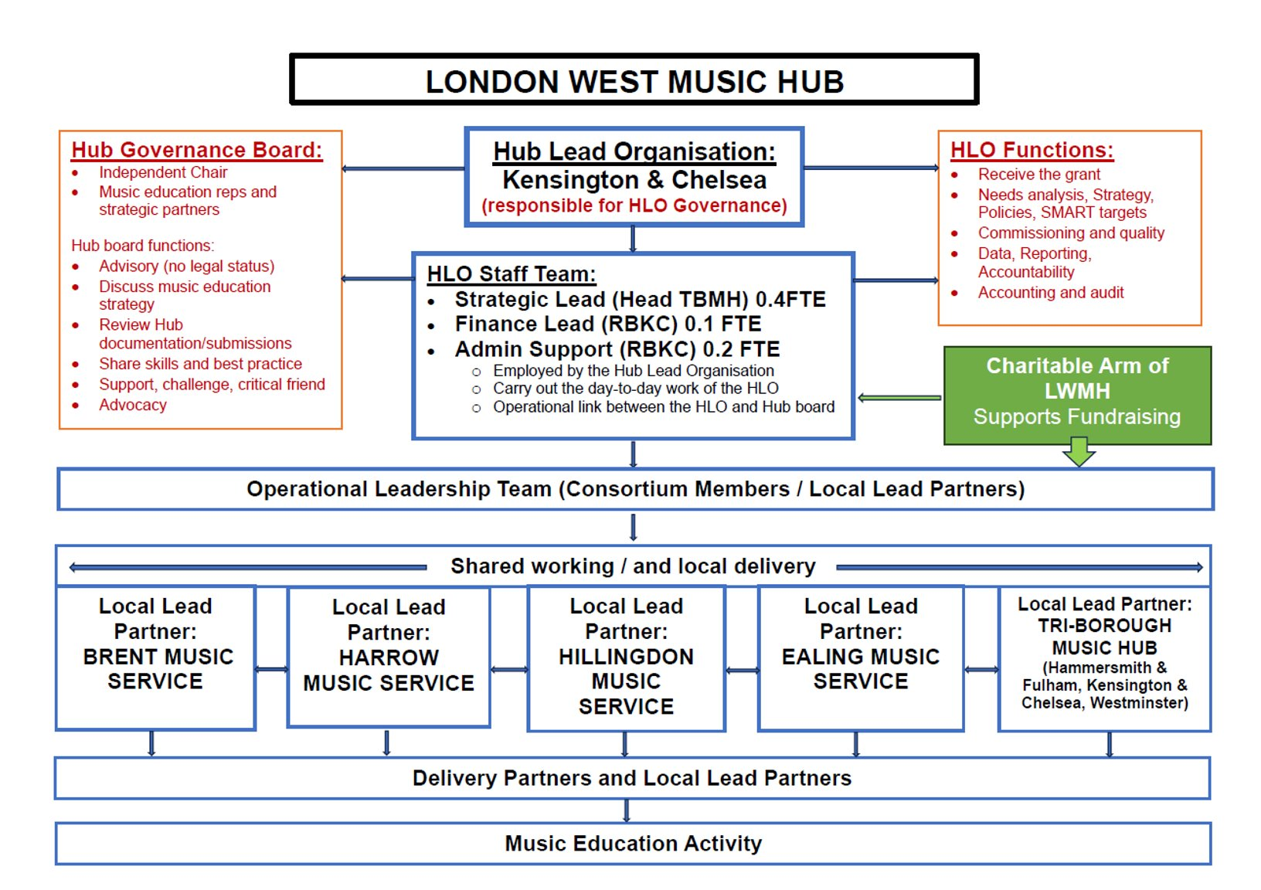

This document was compiled through merging the guidelines set out within the following key documents:
- The Power of Music to Change Lives National Plan for Music Education 2022 - UK Gov
- Model Music Curriculum 2021 UK Gov
- Music Development Matters in the Early Years - Early Education
- National Plan for Music Education Summary for Schools - MTA
- Lead Schools for Music 2023 – Arts Council England
- TBMH Music Curriculum Guidance for Schools Ofsted Framework and Handbook
- TBMH Self-Evaluation Tool

