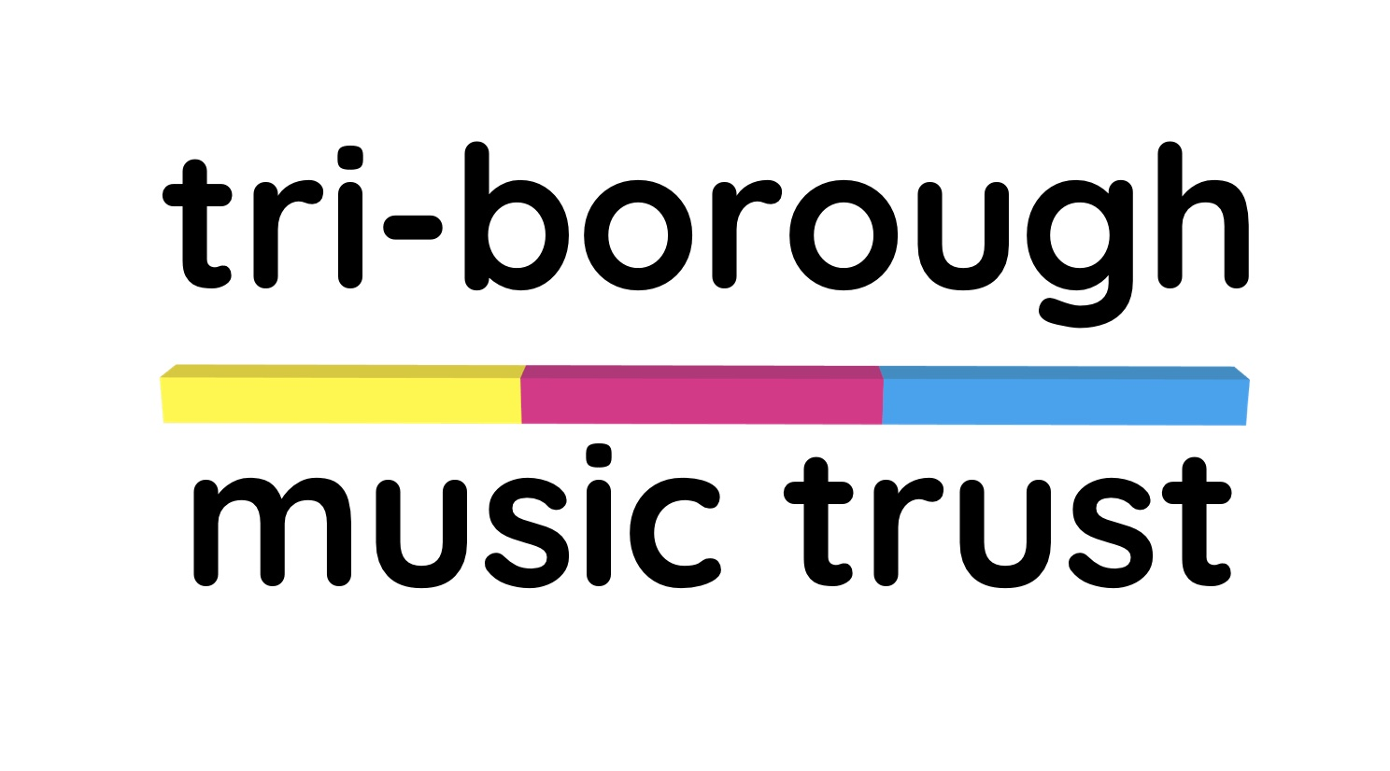

Tri-Borough Music Trust Privacy policy
This privacy policy sets out how Tri-Borough Music Trust use and protects any information that you give when you use this website, and when you sign up to mailing lists hosted via the website.

We are committed to protecting your privacy. We do not collect personal information such as names and email addresses unless you knowingly provide that information, for example signing up to our newsletter or agreeing to volunteer or work with us.

Policy on Information Collection
We retain personal information relating to newsletters, emails, and general enquiries. We only use this information for the purposes described when you submit it. We do not sell data or share it with anyone outside of the charity.

We may collect information about computer hardware and software such as IP addresses, browser types, domain names, access times, and the referring websites that visitors use to access web pages. We use this information to maintain the quality of the service and to collect general statistics. We do not use it to identify individual users.

Where we store your personal data
We are committed to ensuring that your information is secure. In order to prevent unauthorised access or disclosure, we have put in place physical, electronic and managerial procedures to safeguard and secure any sensitive information we collect online.

To record membership of email lists we use a product called Mail Chimp. Information you provide is stored on Mail Chimp’s servers and protected by their data collection and security policies.

To collect payments and donations to the charity we currently use “donorbox” and JustGiving. Payments made via these platforms are covered by their data collection, processing and security policies.

We will take all steps reasonably necessary to ensure that your data is treated securely and in accordance with this privacy policy.

Revisions to the Privacy Policy
We may revise this privacy policy at any time in response to changes in the law or other factors. We encourage you to periodically visit this page to review the most current policy.

Access to information
The GPDR regulations give you the right to request sight of any data we may hold about you. You can do this via the contact us page.

Contact us
Questions, comments and requests regarding this privacy policy are welcome and should be addressed to Jonathan Chambers at Jonathan.Chambers@rbkc.gov.uk

