National Plan for Music – Writing a school Music Development Plan
The new National Plan for Music Education (NPME) HERE was launched in June 2022 and demonstrates how music should be delivered in ALL schools. See the last page of this document for the free support available via the Tri-borough Music Hub to support all schools.
The vision of the new plan is:

To enable all children and young people to learn to sing, play an instrument and create music together, and have the opportunity to progress their musical interests, including professionally.

This means all children and young people:
- experience a broad musical culture in schools and education settings, accessing high quality curricular and co-curricular music, and progressing into appropriate qualifications
- access the expertise, instruments, technology, and facilities they need to learn, create and share their music
- engage with a range of enrichment opportunities to play and sing, to perform, create and experience live music, and have their music heard
- have opportunities to progress their musical interests and talents, and routes into a variety of music careers
- are supported by a skilled and dynamic workforce

Music in Schools
Schools are encouraged to aim high with their music provision, to embed and exceed the national curriculum and to support their pupils to realise their musical potential.

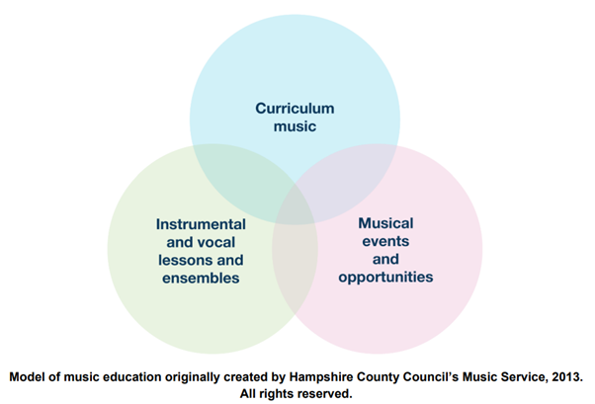
A high-quality school music education consists of three distinct, but interlinked areas of provision.
- Curriculum music, compulsory from key stages 1-3, then optional for examination classes (e.g. GCSE, vocational and technical qualifications and A level).
- Instrumental and vocal lessons, and ensemble membership.
- Musical events and opportunities, such as singing in assembly, concerts and shows, and trips to professional concerts

The NPME sets out the key features of high-quality school music provision as:
- timetabled curriculum music of at least one hour each week of the school year for Key Stages 1 to 3;
- provide access to lessons across a range of instruments and voice;
- develop a school choir and/or vocal ensemble;
- develop a school ensemble/band/group;
- provide space for rehearsals and individual practice;
- develop a termly school performance;
- provide opportunities to enjoy live performances at least once a year.

How should the NPME be used locally?
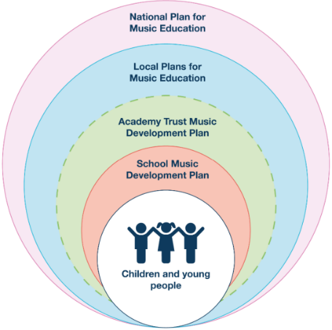
Together, the vision and three goals set out the overarching ambition for music education and explain the national framework for its delivery. This will be realised at a local area level through the Local Plan for Music Education, covering music education in and out of school and co-ordinated by the Music Hub lead organisation.

At school level, it will be captured in the school’s Music Development Plan, helping to show parents and children what they can expect from music education.

School Music Development Plan
Every school should be able to articulate their plan for delivering high-quality music education and supporting pupils to progress, just as they would in any other curriculum subject. The new NPME states that every school (including multi-academy trusts) should have a Music Development Plan that captures the curricular and co-curricular offer and sets out how it will be staffed and funded.’

Whilst acknowledging that it is not a statutory requirement, the new National Plan recommends that schools should have a music development plan in place by 2023/24.

How to put together your plan – where do I start?

Step 1: Create a vision
A Music Development Plan will help to put music at the heart of your school.

The plan will enable all staff to work towards a music education that all their children deserve. It is vital that this is created collaboratively with the Head teacher, SLT and others to ensure the same shared vision and ambition.

Step 2: Audit your current provision
Where are you now and where do you want to be? How will you get there?

Achieving the ambitions of your plan will likely take time – it’s therefore important to consider where you are starting from, and where you would like to be - realism is vital.

Step 3: Write your plan
Write your plan of action – how will you achieve your vision and ensure the key features identified in the NPME are achieved?

Step 4: Review
Ensure you regularly review and update your plan.
Breaking down each stage
Step 1: Create a vision

The NPME says that a Music Development Plan will help a school to:
- Engage critically with its music offer;
- Feed music into wider school improvement;
- Open a dialogue with music services/hubs, both to enhance in-school provision and connect pupils to broader opportunities out of school;
- Publicise their music offer to pupils and parents, including on the school website, so they have an understanding of what to expect.

The School Music Development Plan should set out how your school will deliver high-quality music provision for all pupils in the three areas of curriculum, co-curricular and enrichment, and against the key features as previously outlined:
- timetabled curriculum music of at least one hour each week of the school year for Key Stages 1 to 3
- provide access to lessons across a range of instruments and voice
- develop a school choir and/or vocal ensemble
- develop a school ensemble/band/group
- provide space for rehearsals and individual practice
- develop a termly school performance
- provide opportunities to enjoy live performances at least once a year

In addition to the key features set out above, the following points are also mentioned in the NPME:
- Ensure music lessons are delivered by a designated music lead and ideally a music specialist.
- Ensure that singing is a core element in the provision with daily singing and singing assemblies considered.
- Produce and implement a high-quality music curriculum by adopting the Model Music Curriculum (2021) or implementing a curriculum that is at least comparable in breadth and ambition. This TBMH summary HERE will help schools to see the progression within Year groups and Key Stages.
- Work in partnership with the local music hub and other providers.
- As a school, highlight progression opportunities for children to access ensembles in the wider community provided by the music hub and their partners.

Step 2: Audit
Before writing your plan, you first need to audit where you are now. To support this process, the Music Teachers’ Association, Music Mark and the ISM, part of the #CanDoMusic partnership, have developed a self-evaluation tool. It is designed to be used by primary and secondary teachers, and school leaders, as they review their own provision, identify areas for development and celebrate excellent work.
https://www.musicteachers.org/wp-content/uploads/2022/08/Music-Self-Evaluation_Primary-ver2.pdf

Alternatively you could look at each of the key features of a high-quality music provision, highlighted above against the following questions:
- Where are we now?
- Where do we want to be?
- How will we do it?
- Further details - Resources, timings, problem solving and long-term plans
…and then populate a template similar to the following example (next page)

Example (Primary School):
Key Feature from NPME | Where are we now? | Where do we want to be? | How? | Further details
1 hour of high-quality music per week | No specialist music delivery.  Currently, classroom teachers deliver some music when they can fit it in using an online scheme.  This is ad hoc and nowhere near the weekly one hour. | Whole school music assembly (30 minutes per Key Stage each week).  Class teachers deliver at least 45 minutes of general music lessons each week.  Support for teachers with the Model Music Curriculum/ progression framework/ singing in classroom.  Specialist music teacher(s) to deliver whole class instrumental lessons (funded by PTA if budgets are tight as all children will benefit). | Music Specialist to lead music assembly  Use repertoire suggestions from MMC (or similar) along with musicianship suggestions appropriate for age.  Review available schemes and find one that class teachers are likely to use. Monitor its use.  Alternative - Contact TBMH for support | Speak to TBMH - find out what specialist support is available (CPD/ resources/ delivery etc)  Do you have existing staff with musical skills?  Can music specialist lead music assembly with singing, musicianship and listening activities included…? (linked to MMC)  Subscribe to free trials of Sing Up, Charanga etc. Investigate other free recourses (e.g. BBC 10 pieces, ABRSM classroom 200).  Investigate getting a music specialist in future who could deliver music as PPA cover. This will provide capacity for teachers to focus on other foundation subjects, along with increasing the quality of delivery of music across the school. Specialist delivery is recommended in the new National Plan.
Provide access for instrumental or vocal lessons | xxx | xxx | xxx | xxx

Step 3: Write your plan

Reflect on your findings from the audit/ self-assessment then create your plan – this could be linked with the school improvement plan.

The NPME says that, ‘All schools should produce a Music Development Plan in a form that works for them, and while producing one is not a statutory requirement, we would encourage schools to develop them over the course of next academic year (i.e. from September 2022), to help drive improvements in provision for all children and young people, with the aim of having a revised or new Music Development Plan in place for academic year 2023/24 at the latest’. (p.22)

You therefore have the freedom to develop a plan that works for you and fits within the wider workings of your school.

The key thing is to use your Music Development Plan to celebrate how music is delivered in your school or setting and to use it as a way to focus on your successes and your students.

National Plan for Music Education and all Tri-borough Music Hub Curriculum Support Documents
The long-awaited new NPME was released on 25th June and is a significant milestone in how music must be delivered in ALL schools.
- The document direct link is HERE.
- A host of supporting information has been prepared to help schools understand the implications by Music Mark (HERE) and the Music Teachers Association (HERE).
- A summary of the NPME for schools can be found HERE.
- We have prepared a TBMH video about how schools can approach inclusive music education linked to the NPME can be found – HERE

Tr-borough Music Hub FREE Curriculum Support
TBMH documents to help schools with their own curriculum delivery – these can all be found HERE in Word and PDF formats.
- Free guidance on School Music Education Plan read the front page to understand TBMH’s approach to SMEP.
- Creating your own school/setting music policy (EYFS to post-16) – HERE
  - Answer the prompt questions and you will be able to present a summarised description about how music is delivered in your school
- Self-evaluation tool for music (EYFS to post-16) – HERE
  - Answer the prompt questions and you will be able to get a clearer picture of where your schools may sit within a framework of Silver/Gold/Platinum which tallies with the Artsmark framework.
- Model Music Curriculum - Overview – Teaching Music in Schools – HERE
  - This summary will help schools to see the progression within Year groups and Key Stages
- Music Education Recovery Curriculum framework

Tr-borough Music Hub FREE Teaching Resources
- Free access to TBMH Virtual Music School (more than 1500 resources)
- Free SEND-Friendly Vocal Resource (20 songs)
- Free Singing Assembly resource
  - We have released 4 teaching resources for KS3-5 Music Production & Technology, Hip-hop & Rap & Song-writing, that can all be found here. The direct resource links are here:
- Music Production – T&L Resources (HERE)
- Songwriting – T&L Resources (HERE)
- Hip-Hop – T&L Resources (HERE)
- Teaching young people with Special Educational Needs & Disabilities additional resources (HERE)

With thanks to Wandsworth Music Hub for their support with the creation of this document.

