Supporting Information about Whole Class Instrumental Learning Programmes from the Tri-borough Music Hub

Whole Class Instrumental Learning Programmes
The Tri-borough Music Hub's Whole Class Instrumental Learning (WCIL) Programmes offer schools a progressive series of First-Access musical learning resources from Year 1 through to Year 7. These resources have been commissioned by the TBMH to provide schools and their pupils with a comprehensive approach to the initial stages of learning to play an instrument. This is the starting point of a long-term progression route and access to pathways beyond the programmes.
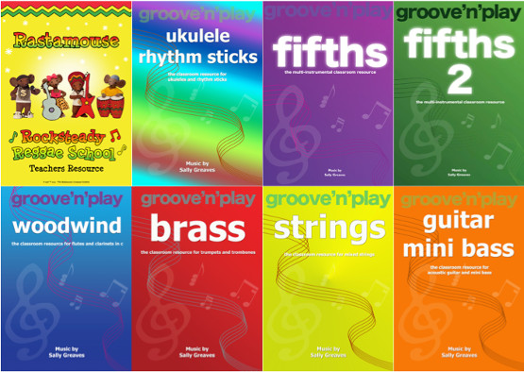
Both the ‘groove ‘n’ play’ class ensemble series and the Rock Steady Reggae School (Rastamouse) programme, devised and composed by Sally Greaves, give children the opportunity to develop their music skills, knowledge, language and understanding, as well as developing instrumental technique.

Each resource package includes high quality visual and audio resources with a teaching book including session plans, teaching notes and learning outcomes. The resources are flexible and can be used according to the skill and experience of the person(s) delivering the programme.

The school’s selected programme choice(s) should reflect the musical experience of the pupils and needs of each school. The most appropriate programme can be discussed with managers at the TBMH.

Programme Costs
The unit cost of 1 TBMH tutor, for one term (10 lessons), teaching one class, including PPA = £487.50
The unit cost of 2 TBMH tutors, for one term, teaching one class, including PPA = £877.50
NOTE: a) this is based on a 45 minute lesson and includes the PPA costs of Lead/Support tutors; b) Instruments can be hired from the Music Hub at a cost of £100 per term (subject to availability). Costs are explained in more detail on p6.

KS2 Incentive for Schools: for Mixed Wind, Mixed Brass, Mixed Strings, Guitars Programmes
The TBMH wants to support schools in developing their provision of KS2 whole class instrumental learning and is introducing a new financial incentive from September 2016. Schools will be able to apply for a proportion of FREE provision for one Year group (KS2 only), based on the number of terms the school buys in from the TBMH (agreed in advance, and according to the needs of the school):
- SIGN UP TO 3 term programme – purchase 2 terms get 1 TERM FREE* (33% discount)
- SIGN UP TO 2 term programme – purchase 1½ terms get ½ TERM FREE* (25% discount)
*For one Year Group only

Programme Delivery
Programmes can be delivered in three different ways:-
- by two TBMH tutors, working alongside the class/music teacher; or
- by one TBMH tutor working with the class/music teacher; or
- the resource can be purchased from the TBMH and delivered ‘in house’ by the school.
NOTE: there must be a minimum of two tutors (or 2 fixed adults with the required instrumental skills) working on any of the KS2 instrumental programmes (Wind, Brass, Strings, Guitars)

Programmes | Year Group Focus | Delivery Focus | Minimum Number Tutors
Rastamouse | 1/2 | Curriculum / Instrumental and voice | 1
Ukulele, Sticks and Songs | 2/3 | Curriculum / Instrumental and voice | 1
Recorder, Sticks and Songs | 3/4 | Curriculum / Instrumental and voice | 1
FIFTHS | 4/5 | Curriculum/ multi-instrumental and voice | 1
Recorder | 3/4 | Instrumental | 1
FIFTHS 2 | 5/6 | Curriculum / multi-instrumental and voice | 1
Woodwind (mixed) | 4/5/6 | Instrumental | 2
Strings (mixed) | 4/5/6 | Instrumental | 2
Brass (mixed) | 4/5/6 | Instrumental | 2
Guitar and Mini Bass | 4/5/6/7 | Instrumental | 2

School (in-house) Delivery
Schools can purchase the lifetime license as a one-off cost and deliver it in-house:

Cost | Description | Applicable to
£250 | Resource including inset* | Independent schools /  Schools outside Tri-borough area
£200 | Resource (teaching book: session plans, PowerPoints, Audio Visual Resources); Plus inset session  Package includes 20% discount for Lifetime licence | Maintained Schools in  Tri-borough area
or
FREE | FREE Resource (teaching book: session plans, PowerPoint’s, Audio Visual Resources); Plus inset session, when purchasing TBMH Tutor Delivery via SLA | Maintained Schools in  Tri-borough area
*Inset for Independent schools or those outside the Tri-borough area can be arranged via the TBMH or Sally Greaves.

Key Messages for Schools:
The most successful outcome for pupils will be when the Class/Music Teacher is present and active with the learning process, to support the progression and development of the pupils. If a Class Teacher is not able to be involved in this learning, then a permanent other school-based adult (e.g. TA with the required instrumental skills) will be expected to actively participate in all learning alongside the pupils, and assist with behaviour management. Schools should also encourage pupils to be able to take their instruments home, where possible and appropriate.

Practical requirements for WCIL programmes:-
- An interactive whiteboard (or computer linked to projector) and good quality sound system is needed for all programmes;
- An appropriate* teaching space with room for pupils to play and handle instruments and where the sound will not disturb other pupils and staff;
*The teaching space set-up prior to a session is a school responsibility.
- A space where instruments can be safely stored between sessions.

